PROJECT OVERVIEW
MADHAV E-COMMERCE
SALES DASHBOARD
Power BI Project Documentation
Data Analyst Portfolio Project | Microsoft Power BI | E-Commerce Domain
K
161
K
2
K
26
K
4.4
Total Revenue
Units Sold
Net Profit
Avg Order Value
Tool Used | Microsoft Power BI Desktop
Domain | E-Commerce / Retail Analytics
Dataset | Madhav E-Commerce Sales Data (Orders, Customers, Products)
Objective | Build an interactive dashboard to track sales, profit, customer behavior, and product performance
Dashboard Type | Multi-visual interactive dashboard with slicers and filters
Time Period | Quarterly analysis (Q1–Q4) with monthly drill-down
PROBLEM STATEMENT
The Madhav E-Commerce store required a centralized visual analytics solution to monitor sales performance across states, categories, customer segments, and payment modes. The management lacked visibility into profitability trends and customer purchase patterns. This dashboard was designed to bridge that gap by converting raw transactional data into actionable business insights.

Madhav E-Commerce Sales Dashboard | Power BI Project | Page 1 of 4

KPI SUMMARY CARDS
The four headline KPI cards at the top of the dashboard provide an instant snapshot of business health.
KEY METRICS & VISUALIZATIONS — PART 1
These are the first things any stakeholder looks at to understand the overall state of the business.
KPI Metric | Value | Business Meaning
Sum of Amount (Revenue) | 161K | Total sales value generated across all orders
Sum of Quantity | 2K | Total number of product units sold
Sum of Profit | 26K | Net profit after cost deduction — profitability indicator
Sum of AOV | 4.4K | Average Order Value — measures revenue per transaction

SUM OF AMOUNT BY STATE (Horizontal Bar Chart )
This horizontal bar chart reveals the geographic distribution of revenue across Indian states. Maharashtra leads with approximately 40K in revenue, followed by Madhya Pradesh, Delhi, and Uttar Pradesh.

Key Insights:
- Maharashtra is the highest revenue-generating state — a priority market for marketing investment
- Uttar Pradesh shows lower revenue despite being a large population state — opportunity for growth
- This chart guides regional sales teams and marketing budget allocation decisions

SUM OF QUANTITY BY CATEGORY (Donut Chart )
This donut chart shows how total product quantity is split across three major categories. The dominant segment (~63%) represents the highest-volume category, indicating the company's core product line.

Key Insights:
- The largest category drives over 60% of unit sales — critical for inventory planning
- Smaller categories (17-19%) represent cross-sell opportunities
- Donut chart was chosen over pie chart for better readability with a central KPI value

PROFIT BY MONTH (Bar Chart — Q1 View )
This bar chart tracks monthly profit trends within the selected quarter. In Q1, January recorded the highest profit (~9K), followed by a gradual decline through February and March.

Key Insights:
- January spike may reflect post-holiday or New Year sales momentum
- Declining trend toward March suggests seasonal dip — opportunity for promotional campaigns
- Monthly trend view helps in forecasting and target-setting for next quarter

Madhav E-Commerce Sales Dashboard | Power BI Project | Page 2 of 4

SUM OF AMOUNT BY CUSTOMER NAME (Bar Chart )
This bar chart highlights the top customers by revenue contribution. Harivansh leads with approximately 10K in purchases, followed by Shiva, Madhav, and Sarita. This is a customer segmentation view.
KEY METRICS & VISUALIZATIONS — PART 2

Key Insights:
- Harivansh is the highest-value customer — ideal candidate for loyalty programs
- Top 4 customers represent a significant share of revenue — reducing churn risk for these is critical
- Useful for CRM strategy, personalized marketing, and customer retention planning
- Orange color coding differentiates the top customer from others visually

SUM OF QUANTITY BY PAYMENT MODE (Donut Chart )
This donut chart breaks down transactions by payment method. COD (Cash on Delivery) dominates at
43.58 %, followed by UPI (17.5%), Debit Card (15.6%), Credit Card (11.75%), and EMI.
Payment Mode | Share | Business Implication
COD (Cash on Delivery) | 43.58% | High fulfillment cost — incentivize digital payments
UPI | 17.5% | Growing digital payment adoption — promote further
Debit Card | 15.6% | Standard digital payment — stable base
Credit Card | 11.75% | Premium segment — upsell high-ticket items
EMI | 11.5% | Installment buyers — good for expensive electronics

SUM OF PROFIT BY SUB-CATEGORY (Horizontal Bar Chart )
This chart provides the most granular profit view — broken down by product sub-category. Printers lead with over 4K profit, followed by Phones, Accessories, Bookcases, and Saree.
Sub-Category | Profit Range | Strategic Action
Printers | ~4K+ | Highest margin product — ensure stock availability
Phones | ~3.5K | High-demand tech product — strong performer
Accessories | ~2.5K | Bundle with phones/printers to boost further
Bookcases | ~1.5K | Moderate performer — review pricing strategy
Saree | ~0.8K | Lowest profit — review cost structure or promote higher-margin variants

DASHBOARD INTERACTIVITY & FILTERS
Feature | Description | Business Value
Quarter Filter Buttons | Toggle between Qtr 1, 2, 3, 4 | Enables quarterly performance comparison
State/Category Slicer | Dropdown to filter by region or category | Personalized view for regional managers
Cross-filtering | Clicking one chart filters all others | Drill-down analysis without extra navigation
Madhav E-Commerce Sales Dashboard | Power BI Project | Page 3 of 4
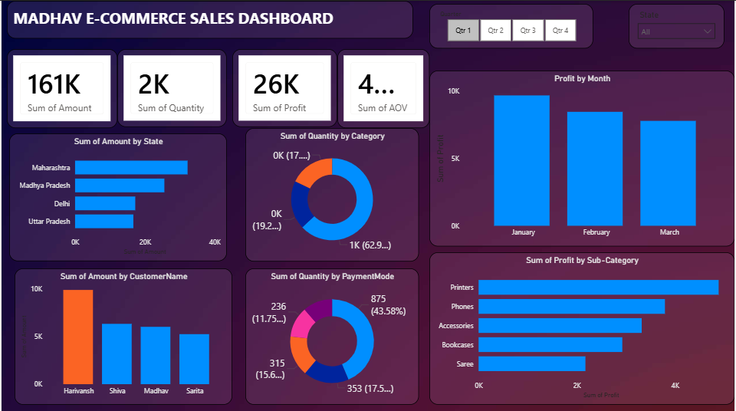

TECHNICAL SKILLS DEMONSTRATED
SKILLS DEMONSTRATED & INSIGHTS
Skill Area | How It's Demonstrated in This Project
Data Cleaning & Modeling | Structured transactional data with proper relationships between orders, customers, products
DAX Formulas | KPI measures: SUM(), AVERAGE(), calculated columns for AOV and profit margins
Data Visualization | 6 chart types: bar, horizontal bar, donut — chosen based on data type and insight goal
Business Acumen | Translated raw data into actionable insights for marketing, inventory, and CRM
Dashboard Design | Dark theme, consistent purple-blue palette, clean layout with logical flow
Interactivity | Quarter buttons, state/category slicers, and cross-filtering across all visuals
Storytelling with Data | Dashboard tells a complete sales story from revenue to product-level profitability

TOP BUSINESS INSIGHTS DISCOVERED
Maharashtra | Top revenue state (~40K) — highest marketing ROI region
Printers | Most profitable sub-category — stock priority and upsell opportunity
COD Dominance | 43.58 % of orders via Cash on Delivery — costly; push digital payment incentives
January Peak | Q1 profit peaks in January — plan campaigns for Feb-March to sustain momentum
Harivansh | Single highest-value customer (~10K) — VIP loyalty program candidate
Category Split | One category drives 63% of unit volume — core product line for inventory focus

Madhav E-Commerce Sales Dashboard | Power BI Project | Page 4 of 4

