Repo-to-Graph System Architecture & Algorithms Guide
This document provides a comprehensive explanation of how the Repo-to-Graph application analyzes source repositories, extracts code symbols, builds a call graph, calculates impact analysis scores, and renders interactive visual layouts.
---

1. System Architecture & Data Flow
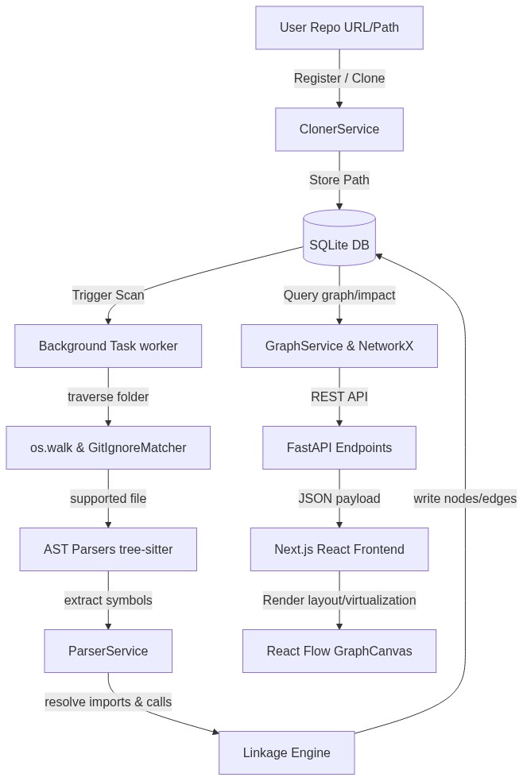
Figure 1: High-Level Architecture and Data Flow Engine

Database Schema
The graph data is persisted in a local SQLite database file repo_to_graph.db using SQLAlchemy models:
- Repository: Stores metadata (id, name, url, local_path).
- Scan: Tracks background jobs (id, repository_id, status [pending/scanning/completed/failed], error_message, created_at, completed_at).
- Node: Holds individual code symbols (id, repository_id, name, type [repo, folder, file, class, function, api, table], file_path, start_line, end_line, properties [JSON]).
- Edge: Defines relationships (id, repository_id, source_id, target_id, type [CONTAINS, IMPORTS, CALLS, CALLS_API, USES], properties [JSON]).
---

2. Scanning & Codebase Traversal
The scanning pipeline is orchestrated by ParserService.scan_repository.

Folder Traversal & GitIgnore Compliance
- os.walk Traversal: Starts at the repository root and walks the folder tree recursively.
- Ignored Directories: Standard build and dependency folders are ignored in-place (dirs[:] = pruned_dirs):
{".git", "node_modules", "venv", ".venv", "env", "__pycache__", ".next", "dist", "build", ".idea", ".vscode", "out"}
- GitIgnoreMatcher: Reads the root .gitignore file and compiles matching patterns using python's fnmatch rules:
- Case 1 (Relative prefix matching): Rules starting with / (e.g. /log) are matched relative to the repository root.
- Case 2 (Relative substring matching): Rules containing a / (e.g. docs/*.pdf) are matched against relative paths.
- Case 3 (Global name matching): Rules with no / (e.g. *.log) match file or folder names anywhere in the tree.
---

3. Concrete Syntax Tree (CST) Parsing
Supported files (.py, .js, .jsx, .ts, .tsx) are parsed using language-specific wrappers around tree-sitter.
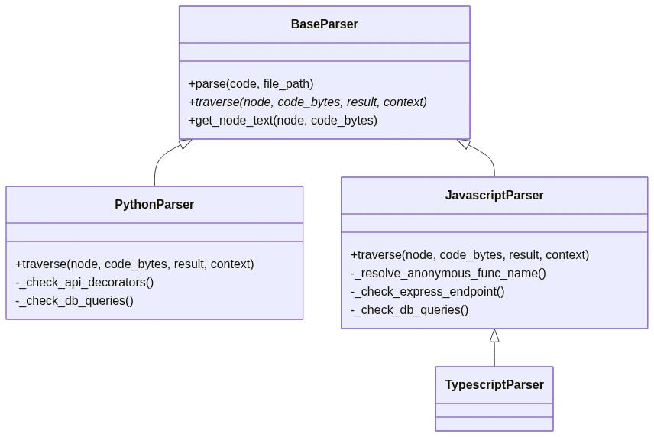
Figure 2: Tree-Sitter Parser Object Hierarchy
For each file, the parser recursively walks the syntax tree and extracts:
- Classes:
- Python: class_definition AST nodes.
- JavaScript/TypeScript: class_declaration AST nodes.
- Functions & Methods:
- Python: function_definition AST nodes.
- JavaScript/TypeScript: function_declaration, method_definition, arrow_function, and anonymous function_expression nodes. (Anonymous functions assigned to variables, assignments, or object properties are resolved to their nearest variable name identifier).
- API Endpoints:
- Python: Parses decorator expressions (e.g. @app.get("/users")) using regular expressions to extract the HTTP method and path string.
- JavaScript/TypeScript: Parses Express routing call expressions (e.g. app.post("/register", ...)).
- Database Queries:
- Looks for SQL command patterns (SELECT, INSERT, UPDATE, DELETE) inside string literals in the AST using regular expressions, capturing the table name and operation.
---

4. Linkage & Dependency Graph Resolution
Once the file structure, classes, functions, and metadata are extracted, the linkage phase builds the relationship edges.

A. Containment (`CONTAINS`)
- repo node $\rightarrow$ top-level folders & root files.
- folder node $\rightarrow$ nested files & folders.
- file node $\rightarrow$ classes & standalone functions declared in the file.
- class node $\rightarrow$ class methods.

B. REST APIs & Databases (`CALLS_API`, `USES`)
- API Route to Function: An API route node (ID: {repo_id}:api:{method}:{path}) is linked to a function node if the decorator/registration line number is located within the function's start and end line boundary.
- Function to DB Table: A function is connected to a table node (ID: {repo_id}:table:{table_name}) with a USES edge if the SQL query string matches the function's line boundaries.

C. Import Resolution (`IMPORTS`)
Imports (ES6, CommonJS require, Python imports) are translated to physical paths by _resolve_import_file_path:
- Dots in modules are mapped to path separators (e.g., services.db $\rightarrow$ services/db).
- The engine generates candidate filenames based on relative levels (../, ./) and typical file extensions (.py, .js, .ts, .tsx, /__init__.py).
- It matches candidates against the list of all registered repository files. If found, an IMPORTS edge is drawn from the importer file to the target file.

D. Function Call Resolution (`CALLS`)
When a function body contains a function call (e.g. callee_name()), the engine maps it to the target function node via _resolve_callee_node_id using a three-tiered lookup strategy:
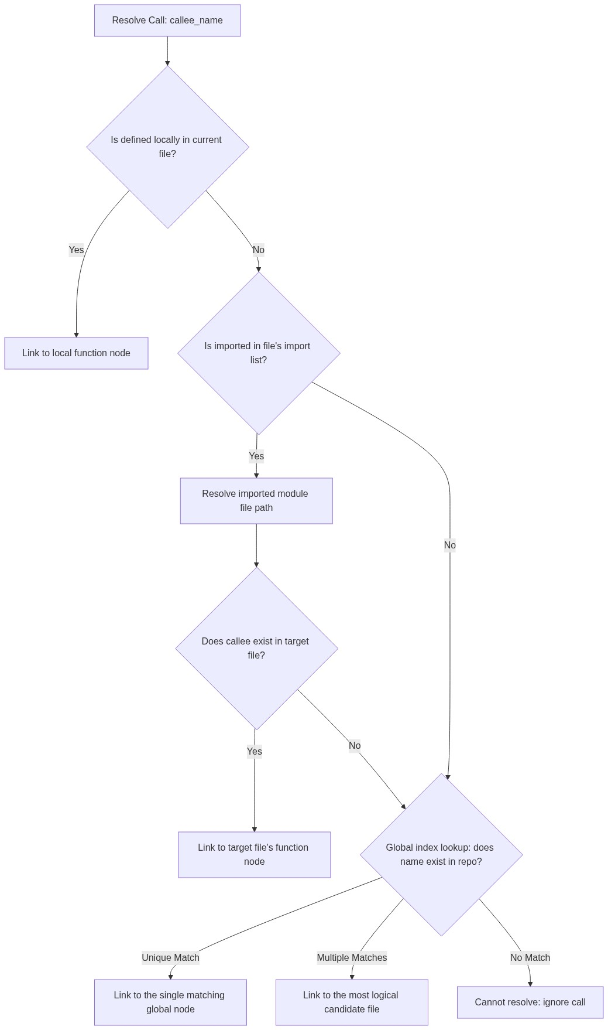
Figure 3: Call Resolution and Symbol Tracing Workflow
---

5. NetworkX Graph Algorithms
The backend service GraphService instantiates a networkx.DiGraph to perform advanced analysis.

Refactoring Impact Analysis
Calculates the downstream dependencies and upstream propagation blast radius of a code element:
- Upstream Propagation (Ancestors): Queries nx.ancestors(G, node_id) by traversing directed edges backwards to locate all transitive callers and depending classes/files.
- Downstream Dependencies (Descendants): Queries nx.descendants(G, node_id) by traversing directed edges forwards to find all elements the target node calls or depends on.
- Refactoring Impact Score: Computed using a weighted formula based on the category of affected upstream components:
$$\text{Impact Score} = 5 \times N_{\text{files}} + 3 \times N_{\text{classes}} + 1 \times N_{\text{functions}}$$
- Low Impact: Score $\le 10$
- Medium Impact: $10 < \text{Score} \le 30$
- High Impact: Score $> 30$ (representing a widespread risk if refactored).

Circular Dependency Detection
Identifies loops that could cause circular imports or stack overflow recursions:
- Circular Imports: Constructs a subgraph containing only IMPORTS edges and runs networkx.simple_cycles() to return cycles of files that import each other.
- Recursion Loops: Constructs a subgraph containing only CALLS edges and runs networkx.simple_cycles() to highlight recursive function calls.
---

6. Frontend Layout & Canvas Optimization
Rendering large codebase graphs efficiently in the browser is handled by GraphCanvas.tsx and @xyflow/react (React Flow).

A. Rendering Performance & Viewport Virtualization
- onlyRenderVisibleElements={true}: Renders only the nodes and edges within the user's viewport clipping boundaries. This prevents browser lag on large graphs.
- High-Level View Projection: For repositories exceeding 600 nodes, the backend hides fine-grained functions/classes and projects their calls to the file level (e.g. fileA.py calls fileB.py). This prevents rendering bottlenecks.
- Edge Animation Optimization: Dash animations are disabled on graphs with more than 150 edges to conserve GPU and browser CPU threads, enabling only upon node hover.

B. Auto-Layout Grid
Nodes are distributed horizontally into structured, thematic columns:
Column X-Coordinate | Node Types
**X = 0** | API Endpoints
**X = 300** | Folders
**X = 600** | Files
**X = 900** | Classes
**X = 1200** | Functions & Methods
**X = 1500** | Database Tables
Within each folder, files, nested classes, and their respective methods are clustered vertically to keep logical relationships visually coherent.

C. Orthogonal Edge Staggering
To prevent vertical overlaps of orthogonal connector lines:
- A custom edge component DistributeStepEdge computes the step path.
- The vertical midpoint centerX is shifted dynamically:
$$\text{centerX} = \text{midX} + \left( \left(\text{Hash}(\text{id}) \pmod 9\right) - 4 \right) \times (\Delta X \times 0.05)$$
This distributes parallel paths side-by-side, maintaining high legibility.

D. Legend Filter Isolation & Layering
Clicking a specific node type in the legend (e.g., viewing only API to Function calls) isolates those components. Since standard layout coordinates would leave large empty gaps, the canvas triggers a layered column layout:
- It isolates the filtered elements.
- It groups them into topological levels (layers) dynamically to minimize backward edge lines.
- It centers the columns vertically to produce a focused architectural flow diagram.

Appendix: Repository Graph Visual Interface
Below is a high-resolution screenshot of the React Flow canvas, showcasing the virtualized multi-column layout, the visual color mapping by symbol type, the left-hand search and metrics sidebar, and the right-hand code snippet inspector.
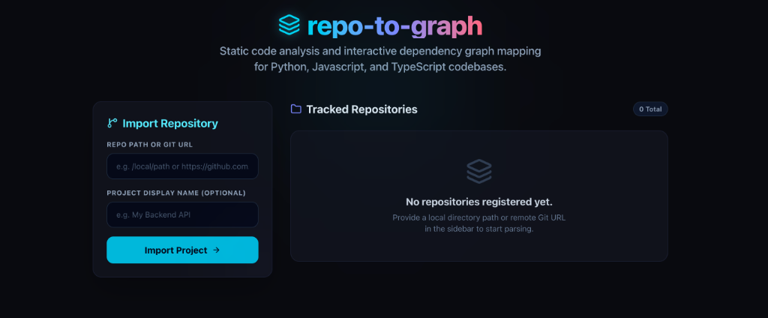
Figure: Interactive Dependency Graph Interface in Browser

