ORIGINAL RESEARCH MANUSCRIPT

Beyond Average Latency: Repeatability and Runtime-Dependent Quantization Rankings for Lightweight Vision Models on Android
  - Akhtar Saleem | Independent Researcher, Peshawar, Pakistan | akhtarsaleem974@gmail.com
  - ORCID: https://orcid.org/0009-0005-9440-224X
  - Journal of Systems Architecture

Abstract
Post-training quantization reduces neural-network storage, but its effect on realized mobile latency depends on model operators, runtime kernels, delegate behavior, and threading. This study evaluates MobileNetV2, MobileNetV3-Small, and EfficientNet-B0 in FP32, FP16, dynamic-range INT8, and full INT8 form on a lower-cost Android 15 phone. We use a leakage-audited, capture-session-grouped DeepWeeds split; GPU-controlled transfer learning; training-only calibration; locked-test classification metrics; and a release-mode LiteRT experiment that planned three randomized complete trials, 20 warm-ups, and 100 timed invocations per successful configuration. The run became incomplete during trial 3; trial 3 was excluded wholesale, and the post hoc bounded analysis retains the two complete balanced trials only. The Android evidence is therefore exploratory rather than confirmatory. Unlike average-only comparisons, the protocol retains immutable per-inference observations, configuration errors, process memory snapshots, battery and thermal context, requested and observed runtime state, median and tail latency, trial-level uncertainty, and quantization rank stability. Locked-test accuracy ranged from 53.93% to 84.43% and artifacts from 1.09 to 15.37 MiB; the fastest mean trial median and p95 were 146.77 ms (mobilenet_v3_small_full_int8__builtin_cpu__4t) and 162.34 ms (mobilenet_v3_small_full_int8__builtin_cpu__2t), respectively. Trial-pair rank correlations had minimum -1.000 and median 0.900; 3 configurations produced 6 preserved error rows. Median- and p95-based Pareto fronts contained 7 and 6 configurations, with 3 shared. The findings demonstrate that compression did not guarantee lower latency and that runtime and tail criteria changed configuration ranking on the tested realme RMX3760; they do not support generalization to other devices. All configuration choices were frozen before a single test-set evaluation, and hashes link models, raw observations, predictions, tables, and figures.
Keywords: Android; LiteRT; TensorFlow Lite; post-training quantization; mobile inference; tail latency; repeatability; Pareto analysis

1. Introduction
Mobile deployment decisions are frequently summarized as a choice between an accurate floating-point model and a smaller integer model. That abstraction is useful for storage but incomplete for execution. Integer-only inference can produce favorable accuracy-latency trade-offs on compatible ARM kernels [1], while hardware-aware quantization methods show that precision should be selected in relation to an execution target [5, 6, 9]. Yet a nominal precision label does not identify graph partitioning, float conversions, unsupported operators, runtime kernels, thread scheduling, or fallback. These details can determine whether a smaller artifact is faster in practice.
The architecture literature reaches a similar conclusion from a different direction. MobileNetV2 and MobileNetV3 introduced blocks designed around mobile constraints [2, 7], whereas later work explicitly reported that FLOPs and parameter count need not predict phone latency [18]. FastViT attributes part of the discrepancy to memory access and structural choices [19], and PikeLPN shows that overlooked non-quantized operations can dominate low-precision networks [29]. MobileNetV4 consequently evaluates universal mobile blocks across heterogeneous accelerators rather than treating one proxy as universal [25].
Production-oriented benchmarks reveal the same stack dependence at system scale. AI Benchmark measures complete Android smartphones [4, 8], MLPerf Mobile specifies controlled and transparent on-device scenarios [11], and nn-Meter builds device-specific latency predictors from fused execution kernels [10]. These works provide strong precedent for real-device measurement. They do not, however, make every practitioner-facing comparison auditable at the level of raw repeated observations, tail behavior, conversion and delegate errors, thermal context, and configuration-rank stability.
Recent Android work narrows the available novelty further. Gherasim and García Sánchez compare multiple model families, quantization formats, CPU modes, GPU and NPU execution, accuracy, average latency, and Pareto fronts on a Snapdragon 8 Gen 2 tablet [33]. Accordingly, the present study does not claim novelty for Android quantization comparison, accelerator comparison, hardware-aware selection, or Pareto optimization. Its narrower contribution is an auditable distributional protocol for ordinary deployable LiteRT variants on a lower-cost consumer phone:
- leakage-audited model development with a test split that remains unopened
until every conversion and device configuration decision is frozen;
- immutable per-inference latency observations from randomized complete
trials, including p95/p99 behavior and trial-level uncertainty;
- explicit retention of conversion and configuration failures rather than
silent substitution or imputation; and
- sensitivity of configuration selection to median versus p95 latency,
artifact size, classification quality, and rank stability.
The study addresses six questions: how standard post-training variants change classification performance and size (RQ1); how precision, runtime, and threads interact in median and tail latency (RQ2); whether rankings persist across complete trials and recorded thermal contexts (RQ3); whether size and latency ranks agree (RQ4); which configurations are Pareto-efficient under median and p95 criteria (RQ5); and which conversion or runtime failures prevent nominally desirable configurations from operating (RQ6).

2. Related work

2.1 Quantization and hardware-aware optimization
Integer-only inference by Jacob et al. established a practical eight-bit deployment path for convolutional networks [1]. HAQ uses hardware feedback to allocate mixed precision [5], HAWQ uses Hessian sensitivity [6], and HAWQ-V3 combines hardware constraints with dyadic integer execution to avoid hidden floating-point operations [9]. QBitOpt reallocates bit widths during training [22], A2Q constrains accumulator overflow [23], and differentiable mixed-precision optimization exposes accuracy-memory Pareto choices [28]. QuantNAS jointly searches architectures and quantization using measured mobile CPU latency [27]. These are richer optimization methods than the four standard post-training exports studied here; they establish the field and bound our claim to measurement methodology.
Post-training work also demonstrates that conversion quality is architecture-dependent. QDrop reduces train-test mismatch during low-bit PTQ [13], PTQ4ViT addresses activation distributions in vision transformers [14], and FQ-ViT and I-ViT implement quantized nonlinear paths [15, 21]. Performance characterization across OpenVINO, TensorFlow Lite, ONNX, and PyTorch shows that precision effects depend on the runtime and edge platform [17]. The present work therefore measures both classification parity and mobile execution; a successful converter call alone is not treated as evidence of a useful deployment.

2.2 Mobile architectures and latency proxies
MobileNetV2's inverted residuals and linear bottlenecks [2] and MobileNetV3's platform-aware search and nonlinearities [7] are widely deployable baselines. EfficientNet supplies a contrasting compound-scaled CNN [34]. Other relevant mobile backbones include MobileViT [12], MobileOne [18], FastViT [19], EfficientViT [20], RepViT [26], and XiNet [24]. MobileNVC demonstrates an end-to-end neural video system on a phone [30], while memory-efficient CNN design emphasizes peak memory as a separate deployment constraint [31]. Together, these studies caution against using parameters or operations as a universal performance surrogate.

2.3 Benchmarks and reproducible on-device evidence
AMC targets model compression for mobile deployment [3], and mobile neural architecture search has extended hardware-aware optimization to super-resolution [16]. AI Benchmark and MLPerf Mobile provide broad smartphone comparisons and reporting rules [4, 8, 11], whereas nn-Meter predicts latency for particular edge-device/runtime combinations [10]. MobileAIBench extends configuration-level evaluation to on-device language and multimodal models [32]. The gap addressed here is smaller: repeatable distributional evidence for standard LiteRT image-classifier exports, including raw tail latency, complete-trial ranking, and errors on an economical Android device.

3. Materials and methods

3.1 Integrity controls and decision sequence
The protocol separated model development, device configuration, and final evaluation. Dataset and capture-session manifests were frozen before training. Architecture, quantization, calibration, parity, Android runtime, thread count, warm-up, trial, randomization, and analysis rules were fixed using training, validation, and pilot evidence. The 3,501-image test manifest was not read by any metric evaluator until the final manifest status was changed to FROZEN_FOR_FINAL_TEST. The final evaluator is fail-closed: it refuses any other status, performs the complete Keras and TFLite evaluation in one session, and hashes both the test manifest and per-sample prediction file.
We distinguish prior project evidence from new-study results. The earlier plant-disease project motivated quantization and size/latency comparisons, but its measurements are not pooled with this experiment. Only reusable procedural lessons, schema design, and failure checks were carried forward.

3.2 Dataset, leakage audit, and splits
DeepWeeds contains 17,509 field images across eight weed classes and a negative class. We used the official archive under CC BY 4.0 (SHA-256 0961f63c01b997bfab1559ad09e99c0e8130617fd96a8b92fdc09940e01b0ce8). Images were grouped into capture sessions defined by the same acquisition instrument and consecutive timestamps separated by at most 90 s. A seeded, deterministic greedy allocation preserved complete groups while approximating class balance, producing 1,105 groups and 10,506/3,502/3,501 images for training/validation/test. The largest group contained 224 images.
The validation audit checked manifest completeness, decodability, filename overlap, exact SHA-256 duplicates, perceptual near-duplicate candidates, and capture-group separation. It found zero missing or unreadable images, zero filename or exact-hash cross-split overlaps, and one perceptual candidate that manual review classified as distinct. No capture group crossed a split. The manifest hashes are a4dde73f...596ab5 (training), a7f73270...76e2b (validation), and 567b554a...dae86 (test); full hashes are retained in the machine-readable metadata.

3.3 Model training
The model set comprises ImageNet-initialized MobileNetV2, MobileNetV3-Small, and EfficientNet-B0 with 224 × 224 RGB input and a nine-class softmax head. Input preprocessing is embedded in each exported Keras graph. Training used TensorFlow 2.21 under WSL2, balanced training-only class weights, Adam, batch size 8, and seed 42. The backbone was frozen for five epochs at learning rate 10^-3 and then fine-tuned for at most 25 additional epochs at 10^-5. Early stopping monitored validation loss with patience five and restored the best checkpoint. Augmentation comprised a deterministic stateless crop, horizontal flip, brightness change, and contrast change.
Heavy tensor computation was fail-closed to an NVIDIA GeForce GTX 1650. Each launcher required a physical TensorFlow GPU, enabled memory growth, executed a smoke tensor on /GPU:0, and recorded the NVIDIA driver and TensorFlow environment. A batch-size-16 feasibility attempt exhausted GPU memory for EfficientNet-B0; batch size 8 was then tested for all models and frozen rather than adjusted per architecture.

3.4 Post-training conversion and validation gating
Each restored Keras model was converted to four LiteRT/TFLite artifacts: FP32, FP16 weight quantization, dynamic-range INT8, and full INT8. Full INT8 used a canonical 800-sample representative set drawn only from the training split; the ordered calibration tensor and its hash were reused for all architectures. Full INT8 required integer input and output tensors and the built-in INT8 operator set. Conversion reports retain failures, file size, SHA-256, and tensor metadata.
Every flatbuffer had to allocate and execute with the built-in interpreter. Validation parity then compared accuracy and top-1 agreement against the Keras reference over all 3,502 validation images. Variants with large degradation were retained as negative evidence and marked unsuitable for selection rather than silently removed. No test outcome influenced conversion, calibration, or the app manifest.

3.5 Android device and inference application
The deployment target was a realme RMX3760 running Android 15/API 35, with a Spreadtrum UMS9230H SoC, eight online CPU cores, approximately 5.63 GiB RAM, and an ARM Mali-G57 GPU. Values were read from Android system properties, ADB, and the app; unavailable GPU core count and NPU identity were not inferred.
The release-mode Flutter application bundles the exact hashed flatbuffers and serves two purposes. Its inference screen selects a bundled configuration, loads an image from camera or gallery, center-crops and resizes to 224 × 224, executes locally, and reports predicted class, confidence, timed inference, and artifact size with a research-only warning. Its experiment screen runs the frozen randomized benchmark in a background Dart isolate, with frozen flatbuffers transferred from the root isolate, and writes an immutable CSV to app-specific external storage. This keeps the UI responsive without changing the interpreter-only timed region.
Android 15 deprecates NNAPI, the phone did not expose a listable neural-networks service, and effective NNAPI execution could not be verified; NNAPI was therefore excluded rather than labelled as accelerated. The tested runtimes were the built-in CPU path and an explicitly constructed XNNPACK CPU delegate. An XNNPACK custom-options constructor caused a reproducible native crash during pilot testing; the stable null-options constructor was frozen. Requested delegate, observed initialization state, delegate errors, and configuration failures were recorded. A configuration that failed was not replaced with a fallback latency.

3.6 Frozen benchmark protocol
The factorial matrix comprised 3 architectures × 4 quantization variants × 2 runtimes × 3 thread counts (1, 2, and 4), subject to preserved configuration failures. Each successful configuration used a deterministic preallocated input tensor, 20 untimed warm-ups, and 100 interpreter-only timed invocations in each of three planned complete trials. The run became incomplete during trial 3, so trial 3 was excluded wholesale and the post hoc bounded analysis retained the two complete balanced trials only. Accordingly, the Android evidence is exploratory rather than confirmatory. Configuration order was reshuffled within every trial using seed 42. The screen remained on; USB charging state, battery saver, thermal status, battery temperature, process proportional set size (PSS), and resident set size (RSS) were recorded. Background applications were not injected, but their absence could not be fully verified.
The benchmark stores one row per timed invocation plus one explicit row for each configuration error. Rows contain model and protocol hashes, architecture, precision, requested and observed delegate state, thread count, trial and randomization index, model-load time, latency, memory, power/thermal context, and error text. Timed values exclude decoding, preprocessing, interpreter construction, and UI work.

3.7 Outcomes and statistical analysis
Classification outcomes are accuracy, macro precision, macro recall, macro F1, per-class metrics, confusion matrices, and TFLite-to-Keras top-1 agreement. Systems outcomes are artifact size, median, p90, p95 and p99 latency, latency coefficient of variation, model-load time, process PSS/RSS, configuration error count, and recorded thermal context.
The complete randomized trial - not each invocation - is the experimental unit for uncertainty. Per-inference rows determine distributional quantiles. For every successful configuration we report the mean and standard deviation of the two complete-trial medians and trial p95 values, plus a deterministic nonparametric 95% bootstrap interval obtained by resampling the two complete-trial summaries (20,000 resamples). Because only two trials and one physical device are available, these intervals describe run repeatability and must not be interpreted as population-level device confidence intervals.
Within each architecture/runtime/thread context, quantization ranks from each pair of complete trials are compared with Spearman correlation. Pareto fronts maximize frozen-validation accuracy and minimize artifact bytes together with either mean trial-median latency or mean trial-p95 latency. A configuration is dominated only when another is no worse on every objective and strictly better on at least one. The test set supplies final reporting quality, but all model and configuration candidates entering this analysis were frozen beforehand.

4. Results

4.1 Training, conversion, and locked-test classification
All 12 frozen flatbuffers completed the locked 3,501-image evaluation. Test accuracy ranged from 53.93% (mobilenet_v3_small full_int8) to 84.43% (mobilenet_v2 float32); the highest macro F1 was 82.05% for mobilenet_v2 float32. Artifact size ranged from 1.09 to 15.37 MiB. The low MobileNetV3-Small full-INT8 validation parity was retained before test opening and remained visible in the locked-test table rather than being removed post hoc.

Table 1. Classification quality, size, validation gating, and artifact identity for every frozen TFLite variant.
Architecture | Variant | Bytes | MiB | Compression vs FP32 | Val. acc. | Val. agreement | Test acc. | Macro P | Macro R | Macro F1 | SHA-256 prefix
efficientnet_b0 | dynamic_int8 | 4,592,176 | 4.38 | 71.5% | 79.73% | 95.69% | 81.49% | 76.89% | 84.64% | 79.68% | 9d69d6ea033b
efficientnet_b0 | float16 | 8,165,448 | 7.79 | 49.3% | 79.87% | 99.74% | 82.52% | 77.72% | 85.78% | 80.89% | 8b487a255909
efficientnet_b0 | float32 | 16,115,064 | 15.37 | 0.0% | 79.78% | 100.00% | 82.55% | 77.74% | 85.83% | 80.93% | 4e7bf575be33
efficientnet_b0 | full_int8 | 4,953,200 | 4.72 | 69.3% | 71.42% | 74.41% | 70.87% | 69.25% | 65.19% | 64.10% | bf768dda79fe
mobilenet_v2 | dynamic_int8 | 2,545,400 | 2.43 | 71.5% | 83.27% | 96.63% | 83.89% | 81.35% | 82.76% | 81.35% | 97e33bb8b77f
mobilenet_v2 | float16 | 4,537,556 | 4.33 | 49.2% | 83.98% | 99.51% | 84.29% | 81.26% | 83.65% | 81.84% | 801130c48bc4
mobilenet_v2 | float32 | 8,937,820 | 8.52 | 0.0% | 84.07% | 100.00% | 84.43% | 81.48% | 83.82% | 82.05% | bec15e3963d4
mobilenet_v2 | full_int8 | 2,748,320 | 2.62 | 69.3% | 82.70% | 93.35% | 84.06% | 81.59% | 83.43% | 81.80% | 0b1cdd47d0b7
mobilenet_v3_small | dynamic_int8 | 1,144,288 | 1.09 | 69.7% | 75.36% | 87.38% | 77.63% | 71.27% | 79.82% | 74.82% | 1c3ca9e08ab1
mobilenet_v3_small | float16 | 1,967,356 | 1.88 | 48.0% | 73.99% | 99.51% | 76.32% | 69.47% | 83.19% | 74.79% | 201167c633c4
mobilenet_v3_small | float32 | 3,782,516 | 3.61 | 0.0% | 73.84% | 100.00% | 76.35% | 69.49% | 83.14% | 74.79% | cf6183dcd31c
mobilenet_v3_small | full_int8 | 1,252,008 | 1.19 | 66.9% | 55.88% | 50.63% | 53.93% | 48.56% | 30.44% | 29.88% | 7eb4e5feb3ad

Keras references and complete per-class metrics/confusion matrices remain in the hash-linked final-test JSON; Table 1 reports the deployable flatbuffers used on the phone.
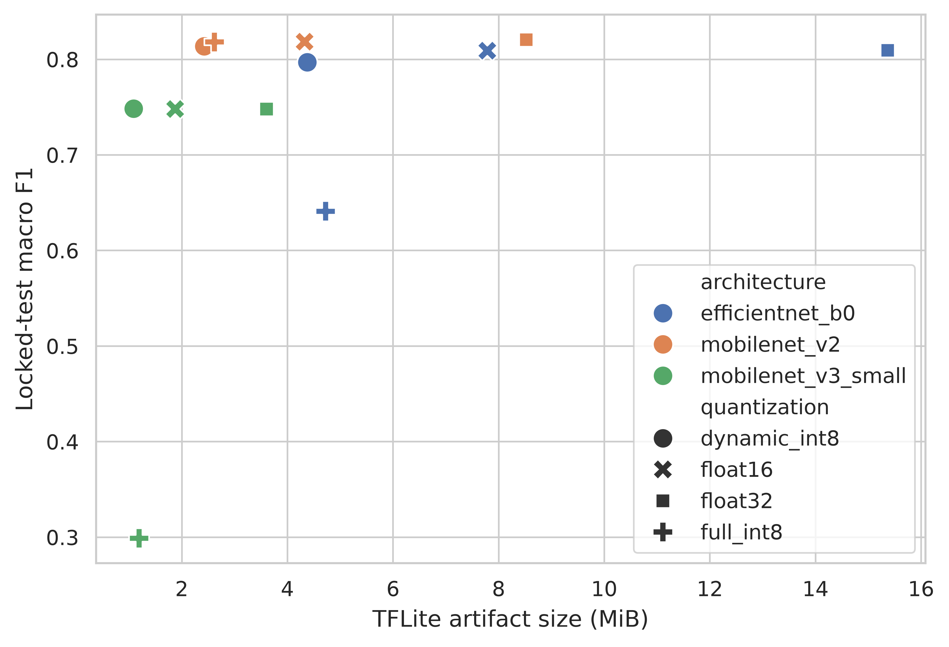
Figure 1. Locked-test macro F1 against TFLite artifact size for all 12 frozen variants; color identifies architecture and marker identifies quantization.

4.2 Android latency, memory, and operational failures
The device run contained 13,800 timed observations from 69 successful configurations and 6 explicit error rows representing 3 failed configurations. The fastest mean trial-median latency was 146.77 ms for mobilenet_v3_small_full_int8__builtin_cpu__4t; the fastest mean trial-p95 latency was 162.34 ms for mobilenet_v3_small_full_int8__builtin_cpu__2t. Across successful configurations, median process PSS snapshots ranged from 397.89 to 673.59 MiB and RSS snapshots ranged from 423.51 to 628.88 MiB.
The preserved failed configurations were: mobilenet_v3_small_full_int8/xnnpack_cpu/1t (2/3 trials: Bad state: failed precondition); mobilenet_v3_small_full_int8/xnnpack_cpu/2t (2/3 trials: Bad state: failed precondition); mobilenet_v3_small_full_int8/xnnpack_cpu/4t (2/3 trials: Bad state: failed precondition). Battery temperature ranged from 41.0 to 46.1 °C, with charging states charging, full. Because USB power remained connected and the preferred ≤35 °C start condition was not met, these observations are not described as a cold or thermally controlled run.

Table 2. Runtime/thread summary across successful model-quantization configurations. Brackets give the observed configuration range; the complete 72-configuration ledger is Supplementary Table 5.
Runtime | Threads | Successful | Failed | Median of trial medians [range] ms | Median of trial p95 [range] ms | Median PSS MiB | Median RSS MiB
builtin_cpu | 1 | 12 | 0 | 375.24 [152.78, 497.94] | 403.53 [167.47, 523.93] | 562.36 | 495.66
builtin_cpu | 2 | 12 | 0 | 376.26 [150.28, 514.27] | 403.66 [162.34, 661.78] | 584.57 | 557.98
builtin_cpu | 4 | 12 | 0 | 378.46 [146.77, 489.14] | 410.57 [164.59, 526.66] | 581.96 | 521.71
xnnpack_cpu | 1 | 11 | 1 | 390.04 [163.91, 456.39] | 409.20 [182.27, 481.95] | 565.30 | 539.58
xnnpack_cpu | 2 | 11 | 1 | 395.03 [166.44, 454.25] | 414.15 [181.49, 468.91] | 475.22 | 506.51
xnnpack_cpu | 4 | 11 | 1 | 393.49 [168.81, 455.59] | 421.70 [183.67, 535.39] | 553.60 | 501.69

The complete 72-configuration ledger, trial-level intervals, throughput, and error rows are provided in the hash-linked supplement. Figures 2 and 3 show the successful configurations for median and p95 latency without replacing unsupported configurations with fallback values.
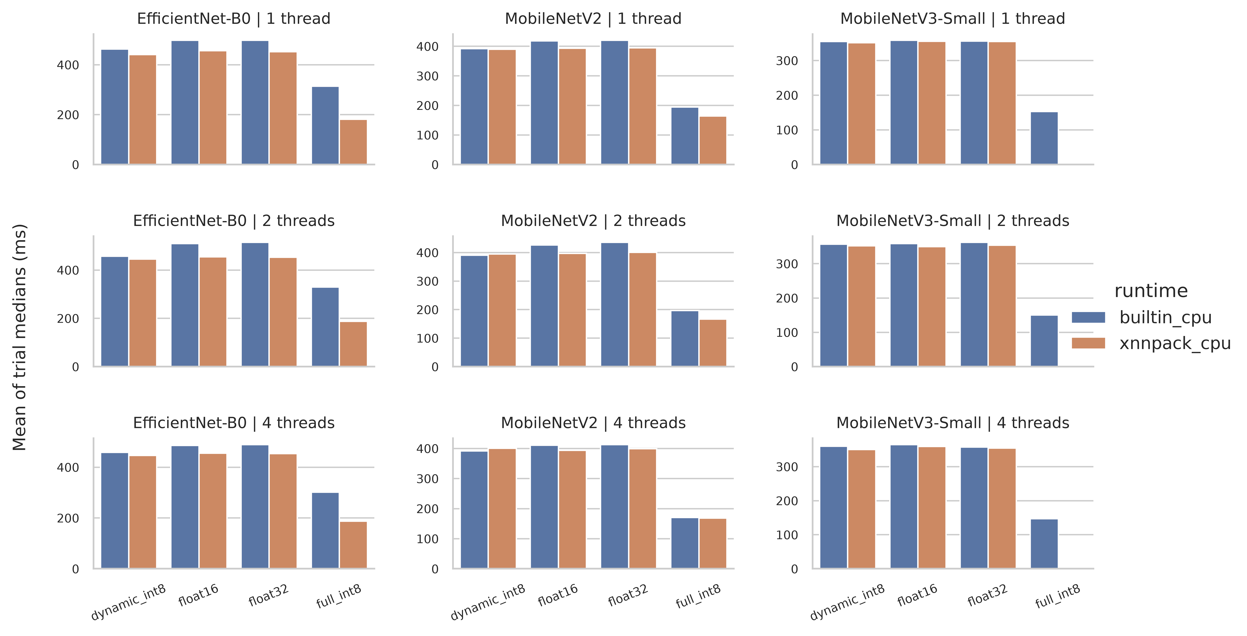
Figure 2. Mean complete-trial median latency by architecture, quantization, runtime, and thread count for every successful configuration.
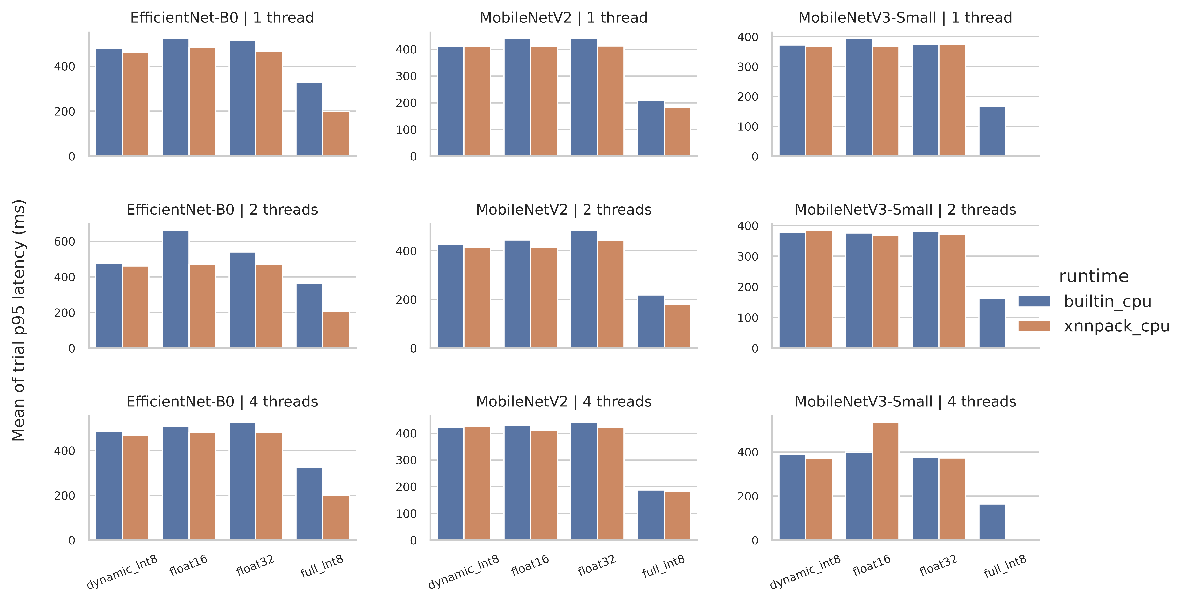
Figure 3. Mean complete-trial p95 latency by architecture, quantization, runtime, and thread count for every successful configuration.

4.3 Rank stability and Pareto sensitivity
Artifact-size and latency orders differed in 18 of 18 architecture/runtime/thread contexts. Quantization order changed between built-in and XNNPACK paths in 7 of 9 comparable architecture/thread contexts. Pairwise complete-trial Spearman correlations ranged from -1.000 to 1.000, with median 0.900.
The validation-quality/size/latency Pareto analysis identified 7 median-based and 6 p95-based configurations, with 3 shared. Median-only configurations were mobilenet_v2_full_int8__xnnpack_cpu__1t, mobilenet_v3_small_dynamic_int8__xnnpack_cpu__4t, mobilenet_v3_small_float16__xnnpack_cpu__2t, mobilenet_v3_small_full_int8__builtin_cpu__4t; p95-only configurations were mobilenet_v2_full_int8__xnnpack_cpu__2t, mobilenet_v3_small_dynamic_int8__xnnpack_cpu__1t, mobilenet_v3_small_full_int8__builtin_cpu__2t. Thus the selected frontier changed when tail latency replaced median latency. Figures 4 and 5 visualize the validation-only Pareto surface and complete-trial rank stability; locked-test metrics are reporting outcomes and were not selection inputs.
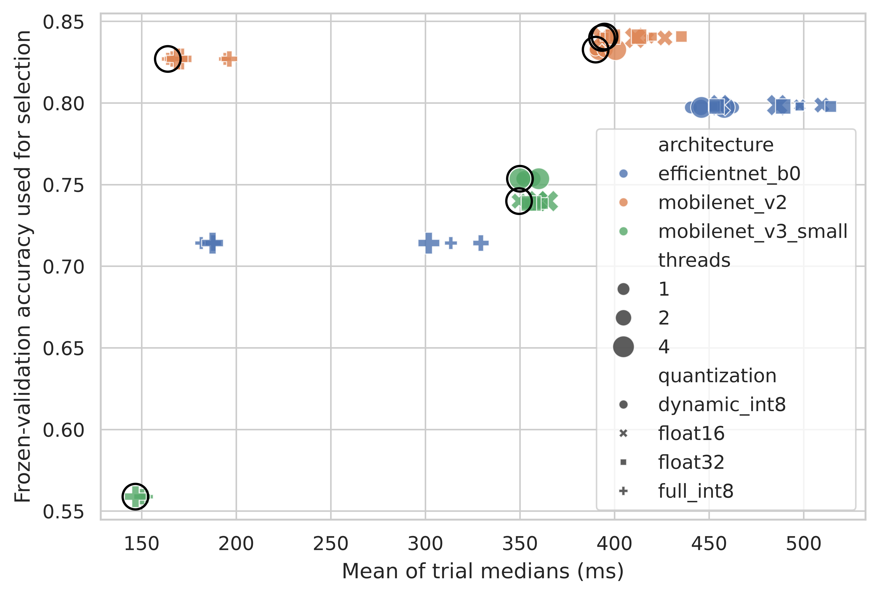
Figure 4. Frozen-validation accuracy versus mean complete-trial median latency; outlined points are on the three-objective validation/size/latency Pareto front.
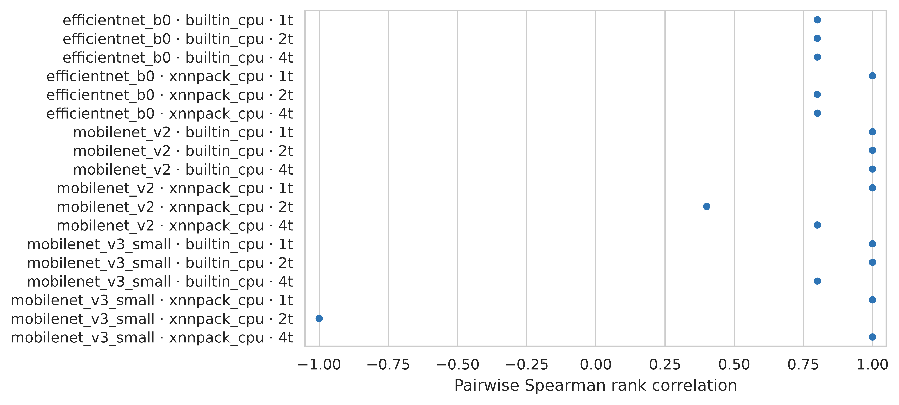
Figure 5. Pairwise Spearman stability of quantization latency ranks across complete trials, stratified by architecture, runtime, and thread count.

5. Discussion
The results separate artifact compression from realized execution. H1 was supported descriptively: size order and median-latency order disagreed in 18/18 contexts. H2 was supported descriptively: runtime changed the quantization ordering in 7/9 comparisons. These reversals are consistent with operator coverage, data conversion, memory access, and runtime-kernel differences, but the logs do not identify a single causal mechanism.
H3 was supported descriptively: 29 INT8 configuration rows were outside the median-based Pareto front, so an unconditional “always INT8” rule would retain choices dominated under the frozen validation/size/device evidence. The poor MobileNetV3-Small full-INT8 parity and its XNNPACK configuration failures show why integer-only conversion success is not equivalent to an accurate, executable deployment [1, 9, 29]. This agrees with the broader Android finding that quantization outcomes depend on model and execution path [33].
For H4, the median trial-level CV was builtin_cpu=0.0052, xnnpack_cpu=0.0078, a max/min ratio of 1.51. These descriptive differences and the median-versus-p95 frontier change are consistent with H4, but 2 complete trials on one device are insufficient for a population-level significance claim. Tail summaries therefore add decision information without converting repeated invocations into pseudo-replicates.
Protocol 1.1 produced an incomplete ANR-terminated run when synchronous LiteRT calls occupied Flutter's UI isolate. That raw file was hashed, preserved, and categorically excluded. Protocol 1.2 transferred the frozen flatbuffers to a background Dart isolate and restarted all trials from the beginning. This correction is part of the failure provenance, not a pooled pilot observation.

6. Threats to validity and limitations
Only one physical Android phone was tested, so the study cannot estimate between-device variability or claim transfer to other SoCs, Android releases, LiteRT builds, or vendor kernels. Two complete balanced trials provide only a limited description of short-run repeatability and imprecise trial-level uncertainty; the planned third trial was excluded wholesale after the run became incomplete, so the Android analysis is exploratory rather than confirmatory. USB charging was recorded rather than eliminated, and background load was not fully controllable. Battery temperature and Android thermal status are contextual observations, not direct SoC power or energy measurements.
XNNPACK initialization can be observed, but the Flutter binding does not expose a complete operator-partition audit. Therefore delegate-state conclusions must remain limited to successfully constructed configurations and preserved errors; they must not imply every operator ran in a specific kernel. PSS and RSS are process snapshots that include runtime and application allocations, not an isolated peak-model-memory instrument. Interpreter-only synthetic-input latency does not represent camera capture, image preprocessing, UI, or end-to-end application response.
DeepWeeds is class-imbalanced and geographically/task specific. Capture-session grouping reduces one leakage mechanism but does not establish ecological external validity. The local inference screen is a research prototype, not an agronomic or safety decision system. Standard PTQ variants were intentionally studied; conclusions do not compare advanced quantization-aware training, mixed-precision search, pruning, distillation, GPU delegates, or vendor NPUs.

7. Conclusion
On the tested realme RMX3760 stack, quantization label and file size alone did not determine deployment performance. The 12 frozen flatbuffers spanned 53.93%-84.43% locked-test accuracy and 1.09-15.37 MiB, while runtime/thread choices changed latency order and median-versus-p95 criteria changed the Pareto frontier. Configuration errors and the MobileNetV3-Small full-INT8 quality loss remained part of the result rather than being hidden by fallback or post-test exclusion.
For this phone and software stack only, a practical shortlist is mobilenet_v2_dynamic_int8__xnnpack_cpu__1t, mobilenet_v2_float16__xnnpack_cpu__1t, mobilenet_v2_float32__xnnpack_cpu__1t; selection among it should use the application's tolerance for median versus tail latency together with the frozen validation quality and artifact-size constraints. No cross-device recommendation follows from one phone, and a new device/runtime combination should rerun the same hashed, complete-trial protocol.

Declarations

Funding
This research received no specific grant from any funding agency in the public, commercial, or not-for-profit sectors.

Conflict of interest
The author declares no known competing financial interests or personal relationships that could have appeared to influence the work reported in this paper.

Ethics statement
The study uses a publicly released image dataset and performance measurements from an investigator-controlled phone. It does not involve human participants, personal data collection, or animal experimentation.

Data availability
The DeepWeeds source archive is available under CC BY 4.0 from its official repository. Frozen split manifests, hashes, validation reports, raw benchmark observations, final per-sample predictions, and derived tables are included in the accompanying artifact package. Redistribution of source images follows the dataset license. A Zenodo record has been reserved for the reproducibility artifact at https://doi.org/10.5281/zenodo.22080295 and will be made public before manuscript submission.

Code availability
Training, conversion, parity evaluation, Android benchmarking, locked-test evaluation, statistical analysis, and figure-generation code are included in the reproducibility artifact. Environment reports and SHA-256 provenance records link executed outputs to their source models and data. The reserved artifact DOI is https://doi.org/10.5281/zenodo.22080295; the Zenodo record will be made public before manuscript submission.

References
1. Benoit Jacob, Skirmantas Kligys, Bo Chen, Menglong Zhu, Matthew Tang, Andrew Howard, Hartwig Adam, Dmitry Kalenichenko (2018). Quantization and Training of Neural Networks for Efficient Integer-Arithmetic-Only Inference. CVPR.
2. Mark Sandler, Andrew Howard, Menglong Zhu, Andrey Zhmoginov, Liang-Chieh Chen (2018). MobileNetV2: Inverted Residuals and Linear Bottlenecks. CVPR.
3. Yihui He, Ji Lin, Zhijian Liu, Hanrui Wang, Li-Jia Li, Song Han (2018). AMC: AutoML for Model Compression and Acceleration on Mobile Devices. ECCV.
4. Andrey Ignatov, Radu Timofte, William Chou, Ke Wang, Max Wu, Tim Hartley, Luc Van Gool (2018). AI Benchmark: Running Deep Neural Networks on Android Smartphones. arXiv preprint. arXiv:1810.01109
5. Kuan Wang, Zhijian Liu, Yujun Lin, Ji Lin, Song Han (2019). HAQ: Hardware-Aware Automated Quantization With Mixed Precision. CVPR.
6. Zhen Dong, Zhewei Yao, Amir Gholami, Michael W. Mahoney, Kurt Keutzer (2019). HAWQ: Hessian Aware Quantization of Neural Networks With Mixed-Precision. ICCV.
7. Andrew Howard, Mark Sandler, Grace Chu, Liang-Chieh Chen, Bo Chen, Mingxing Tan, Weijun Wang, Yukun Zhu, Ruoming Pang, Vijay Vasudevan, Quoc V. Le, Hartwig Adam (2019). Searching for MobileNetV3. ICCV.
8. Andrey Ignatov et al. (2019). AI Benchmark: All About Deep Learning on Smartphones in 2019. arXiv preprint. arXiv:1910.06663
9. Zhewei Yao, Zhen Dong, Zhangcheng Zheng, Amir Gholami, Jiali Yu, Eric Tan, Leyuan Wang, Qijing Huang, Yida Wang, Michael Mahoney, Kurt Keutzer (2021). HAWQ-V3: Dyadic Neural Network Quantization. ICML.
10. Li Lyna Zhang, Shihao Han, Jianyu Wei, Ningxin Zheng, Ting Cao, Yuqing Yang, Yunxin Liu (2021). nn-Meter: Towards Accurate Latency Prediction of Deep-Learning Model Inference on Diverse Edge Devices. ACM MobiSys. doi:10.1145/3458864.3467882
11. Vijay Janapa Reddi et al. (2022). MLPerf Mobile Inference Benchmark: An Industry-Standard Open-Source Machine Learning Benchmark for On-Device AI. MLSys.
12. Sachin Mehta, Mohammad Rastegari (2022). MobileViT: Light-weight General-purpose and Mobile-friendly Vision Transformer. ICLR.
13. Xiuying Wei, Ruihao Gong, Yuhang Li, Xianglong Liu, Fengwei Yu (2022). QDrop: Randomly Dropping Quantization for Extremely Low-bit Post-Training Quantization. ICLR.
14. Zhihang Yuan, Chenhao Xue, Yiqi Chen, Qiang Wu, Guangyu Sun (2022). PTQ4ViT: Post-Training Quantization for Vision Transformers with Twin Uniform Quantization. ECCV.
15. Yang Lin, Tianyu Zhang, Peiqin Sun, Zheng Li, Shuchang Zhou (2022). FQ-ViT: Post-Training Quantization for Fully Quantized Vision Transformer. IJCAI. doi:10.24963/ijcai.2022/164
16. Xindong Zhang, Hui Zeng, Lei Zhang (2022). Efficient Hardware-aware Neural Architecture Search for Image Super-resolution on Mobile Devices. ACCV.
17. Hyunho Ahn, Tian Chen, Nawras Alnaasan, Aamir Shafi, Mustafa Abduljabbar, Hari Subramoni, Dhabaleswar K. Panda (2023). Performance Characterization of using Quantization for DNN Inference on Edge Devices: Extended Version. arXiv preprint. arXiv:2303.05016
18. Pavan Kumar Anasosalu Vasu, James Gabriel, Jeff Zhu, Oncel Tuzel, Anurag Ranjan (2023). MobileOne: An Improved One Millisecond Mobile Backbone. CVPR.
19. Pavan Kumar Anasosalu Vasu, James Gabriel, Jeff Zhu, Oncel Tuzel, Anurag Ranjan (2023). FastViT: A Fast Hybrid Vision Transformer Using Structural Reparameterization. ICCV.
20. Han Cai, Junyan Li, Muyan Hu, Chuang Gan, Song Han (2023). EfficientViT: Lightweight Multi-Scale Attention for High-Resolution Dense Prediction. ICCV.
21. Zhikai Li, Qingyi Gu (2023). I-ViT: Integer-only Quantization for Efficient Vision Transformer Inference. ICCV.
22. Jorn Peters, Marios Fournarakis, Markus Nagel, Mart van Baalen, Tijmen Blankevoort (2023). QBitOpt: Fast and Accurate Bitwidth Reallocation During Training. ICCV Workshops.
23. Ian Colbert, Alessandro Pappalardo, Jakoba Petri-Koenig (2023). A2Q: Accumulator-Aware Quantization with Guaranteed Overflow Avoidance. ICCV.
24. Alberto Ancilotto, Francesco Paissan, Elisabetta Farella (2023). XiNet: Efficient Neural Networks for tinyML. ICCV.
25. Danfeng Qin, Chas Leichner, Manolis Delakis, Marco Fornoni, Shixin Luo, Fan Yang, Weijun Wang, Colby Banbury, Chengxi Ye, Berkin Akin, Vaibhav Aggarwal, Tenghui Zhu, Daniele Moro, Andrew Howard (2024). MobileNetV4: Universal Models for the Mobile Ecosystem. ECCV.
26. Ao Wang, Hui Chen, Zijia Lin, Jungong Han, Guiguang Ding (2024). RepViT: Revisiting Mobile CNN From ViT Perspective. CVPR.
27. Tianxiao Gao, Li Guo, Shanwei Zhao, Peihan Xu, Yukun Yang, Xionghao Liu, Shihao Wang, Shiai Zhu, Dajiang Zhou (2024). QuantNAS: Quantization-aware Neural Architecture Search For Efficient Deployment On Mobile Device. CVPR Workshops.
28. Clemens J. S. Schaefer, Siddharth Joshi, Shan Li, Raul Blazquez (2024). Edge Inference With Fully Differentiable Quantized Mixed Precision Neural Networks. WACV.
29. Marina Neseem, Conor McCullough, Randy Hsin, Chas Leichner, Shan Li, In Suk Chong, Andrew Howard, Lukasz Lew, Sherief Reda, Ville-Mikko Rautio, Daniele Moro (2024). PikeLPN: Mitigating Overlooked Inefficiencies of Low-Precision Neural Networks. CVPR.
30. Ties van Rozendaal et al. (2024). MobileNVC: Real-Time 1080p Neural Video Compression on a Mobile Device. WACV.
31. Jaewook Lee, Yoel Park, Seulki Lee (2024). Designing Extremely Memory-Efficient CNNs for On-device Vision Tasks. ACCV.
32. Rithesh Murthy, Liangwei Yang, Juntao Tan, Tulika Manoj Awalgaonkar, Yilun Zhou, Shelby Heinecke, Sachin Desai, Jason Wu, Ran Xu, Sarah Tan, Jianguo Zhang, Zhiwei Liu, Shirley Kokane, Zuxin Liu, Ming Zhu, Huan Wang, Caiming Xiong, Silvio Savarese (2024). MobileAIBench: Benchmarking LLMs and LMMs for On-Device Use Cases. arXiv preprint. arXiv:2406.10290
33. Iulius Gherasim, Carlos García Sánchez (2025). Hardware optimization on Android for inference of AI models. arXiv preprint. arXiv:2511.13453
34. Mingxing Tan, Quoc V. Le (2019). EfficientNet: Rethinking Model Scaling for Convolutional Neural Networks. ICML.

