Survey Based Analysis of Internet of Things Based Architectural Framework for Healthcare System

***Abstract*— Healthcare is an important gradation in life and IoT has made this healthcare a get-at-able, easy way to live. Its popularity in the world of technology and internet, IoT is increasing in every field of life with the health sector. Due to the hypnosis feature, IoT is becoming more focused in healthcare industry. However although, it has not yet been implemented for the wider scope of hospitals around the developing countries. Among many IoT tools, IoT brings tools to strengthen the workplace such as health, safety, and the medical environment. In this paper, introduce and describing a comprehensive survey of IoT with respect to IoT Technologies, Healthcare methods, statistics, System architecture, enabling technologies, security and privacy issues and success case applied in healthcare. This paper will explores the relationship between Physical System in Healthcare (PSH) and IoT based Healthcare, both in which play the important role an intelligent Cyber world but IoT is the vital role. Moreover, we did a survey to investigate between the edge computing and IoT based Healthcare and discuss issues in edge computing. The results of the investigation can be applied in developing countries.**

Keywords— Physical System in Healthcare (PSH), hospital management system (hms), Survey, Internet of things (IoT)

1. INTRODUCTION

IoT is an interconnected computing device, mechanical and digital machine that provides unique identifiers (Unique identifiers UIDs are commonly used within the healthcare industry. Reporting medical information with the patient's name, a personal code is created) to objects, animals or humans, and the ability to transfer data through a network, which can perform human-to-human or human-to-computer interactions. While connected to the Internet, the Internet of Things (IoT) seamlessly opens up a world of possibilities for treatment in this biodiversity. The advancement in technology has changed the world of thought as well as the development of smartphones and other handheld gadgets. Health is the root of all happiness.

Over the past few years, the modern technology and gadgets have been developed and developed to monitor critical resources in healthcare and other hospitals. But most of these systems are just maintaining a database of patients. Few of the hospitals have tele-health or health system, but these systems have just implemented telemedicine via the technologies of telecommunication, teleconferencing and video conferencing etc. Literature has shown that these systems lack quality and are expensive and we need a better communication and monitoring system. If we talk about HMIS from all around the world, there are some countries, which have better mobile patient care systems. But still, we lack monitoring, communication and tracking of assets and patients. And there is no common framework to manage the patients and other assets at one platform. Hence, so far all the development in the field of health we lack a common communication environment or structural platform, therefore we are proposing an architectural framework that describes the components of hospital-based IoT and their communication at one common platform in an organized way for the better quality of HMIS. We have targeted large scale and medium scale hospitals because only these hospitals have the capabilities to implement this system.

IoT is an emerging technology, which we can find in every field of life. IoT is the fourth generation of the technology revolution of information realm moreover to execute smart recognition, locating, tracking, following, checking and administration, by methods of GPS, infrared sensors, laser scanners, radio frequency identification (RFID) and some other data sensor devices, as indicated by traditional practice [2]. IoT can be defined as; a technology that allows the connection of anything and anyone, anywhere, at any time possibly using any path, network or service [1]. Figure 1 [3], shows the new dimension of communication and information technology i.e. IoT. From the initiation of IoT in Auto-ID Center at MIT toward the start of 2000

numerous innovative developments have been fulfilled by technical scholars. As per Gartner [2], about 26 billion gadgets will be linked with the Internet in 2020 [2]. Because of the improvement of sensor innovations in all fields of life, for instance, industrial, bio, chemical and so on, microcontroller-based systems and networking protocols improvement for embedded frameworks have been tranquil.

The smart hospitals are new sort hospital, incorporated with the functionalities of decision making, management, treatment, administration and diagnosis based on IoT. The peculiarities from the internet of things, for example, thorough recognition, solid transmission, smart processing et cetera gives strategy support framework for the development and execution of smart hospital [4].

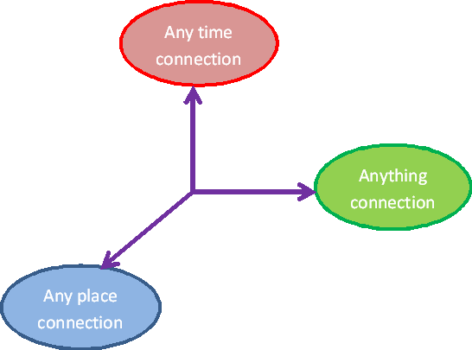

Fig. 1. IoT as a new dimension

In the propelling procedure of the hospital management system, the implementation and the deployment of partial HMS (hospital management system) have made the hospitals to accomplish a certain level of digital information. However still HMS has some insufficiencies, for example, manual info record, settled networking data point, particular single propose, comparatively autonomous systems between every division [1] etcetera, which totally confine the development of hospital information system. Hence the rapidly growing new technology IoT has given the new idea to overwhelm the problems mentioned above.

Consequently, in this paper, the essence of the smart hospital is studied founded on the presentation of healthcare IoT and other associated ideas anticipated by numerous researchers. In the following sections, we have discussed the abstract view of smart hospitals, its application that how it works and then we have presented the survey results.

1. SMART HOSPITAL

When we talk about IoT technology in the medical field, we see, many scholars have put their work based on IoT in medical, healthcare-based IoT, IoT based patient care and other associated ideas, which have the same pith, just distinctive in perspective and scope of depiction. But in Pakistan, none of this is implemented. So we are proposing a smart hospital framework based on IoT. Smart hospital, with the perspective of the IoT technology and built with the course of different program service structures, is the determined impression of the internet of things applied in the particular spots of the hospital and it is another sort of hospital. This has the functionalities of identification of abnormal condition or determination of diseases, treatment, administration and decision making. Furthermore, coordinating the ideas of an intelligent hospital [5], digital doctor's facility, informative hospital and computerized doctor's facility [6], it is the more particular, complete, dynamic, effective depiction regarding hospitals. By the deployment and usage of smart hospital-based IoT, it can execute a digital application system through which individuals can access related, significant, fast and accurate service information, consequently, it can figure it out analysis, diagnosis, administration regularization, and decision making. The concept of a smart hospital is illustrated in figure 2.

1. PARTICIPANTS AND METHODOLOGY

The ultimate goal of the proposed architectural framework is to provide better communication, monitoring of patients, tracking, early diagnosis and treatment, interoperability of data and so on. These features are directly related to better patient health care and the easy and efficient management of an overall hospital.

The primary participants here are the doctors, nurses and management administrator and hospital servants who will use the system. They are capable to ensure that the survey is valid from their perspective, and also that it is performed in accordance with the standards considered. IT-related personals are also considered, who implements and deploys system such systems.

Major respondents were from large hospitals of Islamabad and Rawalpindi including combined military hospital (CMH) and Pakistan institute of medical sciences (PIMS) hospital. The survey was conducted during the months of May 2015 and June 2015.

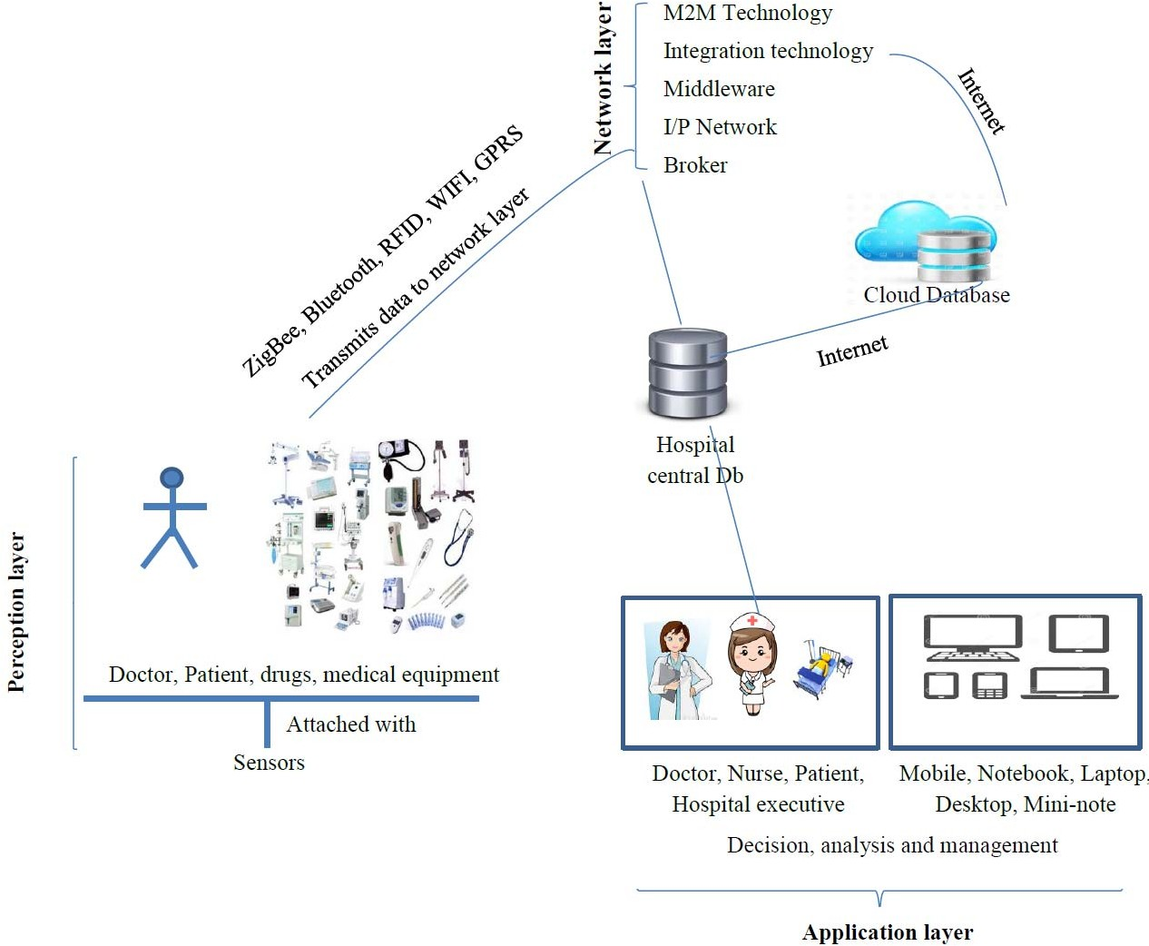

Fig. 2. Conceptual smart hospital

1. CONDUCTING THE SURVEY

The survey was taken out through a questionnaire. Potential members were given a hard copy of the questionnaire and requested to fill up the questionnaire. Before asking them to fill-up the questionnaire we gave them a good understanding about currently used HMIS, our proposed architectural framework that how it works, how the implementation is carried out of such system and some well-known features and characteristics which have significant importance in patient care and HMIS via presentation and video. The survey is done to ensure frameworks feasibility, its implementation and after-effects, and their tradeoffs while using HMIS based IoT.

Survey participants are required to answer around 45 questions. Six sections are mentioned to classify questions. In the first 2 sections, we have asked about the basic computer knowledge of individuals and the availability of computers at their workplaces. In the next two sections, we have asked about the current HMIS and satisfaction with it if they are using any. Then there are questions about the role of HMIS for different outcomes and then there is a section containing questions related to our proposed architectural framework i.e. HMIS based on IoT. For this section we have prepared 22 questions, to analyze how doctors are supporting this system, what they think about the usage of the system. All survey participants

were needed to fill up the form according to their skills and experience.

1. SURVEY RESULTS

Twenty participants from public and private hospitals took part in the survey. The given answers from professionals are then represented in tables and charts. Tables are prepared for each section with respect to the questionnaire. It is revealed while conducting a survey that some questions asked in the survey might not be interpreted as the author intended; otherwise, results could have been more accurate. It is likely because the participants are lack of experience with computer systems. In this section, we have presented results only related to the section containing IoT related questions.

Most of the respondents were happy to adopt IoT based HMIS and agreed that most of the functionalities are beneficial for them as well for patients, especially for time-saving, monitoring and communication purposes.

From Table 1 and Figure 3 is evident that Survey results have about 88 % of respondents are agreed to adopt the use of the IoT based HMIS while 6% are uncertain and 6 % disagreed to accept the system. For the mean values of all the features, most of the individuals participated in the survey have shown their maximum positive interest in the “Strongly Agreed” and “Agreed”.

***Table 1: Survey accumulated Results (%) for IoT based HMIS***

|  |  |  |  |  |  |
| --- | --- | --- | --- | --- | --- |
|  | strongly agree | agree | uncertain/  not applicable | Disagree | strongly disagree |
| 1. Will the system be accepted and used? | 11.76 | 76.47 | 5.88 | 5.88 | 0.0 |
| 2. Patient care is more reliable and perceptive than to the  existing system? | 11.76 | 58.82 | 23.53 | 5.88 | 0.0 |
| 3. This system would help me to see more patients per day and also save time (or go home earlier) than you could  with the existing system. | 23.53 | 64.71 | 5.88 | 5.88 | 0.0 |
| 4. Do you believe that IoT will bring a disruptive change? | 0.0 | 5.88 | 52.94 | 41.18 | 0.0 |
| 5. This system would be more effective for the situation to monitor and instruct far from patient | 23.53 | 64.71 | 5.88 | 5.88 | 0.0 |
| 6. This system wouldn’t just enable us to manage the assets and data of hospital but it would actually help to  provide better patient care | 11.76 | 76.47 | 5.88 | 5.88 | 0.0 |
| 7. Would it be beneficial? | 17.65 | 64.71 | 11.76 | 5.88 | 0.0 |
| 8. The e-health and telemedicine is easy, fast and error  free with the IoT. | 5.88 | 52.94 | 41.18 | 0.0 | 0.0 |
| 9. The way, in which architecture is proposed is suited to the task you want to perform with the software | 11.76 | 47.06 | 35.29 | 5.88 | 0.0 |
| 10. There are some features of these systems, that are not  related to actual work | 0.0 | 35.29 | 52.94 | 11.76 | 0.0 |
| 11. Will system implementation have an impact on control  in the organization | 17.65 | 47.06 | 35.29 | 0.0 | 0.0 |
| 12. You would be able to track the stuff (including equipment and patient data) easily and efficiently with  IoT based hospital | 23.53 | 76.47 | 0.0 | 0.0 | 0.0 |
| 13. Intra-office communication and tasking would be fast, easy, and effective with IoT based hospital | 29.41 | 41.18 | 5.88 | 5.88 | 0.0 |
| 14. The data, you would be able to handle easily (thorough IoT) with the new HMIS that you could not do before? | 23.53 | 76.47 | 0.0 | 0.0 | 0.0 |
| 15. This would provide useful tools for disease management (for instance, diagnosis-specific prompts, alerts, and  Patient education materials). | 17.67 | 58.82 | 17.67 | 5.88 | 0.0 |
| 16 Is the system cost-effective? | 5.88 | 29.41 | 35.29 | 29.41 | 0.0 |
| 17 IoT based HMIS promotes patient safety? | 5.88 | 47.06 | 29.41 | 17.67 | 0.0 |



80%

76%

strongly agre agree uncertain Disagree strongly disagree

76% 76% 76%

70%

65%

65%

65%

60%

59%

59%

53%

53%

53%

50%

47%

47%

47%

41%

41%

41%

40%

35% 35% 35%

35

30%

29%

292%9% 29%

24%24%

24%

24%

24%

20%

18%

18%

181%8%

18%

12% 12%

12%1 % 12%

12% 12%

10%

66%% 6% 66%% 6% 6% 66%% 6%6%

6%

66%%

6%6% 6%

0%

0%

0%

0% 00%%

00%%

0%

1 2 3 4 5 6 7 8 9 10 11 12 13 14 15 16 17

Figure 3. Graphical view of results for the analysis of IoT based HMIS

1. DISCUSSION

We surveyed and asked the respondents about “which

Despite the widespread use of information

the department needs this IoT based HMIS now”?

technology, hospitals in Pakistan still lack in IT

Individuals selected options from the given list, some of the respondents selected more than one option. The

advancement. Currently used many large hospitals still don’t use computer systems, but many are using

accumulated results are shown in figure 4. As we can

simple HMIS systems, such s CMH. Some of

see most of the respondents wanted t in OPD and then in ICU.

e

2

%

hospitals also have implemented a basic level of e-health and working on telehealth and making progress.

Our survey is showing that people are willing to

would change the existing hospital architecture and

accept and use HMIS with advanced technology as

will give a satisfied result and this methodology is for

technology is always there to ease humans and give comfort in our daily life.

sure fit to tackle the issues of a hospital. We have discussed the basic connotation of the smart hospital and have conducted a survey for analysis of IoT based

HMIS. This study investigates the decision about

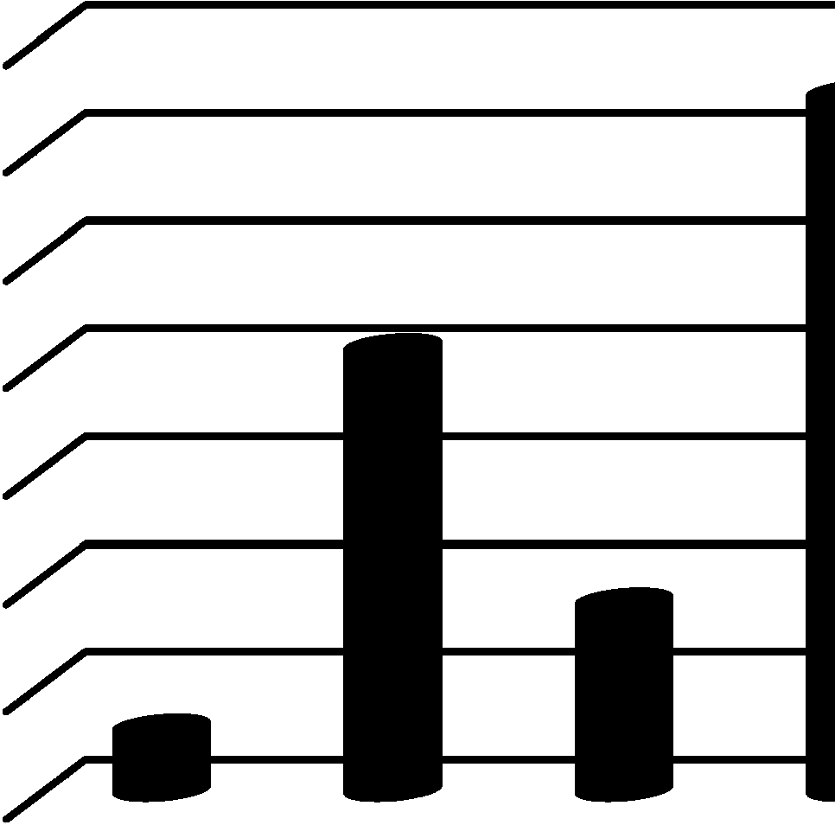

Which department needs this system now??

70.00%

60.00%

50.00%

40.00%

30.00%

20.00%

10.00%

0.00%

64.71%

41.18%

17.65%

17.65%

5.88%

adoption of IoT based hospital management system in Pakistan.

The result shows that 87% of participants were

happy with the features of IoT provided by IoT based smart question that which department

and functionalities hospital. For the needs it now, the

high rated departments are ICU and OPD. To our knowledge, this is the first assessment for the process of the Internet of things implementation in hospitals of Pakistan. In the future, we will discuss the security issues and data formats for all embodied and mobile systems for the versatile implementation in IoT based HMIS.

Figure 4: Results for the priority of d apartment, in which we need this system now.

So does our proposed framework. And around 80% of respondent’s agreed that IoT based system would provide better communication, better health care,

REFERENCES

1. P. Guillemin and P. Friess, “Int rent of things strategic research roadmap,” Cluster Strategic Research Agenda 2009.pdf
2. "Gartner Says the Internet of Things Installed Base Will Grow to 26 Billion Uni s By 2020". Gartner. 2013-12-12. Retrieved 2014-01-02. Wen Hao, “RFID, EPC, and Things of the Internet”, *RFID Technology and Application*, No. 5, 2009, pp. 17-20.
3. P. Guillemin and P. Friess, “Int rent of things strategic research roadmap,” http://www.internet-of-things- research.eu/pdf/IoT
4. Lei Yu, hospital-based on IoT, Journal of Networks,

1

reduce cost, better monitoring, and early diagnosis, better data management and so on.

Most of the questions in the questionnaire were understood and correctly interpreted by most of the respondents. But for some questions respondents were

Vol 7, No 10 (2012), 1654-166, Oct 2012

1. YU MengSun, Medical reform and IOT in health care [A], Summit forum IoT in health domain of china, 2011.5
2. Ma JinJun, A brief talk on the problem in integration of hospital intelligence a d information and

Confused and scored questionnaire

Interpretation. For example some of

with wrong

doctors were

developing direction of intelligence [J], *Intelligent Building & City Information*, 2010, (158), pp. 94-96

thinking that with on distance monitoring as we are

1. Luigi Atzori, Antonio Iera, Gi Como Morabito, “The

already doing in health and communication with patients would difficult.

1. CONCLUSION:

telemedicine, be less and

Internet of Things; A survey”, *Computer Networks*, No. 54, 2010, pp. 2787-2805.

1. Liu Xiaohui, Internet of Tings and Embedded Technology, *Computer Study*, 2011, 4 (2), pp. 27-28
2. He QianFeng, Breakthrough pint of IoT applied in the medical domain is object management [A], Chinese

IoT (Internet of Things) has turned into a real life changer. In the last decade, this technology through its excellence of pertinence is emerging in every zone of

life from logistics to environment observing and

trades to farming. Healthcare is one of those fields which request a motivational provision that may only be fulfilled by IoT in a conservative and helpful way. Implementation of IoT based HMIS framework