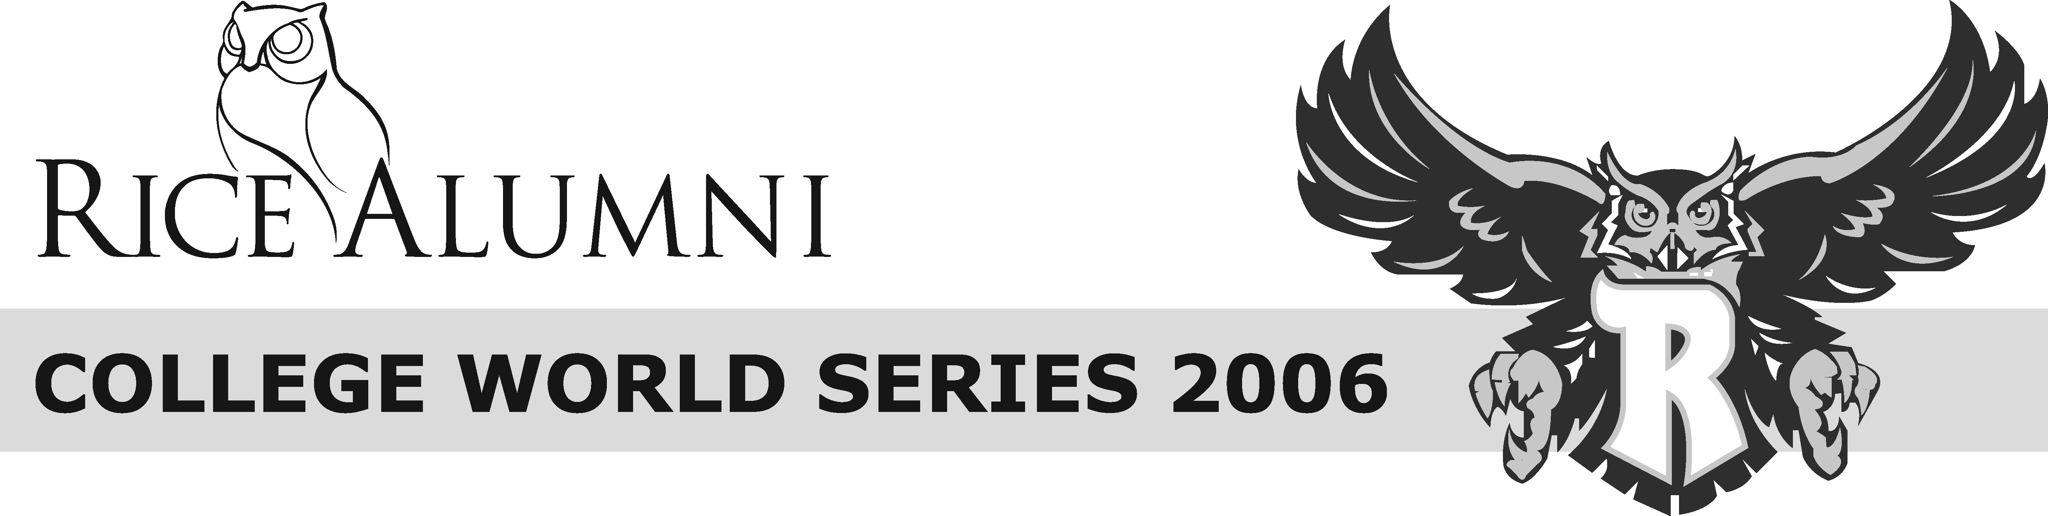
Greet the Team!  Join fellow Rice fans at the team hotel after today’s  game to give the Owls a warm welcome!  Doubletree Downtown  1616 Dodge Street  Team arrives at ~ 5:30 p.m. |  | Greet the Team!  Join fellow Rice fans at the team hotel after today’s  game to give the Owls a warm welcome!  Doubletree Downtown  1616 Dodge Street  Team arrives at ~ 5:30 p.m.
Greet the Team!  Join fellow Rice fans at the team hotel after today’s  game to give the Owls a warm welcome!  Doubletree Downtown  1616 Dodge Street  Team arrives at ~ 5:30 p.m. |  | Greet the Team!  Join fellow Rice fans at the team hotel after today’s  game to give the Owls a warm welcome!  Doubletree Downtown  1616 Dodge Street  Team arrives at ~ 5:30 p.m.

