GUIDELINES FOR TYPESETTING MANUSCRIPTS USING MSWORD
First Author
University Department, University Name, Address,
City, State ZIP/Zone, Country
firstauthor_id@domain_name
http://<webaddress>
Second Author
Group, Laboratory, Address,
City, State ZIP/Zone, Country
secondauthor_id@domain_name
http://<webaddress>
Abstract
This template is designed for all publications of TMRF Kolhapur. The abstract should summarize the context, content and conclusions of the paper in less than 150 words. It should not contain any reference citations or displayed equations. Typeset the abstract in 8 pt roman with baselineskip of 10 pt, making an indentation of 18 pt on the left and right margins.
Keywords: Keyword1; keyword2; keyword3.

The Main Text
Authors are encouraged to have their contribution checked for grammar. Abbreviations are allowed but should be spelt out in full when first used. Integers ten and below are to be spelt out. Italicize foreign language phrases (e.g. Latin, French).
The text is to be typeset in 10 pt roman, single spaced with baselineskip of 13 pt. Text area is 5 inches in width and the height is 8 inches (including running head). Final pagination and insertion of running titles will be done by the publisher. Upon acceptance, authors are required to submit their data source file including postscript files for figures.

Major Headings
Major headings should be typeset in boldface with the first letter of important words capitalized.

Sub-headings
Sub-headings should be typeset in boldface italic and capitalize the first letter of the first word only. Section number to be in boldface roman.

3.1.1. Sub-subheadings
Typeset sub-subheadings in medium face italic and capitalize the first letter of the first word only. Section numbers to be in roman.

Numbering and spacing
Sections, sub-sections and sub-subsections are numbered in Arabic. Use double spacing before all section headings, and single spacing after section headings. Flush left all paragraphs that follow after section headings.

Lists of items
List may be presented with each item marked by bullets and numbers.

Bulleted items
- item one
- item two
- item three.

Numbered items
- item one
- item two
- item three.
The order of subdivisions of items in bullet and numbered lists may be presented as follows:

Bulleted items
- First item in the first level
- Second item in the first level
- First item in the second level
- Second item in the second level
- First item in the third level
- Second item in the third level
- Third item in the second level
- Fourth item in the second level
- Third item in the first level
- Fourth item in the first level

Numbered items
- First item in the first level
- Second item in the first level
  - First item in the second level
  - Second item in the second level
    - First item in the third level
    - Second item in the third level
  - Third item in the second level
  - Fourth item in the second level
- Third item in the first level
- Fourth item in the first level

Equations
Displayed equations should be numbered consecutively, with the number set flush right and enclosed in parentheses. The equation numbers should be consecutive within the contribution
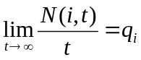. (1)
Equations should be referred to in abbreviated form, e.g. “Eq. (1)”. In multiple-line equations, the number should be given on the last line.
Displayed equations are to be centered on the page width. Standard English letters like x are to appear as x (italicized) in the text if they are used as mathematical symbols. Punctuation marks are used at the end of equations as if they appeared directly in the text.

Theorem Style
Theorem 4.1. Theorems, lemmas, etc. are set on a separate paragraph, with extra 1 line space above and below. They are to be numbered consecutively within the contribution.

Lemma 4.2. Theorems, lemmas, etc. are set on a separate paragraph, with extra 1 line space above and below. They are to be numbered consecutively within the contribution.

Proof. Proofs should end with □

Figures, Tables and Photographs
Figures are to be inserted in the text nearest their first reference. Figure placements can be either top or bottom. Original india ink drawings of glossy prints are preferred. Please send one set of originals with copies. If the author requires the publisher to reduce the figures, ensure that the figures (including letterings and numbers) are large enough to be clearly seen after reduction. If photographs are to be used, only black and white ones are acceptable.
Figures are to be sequentially numbered in Arabic numerals. The caption must be placed below the figure. Typeset in 8 pt Times Roman with baselineskip of 10 pt. Long captions are to be justified by the “page-width”'.Use double spacing between a caption and the text that follows immediately, e.g. Fig. 1.
Previously published material must be accompanied by written permission from the author and publisher.

Tables
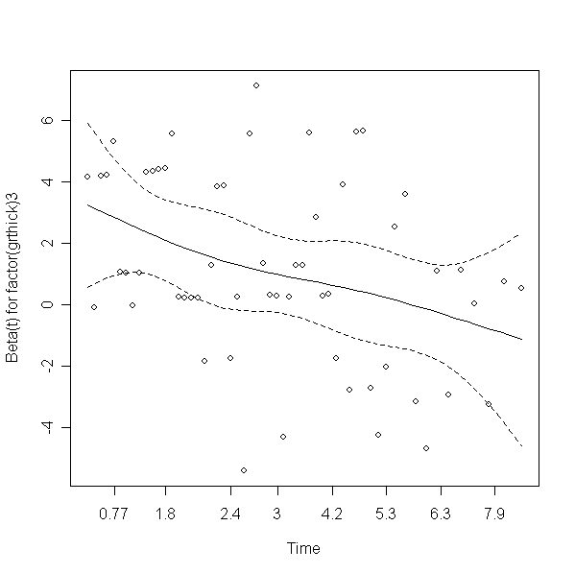
Fig. 1. This is the caption for the figure. If the caption is less than one line then it needs to be manually centered.
Tables should be inserted in the text as close to the point of reference as possible. Some space should be left above and below the table, e.g. Table 1.
Table 1. The planning and control components.
Format symbol | Description
d, i | for a integer value
o | for an octal number
u | for an unsigned integer
X, x | for a hexadecimal number
f | for a floating point number
E, e | for a number in exponential notation
G, g | for a exponential or floating notation whichever suits best.
c | for a character data
s | for a string data
Tables should be numbered sequentially in the text in Arabic numerals. Captions are to be centralized above the tables. Typeset tables and captions in 8 pt Times Roman with baselineskip of 10 pt. Long captions are to be justified by the “table-width”.
If tables need to extend over to a second page, the continuation of the table should be preceded by a caption, e.g., “Table 1 (Continued)”. Notes to tables are placed below the final row of the table and should be flushleft. Footnotes in tables should be indicated by superscript lowercase letters and placed beneath the table.

Running Heads
Please provide a shortened runninghead (not more than eight words) for the title of your paper. This will appear on the top right-hand side of your paper.

Footnotes
Footnotes should be numbered sequentially in superscript lowercase Roman letters.a

Acknowledgments
This section should come before the References. Funding information may also be included here.
- Appendix
Appendices should be used only when absolutely necessary. They should come after the References. If there is more than one appendix, number them alphabetically. Number displayed equations occurring in the Appendix in this way, e.g. (A.1), (A.2), etc.
(A.1)

References
The references section should be labeled “References” and should appear at the end of the paper. Authors should follow a consistent format for the reference entries. For journal names, use the standard abbreviations. An sample format is given in the following page:

Citations in Text
Since the references are unnumbered, citations to them in the text must identify them by authors’ names and year of publication. References should be cited in text in square brackets by giving the last name of the author and the date of publication, e.g. [Chakrabarti (2000)]. A comma should be present before the date. For papers by two authors, the last names are joined by “and”. Papers by three and more authors should be cited by giving the last name of the first author followed by et al. and the date (note that et al. is in italics and that a period follows the abbreviation al.).

Reference List
Reference entries should be ordered alphabetically, starting with the last name of the first author, followed by the first author’s initial(s), and so on for each additional author. For papers with more than three authors, the last name and initials of the first author only should be listed, followed by a comma and et al. Multiple entries for one author or one group of authors should be ordered chronologically, and multiple entries for the same year (including references with three authors that may be cited in the text as “et al.”) should be distinguished by appending sequential lowercase letters to the year; e.g. Sunde and Karp (2001a); Sunde and Karp (2001b).

References
- Akerkar, R. A.; Lingras, P. (2008). An Intelligent Web: Theory and Practice, 1st edn. Johns and Bartlett, Boston.
- Albert, R.; Jeong, H.; Barab´asi, A.-L. (1999): Diameter of the world-wide Web. Nature, 401, pp. 130–131.
- Berry M. W., Dumais S. T., O’Brien G. W. (1995): Using linear algebra for intelligent information retrieval, SIAM Review, 37, pp. 573-595.
- Bharat, K.; Broder, A. (1998): A technique for measuring the relative size and overlap of public Web search engines. Computer Networks, 30(1–7), pp. 107–117.
- Broder, A.; Kumar, R.; Maghoul, F.; Raghavan, P.; Rajagopalan, S.; Stata, R.; Tomkins, A.; Wiener, J. (2000): Graph structure in the Web. Computer Networks, 33(1–6), pp. 309–320.
- Chakrabarti, S. (2000): Data mining for hypertext: A tutorial survey. SIGKDD explorations, 1(2), pp. 1–11.

Typeset names in 8 pt Times Roman, uppercase. Use the footnote to indicate the present or permanent address of the author.
State completely without abbreviations, the affiliation and mailing address, including country. Typeset in 8 pt Times Italic.
Typeset author e-mail address in single line.
a Footnotes should be typeset in 8 pt Times Roman at the bottom of the page.

