Varactor Loaded Transmission Lines For Phase Shifting T/M Applications

Capstone Product Proposal - Team 13

v.1.1

**By:** *Eric Aki, Jianyu Hao, Juan Rivera-Mena*

## **Table Of Contents**

Executive Summary/ Concept of Operations

Brief Market Analysis

Requirements

MUST

SHOULD

MAY

Background

Deliverables

Initial Product Design

Verification Plans

Timeline

Budget and Resources

Team and Development Process

Collaboration Tools Methodology

References

## 

## 

## 

## **Executive Summary/ Concept of Operations**

The objective of the Capstone is to explore the applications of varactor loaded transmission lines as phase-shifters. We will accomplish this by characterizing a varactor over a small frequency range in order to predict its behaviour when scaled to operate at higher frequencies. The main goal of this project is for our models to be accurate enough that scalability is possible. If this goal is reached, optimizing the geometry of the loaded transmission line for the best possible bandwidth and insertion loss would be the next stage.

## **Brief Market Analysis**

Phase-shifting technology is prevalent in phased antenna arrays because of its ability to adjust the directivity of an antenna. We aim to investigate another aspect, mainly being the reverse recovery time of the diodes. This is with the aim of increasing bandwidth of high-frequency pulses.

## 

Figure 1: Competing MMIC phase shifters on the market with selected performance characteristics. Taken from (Ellinger, *et. al.*, 2003)

As seen in Figure 1, There are many microwave IC’s on the market which primarily focus on a narrow band of phase shifting applications. Instead of reinventing the wheel, Rohde and Schwarz tasked us to fully characterize a model for producing a passive varactor loaded transmission line model useful for a larger bandwidth with minimal losses across all applications.

The goal of this is for us is to produce the proof of concept of how realistic designing/creating these modules actually is, and if further investment into this subtopic will be beneficial for Rohde & Schwarz going forward.

## **Requirements**

### **MUST**

* Fully characterize a varactor in MatLab
* Simulate different transmission line geometries in ADS
* Perform memento simulations on transmission line models
* Be modeled based on easily sourced components i.e. Digikey.
* Construct methodology of scaling design for use in higher frequencies
* Submit a “White-paper” style IEEE formatted document detailing design procedure for low frequency model (144Mhz Bandwidth)

### **SHOULD**

* Keep costs to <100$ US per assembled board
* Construct a scalable model of transmission line
* Design module which optimizes power delivery across the entire bandwidth of operation.
* Design module which optimizes scattering parameters and minimizes undesired signal reflection.
* Design module which creates the shortest output pulses possible to generate higher harmonic content.
* Have 50**Ω** input and output impedance
* Perform Rise time vs. NLTL Length and Rise time vs. DC Bias freq. Domain measurements for 144Mhz Bandwidth Design
* Create method for analyzing effects of narrowing and widening line geometry for 6Ghz Bandwidth

### **MAY**

* Design full scale (DC-6Ghz) model with most viable geometry
* Design a model with reliable behavior at different ambient temperatures

## 

## **Deliverables**

* Project Proposal
* Weekly Progress Reports to Faculty Advisor
* (Qty 3) PCB’s of 10 ladder long 144MHz Varactor Loaded Tx Line. With ports to allow for S-parameter De-embedding. (1 Populated)
* Detailed and complete documentation for research, modeling data and Simulation results.
  + In form of “white-paper” design guide
* Rough Draft of Design guide submitted for sponsor revision.
* Revised copy of Design guid submitted to industry sponsor. (At least 1 cycle of revision)
* Bill of Materials for Modeled Design and board materials
* ECE Capstone Poster

## **Initial Product Design**

**What are we proposing to make**

We aim to build a complete model of a Non-Linear Transmission line using varactor diodes and a bias voltage to control their capacitance, and thus their ability to modify line impedance and phase. We also aim to include a model which correctly captures reverse recovery time for the diodes to achieve high pulse speeds such that we can extract high frequency content if the device were to be used as a frequency multiplier/comb generator. We are motivated to make this as this could prove to be a profitable technology for Rohde and Schwarz to manufacture at a later time.

**How are we going to make it?**

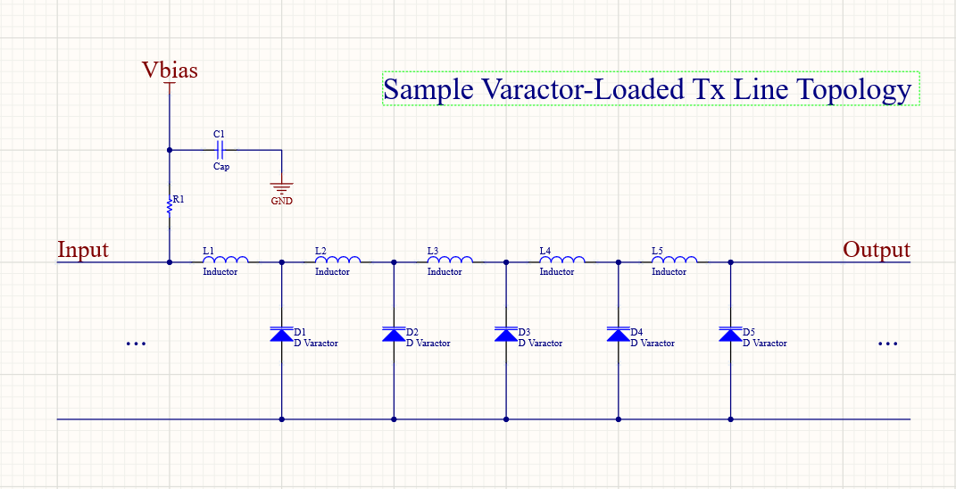

Figure 2: Sample Transmission Line Topology based on ¼ Wavelength Low pass filters.

The how of this project is the main scope of the proposed capstone as we understand it. We will need to investigate which factors have high significance when we need to eventually produce a product. The biggest questions we must try to answer are what components (diodes) are going to be the most versatile while still meeting sponsor requirements, and how many sections (ladders) of Tx lines with modeled parasitics are we able to incorporate into a design before we start to see significant power loss and non-ideal function. The main function to be explored is step input pulse sharpening

Characterization of a varactor diode begins by creating a good model of its behaviour. [2] illustrates a method to characterize a varactor diode. They detail a methodical approach to characterization which include the following equation.

[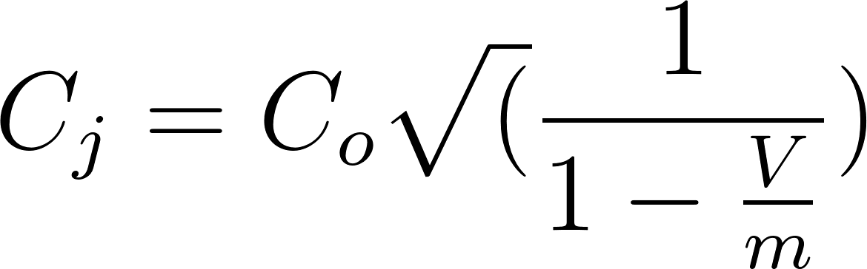](https://www.codecogs.com/eqnedit.php?latex=C_%7Bj%7D%20%3D%20C_%7Bo%7D%5Csqrt(%5Cfrac%7B1%7D%7B1-%5Cfrac%7BV%7D%7Bm%7D%7D)%250)

Where [](https://www.codecogs.com/eqnedit.php?latex=C_%7Bj%7D%250) is the average junction capacitance of the varactor, V is the reverse-biasing voltage and m is a proportionality constant depending on the diode geometry and type.

Starting with V=0, a network analyzer is used to measure port parameters of the circuit. Bias voltage is increased and additional components (i.e. additional inductors to characterize line inductance) are added to the model until simulation and measurements agree to a satisfactory level.

We feel that we can utilize a similar approach to start, prototyping a small model to work at lower frequencies that may be easier to measure would be a good first step in the component characterization. Cutting line of necessary length and width on microstrip and measuring impedance with a varactor attached being the first of those steps.

This will ensure that our model will perform reliably when eventually driven and/or loaded with a 50 Ohm matched module. We can similarly step our biasing voltage to achieve the desired resolution of our model and measure associated power (microwave,rf, or otherwise) using network analyzers.

**What are the biggest risks?**

With the shift to remote meetings and limited access to lab equipment, our greatest risk would be of making incomplete or erroneous measurements of our low frequency prototype and inaccurate or misleading simulations. or Furnishing subpar documentation to our industry sponsor would also constitute a failure to meet the requirements agreed upon by the sponsor.

**What questions do we have that are currently unanswered**

**How much of this do we think we can get done in 5 months**

We hope to accomplish all of our ‘must’ requirements. However, we don’t have much experience with the software that we will use. We also can’t with certainty say how long it will take to come up with a workable model, and then to determine if the model is accurate enough. Optimization of a model and characterization of a component is something that we have not done before, with the help of our advisor and sponsor, we believe we can achieve this goal however.

**Software architecture**

Our project is to build a fully analog and passive device/module. As far as we know, there is no data processing or network connectivity to consider during the course of the project. Because of this, we will likely not need to build any software architecture or environments. All measurements will be done using “standard” lab equipment and there is no need for microcontroller programming nor the need to implement our design digitally with FPGAs. .

**Back up plans (**What if things go wrong? What can we fall back on?)

Due to entering uncertain times with the COVID-19 pandemic,we have had to restrict the amount of hardware deliverables we are able to produce. Our back-up plan entails halting hardware progress after measuring 144Mhz bandwidth model to the best of our ability using either a NanoVNA or scope or sending hardware via USPS to be measured by industry sponsors at the Rohde and Schwarz lab.

If we reach the June soft deadline for technical work on this capstone (See Project Timeline section) before completing all measurements, we will shift to White paper drafting and simulations of the low bandwidth prototype. Following that, we will focus on design of high frequency prototype design process with aid of simulations for next team to pick up from

## **Verification Plans**

After modeling our NLTL design, we may begin looking at constructing them in the lab. To meet the requirements given by our industry sponsor we need to perform many RF/Microwave tests such as impedance matching and scattering parameters by use of a VNA, output power likely through use of high bandwidth spectrum analyzers may need to be carried out by sponsors. We will need to consider power measurements for a wide range of biasing voltages on the varactors. Which will be accomplished by measurements of S-parameters with differing bias and limited transient analysis (particularly rise time) using an Oscilloscope.

. All measurements will be weighed against our expectations generated during the research and modeling phase of the project.

## **Timeline**

Our tentative project timeline can be found on our Github page. The link below will take you to where our Gantt chart lives and will be accessible to anyone invited to be a collaborator.

[Project Gantt Chart](https://github.com/akier900/Capstone_Rohde-Schwarz_Team13/blob/master/Team%20Schedule/ProjectSchedule.mpp)

We are currently in the process of revising this living document and wilh have specific dates regarding time blocks for the ending of technical work, the start of white paper drafting and submission to R&S for revision etc.. It will reflect the changes due to the ongoing COVID-19 Pandemic. This document will be fully updated by Friday, April 17th at 5:00pm.

## **Budget and Resources**

Cost is not a primary constraint on our project as our true purpose is to fully characterize and model this circuit block. The lone cost constraint given is a varactor less than or equal to $100.00 US. All software and labs can be accessed with student licenses or privileges.

**Resources that we will provide or have access to through PSU**

* ADS Simulation Software
* Matlab and Simulink

**Resources Provided by Industry Sponsor**

* **Possibility of measurements carried out by Sponsors (Rohde and Schwarz Labs)**
* Lab complete with High Frequency measurement equipment
* Materials and components cost (Diodes, board materials, waveguides if necessary)

## **Team and Development Process**

* Eric Aki
  + Sponsor Liaison
  + Focus: Colead on Matlab, ADS simulation, Research and Prototyping Lead
* Juan Rivera-Mena
  + Lead on MatLab simulations
  + Lead on ADS simulation
* Jianyu (Oscar) Hao
  + Faculty Advisor Liaison
  + Focus: Research and Prototyping, Accounting

### **Collaboration Tools Methodology**

Our team documentation will be found on a private Github Repository.

<https://github.com/akier900/Capstone_Rohde-Schwarz_Team13/tree/master/Team%20Schedule>

## **References**

[1] Frank Ellinger, Heinz Jäckel, Werner Bächtold, April 2003, *Varactor-Loaded Transmission-Line Phase Shifter at C-Band Using Lumped Elements, IEEE Transactions on Microwave Theory and Techniques*, Vol. 51, Pg. 1139.

[2] D. Xu and G. Branner,“An efficient technique for varactor diode characterization,” in *Proc. 40th Midwest Circuits Syst. Symp.,* 1997, vol. 1, pp. 591–594.