**GTU Department of Computer Engineering**

**CSE443 Object Oriented Analysis and Design**

**Fall 2021 - Homework 3 Report**

**Akif KARTAL**

**171044098**

**Question 1**

Use Adapter Design pattern.

Implement a simple lineer data structure which will be a linked list and then Using adapter pattern convert that class to a thread safe class.

**Question 2 – Composite and Iterator**

**Solution**

**2.1** **Understanding the problem**

The problem is like the following picture;

Here, emails contains both address and name of its owner, groups contains an arbitrary number of personal or group addresses also **groups are composite, emails are leaf**.

**2.2 Class Diagram**

**2.2.1 Classes in my solution**

**2.2.2 Composite Pattern Class Diagram**

Here, EmailComponent class is abstract class, Email is leaf class and CompositeEmail is a composite class with add, remove and get methods.

**2.2.3 Full Class Diagram**

Here, we will see full diagram note that I used iterator design pattern to traverse all tree easily as expected in homework pdf file.

Here, Composite iterator implements **java.util iterator** interface to use in composite email class. NullIterator class is used in Email leaf class. Main class is for test purpose.

**2.3 Test Results**

Check Main.java class and run to see results. Some part of result is following;

**Question 3 – Concurrency patterns**

**Solution**

**3.1 Understanding the** **synchronization barrier problem**

In order to solve this problem, we will apply following solution in 2 different ways with java;

*This solution was taken from CSE344 System Programming Course slides.

**Some notes on my solution**

* In order **to create thread** in java I will use **Runnable interface** for both solutions.
* Note that, since all threads works with different portion of the matrix which means different buffer, we don’t have any synchronization problem other than synchronization barrier.
* In my solution, all threads will use **same thread function** with different coordinates.
* I will explain my solutions with simple example. You can check the source code after reading.

**3.2 Using Java’s synchronized**

**3.2.1 Classes in my solution**

**3.2.2 Shared Data and Lock Object Class**

*Atomic integer is much better between threads in java.

**3.2.3 Common Thread Function between Threads**

**\***Here, synchorized keyword acts like a mutex and it locks and unlock code in its scope. We are using lockData object like a mutex(with the help of object class) since it is common and shared between all threads.

**3.2.4 Creating Threads and Testing**

**3.3.5 Output**

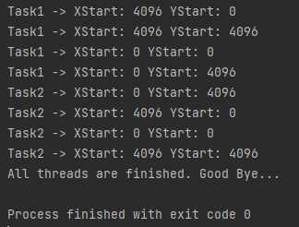

**\***As you can see all task2s **didn’t start** all task1s are finished.

**3.3 Using mutex(es) and monitor(s)**

**3.3.1 Classes in my solution**

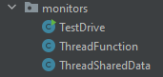

**3.3.2 Shared Data between Threads**

*Atomic integer is much better between threads in java.

**3.3.3 Common Thread Function between Threads**

**3.3.4 Creating Threads and Testing**

**3.3.5 Output**

**\***As you can see all task2s **didn’t start** all task1s are finished.

**3.4 Calculating A+B and Discrete Fourier Transform**

**3.4.1 A+B Implementation**

**3.4.2 Discrete Fourier Transform Formula and Implementation**

