This README file describes the encryption technology (FERNET) and the MFA(Multifactor authentication) method that is used to provide security by applying OOP principles and concepts during the access of a user to the ASMIS. The code can be initiated by running the “main.py” file in Pycharm compiler or by typing python3 main.py at Codio which uses Ubuntu. The main.py includes a choice menu which prompts the user to select an option. There are 3 available options:

* y --> A new user who has to preform a registration with a valid username and a valid password registered twice.
* n-->The user is an existing registered user. The user is requested to login by editing a valid username and password that has already been registered in the past.
* other button/s--> This option is activated by pressing any button except y/n and returns the user back to the main menu.

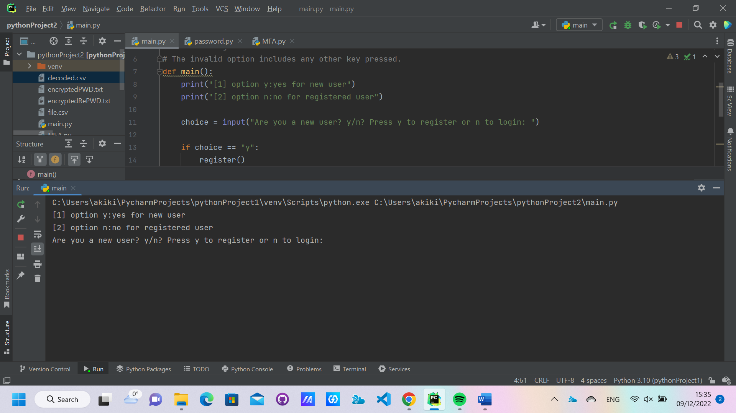

Concerning the registration of the username, the user has to type a username and insert twice a password. The two passwords should match. Conditions regarding the username and passwords are described below at validName(username) and validPassword(password).

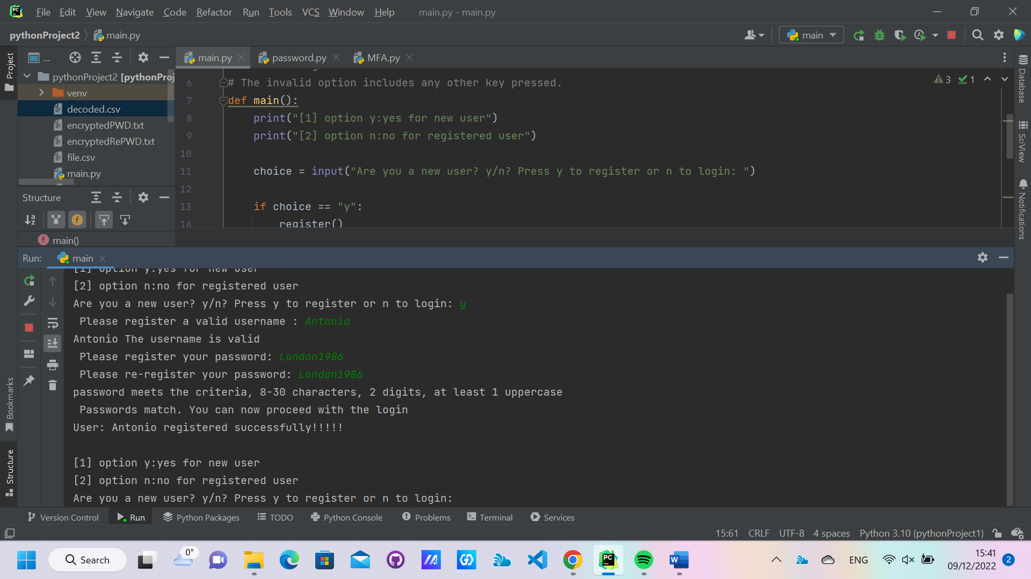

Furthermore, once the user performs the registration, then the FERNET encryption method is applied which is performed for both the 1st password (registration password) and the second password (confirmation password). Moreover, the username and encrypted password are stored in the file.csv. Furthermore, there is a decryption of the encrypted password which is stored in the decoded.csv file together with the registration username. The decryption of the password is performed to facilitate the procedure of the login.

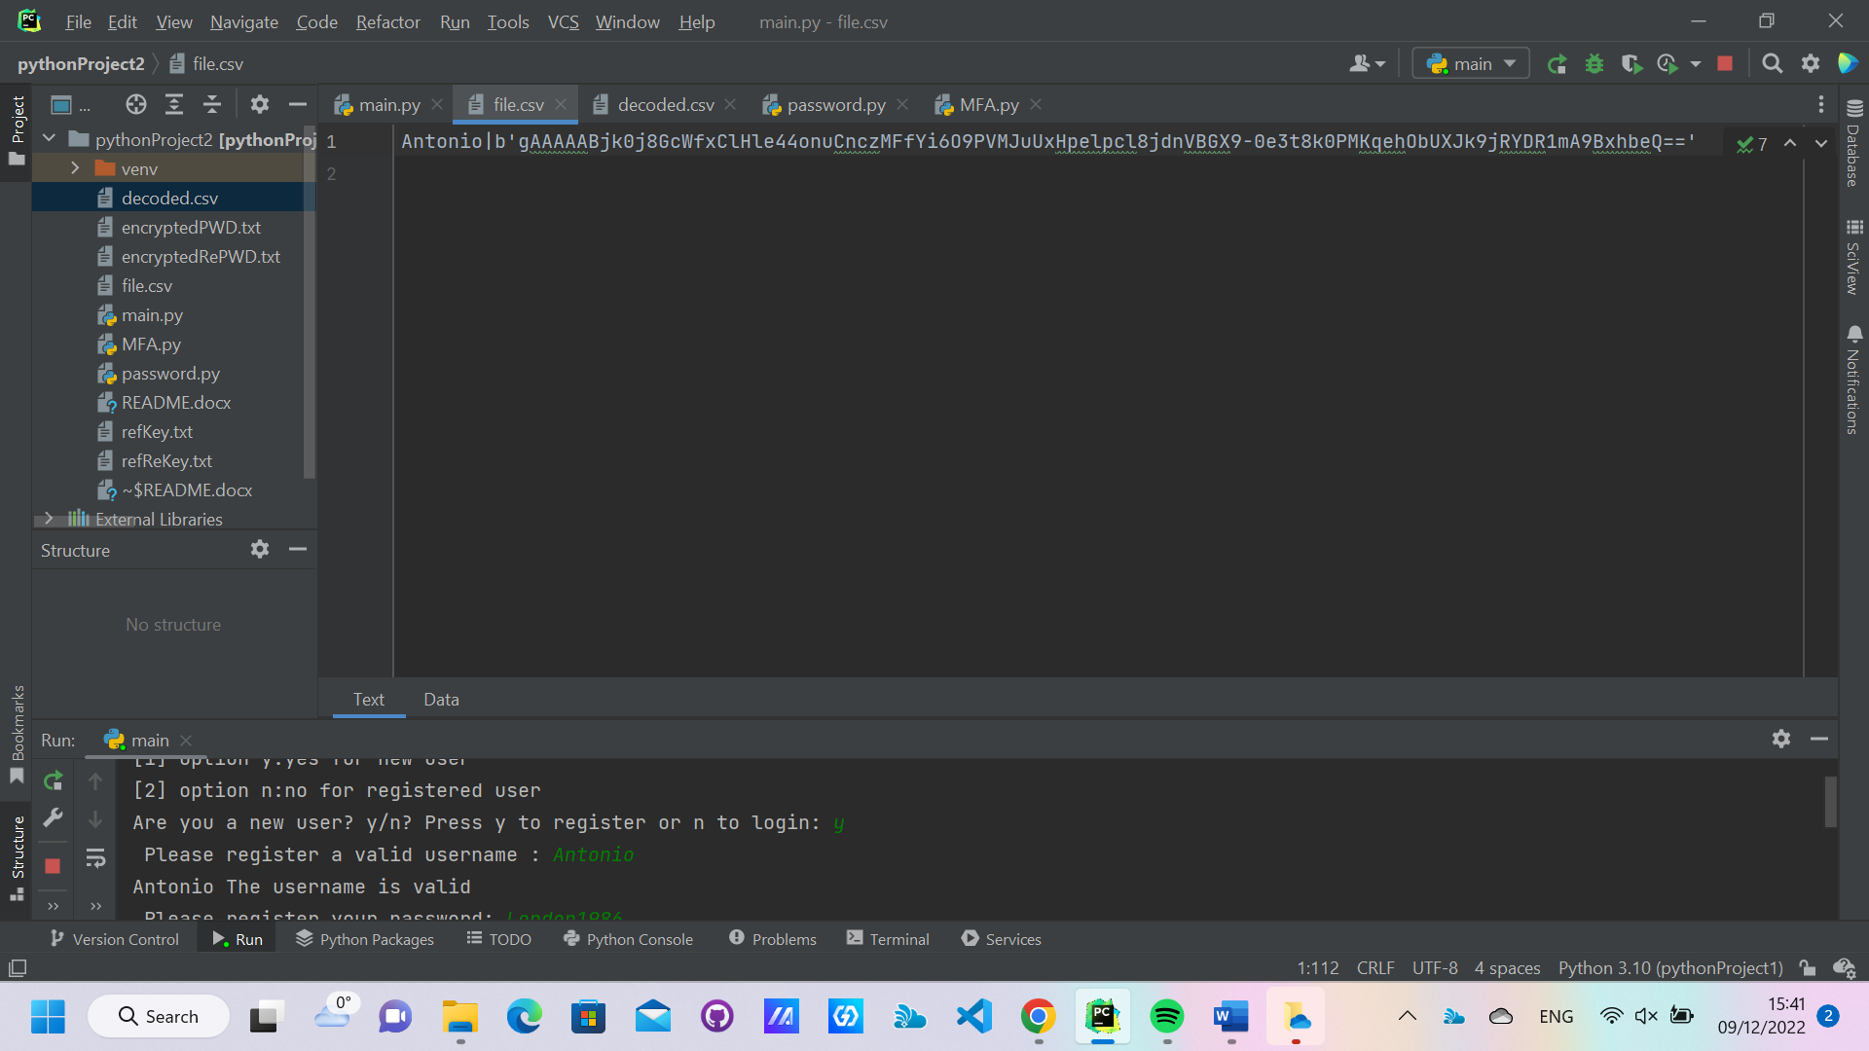

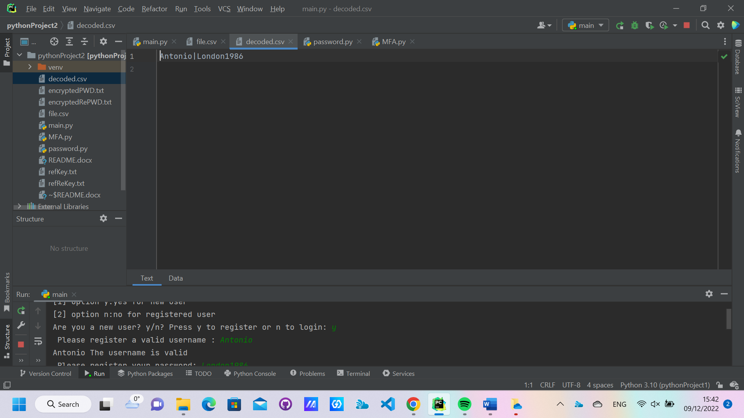

Concerning the login, the user is requested to enter a valid username and a valid password.

If the user manages to enter correct and valid credentials that exist in the decoded.csv, then the user will be requested to enter a valid PIN code. This function is implemented by calling the MFA function.

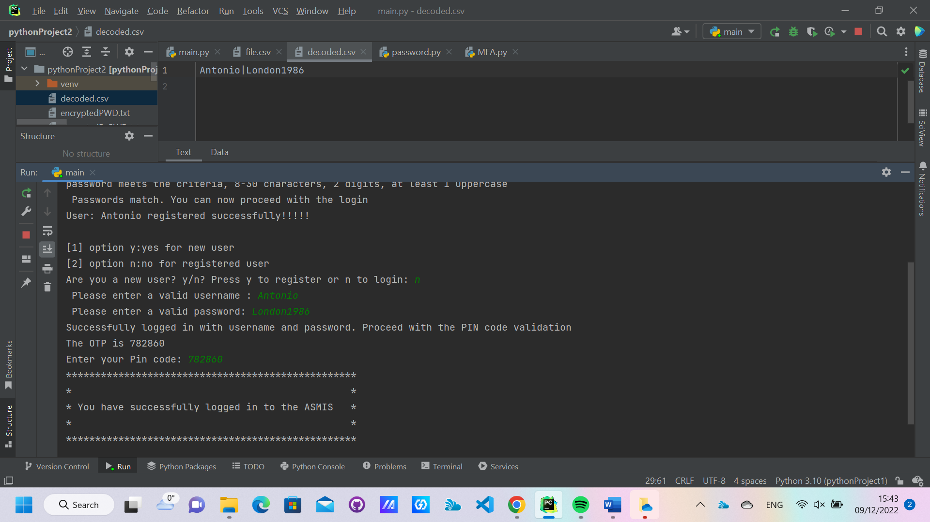

Main functions explained:

main(): It includes the main menu which is composed by the choice menu. In the choice menu there are two valid options register() and login() and one invalid option which is activate if the user press any other button.

register(): This function allows a new user without any valid credentials to create an account to the ASMIS using the FERNET method. During the registration the encoded data are stored in the file.csv and the decrypted data are store in the decoded.csv

login(): The user enters his credentials. If the credentials already exist in the decoded.csv file then the user will be requested to continue with the MFA authentication. The user has three attempts to login else he will be returned to the main menu

MFA(): this function describes implement the onetime code generation which allows the user to type a pin code using only digits otherwise an exception is thrown and if valid to login to the ASMIS. The user has maximum two attempts. This action follows the credentials validation in the login function.

validName(username): check if a username is valid with the following conditions: between 2-30 characters, maximum two digits, only alphanumeric characters allowed.

validPassword(password): check if a password is valid with the following conditions: between 2-30 characters, at least two digits, at least one uppercase character.Linked functions: CountDigitsFor(password), upperCasePassword(password). Further explanation on the comment of the code.

For further information, a video(82 MB) has been uploaded with a few attempts to register and login with valid and invalid credentials.