COMS W1007            TR 1:10-2:25 PM

Columbia University                          Fall 2014

**Homework 1: Theory**

**September 30, 2014**

CUNIX ID: ami2119

Last Name: Iwamizu

First Name: Akiko

# Part 1: Theory (50 points)

1. For responses A – D, I used this website: http://www.developer.com/design/article.php/3308941
2. Three examples of “aspects” of design that object-oriented design does NOT address:
   1. Logging
   2. Context-sensitive error handling
   3. Performance optimization
3. What “advice” is
   1. An advice defines what additional code needs to be executed and when (before, after, or around join points). For example, an aspect can be used to implement a precondition before the execution of a method to aid in the testing of arguments.
4. What a “weaver” does
   1. An aspect weaver is used to combine both the source code and aspects into an executable form that can be sent to the compiler to create an executable program.
5. A system or product that can be used to incorporate AOP into Java (just one is sufficient)
   1. AspectJ – software that is used as an extension of Java for AOP
6. At least one disadvantage of AOP that explains why it hasn’t been incorporated into Java
   1. Debugging – if there is a bug in the aspect and the advice causes some changes, then it can lead to problems in the source code with no explanation[1]
7. URL to Java Platform, Standard Edition 6 API: http://docs.oracle.com/javase/6/docs/api/

For the Clipboard class:

* 1. Fields: owner, contents
  2. Constructor: Clipboard
     1. parameter: name (of type String)
  3. Methods:
     1. getName
        1. no parameters
        2. returns the name of this clipboard object
     2. setContents
        1. parameters: contents (the transferable object representing the clipboard content), owner (the object which owns the clipboard content)
        2. does not return anything – it is void
     3. getContents
        1. parameters: requestor (the object requesting the clip data)
        2. returns the current transferable object on the clipboard
     4. getAvailableDataFlavors
        1. no parameters
        2. returns an array of DataFlavors in which the current contents of this clipboard can be provided
     5. isDataFlavorAvailable
        1. parameters: flavor (the requested DataFlavor for the contents)
        2. returns true if the current contents of this clipboard can be provided in the specified DataFlavor; false otherwise
     6. getData
        1. parameters: flavor (the requested DataFlavor for the contents)
        2. returns an object representing the current contents of this clipboard in the specified DataFlavor
     7. addFlavorListener
        1. parameters: listener (the listener to be added)
        2. does not return anything – it is void
     8. removeFlavorListener
        1. parameters: listener (the listener to be removed)
        2. does not return anything – it is void
     9. getFlavorListeners
        1. no parameters
        2. returns all of this clipboard’s FlavorListeners or an empty array if no listeners are currently registered

The Clipboard class implements a mechanism to transfer data using cut/copy/paste operations in Java. Java allows you to have as many clipboards as needed, and accessing one is as easy as calling its’ name via the constructor. This class contains methods that allows you to interact with the operating system in order to temporarily store data (ie. Cut, copy, and pasting data) or to transfer data from one application to another.[2] This means that Java is a multiplatform language because it is operating systems behave differently towards clipboards, so the creators of Java had to take this into account and make Java capable of dealing with the differences.[3]

1. A word is a fixed-sized group of digits (either binary or decimal) that are handled as a unit by the instruction set or hardware of the processor. Instructions and data for the Elliot 803 are based around a 39-bit word length with binary representation in 2's complement arithmetic.[4] Because the word is in two’s-complement we know that 2n is the number of ways the bits in a binary word of length n can be arranged.[5] Thus, if we have a 39-bit word length, then n = 39 and the range of signed integers is

**-274,877,906,944, …, 274,877,906,943**



BMICalc.java:

import java.text.DecimalFormat;

public class BMICalc{

public BMICalc(double w, double h)

{

double formula = ((w / Math.pow(h,2)) * 703);

DecimalFormat df = new DecimalFormat(".#");

System.out.println("Your BMI is: " + df.format(formula));

}

}

BMITester.java:

public class BMITester{

public static void main(String[] args)

{

double weight = Integer.parseInt(args[0]);

double height = Integer.parseInt(args[1]);

BMICalc bmi = new BMICalc(weight, height);

}

}

1. (10 points) CRC for the programming part:

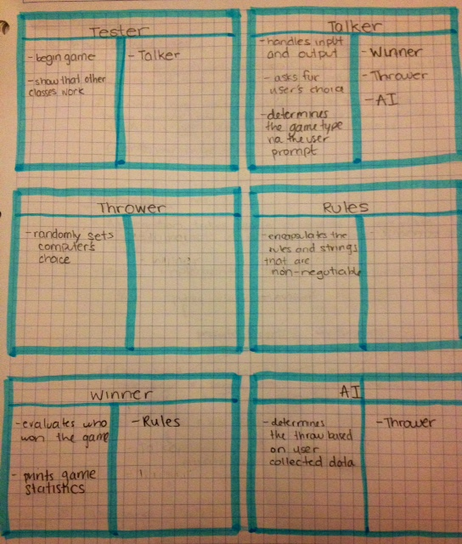

1. (10 points) UML for the programming part:

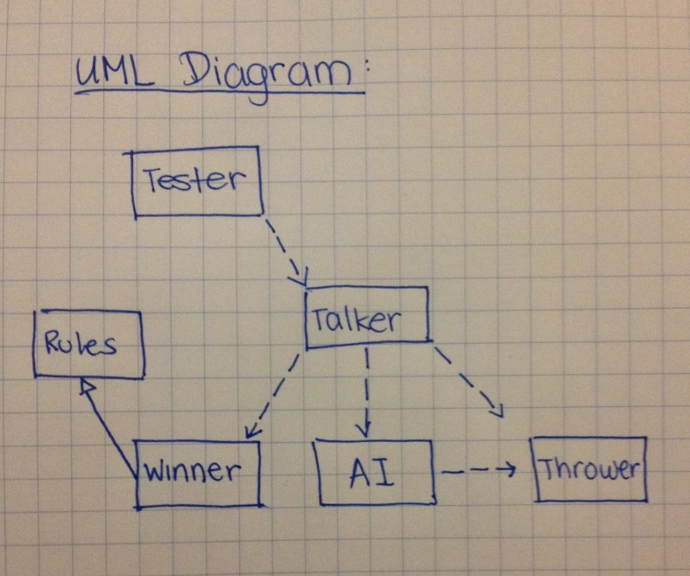

1. http://stackoverflow.com/questions/875512/what-are-the-disadvantages-of-aspect-oriented-programming-aop
2. http://msdn.microsoft.com/en-us/library/c2thcsx4(v=vs.110).aspx
3. http://www.javaworld.com/article/2077562/core-java/java-tip-61--cut--copy--and-paste-in-java.html
4. http://en.wikipedia.org/wiki/Elliott_803
5. http://en.wikipedia.org/wiki/Power_of_two#Computer_science