**Analyzing the accidents in Bengaluru**

**Introduction**

There are a lot of vehicles driving on the roadway every day in India, and traffic accidents could happen at any time anywhere. Some accident involves fatality, means people die in that accident. There are many phases included in, human population, vehicle population(motorcycle, car, lorry)and if it is calculated for total number of accident I the year, recent for the accidents, it provides a comprehensive analysis of report is find out the number of person killed/year and injured for (Grievous/minor) in a road traffic accidents. This project is attempted to analyze the road accident data in Bengaluru based on dataset provided by Intel's Collision Detection System (CDS) or Collision Avoidance System (CAS) sensors installed in buses in 2018.

Before further deep dive, it is important to understand the types of alarms captured by CDS or CAS. More details are available here.

**Details about the Data**

Device Code: Unique device code for the CAS installed in the vehicles

Latitude: Latitude of the location where the collision warning was generated

Longitude: Longitude of the location where the collision warning was generated

Ward Name: Bangalore ward in which this location details latitude and longitude falls under

Type of Alarm: The type of collision alert generated by the collision avoidance system

Recorded Date and Time: Date and time at which the alert was generated

Speed: Speed of the vehicle at the time when the collision alert was generated. Values of all the speed are in km/hr.

**Collision Detection System Alarm types**

FORWARD COLLISION WARNINGS (FCW)

A FCW alerts drivers of an imminent rear-end collision with a car, truck, or motorcycle.

URBAN FORWARD COLLISION WARNINGS (UFCW)

UFCW provides an alert before a possible low-speed collision with the vehicle in front, thus assisting the driver at a low speed in densely heavy traffic. This is usually applicable when driving under approx 30 kmph.

HEADWAY MONITORING WARNING (HMW)

The headway monitoring warning (HMW) helps drivers maintain a safe following distance from the vehicle ahead of them by providing visual and audible alerts if the distance becomes unsafe. Active above 30 kmph, this sensor generates alarm and displays the amount of time, in seconds, to the vehicle in front when that time becomes 2.5 seconds or less.

LANE DEPARTURE WARNINGS (LDW)

The LDW provides an alert when the vehicle unintentionally departs from the driving lane without using the turn signals. If the turn signals are used when changing lanes, an alert is not generated. Usually active above 55 kmph, LDW might not work well if lanes are unmarked or poorly marked.

This is further classified into: (a) LDWL, for lane departures towards left lane and (b) LDWR, for the same towards right lane.

PEDESTRIANS AND CYCLIST DETECTION AND COLLISION WARNING (PCW)

The PCW notifies the driver of a pedestrian or cyclist in the danger zone and alerts drivers of an imminent collision with a pedestrian or cyclist. PCW works well when vehicle is below 50 kmph.

OVERSPEEDING

Detects and classifies various visible speed limit signs and provides visual indication when the vehicle’s speed exceeds the posted speed limit

**Data Analysis**

**Dataset Generation:**

The dataset for this project is generated based on available datasets for traffic analysis. The dataset is created for a different location in Bangalore like Kadugodi, Garudachar Playa,

Hudi with various types like Overspeed, UFCW, HMW. For easy understanding. The dataset will be given in the form of a .csv file.

**Feature Identification:**

The necessary features for the project are to be identified like device location, latitude, longitude, speed, time and date etc. The features which are associated with the project

are identified for the dataset by using which the analysis could be easily performed.

**Feature Extraction:**

Feature extraction will in general make use of the dimensionality reduction procedure to reduce and consider only those necessary attributes necessary for the project like time, speed, location between the locations

**Machine Learning Algorithm used for Analysis:**

The Machine learning algorithm that is used for the traffic analysis help in classifying

whether the accident rate is in a area based on the location that has been loaded to the algorithm.

**Verification:**

The Verification step will check whether the analysis done on the dataset is proper or not. This means that the analysis step is giving the proper result or not.

Conclusion

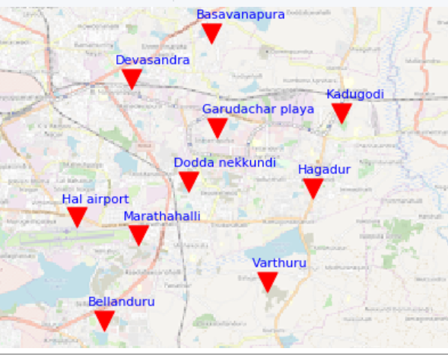

From the above analysis , the top most accidents prone zone are concluded as given in above chart