**DevOps**

**Day 1**

**Activity 1: Standing up tools using AWS Cloud Formation service**

Table of Contents

Table of Contents 2

Activity: Standing up tools using Cloud Formation service - AWS 3

Create stack 4

Observing Servers 5

Observing Tools 7

Troubleshooting 8

Activity: Standing up tools using Cloud Formation service - AWS

The list of steps to be performed in this activity is given below:

|  | **Task Description** | **Target Date for Completion** | **Supporting Documents/Personnel** |
| --- | --- | --- | --- |
|  | Stack creation | Day 1 | Faculty, Participants |
|  | Observing servers | Day 1 | Faculty, Participants |
|  | Observing Tools | Day 1 | Faculty, Participants |

**Activity Duration:** 30 minutes

**Activity Description:**

Activity Type: Individual

Purpose: In this module we will use Amazon Web Services (AWS) to stand up an initial set of tools and environments required for this training course.

This action will be done using a single, re-usable, pre-written template, created for the Amazon Cloud Formation resources provisioning service.

**Technical Overview:** In this activity, you will create stack and observe servers, tool available on it.

**Activity Inputs/Templates:** adop-doa-materials-master.zip (Faculty will share the same).

**Activity Instructions:**

Create stack

Follow the below steps to create a stack

1. Login to AWS portal using the below mentioned URL & AWS credentials

|  |  |
| --- | --- |
| **AWS Login Page** | **https://agile-techpractices.signin.aws.amazon.com/console** |
| **AWS Account Login** | **DevOpsUser** |
| **Password** | **<Will be provided by faculty>** |

1. In the top-right corner, change the region to **EU (Ireland)**
2. From the list of AWS services, click on **CloudFormation** under "Management Tools" (Hit CTRL+F to search for CloudFormation if you can't see it)
3. Click on the **Create Stack** button at top right corner by selecting the option **“with new resources (standard)”**
4. On the *Prerequisite – Prepare template page go to Specify template section*:
   * + 1. Click/Check on “Upload a template file” radio button and click “Choose File” button.

2. Navigate to **adop-doa-materials/Standing_Up_Tools** folder.

3. Select the file "doa_stack.json" and click "Open"

4. Click: "Next"

1. On the *Specify Stack Details* page:

1. In Stack name section, enter your stack name in the format of

LocationNameDate – Eg: “**CDCJohn25Apr**”

2. Provide value for ***AdopUsername*** as “**training**” and ***AdopUserPassword*** as “**accenture123**”

**Note:** Please remember your stack name which you will be using in future.

**Key Name: select** devops_key from drop down control

1. On the *Options* page:

1. Under tags, you can provide your own key-value pairs if you would like to identify your stack resources. CloudFormation will also create its own tags for the stack that can be referred to.

2. Create a tag with the following values:  
 Key: **Created by**

Value: **<YOURNAME>**

3. Click: “Next”

1. On the *Review* page:

1. Here you can review the template details, estimate the cost of your infrastructure, review stack parameters and the tags you have provided

2. Click: “Create”

1. Give it some time (**Maximum 30 minutes**) and watch the Events tab on the CloudFormation console as it goes to work setting up our infrastructure.
2. You should get a message **CREATE_COMPLETE** as the status of the stack.

Observing Servers

1. Cloud Formation scripts produce outputs after the stack has been created successfully
2. From AWS console, select EC2 service to watch the running instances of the created stack.

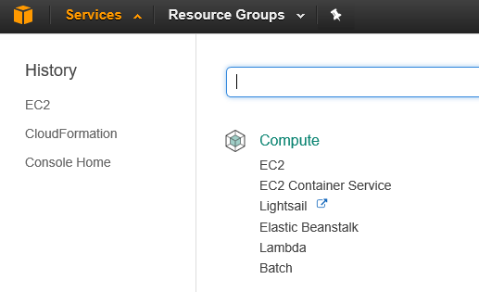

1. Search for your instance by typing your stack name and check details of the instance.

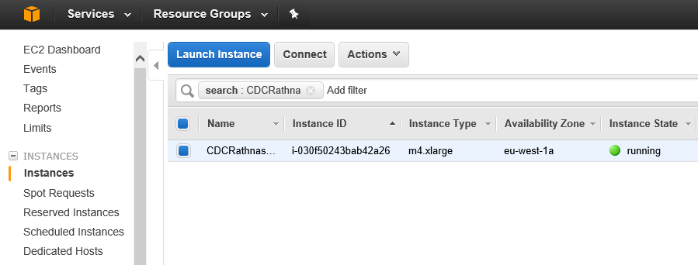

Observing Tools

1. Tick the checkbox to select the stack which you have created.
2. Clicking on the "Outputs" tab which will provide you with the EC2 instance created
3. Note the public IP of your instance as highlighted below.

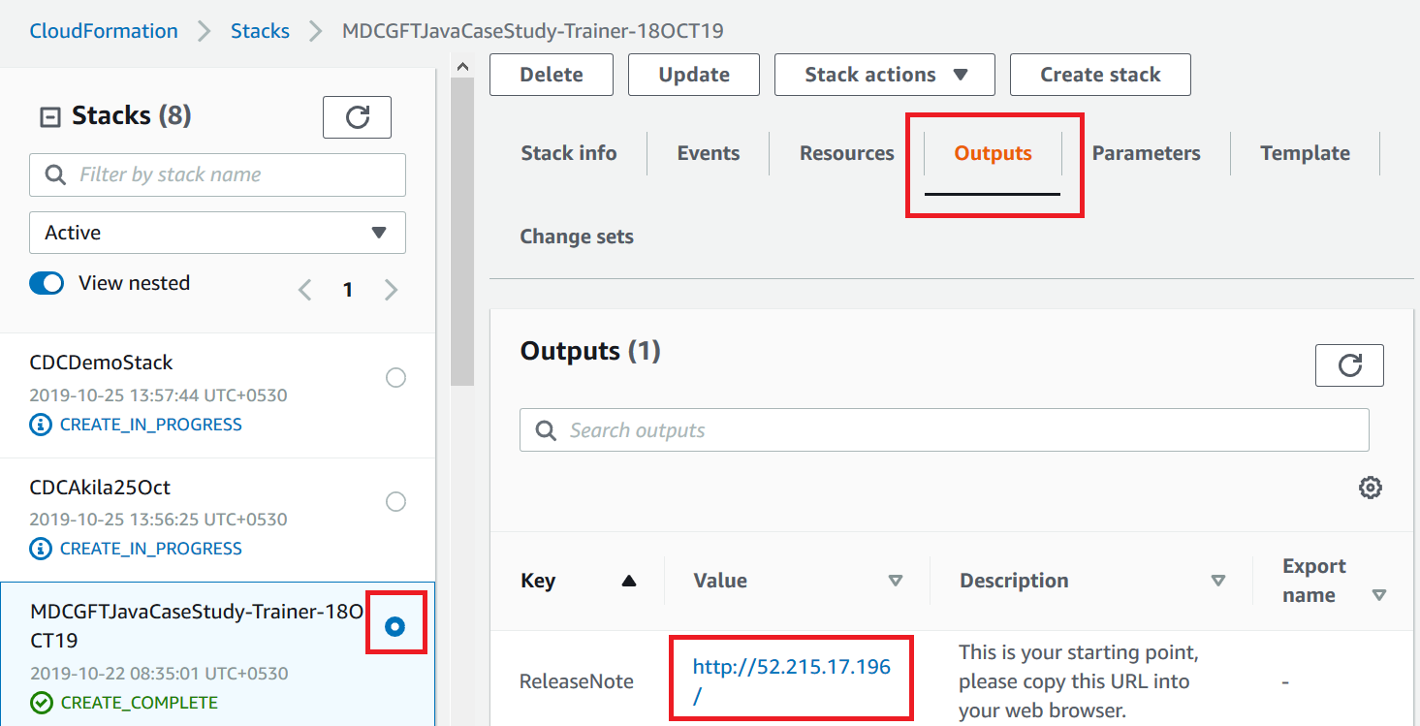

1. Click on the public IP address provided under output tab of your stack to open ADOP home page
2. Provide username(**training**) and password(**accenture123**) you entered while creating the stack.
3. Click on Jenkins link to observe Jenkins tool
4. Click on Gerrit link to observe Git and Gerrit
5. Click on SonarQube link to observe Sonar tool
6. Browse around as shown below but don’t change any configuration

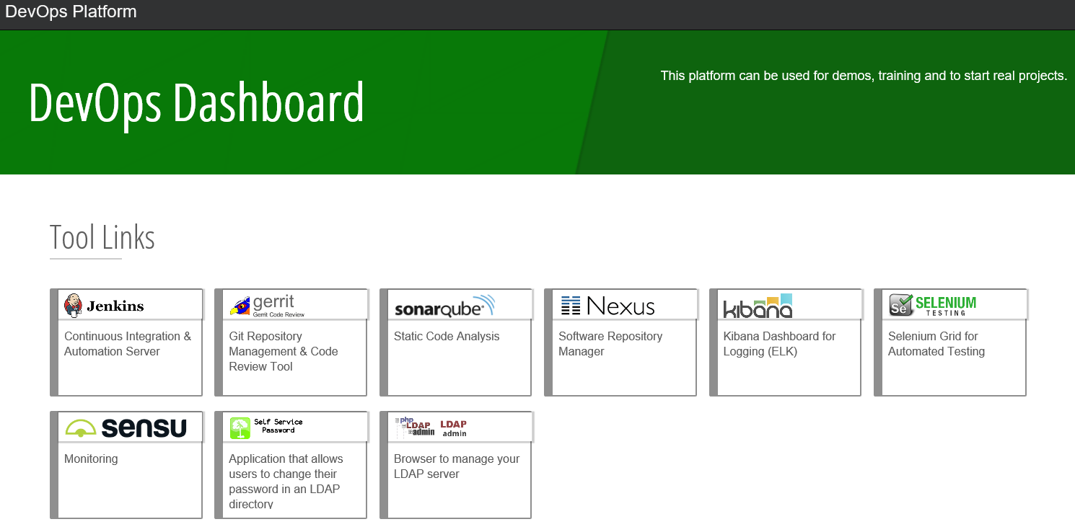

Troubleshooting

1. If an error occurs while creating the stack, then check the availability zone on top right corner of AWS page. (It must be EU Ireland zone).