**DevOps**

**Day 1**

**Activity 2: SCM Applied**

Table of Contents

Table of Contents 2

Activity: SCM Applied 3

Installation of Git 4

Create project in Gerrit 4

Create Branch 5

Populating a repository 6

Troubleshooting 7

Activity: SCM Applied

The list of steps to be performed in this activity is given below:

|  | **Task Description** | **Target Date for Completion** | **Supporting Documents/Personnel** |
| --- | --- | --- | --- |
|  | Installation of Git | Day 1 | Faculty, Participants |
|  | Create project in Gerrit | Day 1 | Faculty, Participants |
|  | Create Branch | Day 1 | Faculty, Participants |
|  | Populating a repository | Day 1 | Faculty, Participants |

**Activity Duration:** 45 minutes

**Activity Description:**

Activity Type: Individual

Purpose: In this module, the activity aims in providing an introduction to SCM tools like Git and Gerrit. Git is a version control system and repository to maintain the code and its versions. Gerrit is a code review tool and can be integrated with CI pipeline

**Technical Overview:** In this activity, you will create project and populate project with contents in the repository.

**Activity Inputs/Templates:** adop-doa-materials-master.zip (Faculty will share the same).

**Activity Instructions:**

Installation of Git

Follow the below steps to install Git if Git is already not installed in your laptop/desktop.

1. Download Git from the below URL

<https://git-for-windows.github.io/>

1. Start installation
   1. Select “Git bash” and “Git GUI”
   2. Select “Use Git from windows command prompt”
   3. Keep remaining options as default and click **Install** button.
2. If Git installation is completed successfully, then follow these steps.
   1. Navigate to All Programs
   2. Click on Git and select Git Bash

Create project in Gerrit

1. Navigate to your Gerrit server by typing <http://public-ip/gerrit/> URL or this link is available from ADOP home page also.
2. Click 'Sign in' in the top right corner of the screen



1. Sign in using the Username (**training**) / Password (**accenture123**) you specified in previous activity
2. Click "**Projects**" and then click “**List”** to browseavailable projects
3. Click "**Projects**" and then click "**Create New Project** “
4. Type in the project name, for example **ExampleProject** in the "Project Name" field
5. Type "**All-Projects**" in the "**Rights Inherit From:**" field
6. Check on the "**Create initial empty commit**" checkbox
7. Click "**Create Project**"

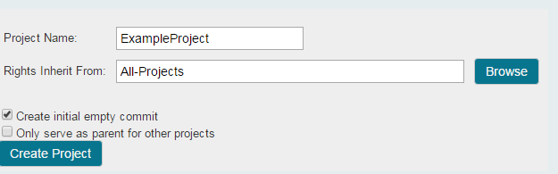

Create Branch

1. Click on the "**Projects**" link
2. Click on the "**List**" link
3. Click the **ExampleProject**that you created earlier
4. Click on **Branches**
5. Type "*develop*" in the Branch Name field*.*
6. Copy the SHA Hash for "**master**" and paste it into the "**Initial Revision**" field
7. Click "**Create Branch** “

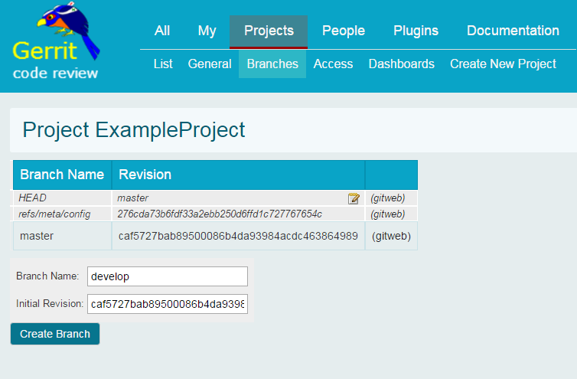

Populating a repository

1. Clone the empty sample project you created in the previous step by using “git clone command”. Clone command can be found in Gerrit on the top of project

git clone <http://username@public-IP/gerrit/ExampleProject>

*Example:*

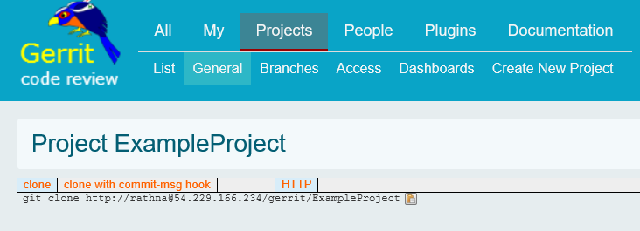

1. Navigate to Git bash on your workstation and make sure that you have changed the directory to the right directory where you want to clone your project and execute the git clone command.
   1. cd /c/Data/DevOpsAcademy
   2. git clone <http://username@public-IP/gerrit/ExampleProject>
2. Change to your Gerrit repository directory

cd ExampleProject

1. Initially, you will be on the master branch. Switch to the develop branch.

$ git checkout develop

1. Copy the contents of the "Sample_Source_Code" (provided within adop-doa-materials - *Lab_Modules/Module_2*) folder into the "ExampleProject" folder manually without using Git command.
2. After copying content, navigate to git bash and execute the below commands
   1. git add .
   2. git status
   3. git commit -m "Adding sample project contents "
   4. git push --set-upstream origin develop
   5. git checkout master
   6. git merge develop
   7. git push

***Note: Enter password as “accenture123” while pushing your code into repository.***

Troubleshooting

1. Pushing the changes gives merge issue (conflicit – when more than one developer tries to push their changes), follow the below steps to recover the issue
   1. Type git pull
   2. Open the file and check what is the issue
   3. Correct the file and follow the sequence of command execution like add, commit and push