CHAPTER 1
INTRODUCTION
The project “ONLINE VOTING SYSTEM” is designed using Microsoft ASP.Net as front end and MS-SQL Server 2000 as back end. The coding language used is VB.Net. The dotnet framework used is 2.0

Traditional voting systems should be computerized to reduce the vote counting time, to provide evidence that a vote is being correctly accounted, to reduce fraud, remove errors in filling out ballots, to improve system usability for people with special needs.

E-voting increasingly replacing traditional paper based systems. This raises several security issues, given that democratic principles depend on the electoral process’s integrity. An electronic voting system must ensure the voter’s authenticity, anonymity. It must also ensure audit ability in a software or hardware environment that could malfunction.

In this System the fingerprints of all voters and details are stored before the election. The voters have to register their fingerprints on the day of election through online; this will be compared with the already stored prints. If both matches their votes will be taken in to the account and if not their vote will be discarded.

So No one can vote for others this will reduce the illegal votes. User can view all the nominees in their district with their corresponding party symbols. They can also view how many votes are registered before they are going to register their votes, this may be useful to know the leading result.
CHAPTER 2
LITERATURE REVIEW
2.1 EXISITING SYSYTEM

- Security involving communications and networks is not as simple as it might first appear to the novice. The requirements for security services a can be given self-explanatory one word labels: confidentiality, authentication, no repudiation, integrity. But the mechanisms used to meet those requirements can be quite complex and understanding them may involve rather subtle reasoning.
- In developing a particular security mechanism or algorithm one must always consider potential countermeasures. In many cases, countermeasures are designed by looking at the problem in a completely different way.
- Because of point 2, the procedures used to provide particular services are often counterintuitive: It is not obvious form the statement of a particular requirement that such elaborate measures are needed. It is only when the various countermeasures are considered that the measures used make sense.
- Having designed various security mechanisms, it is necessary to decide where to use them. This is true both in terms of physical placement and in a logical sense.
- Security mechanisms usually involve more than a particular algorithm or protocol. They usually also require that participants be in possession of some secret information (e.g. an encryption key), which raises questions about the creation, distribution, and protection of that secret information. There is also a reliance on communications protocols whose behaviors may complicate the task of developing the security mechanism. For example, if the proper functioning of the security mechanism requires setting time limits of the transit time of a message form sender to receiver, they may protocol or networks security service and mechanism can be seemed.

2.2 DRAWBACKS OF EXISTING SYSTEM

No security measures are provided in the existing voting system and manual database is not more effective. Voter has come to their native place to vote. Centralized data base is not available in existing system.

2.3 PROPOSED SYSTEM

The project is to implement the electronic voting system using finger print image authentication. In this, fingerprint will be used for substantiation and to monitor the presence of a person. There will be a central data repository with all finger print scan where mapping will be made for verification to vote for the particular ID number.

2.4. ADVANTAGES OF PROPOSED SYSTEM:
Fingerprints are processed through the image data comparison system. The fingerprints are submitted by uploading and converted as byte array which is checked with voter finger print image already present in the database.

- The security is more in the proposed system.
- Remote voting is possible and so military people or government officials can easily access the system.
- Consolidated reports are viewed whenever required.
- Easy to use options are provided in the web page and giving input is fast.

CHAPTER 3
SOFTWARE AND HARDWARE SPECIFICATION

31.3.1 HARDWARE SPECIFICATION

This section gives the details and specification of the hardware on which the system is expected to work,

Processor : Pentium IV 1.7 GHz
Hard Disk Capacity : 80 GB
RAM : 1 GB
Monitor : 15’’ Color
Keyboard : 102 keys
Mouse : 3 buttons

1.3.2 SOFTWARE SPECIFICATION

This section gives the details of the software that are used for the development,

Environment : Visual Studio .Net 2005
Front-End : ASP.Net
Back-End : MS SQL Server 2000
Operating System : Windows XP SP2
Browser : Internet Explorer 6.0

3.3 SOFTWARE DESCRIPTION

3.3.1 THE MICROSOFT .NET FRAMEWORK

The .NET Framework is the infrastructure for the Microsoft .NET platform.
The .NET Framework is an environment for building, deploying, and running Web applications and Web Services. Microsoft's first server technology ASP (Active Server Pages), was a powerful and flexible "programming language". But it was too code oriented. It was not an application framework and not an enterprise development tool. The Microsoft .NET Framework was developed to solve this problem.

.NET Framework advantages:
- Easier and quicker programming
- Reduced amount of code
- Declarative programming model
- Richer server control hierarchy with events
- Larger class library
- Better support for development tools

The .NET Framework consists of 3 main parts:
Programming languages:
- C# (Pronounced C sharp)
- Visual Basic (VB .NET)
- J# (Pronounced J sharp)
Server technologies and client technologies:
- ASP .NET (Active Server Pages)
- Windows Forms (Windows desktop solutions)
- Compact Framework (PDA / Mobile solutions)
Development environments:
- Visual Studio .NET (VS .NET)
- Visual Web Developer

3.3.2 ASP.NET

ASP.NET is a web application framework developed and marketed by Microsoft to allow programmers to build dynamic web sites, web applications and web services. It was first released in January 2002 with version 1.0 of the .NET Framework, and is the successor to Microsoft's Active Server Pages (ASP) technology. ASP.NET is built on the Common Language Runtime (CLR), allowing programmers to write ASP.NET code using any supported .NET language. The ASP.NET SOAP extension framework allows ASP.NET components to process SOAP messages.

3.3.2.1 Characteristics

Pages
.NET pages, known officially as "web forms", are the main building block for application development. Web forms are contained in files with an ".aspx" extension; these files typically contain static (X)HTML markup, as well as markup defining server-side Web Controls and User Controls where the developers place all the required static and dynamic content for the web page.

Code-behind model
Microsoft recommends dealing with dynamic program code by using the code-behind model, which places this code in a separate file or in a specially designated script tag. Code-behind files typically have names like MyPage.aspx.cs or MyPage.aspx.vb while the page file is MyPage.aspx (same filename as the page file (ASPX), but with the final extension denoting the page language).

3.3.2.2 Controls

User controls
An event bubbling mechanism provides the ability to pass an event fired by a user control up to its containing page.

Custom Controls
Programmers can also build Custom controls for ASP.NET applications. Unlike User controls, these controls don't have an ASCX markup-file, having all their code compiled into a DLL-file. Such Custom controls can be used across multiple web-applications and Visual Studio projects (which is not allowed with User controls). By using a Register directive, the control is loaded from the DLL.

3.3.2.3 State Management

ASP.NET applications are hosted by a web server and are accessed using the stateless HTTP protocol. As such, if an application uses stateful interaction, it has to implement state management on its own. ASP.NET provides various functions for state management. Conceptually, Microsoft treats "state" as GUI state; problems may arise if an application needs to keep track of "data state", for example, a finite state machine which may be in a transient state between requests (lazy evaluation) or which takes a long time to initialize.

Application State

Application state is held by a collection of shared user-defined variables. These are set and initialized when the Application_OnStart event fires on the loading of the first instance of the applications and are available till the last instance exits. Application state variables are accessed using the Applications collection, which provides a wrapper for the application state variables. Application state variables are identified by name.

Session State

Server-side session state is held by a collection of user-defined session variables, which are persisted during a user session. These variables, accessed using the Session collection, are unique to each session instance. Then variables can be set to be automatically destroyed after a defined time of inactivity, even if the session does not end. Client-side user session is maintained by either a cookie or by encoding the session ID in the URL itself.
ASP.NET supports three modes of persistence for session variables:
In Process Mode, ASPState Mode, SqlServer Mode

View State

View state refers to the page-level state management mechanism, utilized by the HTML pages emitted by ASP.NET applications to maintain the state of the web form controls and widgets. The state of the controls is encoded and sent to the server at every form submission in a hidden field known as __VIEWSTATE. The server sends back the variable so that when the page is re-rendered, the controls render at their last state. At the server side, the application may change the viewstate, if the processing requires a change of state of any control. The states of individual controls are decoded at the server, and are available for use in ASP.NET pages using the ViewState collection.

The main use for this is to preserve form information across postbacks. View state is turned on by default and normally serializes the data in every control on the page regardless of whether it is actually used during a postback. This behavior can (and should be) modified, however, as View state can be disabled on a per-control, per-page, or server-wide basis.

Server-side Caching

ASP.NET offers a "Cache" object that is shared across the application and can also be used to store various objects. The "Cache" object holds the data only for a specified amount of time and is automatically cleaned after the session time-limit elapses.Other means of state management that are supported by ASP.NET are cookies, caching, and using the query string.

3.3.2.4 Template engine

When first released, ASP.NET lacked a template engine. Because the .NET framework is object-oriented and allows for inheritance, many developers would define a new base class that inherits from "System.Web.UI.Page", write methods here that render HTML, and then make the pages in their application inherit from this new class. While this allows for common elements to be reused across a site, it adds complexity and mixes source code with markup. Furthermore, this method can only be visually tested by running the application - not while designing it. Other developers have used include files and other tricks to avoid having to implement the same navigation and other elements in every page.

3.3.2.5 File Extensions Supported by ASP.NET
Table 3.1 File extensions supported by ASP.NET
Extension | Required version | Description
Asax | 1.0 | Global.asax, used for application-level logic
Ascx | 1.0 | Web UserControls: custom controls to be placed onto web

Table 3.1(continued)
Dbml | 3.5 | LINQ to SQL data classes file
Master | 2.0 | master page file. Default file name is Master1.master
Resx | 1.0 | resource files for internationalization and localization. Resource files can be global (e.g. messages) or "local" which means specific for a single aspx or ascx file.
Sitemap | 2.0 | sitemap configuration files. Default file name is web.sitemap
Skin | 2.0 | theme skin files.
Svc | 3.0 | Windows Communication Foundation service file
Edmx | 3.5 | ADO.NET Entity Framework model
Dbml | 3.5 | LINQ to SQL data classes file
Master | 2.0 | master page file. Default file name is Master1.master
Resx | 1.0 | resource files for internationalization and localization. Resource files can be global (e.g. messages) or "local" which means specific for a single aspx or ascx file.
Sitemap | 2.0 | sitemap configuration files. Default file name is web.sitemap
Skin | 2.0 | theme skin files.
Svc | 3.0 | Windows Communication Foundation service file
Edmx | 3.5 | ADO.NET Entity Framework model

3.3.3 C SHARP
Keywords

Keywords are predefined, reserved identifiers that have special meanings to the compiler. They cannot be used as identifiers in your program unless they include @ as a prefix. For example, @if is a valid identifier but if is not because if is a keyword. The following table lists keywords that are reserved identifiers in any part of a C# program.
Table 3.2 Keywords
abstract | const | extern | int | out | short | typeof
as | continue | false | interface | override | sizeof | uint
base | decimal | finally | internal | params | stackalloc | ulong
bool | default | fixed | is | private | static | unchecked
break | delegate | float | lock | protected | string | unsafe
byte | do | for | long | public | struct | ushort
case | double | foreach | namespace | readonly | switch | using
catch | else | goto | new | ref | this | virtual
char | enum | if | null | return | throw | volatile
checked | event | implicit | object | sbyte | true | void
class | explicit | in | operator | sealed | try | while

Contextual Keywords

A contextual keyword is used to provide a specific meaning in the code, but sit is not a reserved word in C#. Some contextual keywords, such as partial and where, have special meanings in two or more contexts. The following Table 3.3 lists the Contextual Keywords.
Table 3.3 Contextual Keywords
add | from | get
global | group | into
join | let | orderby
partial (type) | partial (method) | remove

Operators

C# provides a large set of operators, which are symbols that specify which operations to perform in an expression. Many operators can be overloaded by the user, thus changing their meaning when applied to a user-defined type. The following Table 3.4 lists the C# operators grouped in order of precedence. Operators within each group have equal precedence.
Table 3.4 Operators
Operator category | Operators
Primary | x.y, f(x), a[x], x++, x--, new, typeof, checked, unchecked,->
Unary | +, -, !, ~, ++x, --x, (T)x, true, false, &, sizeof
Multiplicative | *, / ,%
Additive | +, -
Shift | <<, >>
Relational and type testing | <, >, <=, >=, is, as
Equality | ==, !=
Logical AND | &
Logical XOR | ^
Logical OR | |
Conditional AND | &&
Conditional OR | ||
Conditional | ?:
Assignment | =, +=, -=, *=, /=, %=, &=, |=, ^=, <<=, >>=
Null-coalescing | ??
Lambda | => Operator (C# Reference)

Arithmetic Overflow

The arithmetic operators (+, -, *, /) can produce results that are outside the range of possible values for the numeric type involved. You should refer to the section on a particular operator for details, but in general:
- Integer arithmetic overflow either throws an OverflowException or discards the most significant bits of the result. Integer division by zero always throws aDivideByZeroException.
- Floating-point arithmetic overflow or division by zero never throws an exception, because floating-point types are based on IEEE 754 and so have provisions for representing infinity and NaN (Not a Number).
- Decimal arithmetic overflow always throws an OverflowException. Decimal division by zero always throws a DivideByZeroException.
When integer overflow occurs, what happens depends on the execution context, which can be checked or unchecked. In a checked context, an OverflowException is thrown. In an unchecked context, the most significant bits of the result are discarded and execution continues. Thus, C# gives you the choice of handling or ignoring overflow.

C# Preprocessor Directives

The following are the C# language's preprocessor directives:
#if #else #elif #endif #define
#undef #warning #error #line #region
#endregion #pragma #pragma warning #pragma checksum
While the compiler does not have a separate preprocessor, the directives described in this section are processed as if there was one; these directives are used to aid in conditional compilation. Unlike C and C++ directives, you cannot use these directives to create macros.

C# Language Features

The following are the features:
- Arrays
- Constructors and Destructors
- Indexers
- Main
- Properties
- Passing Parameters
- XML Documentation

SQL SERVER 2000

SQL Server 2000 (codenamed Yukon), released in October 2000, is the successor to SQL. It included native support for managing XML data, in addition to relational data. For this purpose, it defined an xml data type that could be used either as a data type in database columns or as literals in queries. XML columns can be associated with XSD schemas; XML data being stored is verified against the schema. XML is converted to an internal binary data type before being stored in the database. Specialized indexing methods were made available for XML data. XML data is queried using XQuery; SQL Server 2005 added some extensions to the T-SQL language to allow embedding XQuery queries in T-SQL. In addition, it also defines a new extension to XQuery, called XML DML, that allows query-based modifications to XML data. SQL Server 2000 also allows a database server to be exposed over web services using TDS packets encapsulated within SOAP (protocol) requests. When the data is accessed over web services, results are returned as XML.

For relational data, T-SQL has been augmented with error handling features (try/catch) and support for recursive queries (Common Table Expressions). SQL Server 2005 has also been enhanced with new indexing algorithms and better error recovery systems. Data pages are check summed for better error resiliency, and optimistic concurrency support has been added for better performance. Permissions and access control have been made more granular and the query processor handles concurrent execution of queries in a more efficient way. Partitions on tables and indexes are supported natively, so scaling out a database onto a cluster is easier. SQL CLR was introduced with SQL Server 2005 to let it integrate with the .NET Framework.

SQL Server 2000 introduced "MARS" (Multiple Active Results Sets), a method of allowing usage of database connections for multiple purposes

SERVICES

SQL Server also includes an assortment of add-on services. While these are not essential for the operation of the database system, they provide value added services on top of the core database management system. These services either run as a part of some SQL Server component or out-of-process as Windows Service and presents their own API to control and interact with them.

SERVICE BROKER

The Service Broker, which runs as a part of the database engine, provides a reliable messaging and message queuing platform for SQL Server applications. Used inside an instance, it is used to provide an asynchronous programming environment. For cross instance applications, Service Broker communicates over TCP/IP and allows the different components to be synchronized together, via exchange of messages

REPLICATION SERVICES

SQL Server Replication Services are used by SQL Server to replicate and synchronize database objects, either in entirety or a subset of the objects present, across replication agents, which might be other database servers across the network, or database caches on the client side. Replication follows a publisher/subscriber model, i.e., the changes are sent out by one database server ("publisher") and are received by others ("subscribers"). SQL Server supports three different types of replication.

- Maintaining relationships between the data in the database
- Ensuring that data is stored correctly, and that the rules defining data relationships are not violated.
Recovering all data to appoint of known consistency in case of system failur

CHAPTER 4
PROJECT DESCRIPTION
4.1 PROBLEM DESCRIPTION

In listening to the problems here there is various problems faced by each and every citizen in the country. The major problem is that there is not a single unique identity/card for all propose for the government departments which are used by the citizens. So there is a multiplicity in card (different cards for different department). So the citizen is suffered to take correct card for a right department. So there is a missing of card is possible. So we are disused to use a unique id/card for all purpose for those activities like id, verification and proofs.

We not yet find a good security in this existing one because there is a theft in major time. We can’t maintain these logs for maximum time and we should enter these records later. We should also keep these record safely by avoid accident like fire and natural disasters.

There is missing of records are possible in keeping these record in a paper format. But when we are in a electronic records (E-records) we can be keep safely by maintaining it by the server and back backups we need to keep and we can store Hard disks and other storage areas.

Thus we are going to make a good advanced technology of having these records in electronic formats. It gives us very big advantages we ever seen before. Thus we are maintaining a good record for a long period and it could not be easily destroy by any natural disasters and accident.Therefore backups are there as well as data is located in different servers,which are placed at different locations of country.
These are problems facing on the existing system that we can solve by this electronic proposed system.

4.2 MODULE DESCRIPTION

This project helps to maintain the details of the Candidates, Voters details, Votes and zone details in full fledged security. Unauthorized persons cannot access the data. In voter creation, usually voter will be given a password. But in this web site, the password as well as finger print image is given. The image will be converted in to byte array and saved in database.

The proposed system has the facility with uploading the finger print image of voters during voting process and security is better than the earlier system.

This project succeeds the voting process problems especially when the voters are out of their zone such as military people. This web application contains the following modules,

        - Admin Module
        - Party Module
        - Zone Module
        - Candidate Module
        - Voter Module
        - Voting Module
        - Report Module

Administrator Login

This is a module used by the admin to enter into the modules. The Admin enters into the project by giving their username and password.

Party Addition

The administrator adds new party details such as party id and name. If the party name is already exists then it wont be added. In addition, all the party names are displayed below in a grid so that the administrator may not enter duplicate names.

Zone Addition

The administrator adds new zone details such as zone id and name. If the party zone is already exists then it wont be added. In addition, all the zone names are displayed below in a grid so that the administrator may not enter duplicate names.

Candidate Addition

The administrator adds new candidate details such as Candidate id, name, address, phone, gender, age, finger print image, number of attempts and income. If the candidate is already exists then it wont be added. In addition, all the candidate names are displayed below in a grid.

Candidate/Zone Allotment

The administrator adds zone details for each Candidate using this module. The zone id, candidate id and party id are selected. In addition, all the details are displayed below in a grid.

Election Date Fixing

The administrator adds election date using this module. In addition, all the previous election dates are displayed below in a grid.

Voter Addition

The administrator adds new voter details such as voter id, name, address, phone, gender, age, father name, mother name, occupation, finger print image and income. If the voter is already exists then it cannot be added. In addition, all the voter names are displayed below in a grid.

View Result

The administrator view the vote count got by all candidates in the election. The grid view control is provided with allow paging and allow sorting option so ten records per page can be viewed and any column can be sorted and displayed.

Voter Login

Through this module, the voter logins using voter id and password.
View Parties

The voter views all the party names using this module.

View Candidates

The voter views all candidates details such as name, zone which he belongs, the address and other details using the grid view control.

View Zones

The voter views all zone details such as id and name using the grid view control.
Make Vote

The voter makes vote using this module. During the vote entry, the voter uploads the finger print image and selects the party id and name. If the vote is already made then an error message is displayed.

View Result

The voters view the vote count got by all candidates in the election. The grid view control is provided with allow paging and allow sorting option so ten records per page can be viewed and any column can be sorted and displayed.

Reports

Both the administrator and voters view reports such as parties, zones, candidates list, and result status using grid view controls.

SYSTEM FLOW DIAGRAM

.
ONLINE VOTING
Administrator Login
Voter Login
Zone Creation
Party Creation
Candidate Creation
Candidate / Zone
Allotment
Election Date Fixing
Voter Creation
View Result
Change Password
Sign Out
View Parties
Make Vote
View Zones
View
Candidates / Zone
View Election Date
View Result
Change Password
Sign Out

3.2 DATA FLOW DIAGRAM

Admin
Election Date
Votes Made
Admin Login
Party
Creation
Zone
Creation
Candidate
Creation
Parties
Zone Details
Candidate list
Election Date
Fixing
View Result
Votes Count
Voter
Creation
Voters List
Zone Details
Candidate
Zone
Allotment
Candidate Zone Details

LEVEL - 1

Voter Login
View Parties
View Zones
View Candidates
Make Vote
View Result
View
Election
Date
Parties
Voters List
Zones
Candidates list
Votes Made
Votes Count
Candidate Zone Details
Election Date
CHAPTER 5
TESTING
Testing is an integral part of any system development life cycle. Insufficient and untested applications may trend to crash and result in loss of economic and manpower investment besides user’s dissatisfaction and downfall of reputation. Software testing can be looked upon as one among the many process, an organization performs, and that provides the last opportunity to correct any flaws in the developed system. Software testing includes selecting test data that have more probability of giving errors.

The first step in system testing is to develop a plan that tests all aspects of the system. Completeness, correctness, reliability and maintainability of the software are to be tested for the best quality assurance that the system meets the specification and requirements for its intended use and performance. System testing is the most useful practical process of executing a program with the implicit intention of finding errors that make the program fails. System testing is done in three phases
- Unit testing
- Integration testing
- System testing

5.1 SYSTEM TESTING

After the source code has been completed, documented as related data structures. Completion of the project has to undergo testing and validation where there is subtitle and definite attempt to get errors. The project developer treats lightly, designing and execution of the project test that will demonstrates that the program works rather than uncovering errors, unfortunately errors will be present and if the project developer doesn’t found errors, the user will find out.

The project developer is always responsible for testing the individual units i.e. modules of the program. In many cases, developer should conduct the integration testing i.e. the testing step that leads to the construction of the complete program structure.

UNIT TESTING

In unit testing, user has to test the programs making up the system. For this reason, Unit testing sometimes called as Program testing. The software units in a system are the modules and routines that are assembled and integrated to perform a specific function.
In this project, voter details, candidate details could be tested individually like given all the fields and can be updated for all criteria.

INTEGRATION TESTING

Integration testing is a systematic technique for constructing the program structure. While at the same time conducting tests to uncover errors associated with interfacing. The objective is to take unit tested modules and build a program structure that has been dictated by design.
In this integration testing its done using the main module and based on the type of integration testing the subordinate tables and other criteria along with their path, is replaced one at a time with actual modules. In the project, after integrating the all modules, they are tested with their integration and that could integrated and manipulated with respect to the to and fro in between modules.

VALIDATION TESTING

It is said that validation is successful when the software functions in a systematic manner that can be reasonably accepted by the customers. This type of testing is very important because it is the only way to check whether the requirements given by user have been completely fulfilled.
The input given to various forms are validated effectively. The input is given for voter details, candidate and vote details. Each module is tested independently. In this project, username and password is validated successfully before login. Finger print image is uploaded and validated through byte array comparison with database data for vote verification.

4.2 SYSTEM IMPLEMENTATION

When the initial design was done for the system, the client was consulted for the acceptance of the design so that further proceedings of the system development can be carried on the project. After the development of the system a demonstration was given to them about the working system. The aim of the system illustration was to identify any malfunction of the system.
After the management of the system was approved the system implemented in the concern, initially the system was run parallel with existing manual system. The system has been tested with live data and has proved to be error free and user friendly.

Implementation is the process of converting a new or revised system design into an operational one when the initial design was done by the system; a demonstration was given to the end user about the working system. This process is uses to verify and identify any logical mess working of the system by feeding various combinations of test data. After the approval of the system by both end user and administrator the system was implemented.

5. CONCLUSION

The new system eliminates the difficulties in the existing system. It is developed in a user-friendly manner. The system is very fast and any transaction can be viewed or retaken at any level. Error messages are given at each level of input of individual stages. This software is very particular in reducing the work and achieving the accuracy. It will reduce time be avoids redundancy of data.

The user can easily understand the details available from the report. This software will support for the future development.

The software is menu driven. Simplicity and the hallmark of this project.

Very large date can be stored and also can be retrieved very easily.
- Speed and accuracy is maintained in the votes with finger prints.
- Data is entered in formatted manner.
- The report can be taken in any format.
- Modification and maintenance can be made very easily

SCOPE FOR FUTURE ENHANCEMENT

The system is very flexible and user-friendly, so the maintenance based on the changing environment and requirements can be incorporated easily. Any changes that are likely to cause failures are prevented with security and preventive measures could be taken. The coding is done in understandable and flexible method program which helps easy changing.

Since MS-SQL Server and ASP.NET are very flexible tools. User can easily incorporate any modular program in the application.

- It facilitates the user to easily vote by uploading the finger print once.
- Facilities fast data backup and restoration facility in case of data loss situations.
- If the modules are written as web services, then it can be used other web sites also.
TABLE DESIGN
TABLE STRUCTURE
Table : Admin
FIELD NAME | TYPE | SIZE
UserName | Varchar | 15
Password | Varchar | 15

Table : Candidate_ZoneDetails
FIELD NAME | TYPE | SIZE
CandidateID | SmallInt | 2
ZoneID | SmallInt | 2
PartyID | SmallInt | 2
Table : CandidatesList
FIELD NAME | TYPE | SIZE
CandidateID | Int | 4
CandidateName | Varchar | 30
Address | Varchar | --
Phone | Varchar | 20
Gender | Varchar | 6
DOB | Date/Time | 8
FatherName | Varchar | 30
MotherName | Varchar | 30
MaritalStatus | Varchar | 10
Occupation | Varchar | 30
IncomePerMonthRs | Decimal | 19
NumberofAttempt | SmallInt | 2
Table : Elections
FIELD NAME | TYPE | SIZE
SNo | SmallInt | 2
ElectionDate | Date/Time | 8
Table : Parties
FIELD NAME | TYPE | SIZE
PartyID | SmallInt | 2
PartyName | Varchar | 50
TotalCount | Number | 4

Table : Voters_ZoneDetails
FIELD NAME | TYPE | SIZE
VoterID | Int | 4
ZoneID | Int | 4

Table : VotersList
FIELD NAME | TYPE | SIZE
VoterID | Int | 4
VoterName | Varchar | 30
Address | Varchar | --
Phone | Varchar | 20
Gender | Varchar | 6
DOB | Date/Time | 8
FatherName | Varchar | 30
MotherName | Varchar | 30
MaritalStatus | Varchar | 10
Occupation | Varchar | 30
IncomePerMonthRs | Decimal | 19
LastVoteDate | Date/Time | 8
VoteMade | Bit | 1
Password | Varchar | 15
ZoneId | SmallInt | 2

Table : VotesCount
FIELD NAME | TYPE | SIZE
SNo | Number | 4
ZoneID | SmallInt | 2
CandidateId | SmallInt | 2
VoteCount | Int | 4
ElectionDate | Date/Time | 8

Table : VotesMade
FIELD NAME | TYPE | SIZE
SNo | Int | 4
VoterId | Int | 4
ElectionDate | Date/Time | 8
VoteMade | Bit | 1

Table : ZoneDetails
FIELD NAME | TYPE | SIZE
ZoneID | SmallInt | 2
ZoneName | Varchar | 100

APPENDIX 2
ADMINISTRATOR LOGIN

Partial Class adminlogin
Inherits System.Web.UI.Page

Protected Sub Button1_Click(ByVal sender As Object, ByVal e As System.EventArgs) Handles Button1.Click
Dim found As Boolean
Try
If cls.con.State <> Data.ConnectionState.Open Then cls.con.Open()

Dim un As String = TextBox1.Text.Trim.Replace("'", "")
un = un.Replace("--", "")
un = un.Replace(";", "")
Dim ps As String = TextBox2.Text.Trim.Replace("'", "")
ps = ps.Replace("--", "")
ps = ps.Replace(";", "")
cls.cmd.CommandText = "Select Count(*) From Admin Where UserName='" & un & "' and [Password]='" & ps & "'"

If cls.cmd.ExecuteScalar() > 0 Then
Session("username") = un

Session("usertype") = "admin"
found = True
Else
Label1.Text = "Invalid UserName/Password."
End If

down:
Catch ex As Exception
Label1.Text = "Error! " & ex.Message
Finally
If cls.con.State <> Data.ConnectionState.Closed Then cls.con.Close()
End Try

If found Then
Response.Redirect("adminoptions.aspx")
End If
End Sub

Protected Sub Page_Load(ByVal sender As Object, ByVal e As System.EventArgs) Handles Me.Load

End Sub
End Class
ADD PARTY FORM

Partial Class addparty
Inherits System.Web.UI.Page

Protected Sub Button1_Click(ByVal sender As Object, ByVal e As System.EventArgs) Handles Button1.Click
Try
If con.State <> Data.ConnectionState.Open Then con.Open()

cmd.CommandText = "insert into parties(PartyName,TotalCount) values('" & TextBox1.Text & "'," & TextBox2.Text & ")"
If cmd.ExecuteNonQuery() > 0 Then
lblMessage.Text = "Party Details Saved"
Else
lblMessage.Text = "Party Details Not Saved"
End If
Catch ex As Exception
lblMessage.Text = ex.Message
Finally
con.Close()
End Try
End Sub
End Class
ADD ZONE FORM

Imports System.Data.SqlClient
Partial Class addzone
Inherits System.Web.UI.Page

Protected Sub Button1_Click(ByVal sender As Object, ByVal e As System.EventArgs) Handles Button1.Click
Try
If con.State <> Data.ConnectionState.Open Then con.Open()
cmd.CommandText = "Delete From ZoneDetails Where ZoneID=" & TextBox1.Text & ""
cmd.ExecuteNonQuery()
cmd.CommandText = "insert into ZoneDetails([ZoneID], [ZoneName]) values(" & TextBox1.Text & ",'" & TextBox2.Text & "')"

If cmd.ExecuteNonQuery() > 0 Then
lblMessage.Text = "Zone Details Saved"
Else
lblMessage.Text = "Zone Details Not Saved"
End If
Catch ex As Exception
lblMessage.Text = ex.Message
Finally
con.Close()
End Try
SqlDataSource1.SelectCommand = "Select * From ZoneDetails"
SqlDataSource1.DataBind()
GridView1.DataBind()
End Sub

Protected Sub Page_Load(ByVal sender As Object, ByVal e As System.EventArgs) Handles Me.Load
If con.State <> Data.ConnectionState.Open Then con.Open()
End Sub
End Class
ADD CANDIDATE FORM

Partial Class addcandidate
Inherits System.Web.UI.Page

Protected Sub Button1_Click(ByVal sender As Object, ByVal e As System.EventArgs) Handles Button1.Click
Try
If con.State <> Data.ConnectionState.Open Then con.Open()
Dim g As String = ""
If RadioButton1.Checked Then
g = "Married"
Else
g = "Unmarried"
End If
Dim fname As String = ""
Dim saved As Boolean
If FileUpload1.PostedFile Is Nothing Then
fname = ""
cmd.CommandText = "insert into CandidatesList([CandidateID], [CandidateName], [Address], [Phone], [Gender], [DOB], [FatherName], [MotherName], [MaritalStatus], [Occupation], [IncomePerMonthRs], [FingerPrintImage], [NumberofAttempt]) values('" & TextBox1.Text & "','" & TextBox2.Text & "','" & TextBox3.Text & "','" & TextBox4.Text & "','" & DropDownList1.SelectedItem.Text & "','" & TextBox6.Text & "','" & TextBox7.Text & "','" & TextBox8.Text & "','" & g & "','" & TextBox10.Text & "','" & TextBox11.Text & "','" & fname & "','" & TextBox13.Text & "')"
cmd.ExecuteNonQuery()
saved = True
Else

Dim fn() As String = Split(FileUpload1.PostedFile.FileName, "\")
fname = fn(UBound(fn))
FileUpload1.PostedFile.SaveAs(Server.MapPath(".") & "\CandidateFingerPrintImages\" & fname)
Dim f As New System.IO.FileStream(Server.MapPath(".") & "\CandidateFingerPrintImages\" & fname, IO.FileMode.Open)
Dim b(f.Length - 1) As Byte
f.Read(b, 0, b.Length)
cmd.CommandText = "insert into CandidatesList([CandidateID], [CandidateName], [Address], [Phone], [Gender], [DOB], [FatherName], [MotherName], [MaritalStatus], [Occupation], [IncomePerMonthRs], [FingerPrintImage], [NumberofAttempt]) values('" & TextBox1.Text & "','" & TextBox2.Text & "','" & TextBox3.Text & "','" & TextBox4.Text & "','" & DropDownList1.SelectedItem.Text & "','" & TextBox6.Text & "','" & TextBox7.Text & "','" & TextBox8.Text & "','" & g & "','" & TextBox10.Text & "','" & TextBox11.Text & "','" & fname & "','" & TextBox13.Text & "')"
cmd.ExecuteNonQuery()
Dim p As New System.Data.SqlClient.SqlParameter("@image", Data.SqlDbType.Image)
p.Value = b
cmd.CommandText = "Update CandidatesList Set FingerPrintImage=@Image Where CandidateId=" & TextBox1.Text
cmd.Parameters.Clear()
cmd.Parameters.Add(p)
cmd.ExecuteNonQuery()
saved = True
End If
If saved = True Then
lblMessage.Text = "Candidate Details Saved"
Else
lblMessage.Text = "Candidate Details Not Saved"
End If
Catch ex As Exception
lblMessage.Text = ex.Message
Finally
con.Close()
End Try
End Sub

Protected Sub Page_Load(ByVal sender As Object, ByVal e As System.EventArgs) Handles Me.Load

If con.State <> Data.ConnectionState.Open Then con.Open()
cmd.CommandText = "select max(candidateid) from candidateslist"
If cmd.ExecuteScalar Is Nothing Then
TextBox1.Text = 1
Else
TextBox1.Text = cmd.ExecuteScalar + 1
End If
End Sub
End Class
CANDIDATE / ZONE ALLOTMENT

Imports System.Data.SqlClient
Partial Class addcandidatezone
Inherits System.Web.UI.Page

Protected Sub Button1_Click(ByVal sender As Object, ByVal e As System.EventArgs) Handles Button1.Click
Try
If con.State <> Data.ConnectionState.Open Then con.Open()
cmd.CommandText = "Delete From Candidate_ZoneDetails Where CandidateID=" & DropDownList1.SelectedItem.Text & " and ZoneId=" & DropDownList2.SelectedItem.Text
cmd.ExecuteNonQuery()
cmd.CommandText = "insert into Candidate_ZoneDetails([CandidateID], [ZoneId],PartyId) values(" & DropDownList1.SelectedItem.Text & "," & DropDownList2.SelectedItem.Text & "," & DropDownList3.SelectedItem.Text & ")"

If cmd.ExecuteNonQuery() > 0 Then
lblMessage.Text = "Candidate Zone Details Saved"
Else
lblMessage.Text = "Candidate Zone Details Not Saved"
End If
Catch ex As Exception
lblMessage.Text = ex.Message
Finally
con.Close()
End Try

End Sub

Protected Sub Page_Load(ByVal sender As Object, ByVal e As System.EventArgs) Handles Me.Load

If con.State <> Data.ConnectionState.Open Then con.Open()
cmd.CommandText = "select candidateid from candidateslist"
Dim r As SqlDataReader = cmd.ExecuteReader
DropDownList1.Items.Add("Select")
While r.Read
DropDownList1.Items.Add(r(0))
End While
r.Close()

cmd.CommandText = "select ZoneId from ZoneDetails"
r = cmd.ExecuteReader
DropDownList2.Items.Add("Select")
While r.Read
DropDownList2.Items.Add(r(0))
End While
r.Close()

cmd.CommandText = "select PartyId from Parties"
r = cmd.ExecuteReader
DropDownList3.Items.Add("Select")
While r.Read
DropDownList3.Items.Add(r(0))
End While
r.Close()

End Sub
End Class

ADD VOTER FORM
Imports System.Data.SqlClient
Partial Class addvoter
Inherits System.Web.UI.Page

Protected Sub Button1_Click(ByVal sender As Object, ByVal e As System.EventArgs) Handles Button1.Click
Try
If con.State <> Data.ConnectionState.Open Then con.Open()
Dim g As String = ""
If RadioButton1.Checked Then
g = "Married"
Else
g = "Unmarried"
End If
Dim fname As String = ""
Dim saved As Boolean
If FileUpload1.PostedFile Is Nothing Then
fname = ""

cmd.CommandText = "insert into VotersList([VoterID], [VoterName], [Address], [Phone], [Gender], [DOB], [FatherName], [MotherName], [MaritalStatus], [Occupation], [IncomePerMonthRs],[Password],ZoneId) values('" & TextBox1.Text & "','" & TextBox2.Text & "','" & TextBox3.Text & "','" & TextBox4.Text & "','" & DropDownList1.SelectedItem.Text & "','" & TextBox6.Text & "','" & TextBox7.Text & "','" & TextBox8.Text & "','" & g & "','" & TextBox10.Text & "','" & TextBox11.Text & "','" & TextBox5.Text & "'," & DropDownList2.SelectedItem.Text & ")"
cmd.ExecuteNonQuery()
saved = True

Else
' FileUpload1.PostedFile.SaveAs(Server.MapPath(".") & "\VoterFingerPrintImages\" & fname)

Dim fn() As String = Split(FileUpload1.PostedFile.FileName, "\")
fname = fn(UBound(fn))
FileUpload1.PostedFile.SaveAs(Server.MapPath(".") & "\VoterFingerPrintImages\" & fname)
Dim f As New System.IO.FileStream(Server.MapPath(".") & "\VoterFingerPrintImages\" & fname, IO.FileMode.Open)
Dim b(f.Length - 1) As Byte
f.Read(b, 0, b.Length)
Dim p As New System.Data.SqlClient.SqlParameter("@image", Data.SqlDbType.Image)
p.Value = b
cmd.CommandText = "Update VotersList Set FingerPrintImage=@Image Where VoterId=" & TextBox1.Text
cmd.Parameters.Clear()
cmd.Parameters.Add(p)
cmd.ExecuteNonQuery()
saved = True
End If
If saved = True Then
lblMessage.Text = "Voter Details Saved"
Else
lblMessage.Text = "Voter Details Not Saved"
End If
Catch ex As Exception
lblMessage.Text = ex.Message
Finally
con.Close()
End Try

End Sub

Protected Sub Page_Load(ByVal sender As Object, ByVal e As System.EventArgs) Handles Me.Load
If Page.IsPostBack = False Then
If con.State <> Data.ConnectionState.Open Then con.Open()
cmd.CommandText = "select max(Voterid) from Voterslist"
If cmd.ExecuteScalar Is Nothing Then
TextBox1.Text = 1
Else
TextBox1.Text = cmd.ExecuteScalar + 1
End If
cmd.CommandText = "select zoneid from zonedetails"
Dim r As SqlDataReader
r = cmd.ExecuteReader
While r.Read
DropDownList2.Items.Add(r(0))
End While
r.Close()
End If

End Sub
End Class
CHANGE PASSWORD FORM

Partial Class chpass
Inherits System.Web.UI.Page

Protected Sub Button1_Click(ByVal sender As Object, ByVal e As System.EventArgs) Handles Button1.Click

Try
If cls.con.State <> Data.ConnectionState.Open Then cls.con.Open()

Dim un As String = TextBox1.Text.Trim.Replace("'", "")
un = un.Replace("--", "")
un = un.Replace(";", "")
Dim ps As String = TextBox2.Text.Trim.Replace("'", "")
ps = ps.Replace("--", "")
ps = ps.Replace(";", "")
Dim ps2 As String = TextBox3.Text.Trim.Replace("'", "")
ps2 = ps2.Replace("--", "")
ps2 = ps2.Replace(";", "")
cls.cmd.CommandText = "Select Count(*) From Admin Where UserName='" & un & "' and [Password]='" & ps & "'"

If cls.cmd.ExecuteScalar() > 0 Then

cls.cmd.CommandText = "Update Admin Set [Password]='" & ps2 & "' Where UserName='" & un & "'"
cls.cmd.ExecuteNonQuery()

Label1.Text = "Password Updated."
Else
Label1.Text = "Invalid UserName/Password."
End If

down:
Catch ex As Exception
Label1.Text = "Error! " & ex.Message
Finally
If cls.con.State <> Data.ConnectionState.Closed Then cls.con.Close()
End Try
End Sub

Protected Sub Page_Load(ByVal sender As Object, ByVal e As System.EventArgs) Handles Me.Load

End Sub
End Class
VOTER LOGIN FORM

Partial Class voterlogin
Inherits System.Web.UI.Page

Protected Sub Button1_Click(ByVal sender As Object, ByVal e As System.EventArgs) Handles Button1.Click
Dim found As Boolean
Try
If cls.con.State <> Data.ConnectionState.Open Then cls.con.Open()

Dim un As String = TextBox1.Text.Trim.Replace("'", "")
un = un.Replace("--", "")
un = un.Replace(";", "")
Dim ps As String = TextBox2.Text.Trim.Replace("'", "")
ps = ps.Replace("--", "")
ps = ps.Replace(";", "")
cls.cmd.CommandText = "Select Count(*) From VotersList Where VoterId=" & Val(un) & " and [Password]='" & ps & "'"

If cls.cmd.ExecuteScalar() > 0 Then
Session("voterid") = un

Session("usertype") = "voter"
found = True
Else
Label1.Text = "Invalid Voter Id/Password."
End If

down:
Catch ex As Exception
Label1.Text = "Error! " & ex.Message
Finally
If cls.con.State <> Data.ConnectionState.Closed Then cls.con.Close()
End Try

If found Then
Response.Redirect("MakeVote.aspx")
End If
End Sub

End Class
MAKE VOTE FORM
Imports System.Data.SqlClient
Partial Class MakeVote
Inherits System.Web.UI.Page

Protected Sub Page_Load(ByVal sender As Object, ByVal e As System.EventArgs) Handles Me.Load
If Session("voterid") = "" Then
Response.Redirect("voterlogin.aspx")
Exit Sub
End If
If Page.IsPostBack = False Then
TextBox1.Text = Session("voterid")

If con.State <> Data.ConnectionState.Open Then con.Open()
cmd.CommandText = "Select ZoneId From VotersList Where VoterId=" & Session("voterid")
Label2.Text = cmd.ExecuteScalar

cmd.CommandText = "select B.CandidateId,A.CandidateName from CandidatesList A,Candidate_ZoneDetails B Where A.CandidateId=B.CandidateId and B.ZoneId=" & Label2.Text
Dim r As SqlDataReader = cmd.ExecuteReader
While r.Read
DropDownList1.Items.Add(r(0) & ":" & r(1))
End While
r.Close()
End If
End Sub

Protected Sub Button1_Click(ByVal sender As Object, ByVal e As System.EventArgs) Handles Button1.Click
If con.State <> Data.ConnectionState.Open Then con.Open()
cmd.CommandText = "Select Count(*) From VotesMade Where VoterId=" & Session("voterid") & " and ElectionDate='" & Format(DateTime.Today, "MM-dd-yyyy") & "'"
If cmd.ExecuteScalar > 0 Then
Label1.Text = "Vote Already Made."
If con.State <> Data.ConnectionState.Closed Then con.Close()
GoTo down
End If
cmd.CommandText = "select FingerPrintImage From VotersList Where VoterId=" & Session("voterid")

If cmd.ExecuteScalar Is DBNull.Value Then
ElseIf cmd.ExecuteScalar Is Nothing Then
Else

Try
Dim fn As String = Server.MapPath(".") & "\VoteImages\" & DateTime.Now.Ticks & ".jpg"
FileUpload1.PostedFile.SaveAs(fn)

Dim f As New System.IO.FileStream(fn, IO.FileMode.Open)
Dim b1(f.Length - 1) As Byte
Dim b2(f.Length - 1) As Byte
b1 = CType(cmd.ExecuteScalar, Byte())
f.Read(b2, 0, b2.Length)

Dim found As Boolean
found = True
For i As Integer = 0 To f.Length - 1
If b1(i) <> b2(i) Then
found = False
Exit For
End If
Next
If found Then
cmd.CommandText = "Insert into VotesMade(VoterId,ElectionDate,VoteMade) Values (" & Session("voterid") & ",'" & Format(DateTime.Today, "MM-dd-yyyy") & "',1)"
cmd.ExecuteNonQuery()
Label1.Text = "Vote Made."
'Dim partyid As Integer
Dim candidateid As Integer = Split(DropDownList1.SelectedItem.Text, ":")(0)
cmd.CommandText = "select Count(*) from Votescount where ZoneId=" & Label2.Text & " and CandidateId=" & candidateid
If cmd.ExecuteScalar > 0 Then
cmd.CommandText = "Update VotesCount Set VoteCount=VoteCount+1 Where ZoneId=" & Label2.Text & " and CandidateId=" & candidateid & " and ElectionDate='" & Format(DateTime.Today, "MM-dd-yyyy") & "'"
cmd.ExecuteNonQuery()
Else
cmd.CommandText = "Insert into VotesCount(ZoneId,CandidateId,VoteCount,ElectionDate) Values(" & Label2.Text & "," & candidateid & ",1,'" & Format(DateTime.Today, "MM-dd-yyyy") & "')"
cmd.ExecuteNonQuery()
End If
Label1.Text &= ". Vote Count Added."
Else
Label1.Text &= "Finger Print Not Match"
End If
f.Close()
Catch ex As Exception
Label1.Text = ex.Message
Finally
If con.State <> Data.ConnectionState.Closed Then con.Close()
End Try
down:
End If
End Sub

End Class
CHANGE PASSWORD (VOTER)

Partial Class chpassvoter
Inherits System.Web.UI.Page

Protected Sub Button1_Click(ByVal sender As Object, ByVal e As System.EventArgs) Handles Button1.Click

Try
If cls.con.State <> Data.ConnectionState.Open Then cls.con.Open()

Dim un As String = TextBox1.Text.Trim.Replace("'", "")
un = un.Replace("--", "")
un = un.Replace(";", "")
Dim ps As String = TextBox2.Text.Trim.Replace("'", "")
ps = ps.Replace("--", "")
Dim ps2 As String = TextBox3.Text.Trim.Replace("'", "")
ps2 = ps2.Replace("--", "")
ps2 = ps2.Replace(";", "")
cls.cmd.CommandText = "Select Count(*) From VotersList Where VoterId=" & Val(un) & " and [Password]='" & ps & "'"

If cls.cmd.ExecuteScalar() > 0 Then
cls.cmd.CommandText = "Update VotersList Set [Password]='" & ps2 & "' Where VoterId=" & Val(un) & ""
cls.cmd.ExecuteNonQuery()

Label1.Text = "Password Updated."
Else
Label1.Text = "Invalid VoterId/Password."
End If

down:
Catch ex As Exception
Label1.Text = "Error! " & ex.Message
Finally
If cls.con.State <> Data.ConnectionState.Closed Then cls.con.Close()
End Try
End Sub
End Class

APPENDIX 3
SCREEN SHOTS

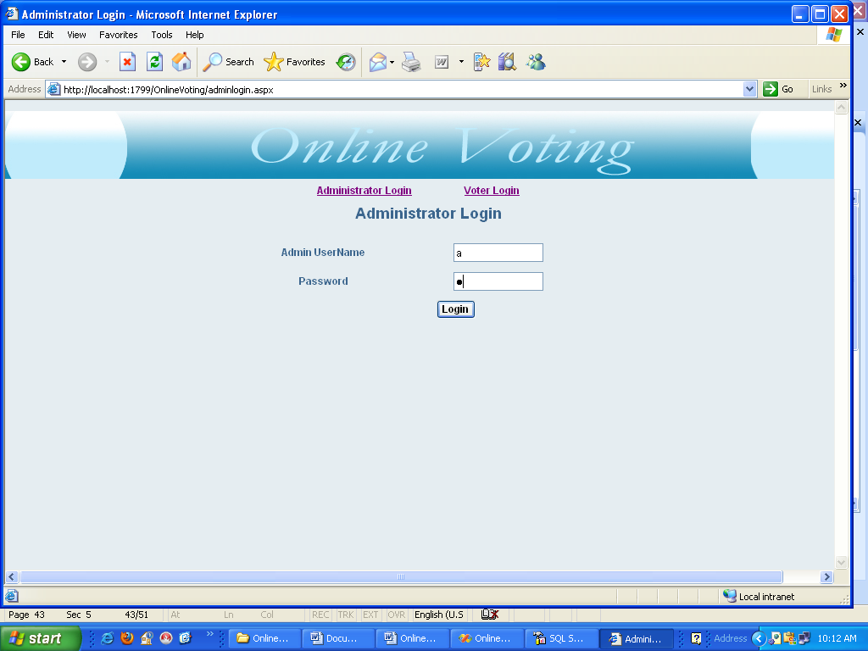

Figure A 3.1 Login Screen

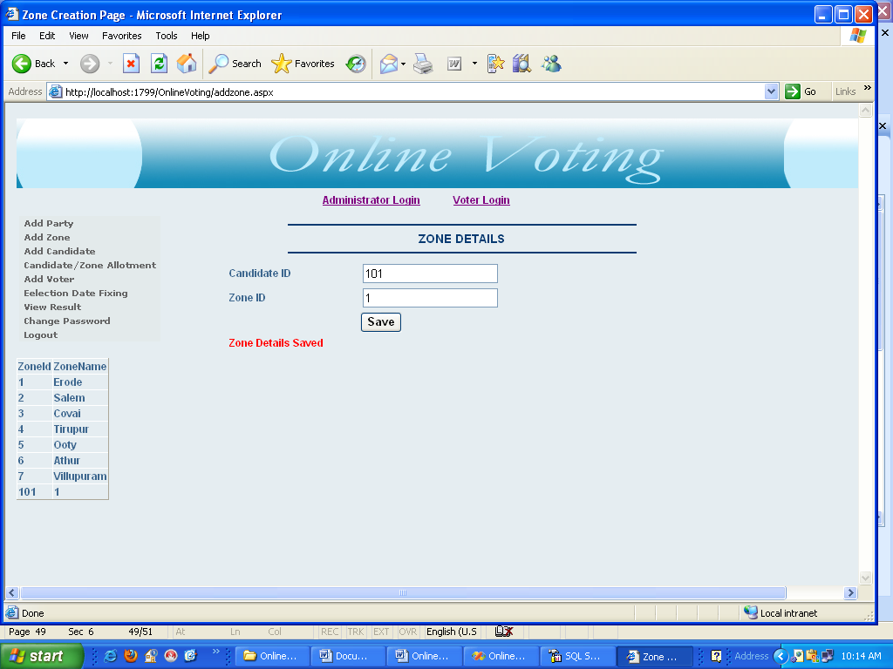

Figure A 3.1Municipality – Addition of Birth Certificate

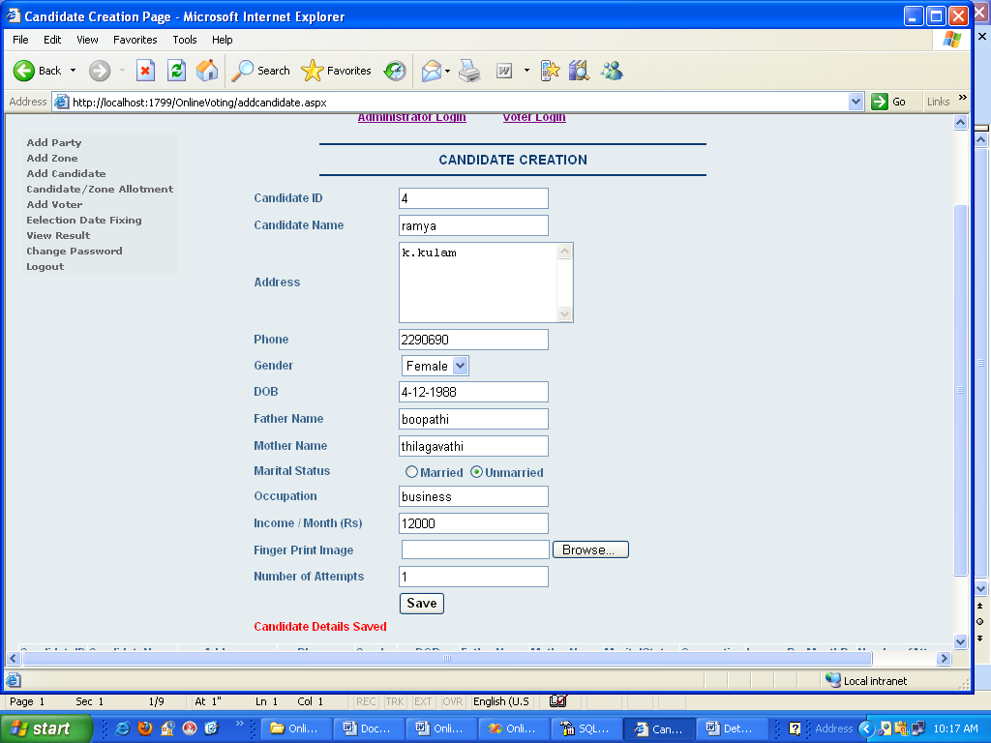

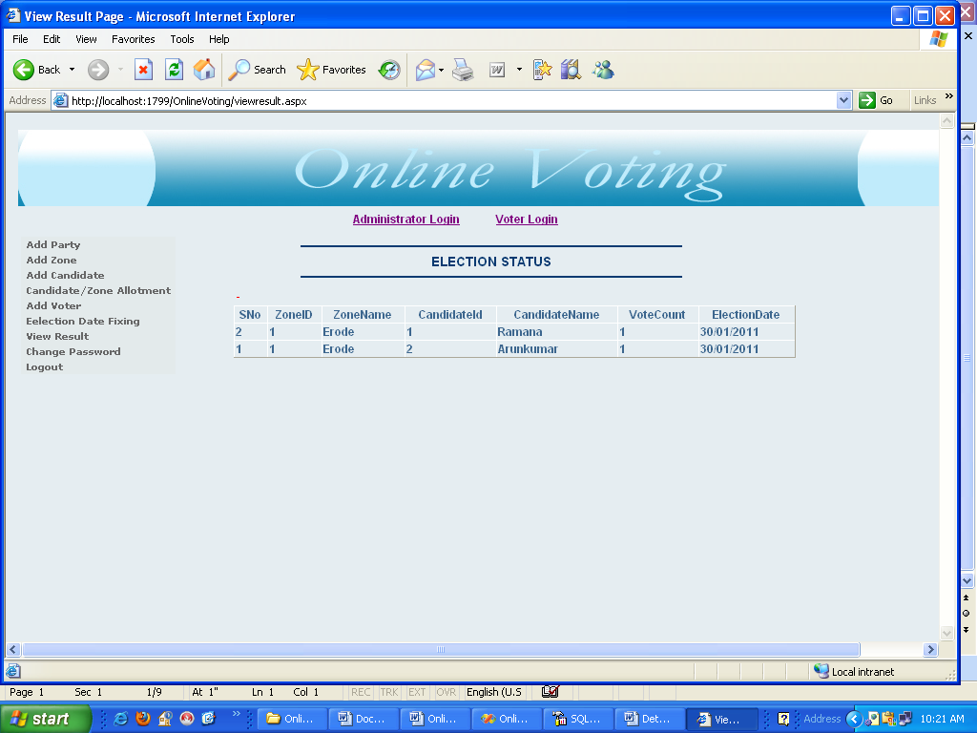
7. BIBLIOGRAPHY

BOOKS
- Benolt Marchal, VB.NET by example 2003 – TataMcGraw- Hill.
- Grey Buczek, .NET developers guide 2002, Prentice-Hall India.
- Ingo Rammer and Mario Szpuszta, Advanced .NET Remoting 2nd Edition (March 2005)
- Matthew mac donald,Microsoft, Visual Basic.NET Programmer’s Cookbook:-,Tata McGraw-Hill Edition
- Marchu, “ASP.NET With .Net 2.0 “ Orelliy March 2005
- Pankaj Jalole, An Integral approach to software engineering,Nilesh 2nd edition

WEBSITES

http://www.dotnetspider.com
http://www.aspnetbegineers.com
http://www.quickstart.com

