Möbius Strip Test Results

# Test Case 1

Parameters: R = 1.0, w = 0.3, n = 200

Surface Area ≈ 1.8864

Edge Length ≈ 6.3008

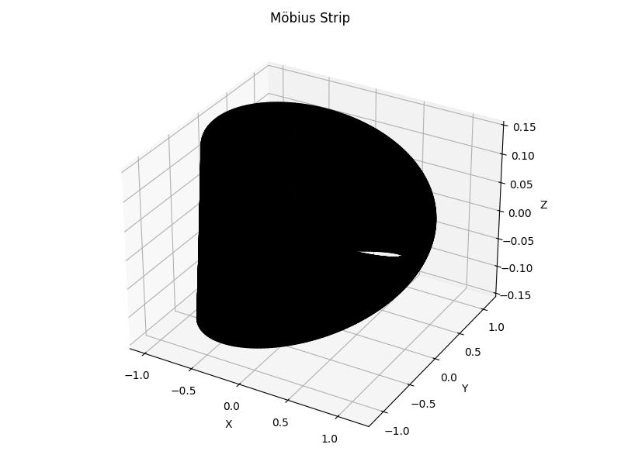

# Test Case 2

Parameters: R = 1.5, w = 0.2, n = 150

Surface Area ≈ 1.8847

Edge Length ≈ 9.4293

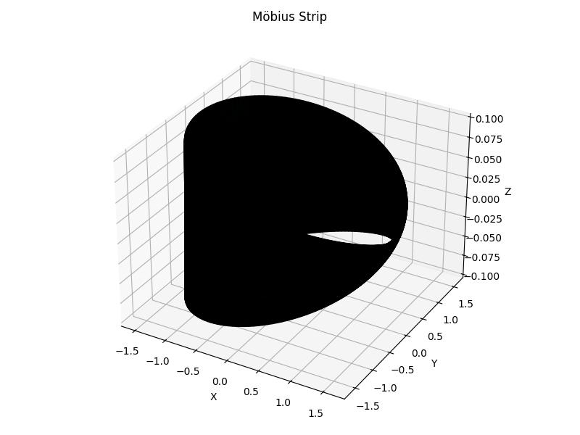

# Test Case 3

Parameters: R = 0.8, w = 0.1, n = 100

Surface Area ≈ 0.5024

Edge Length ≈ 5.0282

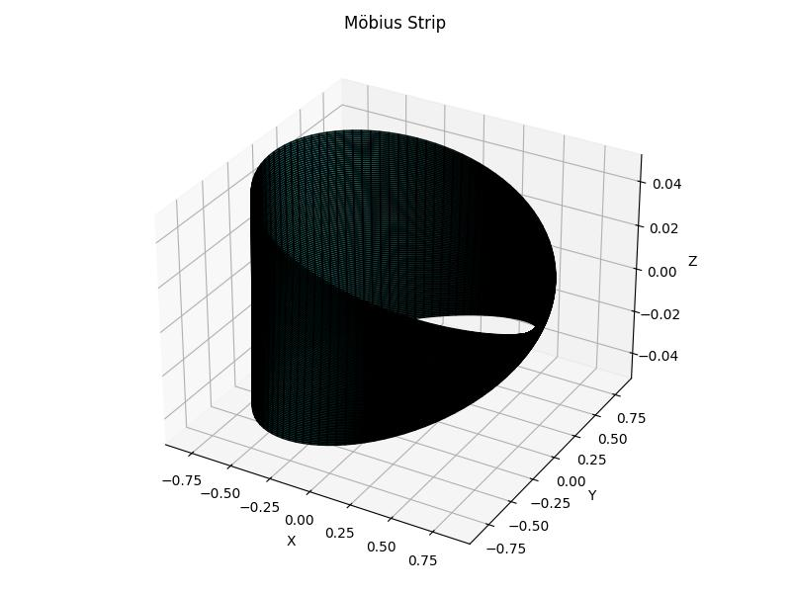

# Test Case 4

Parameters: R = 0.01, w = 0.01, n = 10

Surface Area ≈ 0.0006

Edge Length ≈ 0.0637

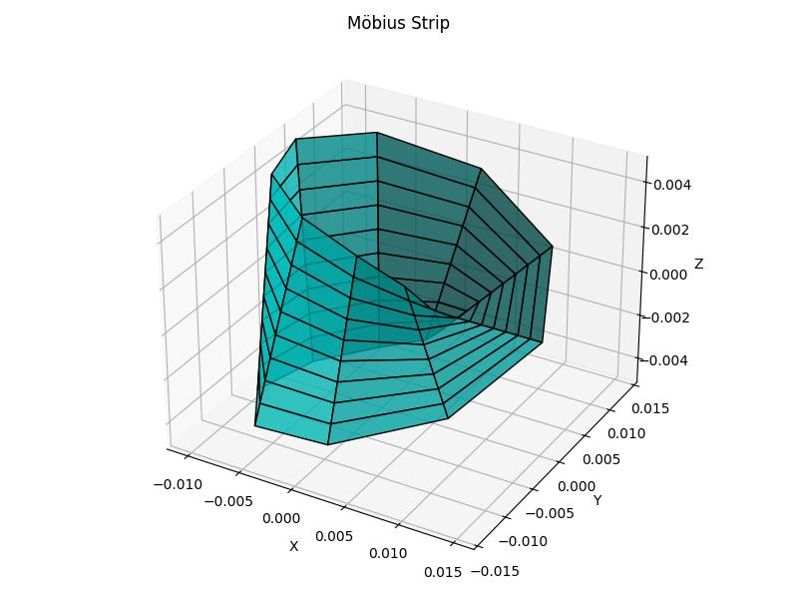

# Test Case 5

Parameters: R = 0.1, w = 0.05, n = 20

Surface Area ≈ 0.0309

Edge Length ≈ 0.6304

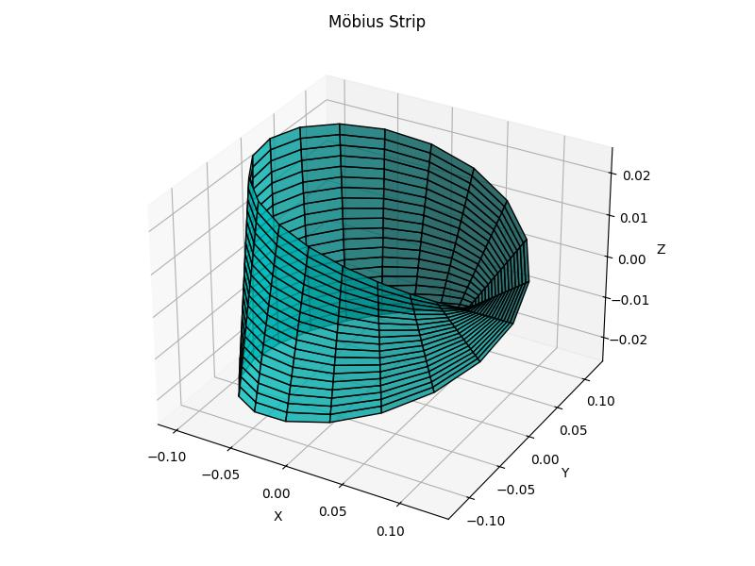

# Test Case 6

Parameters: R = 5.0, w = 2.0, n = 1000

Surface Area ≈ 62.9373

Edge Length ≈ 31.5758

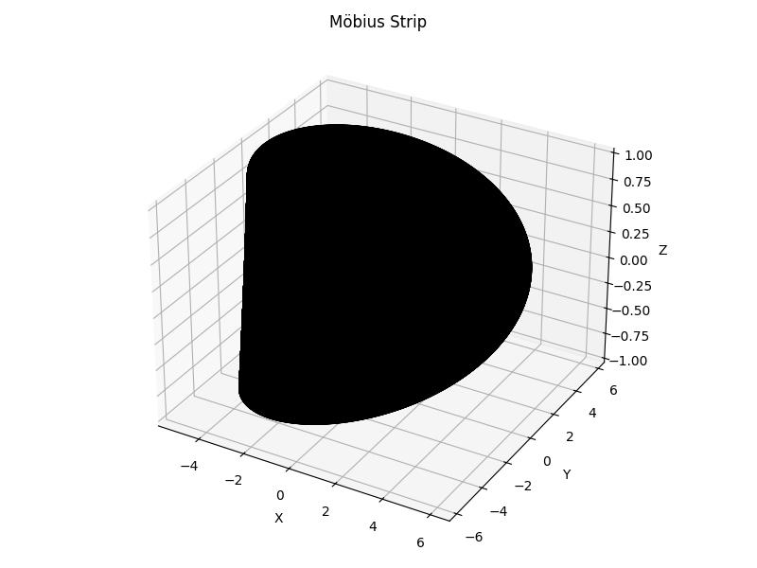

# Test Case 7

Parameters: R = 10.0, w = 5.0, n = 2000

Surface Area ≈ 314.9906

Edge Length ≈ 63.3365

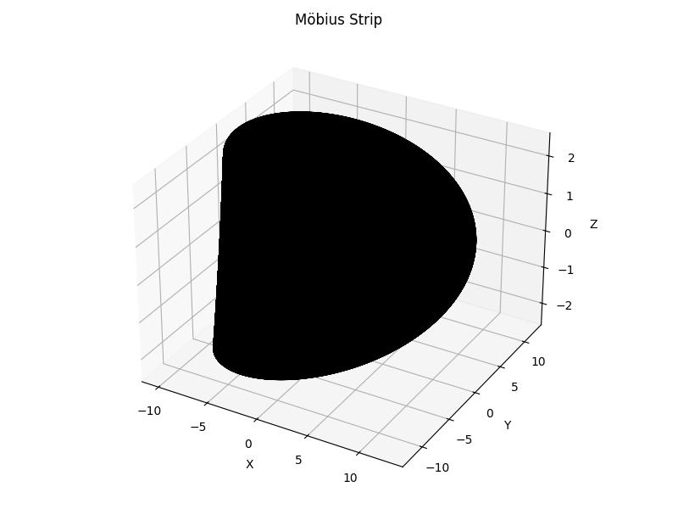

# Test Case 8

Parameters: R = 1.0, w = 0.0001, n = 200

Surface Area ≈ 0.0006

Edge Length ≈ 6.2829

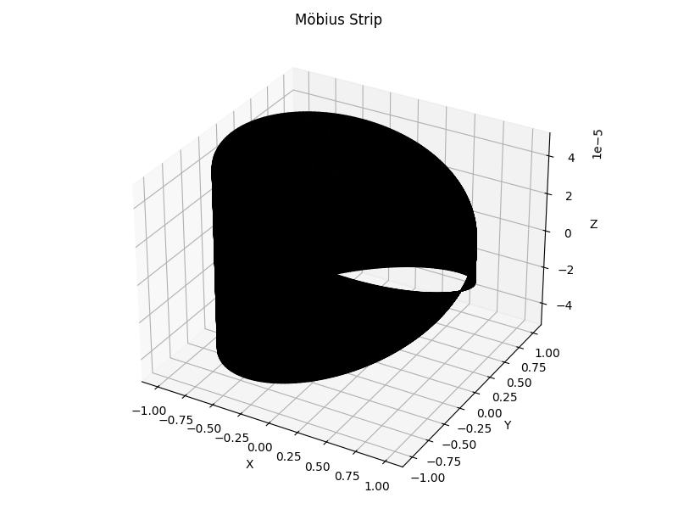

# Test Case 9

Parameters: R = 2.0, w = 1e-05, n = 500

Surface Area ≈ 0.0001

Edge Length ≈ 12.5663

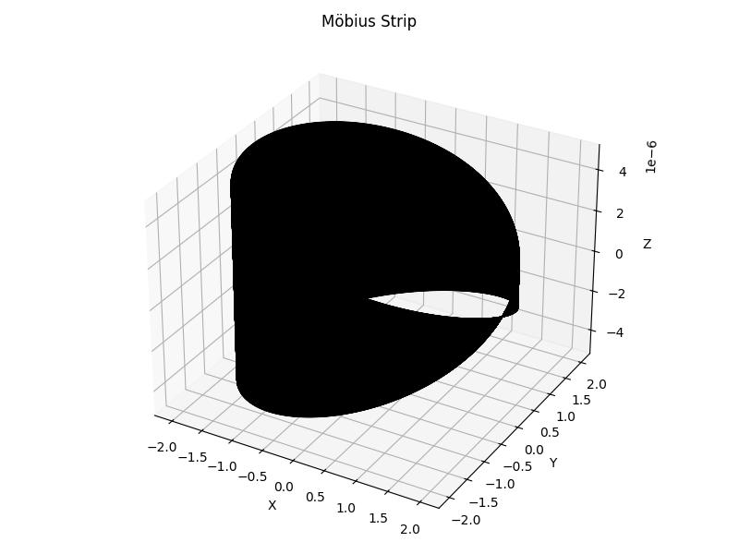

# Test Case 10

Parameters: R = 1.0, w = 3.0, n = 300

Surface Area ≈ 21.6113

Edge Length ≈ 9.3472

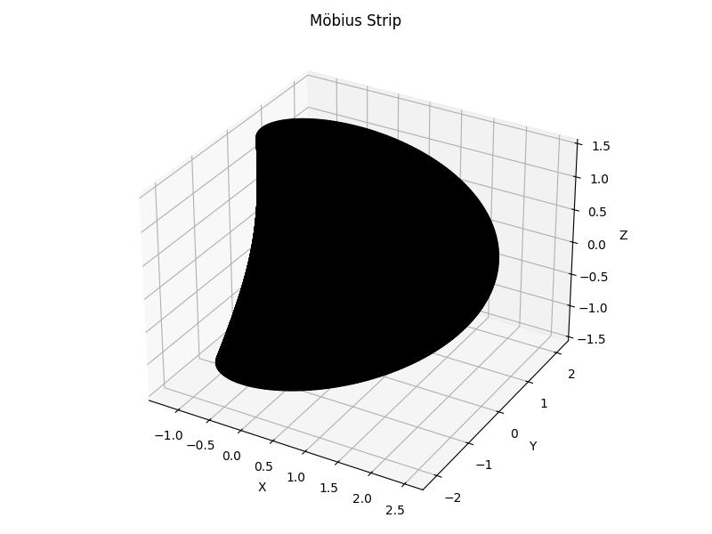

# Test Case 11

Parameters: R = 0.5, w = 2.5, n = 250

Surface Area ≈ 11.2194

Edge Length ≈ 7.0134

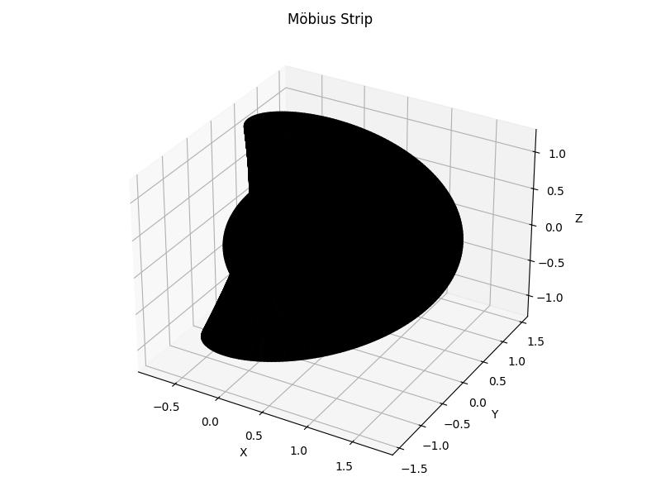

# Test Case 12

Parameters: R = 1.0, w = 0.2, n = 50

Surface Area ≈ 1.2537

Edge Length ≈ 6.2868

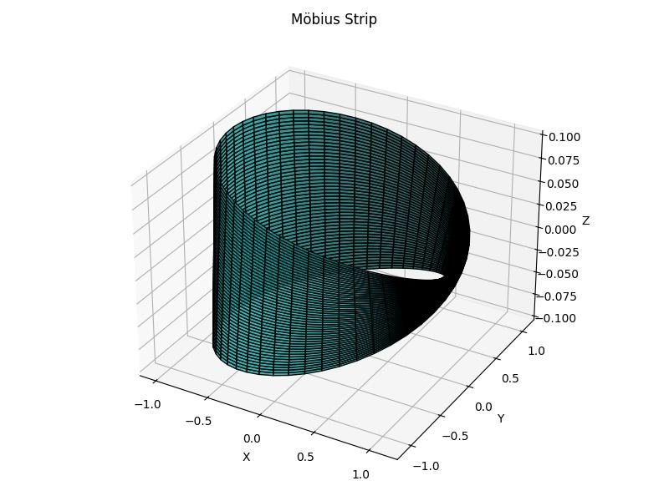

# Test Case 13

Parameters: R = 1.0, w = 0.2, n = 100

Surface Area ≈ 1.2563

Edge Length ≈ 6.2900

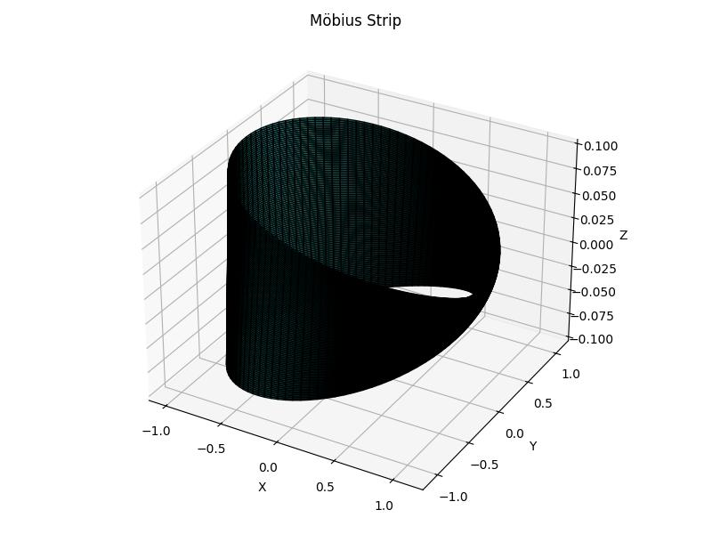

# Test Case 14

Parameters: R = 1.0, w = 0.2, n = 200

Surface Area ≈ 1.2570

Edge Length ≈ 6.2908

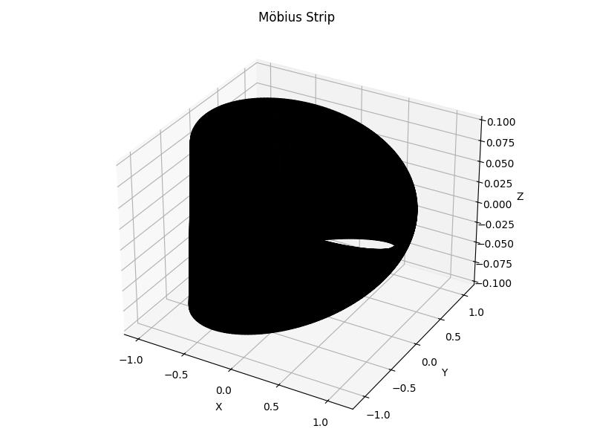

# Test Case 15

Parameters: R = 1.0, w = 0.2, n = 400

Surface Area ≈ 1.2571

Edge Length ≈ 6.2910

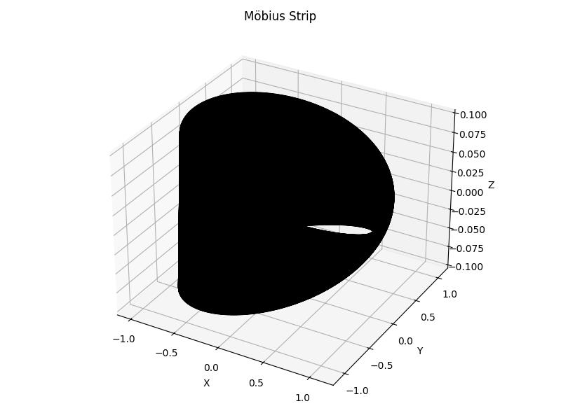

# Test Case 16

Parameters: R = 0.2, w = 0.05, n = 100

Surface Area ≈ 0.0628

Edge Length ≈ 1.2589

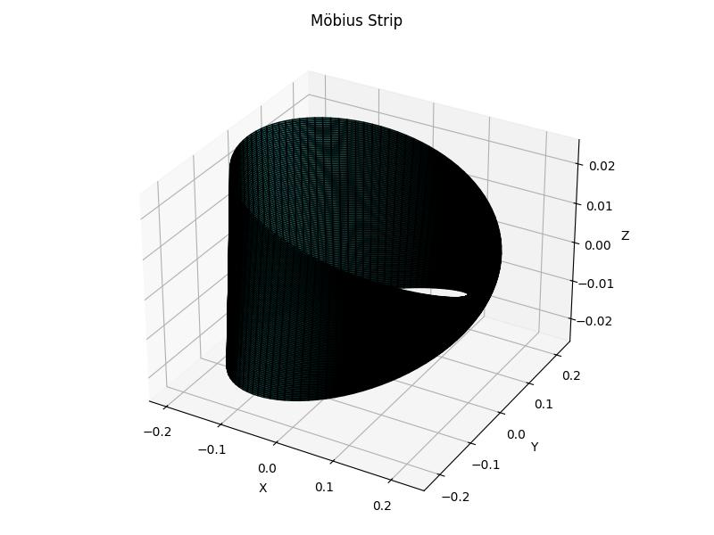

# Test Case 17

Parameters: R = 0.5, w = 0.1, n = 100

Surface Area ≈ 0.3141

Edge Length ≈ 3.1450

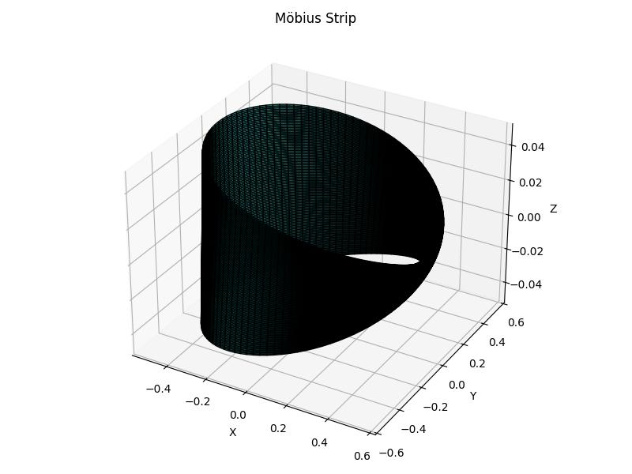

# Test Case 18

Parameters: R = 2.0, w = 0.2, n = 100

Surface Area ≈ 2.5118

Edge Length ≈ 12.5682

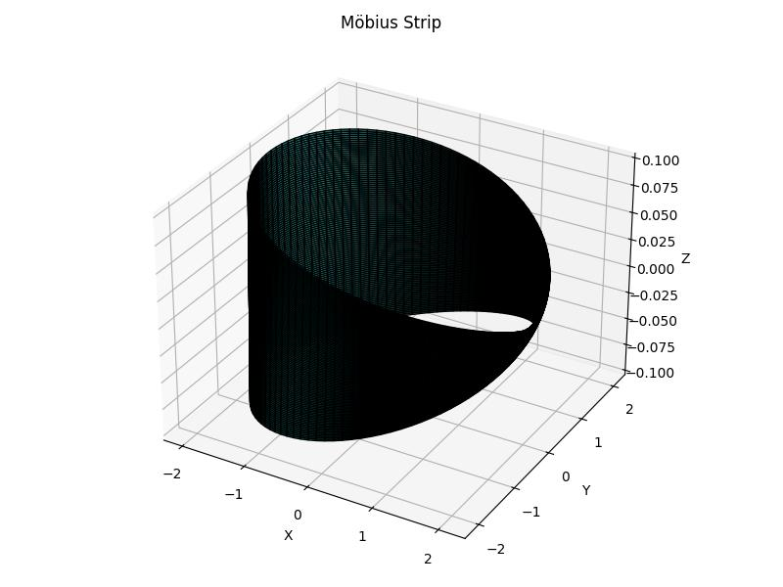

# Test Case 19

Parameters: R = 3.0, w = 0.5, n = 100

Surface Area ≈ 9.4212

Edge Length ≈ 18.8628

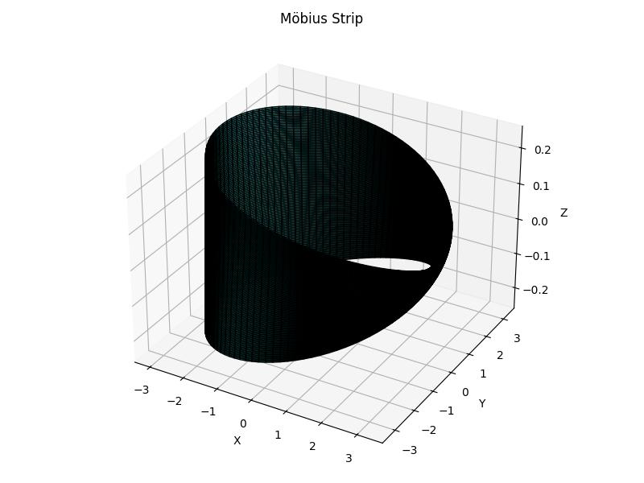

# Test Case 20

Parameters: R = 1.0, w = 0.01, n = 100

Surface Area ≈ 0.0628

Edge Length ≈ 6.2822

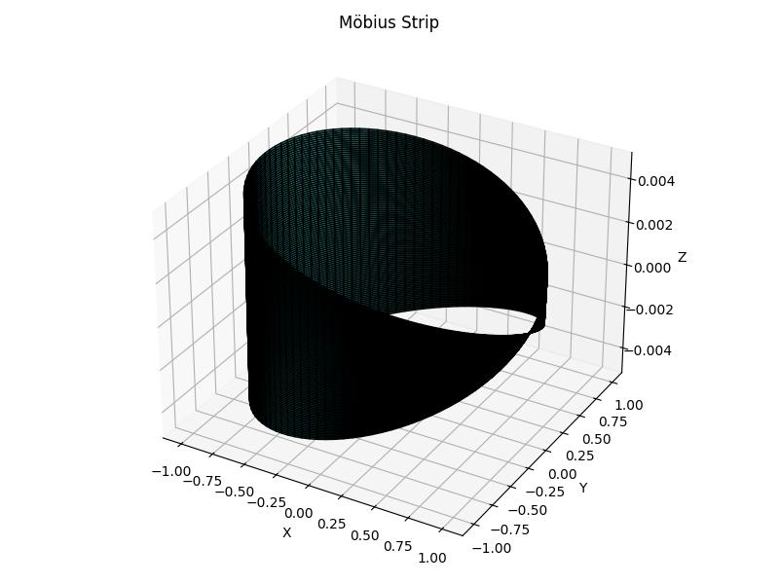

# Test Case 21

Parameters: R = 1.0, w = 0.1, n = 100

Surface Area ≈ 0.6280

Edge Length ≈ 6.2841

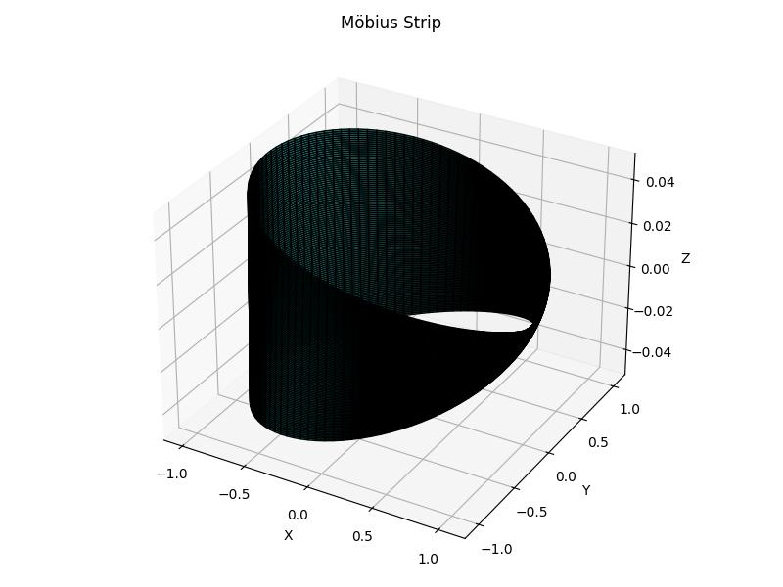

# Test Case 22

Parameters: R = 1.0, w = 1.0, n = 100

Surface Area ≈ 6.3489

Edge Length ≈ 6.5022

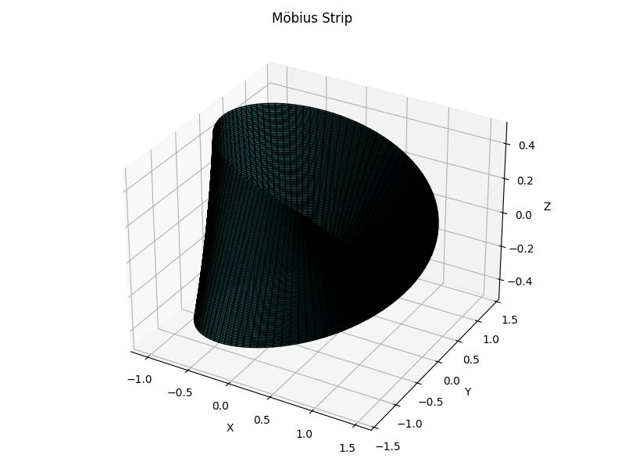

# Test Case 23

Parameters: R = 1.0, w = 2.0, n = 100

Surface Area ≈ 13.2447

Edge Length ≈ 7.4718

