**SQL Query Output Screenshots**

Question 5 - Connect to sql and write a query to get list of Provider names whose Providername is starting with letter T.

(Attach screenshots for this question)

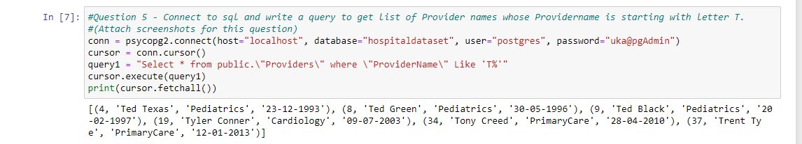

Query executed in sql

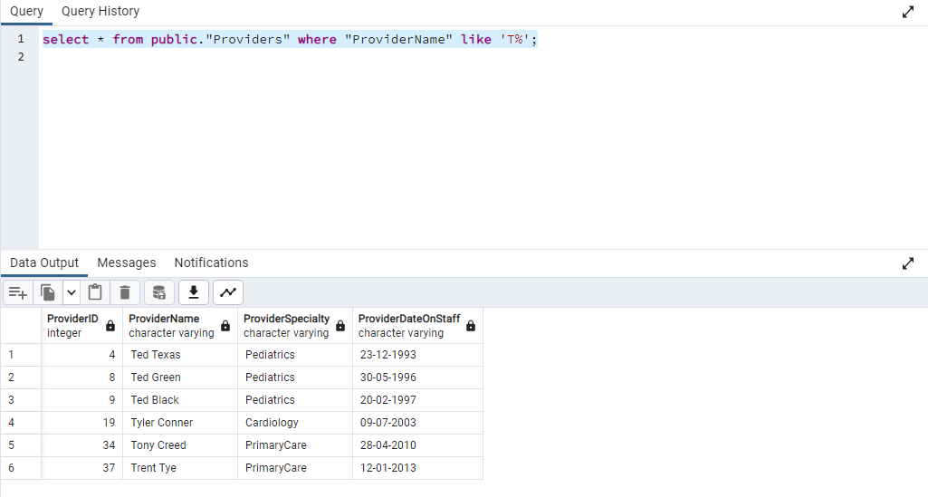

Q 60 : Connect to sql and write a query to get Ambulatory visit record's year. (Attach screenshots for this question)

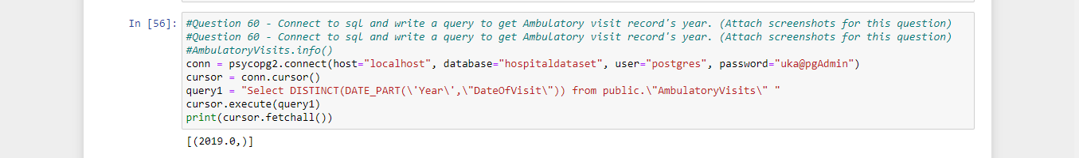

Executing the same in sql

