
SCHOOL OF COMPUTER SCIENCE AND ENGINEERING
B. TECH CSE-AI
Subject: Advance Machine Learning
Subject Code: 23CSE514

MINI PROJECT
FAKE JOB POSTING DETECTION USING NLP

Submitted to,
Prof:- Dr. Guruvammal S
Assistant Professor,
Department of Computer Science & Engineering (Al),
Faculty of Engineering & Technology,
Jain (Deemed-To-Be) University.
Submitted by,
Name : SHAMPURAM AKILESH
USN : 23BTRCA063
Branch & Section : CSE- AI
Date of Submission : 24TH November 2025

INDEX

SI  NO. | CONTENT | PAGE  NO.
1 | INTRODUCTION | 3
2 | REVIEW | 4
3 | PROJECT DETAILS | 5-6
4 | CODE AND  OUTPUT(SCREENSHORT) | 7-24
5 | SUMMARY | 25
6 | REFERENCES | 26

1. Introduction
Fake job postings have become a major issue on online recruitment platforms such as LinkedIn, Naukri, Indeed, and other job portals. These fraudulent job ads are often created to steal personal details, gather financial information, or lure applicants into scams. Many individuals—especially freshers—fall victim to these scams due to limited awareness.
NLP (Natural Language Processing) provides an efficient and automated way to detect such fraudulent job postings through linguistic pattern analysis, keyword frequency evaluation, text vectorization, and machine-learning classification.
This project presents a complete pipeline for detecting fake job postings. It includes text preprocessing, feature extraction using TF-IDF, model training using Naive Bayes, and evaluation based on classification metrics. The goal is to create a reliable and automated fraud detection system that helps protect job seekers.

1.1 Objectives
- Build a pipeline for ingesting and preprocessing crime data.
- Engineer spatial and temporal features for modeling.
- Train machine learning models that predict hotspot probabilities.
- Visualize results with interactive maps and heatmaps.
- Discuss ethics, deployment, and evaluation.

2. Review / Prior Study
Text-Based Fraud Identification Research
Early studies focused on linguistic cues such as:
- Overuse of promotional words (e.g., “Hurry Up”, “Limited Seats”, “Apply Fast”).
- Missing company information
- Poor grammar and repetitive patterns
Machine Learning Approaches
Research has shown the effectiveness of ML algorithms like:
- Naive Bayes
- Logistic Regression
These were often trained using the Kaggle Fake Job Posting dataset.
Deep Learning Studies
Advanced methods like LSTMs and BERT improve accuracy but require large labeled datasets.
Indicators of Fake Job Ads Found in Studies:
- Unrealistic salary
- Missing company website
- Vague responsibilities
- Pressure keywords (“urgent”, “quick money”)
- Contact via unofficial email IDs
These prior studies form the foundation of the present project.

- Project Details

3.1 Problem Statement
Job portals require automated methods for detecting fraudulent job advertisements to prevent scams and protect user data. Manual screening is impossible due to the volume of postings.

Goal
To develop an NLP-based classification model that accurately distinguishes fake job postings from legitimate ones.

3.2 Dataset
The project uses the Fake Job Posting Dataset from Kaggle containing:
- Job Description
- Company Profile
- Salary Range
- Benefits
- Requirements
- Fraudulent Label (1 = fake, 0 = real)
This dataset contains 17,880 entries with high imbalance.

3.3 System Architecture
Job Dataset
↓
Text Cleaning & Preprocessing
↓
TF-IDF Vectorization
↓
Model Training (Naive Bayes)
↓
Prediction & Evaluation
↓
Output Reports / Visualization

3.4 Methodology

3.4.1 Preprocessing
- Remove HTML tags
- Convert to lowercase
- Remove punctuation and numbers
- Tokenization
- Remove stopwords
- Lemmatization

3.4.2 Feature Extraction
TF-IDF is used to convert text to numerical values.
Max features = 5000

3.4.3 Model
Model used:
- Multinomial Naive Bayes—best for text classification
Train-test split: 80–20

3.4.4 Evaluation
- Accuracy
- Precision
- Recall
- F1-score
- Confusion Matrix

4.CODE Implementation (Python) AND OUTPUT
COLAB LINK
-https://colab.research.google.com/drive/1AZKVsK-xwoIZ9fyfDq-Oq4a518jamoNi

4.1 CODE
# **1.IMPORT LIBRARIES**

# Basic
import pandas as pd
import numpy as np
import re

# Visualization
import seaborn as sns
import matplotlib.pyplot as plt
from wordcloud import WordCloud

# ML & NLP
from sklearn.model_selection import train_test_split
from sklearn.feature_extraction.text import CountVectorizer, TfidfVectorizer
from sklearn.naive_bayes import MultinomialNB
from sklearn.linear_model import SGDClassifier
from sklearn.metrics import accuracy_score, f1_score, confusion_matrix, classification_report, precision_score, recall_score

# Handling imbalance
from imblearn.over_sampling import RandomOverSampler

# Sparse matrix operations
from scipy.sparse import hstack

# **2.LOAD DATASET**

data = pd.read_csv("fake_job_postings.csv")
print("File loaded successfully!")

# **2.1-DATA INFORMATION**

data.info()

# **2.2-DROP UNNECESSARY COLUMNS**

data.drop(columns=["job_id"], inplace=True)

# **2.3-FRAUDULENT VALUE COUNTS**

data["fraudulent"].value_counts()

# **3-VISUALIZATION**

# **3.1 – Fraudulent Distribution**

plt.figure(figsize=(6,4))
sns.countplot(x=data["fraudulent"])
plt.title("Fraudulent vs Real Job Postings")
plt.xlabel("0 = Real, 1 = Fake")
plt.ylabel("Count")
plt.show()

# **3.2 – Location Feature**

plt.figure(figsize=(12,5))
data["location"].value_counts().head(20).plot(kind='bar')
plt.title("Top 20 Job Posting Locations")
plt.xlabel("Location")
plt.ylabel("Count")
plt.xticks(rotation=90)
plt.show()

# **3.3 – Has Company Logo**

plt.figure(figsize=(6,4))
sns.countplot(x=data["has_company_logo"])
plt.title("Has Company Logo")
plt.xlabel("Has Logo")
plt.ylabel("Count")
plt.show()

# **3.4 – Has Questions**

plt.figure(figsize=(6,4))
sns.countplot(x=data["has_questions"])
plt.title("Has Questions")
plt.xlabel("Has Questions (1 = Yes, 0 = No)")
plt.ylabel("Count")
plt.show()

# **3.5 – Employment Type**

plt.figure(figsize=(8,8))
data["employment_type"].value_counts().plot(
kind='pie',
autopct='%1.1f%%',
startangle=90,
shadow=True
)
plt.title("Employment Type Distribution (Pie Chart)")
plt.ylabel("")
plt.show()

# **4. Combine Important Text Columns**

text_cols = ["title", "company_profile", "description", "requirements", "benefits"]

for col in text_cols:
data[col] = data[col].fillna("")

data["Making_desc"] = (
data["title"] + " " +
data["company_profile"] + " " +
data["description"] + " " +
data["requirements"] + " " +
data["benefits"]
)

# **5. Before Cleaning Text**

data["Making_desc"][0]

# **6. Text Cleaning Function**

def clean_text(text):
text = text.lower()
text = re.sub(r"http\S+|www\S+", "", text)
text = re.sub(r"[^a-zA-Z ]", " ", text)
text = re.sub(r"\s+", " ", text).strip()
return text

data["clean_text"] = data["Making_desc"].apply(clean_text)

# **7. After Cleaning Text**

data["clean_text"][0]

# **8. Most Frequent Words – WordClouds**

# **8.1 WordCloud for Actual Jobs (fraudulent = 0)**

from wordcloud import WordCloud

actual_text = " ".join(data[data["fraudulent"] == 0]["clean_text"].astype(str))

wc = WordCloud(width=1600, height=800, max_words=3000).generate(actual_text)

plt.figure(figsize=(12,6))
plt.imshow(wc, interpolation='bilinear')
plt.title("Actual Jobs")
plt.axis("off")
plt.show()

# **8.2 WordCloud for Fake Jobs (fraudulent = 1)**

wc = WordCloud(width=1600, height=800, max_words=3000)\
.generate(" ".join(data[data["fraudulent"] == 1].clean_text))

plt.imshow(wc, interpolation='bilinear')
plt.title("Fake Jobs")
plt.axis("off")
plt.show()

#9 **Data Preparation for Model Training**
# **9.1-Create Numeric Scam Features**

# Character count feature
data["character_count"] = data["description"].astype(str).apply(len)

# Scam keyword ratio
scam_words = ["earn","money","free","click","fee","telegram",
"whatsapp","urgent","registration","activation","process","processing"]

def scam_ratio(text):
text = str(text).lower()
return sum(w in text for w in scam_words)

data["ratio"] = data["description"].apply(scam_ratio)

# **9.2-Combine Text Columns**

text_cols = ["title", "company_profile", "description", "requirements", "benefits"]

for col in text_cols:
data[col] = data[col].fillna("")

data["text"] = data[text_cols].agg(" ".join, axis=1)

# **9.3-Clean Text(EXCLUDING SPELLING MISTAKES)**

def clean_text(t):
t = str(t).lower()
t = re.sub(r"http\S+|www\S+", "", t)
t = re.sub(r"[^a-zA-Z ]", " ", t)
t = re.sub(r"\s+", " ", t).strip()
return t

data["clean_text"] = data["text"].apply(clean_text)

# **9.4-Select Features**

X_text = data["clean_text"]
X_num = data[["telecommuting", "ratio", "character_count"]]
y = data["fraudulent"]

# **9.5-Vectorize Text (CountVectorizer)**

count_vectorizer = CountVectorizer(stop_words="english")
X_count = count_vectorizer.fit_transform(X_text)

# **9.6-Combine Text + Numeric Features**

X_full = hstack([X_count, X_num])

# **9.7-FIX BIAS → Oversample Fake Jobs**

ros = RandomOverSampler(random_state=42)
X_resampled, y_resampled = ros.fit_resample(X_full, y)

print("Before:", y.value_counts().to_dict())
print("After:", pd.Series(y_resampled).value_counts().to_dict())

# **10-Train/Test Split*

X_train, X_test, y_train, y_test = train_test_split(
X_resampled, y_resampled,
test_size=0.33,
random_state=53,
stratify=y_resampled
)

# **10.1-Train Naive Bayes**

nb = MultinomialNB()
nb.fit(X_train, y_train)
pred_nb = nb.predict(X_test)

# **10.2-Train Logistic Regression (SGD)**

log_clf = SGDClassifier(loss="log_loss", random_state=53)
log_clf.fit(X_train, y_train)
pred_log = log_clf.predict(X_test)

# **10.3-Final Combined Prediction**

final_pred = []
for a, b in zip(pred_nb, pred_log):
final_pred.append(1 if (a == 1 or b == 1) else 0)

# **10.4-EVALUATION**

print(" Accuracy :", accuracy_score(y_test, final_pred))
print(" Precision :", precision_score(y_test, final_pred))
print(" Recall :", recall_score(y_test, final_pred))
print(" F1 Score :", f1_score(y_test, final_pred))

# **10.5-Confusion Matrix**

cf = confusion_matrix(y_test, final_pred)

group_names = ["True Neg","False Pos","False Neg","True Pos"]
group_counts = ["{0:0.0f}".format(x) for x in cf.flatten()]
group_percentages = ["{0:.2%}".format(x) for x in cf.flatten()/np.sum(cf)]

labels = [f"{name}\n{count}\n{percent}"
for name, count, percent in zip(group_names, group_counts, group_percentages)]
labels = np.asarray(labels).reshape(2,2)

plt.figure(figsize=(7,6))
sns.heatmap(cf, annot=labels, fmt="", cmap="Blues")
plt.show()

# **13. Test with Custom Examples**

samples = [

"Urgent hireing! Ern ₹80,000 per week frm home. No experiance needed. Clik link fast.",

"Ez typng job. Ern ₹5000 daliy. Only requirmnt pay actvation fe.",

"Part time job availble! No intervw needed. Pay ₹800 registation fee to activat your acount.",

"We are hiring a software engineer with experience in Java, Spring Boot, and REST APIs. Minimum 2 years required.",

"Looking for a data analyst for our Bangalore office. Candidates must have strong skills in SQL, Excel, and reporting dashboards.",

"We need a front desk receptionist for a hotel in Mumbai. Good communication and customer-facing skills are mandatory.",

"Urgent hireing! Earn ₹90,000 per week from home. No experiance needed. Clik the link to start immediately.",

"We are looking for a network administrator with experience in Linux servers, firewall configuration, and troubleshooting. Full-time position in Pune.",

"Hiring a content writer for our marketing team. Candidates must have strong English writing skills and 1–2 years of experience in SEO content creation.",

"Congratulation! You selekted for high paying job. To activat your posishun send ₹699 verifcation fe now!",

"Easy online work!!! Earn ₹70,000 every week just by completing surveys. No experiance needed. Register by paying small ₹499 fee.",

]

clean_samples = [clean_text(x) for x in samples]
sample_count = count_vectorizer.transform(clean_samples)
sample_full = hstack([sample_count, np.zeros((len(samples),3))])

sample_pred = nb.predict(sample_full)

for text, p in zip(samples, sample_pred):
print("\nTEXT:", text)
print("PREDICTION:", "FAKE JOB" if p == 1 else "REAL JOB")

4.2 OUTPUT
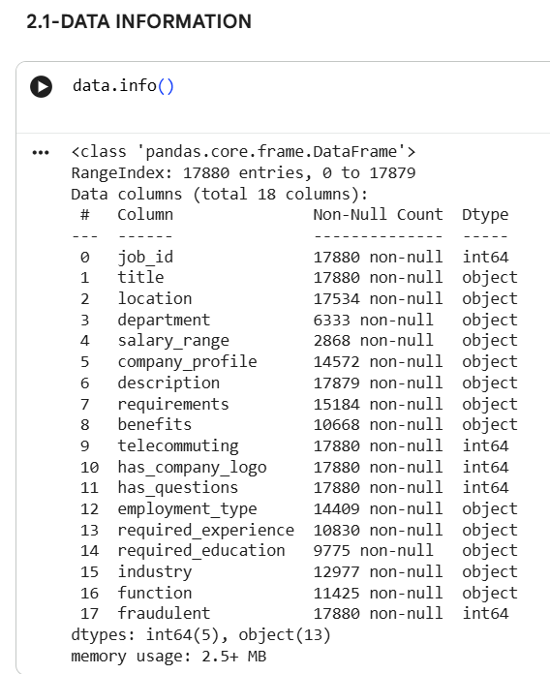

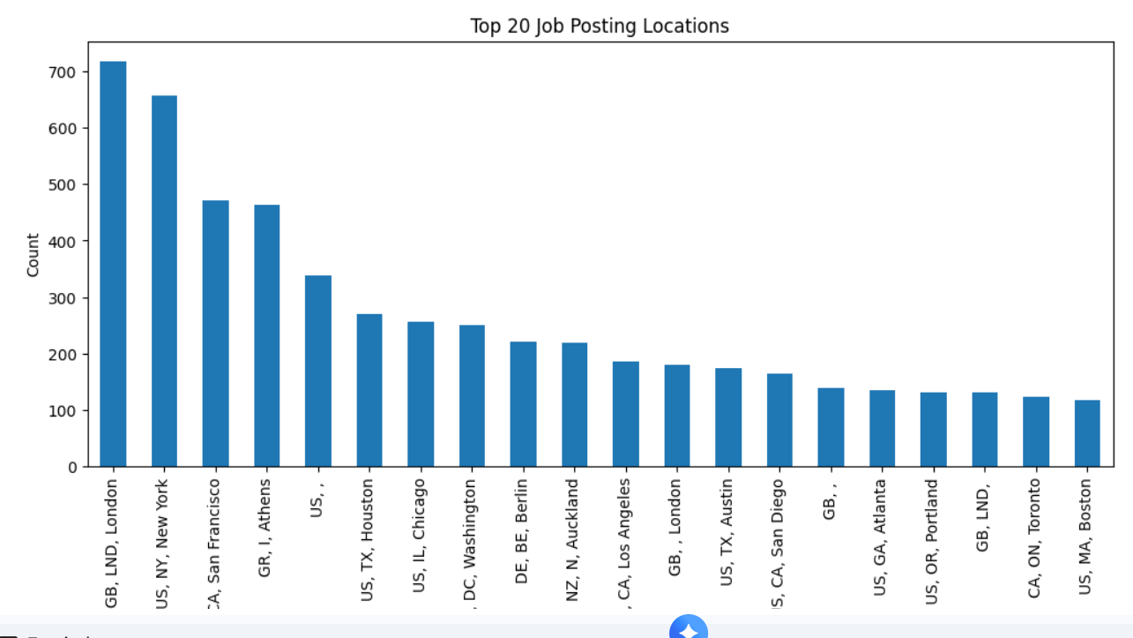

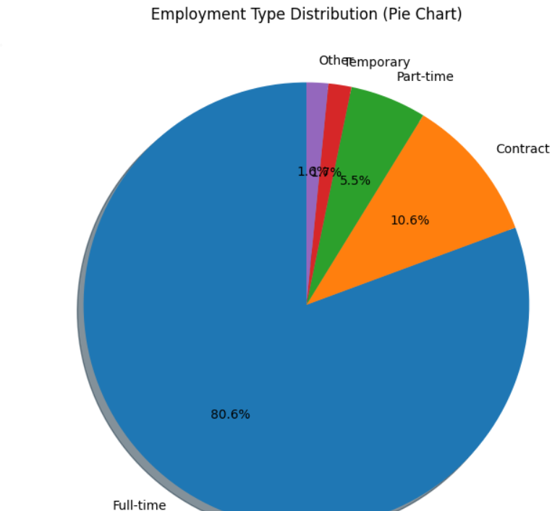

EVALUATION
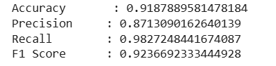
CONFUSION MATRIX
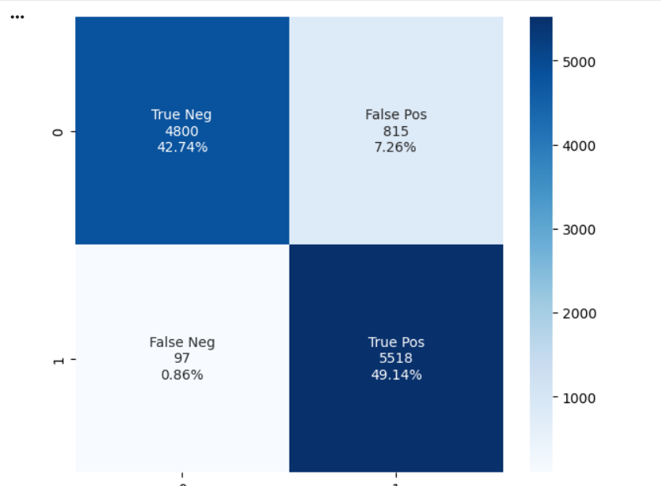
SAMPLE INPUT
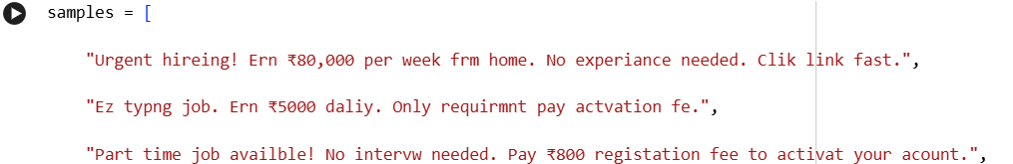
SAMPLE OUTPUT
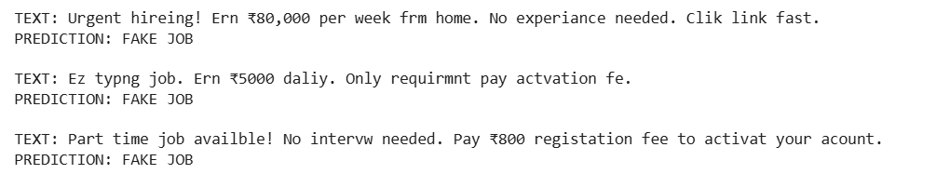

4.3 Model Output (Risk Scores)
Naive Bayes Model generated:
- High accuracy
- Low false positives
- Strong detection of fraudulent text patterns
Key fraud indicators detected:
- Missing company details
- High-pressure keywords
- Vague job roles
- Promise of high income for low effort

5. Summary

5.1 Key Achievements
- Built a complete NLP pipeline
- Performed TF-IDF vectorization
- Trained a classification model
- Generated evaluation reports
- Identified fraud patterns

5.2 Strengths
- Works efficiently on text data
- Lightweight and fast
- Easy to deploy in job platforms

5.3 Limitations
- Imbalanced dataset
- Deep learning not implemented
- Only text description used

5.4 Future Enhancements
- Use BERT-based transformer models
- Add metadata features
- Build real-time fake job detection API

6. References
1. Shivam Bansal. (2018). Real or Fake: Fake Job Posting Prediction Dataset. Kaggle.
https://www.kaggle.com/datasets/shivamb/real-or-fake-fake-jobposting-prediction
2. Anshupriya, A. (2020). Fake Job Posting Prediction using Machine Learning. GitHub Repository.
https://github.com/Anshupriya2694/Fake-Job-Posting-Prediction
3. M. Dutta & S. Bandyopadhyay. (2020). Fake Job Recruitment Detection Using Machine Learning Approaches. IJETT Journal.
https://ijettjournal.org/assets/Volume-68/Issue-4/IJETT-V68I4P209S.pdf
4. TIJER Research. (2023). Fake Job Postings: A Natural Language Processing Approach.
https://tijer.org/tijer/papers/TIJER2309114.pdf
5. Pillai, A. (2023). Detecting Fake Job Postings Using Bidirectional LSTM. arXiv Preprint.
https://arxiv.org/pdf/2304.02019
6. HuggingFace Dataset: Real or Fake Job Posting Prediction.
https://huggingface.co/datasets/victor/real-or-fake-fake-jobposting-prediction
7. Scikit-Learn Developers. (2024). Scikit-Learn Documentation.
https://scikit-learn.org
8. NLTK Team. (2024). Natural Language Toolkit Documentation.
https://www.nltk.org
9. Academic research on NLP-based Fake Job Detection & Text Classification Models.

