**Trigger Jenkins Job on GIT Commit [Jenkins- GitHub hook trigger for GITScm polling]**

1. Install the GIT Plugin for Jenkins

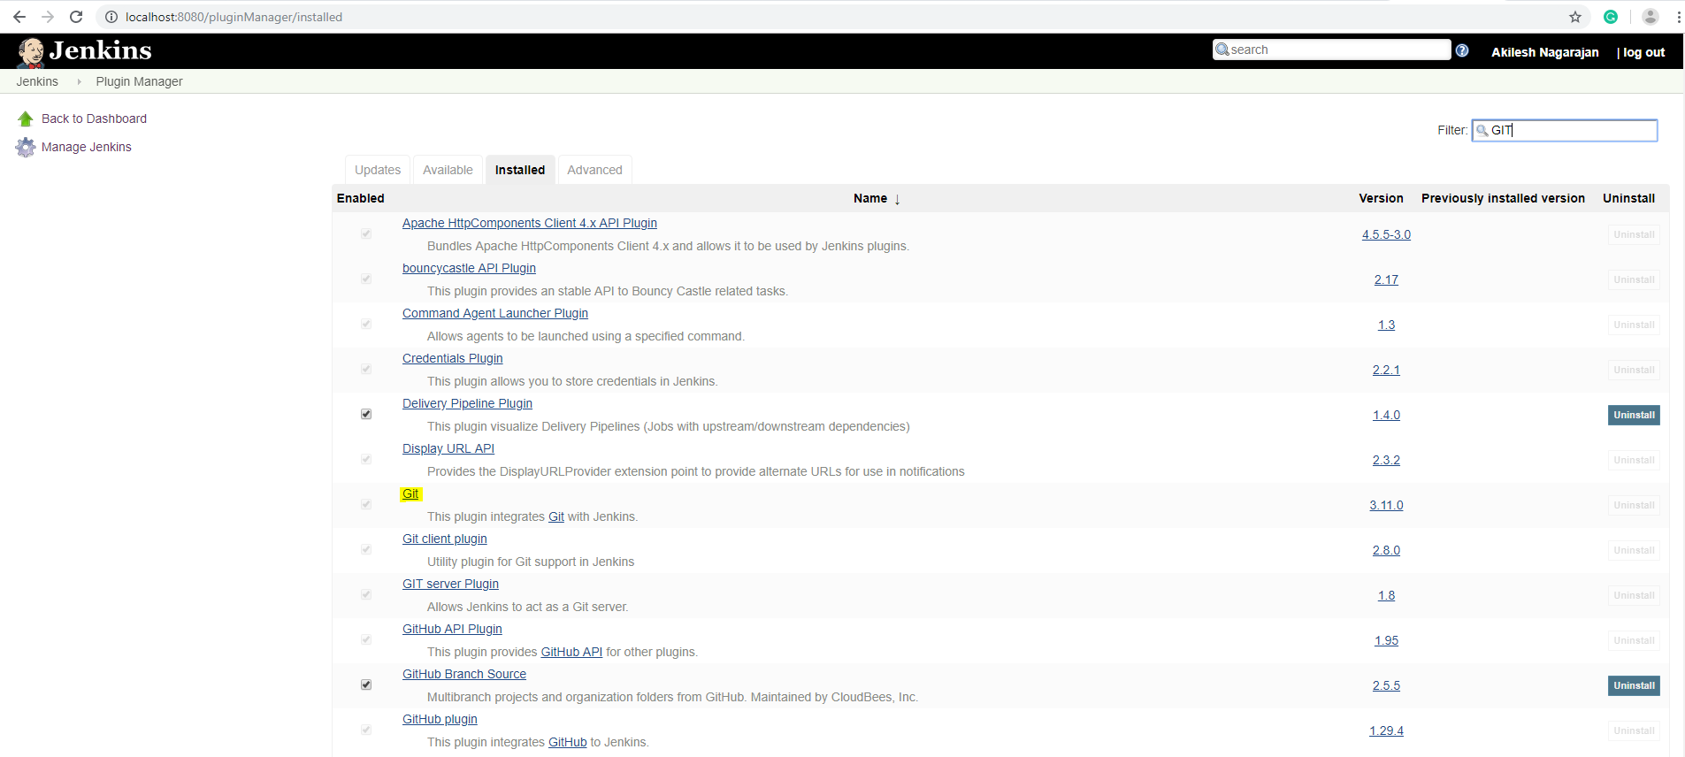

1. Download NGROK utility to tunnel the localhost to public internet.

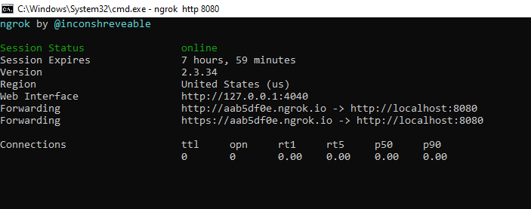

1. Adding Webhooks on GIT Repository

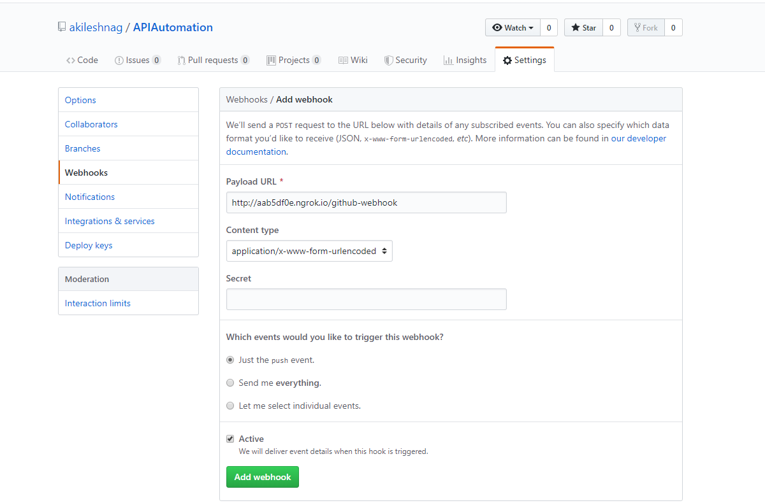

1. GIT SCM Polling configuration in Jenkins

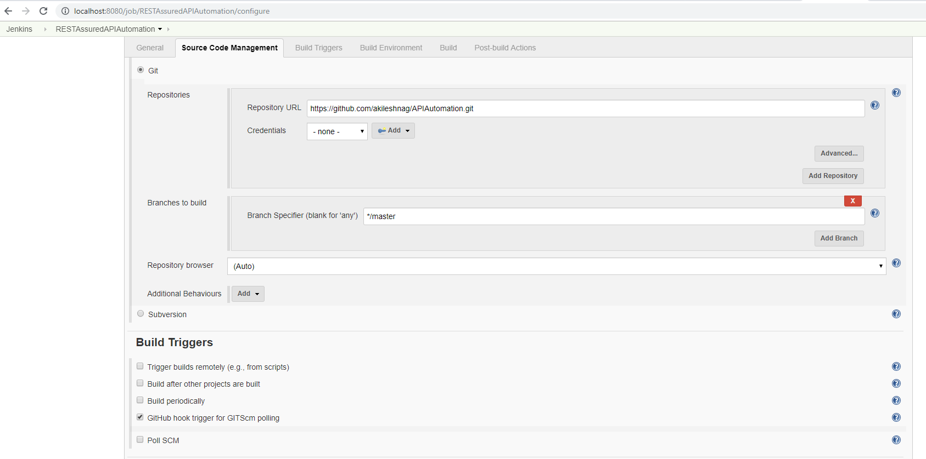

1. Triggering build on Updating Comments and committing to master

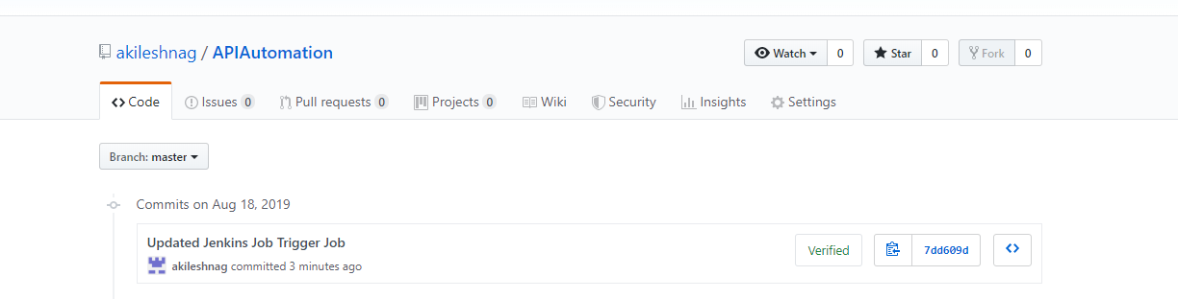

1. Console output confirming the same on Jenkins

