**CUSTOMER REQUIREMENT SPECIFICATION**

|  |  |  |  |  |  |  |  |  |
| --- | --- | --- | --- | --- | --- | --- | --- | --- |
|  | https://lh4.googleusercontent.com/proxy/YA9Xoqs7jhpeuwrEjwhdi_EVSCDwUdpr72V-2YHZ2lz2y1FaqityK8c8RlZRTvUDEw3Y2TekyGNi07wcREil5Ez3ii80dA-DE8G6HAQjEmJVz8W32Wy2uaDAWwuZs6uPZtJp2zrUJ_Qps2T1CUmSpuPR8dk2XA=w128-h144-k-no | | | **Document Ref.:** | | |  | |
| **Version No.:** | | |  | |
| **Date :** | | |  | |
| **Project Name:** |  | | | | | | |
| **Project Code:** |  | | | | | | |
| **Status:** | **Draft** / **Current** / **Superseded** | | | | | | |
| **Document Type:** | **Controlled** / **Uncontrolled** | | | | | | |
|  | | | | | | | |
|  | | | | | | | |
| **Prepared By:** | | | | **Reviewed By:** | | | |
| **Name** | | **Date** | | **Name** | | | **Date** |
|  | |  | |  | | |  |
|  | | |  |
|  | |  | | **Approved By:** | | | |
| **Name** | | | **Date** |
|  | |  | |  | | |  |
|  | | |  |
| **Distribution List** | | | | | | | |
| **Project Representative(s)** | | | | | **Guide Representative(s)** | | |
| 1. <Name1> 2. <Name2> 3. <Name3> | | | | | 1. <Name4>  |  |  |  |  |  |  |  |  | | --- | --- | --- | --- | --- | --- | --- | --- | | **<Title>** | | | | | | | | | **<Summary>** | | | | | | | |  1. <Name5> 2. <Name6> | | |

TABLE OF CONTENTS

**Definitions, Acronyms and Abbreviations 3**

**References 3**

**Change History 4**

**1.0** **Introduction 5**

**1.1** **Scope 5**

**2.0** **Product Perspective 6**

**2.1 User Characteristics** **6**

**2.2 General Constraints, Assumptions and Dependencies** **7**

**2.3 Risks** **7**

**3.0 System Architecture** **8**

**4.0 Requirements List** **9**

**4.1 Module / Scenario 1** **9**

**4.2 Module / Scenario 2** **9**

**4.3 Module / Scenario n** **9**

**5.0 External Interface Requirements** **10**

**5.1 Hardware Requirements** **10**

**5.2 Software Requirements** **10**

**5.3 Communication Interfaces** **11**

**6.0 User Interfaces** **12**

**7.0 Performance Requirements** **13**

**8.0 Special Characteristics** **14**

**9.0 Help** **15**

**10.0 Other Requirements** **16**

**10.1 Site Adaptation Requirements** **16**

**10.2 Safety Requirements** **16**

**11.0 Packaging 1****7**

**12.0 Traceability Matrix 1**

**8**

**Definitions, Acronyms and Abbreviations**

This section provides for definition of all terms, acronyms and abbreviations required for interpreting the CRS. Well known abbreviations need not be stated.

**References**

This section describes the complete list of documents referred to prepare the CRS. The reference documents shall describe the title, version number, dates, authors and publishers.

**Change History**

This section describes the details of changes that have resulted in the current CRS document.

|  |  |  |  |  |
| --- | --- | --- | --- | --- |
| **#** | **Date** | **Document Version No.** | **Change Description** | **Reason For change** |
|  |  |  |  |  |
|  |  |  |  |  |
|  |  |  |  |  |

# Introduction

The aim of this document is to gather and analyze and give an in-depth insight of the complete **ATS** by defining the problem statement in detail. Nevertheless, it also concentrates on the capabilities required by stakeholders and their needs while defining high-level product features. The detailed requirements of the **ATS** are provided in this document. The audience for this document are the customers and the developers of this software.

* 1. ***Scope***

This project is implemented to help organisations to rate and rank automobiles over a variety of universally accepted testing parameters with the help of a robust and efficient web-based software, which is in turn used by the public to make informed decisions while purchasing these automobiles.

The software does not use real-time data and requires the database to be populated before the software is operational.

# Product Perspective

The ATS is an independent utility which provides the feature of automating the testing and ranking process of various quality tests involved in Automobile manufacturing. This system makes ranking and testing of vehicles against different industrial standards efficient and interactive. It is a learning tool which uses different metrics and standards of past quality tests to improve the ranking model.

Development platform:

**Hardware**: Intel I5, 4-8GB RAM systems running Windows 10 and Ubuntu 16.04 Operating System.

**Software**: Google Chrome browser, Apache and SQL (for web server and database features)

Deployment platform:

**Hardware**: Intel I5, 4-8GB RAM systems running Windows, Mac or Linux Operating System. Android version 7 or higher. iOS 11 or higher.

**Software**: Microsoft Edge, Google Chrome, Safari, Mozilla Firefox or Internet Explorer (supporting HTML5)

* 1. ***User Characteristics***

|  |  |
| --- | --- |
| Predictor-tool Administrator | This administrator is responsible for the predicting tool back-end of the ATS. This administrator can fine tune or change the different metrics and parameters as per the need. This user is given an encrypted user id-key pair to ensure the security of the tool. |
| Database Administrator | This administrator is responsible for the databases and has permissions to read, write and alter data in the database. This user is also given an encrypted user id-key pair to ensure authorized access to the database. |
| Customer or End user | The customer or end user of the ATS is an organization or individual who wants to use the testing tool to test and rank automobiles. This user is responsible for entering the different test results and choosing standards for testing and ranking the vehicles. |

* 1. ***General Constraints, Assumptions and Dependencies***

**General Constraints:**

* Version of Operating System
* Processor speed of deployment system for training the model
* Database to Model interaction speed.
* Model to GUI interaction speed.
* Availability and reliability of the database.
* Timeout of server connections.

**Assumptions:**

* Different testing phases used by the customer will have different quantitative metrics which can be used as inputs for the predictor tool.
* The database used for the model is accurate and noise-free.
* Latency between database and tool and tool and GUI is not high enough to affect the results of calculation.

**Dependencies:**

* Accuracy of the predictor tool depends on the dataset used.
* User dependency to input accurate test metrics in required format.
* Database management dependencies.

* 1. ***Risks***
* The user may enter wrong parameter values, or accurate values in wrong format which could give erroneous rank prediction.
* The dataset used for training the model can be noisy or inaccurate.

# System Architecture

Modular diagram of ATS:

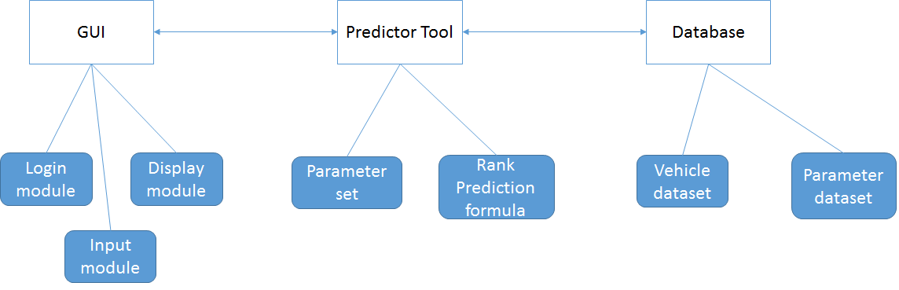

The main modules of ATS and their functioning is as follows:

* Graphical User Interface(GUI):
  + Login Module: Responsible for ensuring security to the interface as well as redirecting the different kinds of users to different pages based on their clearance level.
  + Input Module: Responsible for accepting input from the different kinds of users and passing it to the predictor tool. The inputs maybe dataset entries, parameters for prediction or test result values.
  + Display Module: Responsible for displaying the results from the tool to the user.
* Predictor tool model:
  + Parameter set: Consists of the parameters used in rank and comfortability prediction.
  + Rank Prediction formula: The weighted formula, considering the different testing values in different measures for producing a final rank for the automobile.
* Database:
  + Vehicle dataset: Consists of data about different vehicle models and their parameters.
  + Parameter dataset: Consists of data about the different parameters used in rank prediction.

User Interaction:

In ATS, there are three different kinds of users who interact at different levels and modules:

* End User: The end user uses the tool as it is and enters test results to the tool in order to predict the rank of the vehicle.
* Database Administrator: The database administrator interacts with the database and enters and alters data stored in it. A different login is provided for this kind of user which directs him to the database interface.
* Prediction Tool Administrator: The tool administrator has the capability to alter the parameter values used for vehicle evaluation and rank prediction via the interface provided. A different login is provided for this kind of user which directs him to the parameter interface

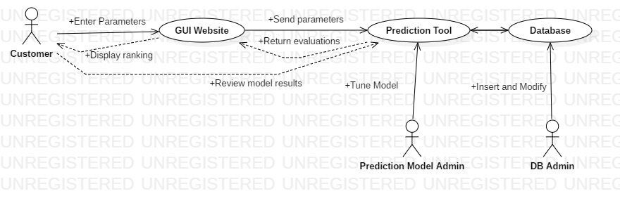

# Requirements List

# *Predictor tool Module*

* + 1. ***Non-Functional Requirements***

|  |  |
| --- | --- |
| **Reqmt #** | **Requirement** |
| RMNF1 | The weights of the rating formula should be updated only for new ratings, i.e. changes made to the weights should not be reflected in ongoing calculations. |
| RMNF5 | In case of failure, the module should re-obtain full functionality and consistency within one minute. |
| RMNF6 | The module should display the rating and rank of the automobile within 500 milliseconds. |

* + 1. ***Functional Requirements***

|  |  |
| --- | --- |
| **Reqmt #** | **Requirement** |
| RMFR1 | The module should be able to rank the automobiles based on filters such as type, cost range with user specified precision upto Rs 1000, time range with user specified precision upto 1 month. |
| RMFR2 | The module administrator should be able to set and modify the rating formula and its weights. |

* 1. ***Login Module***
     1. ***Non-Functional Requirements***

|  |  |
| --- | --- |
| **Reqmt #** | **Requirement** |
| LMNF1 | After entering the login details, the dashboard should be displayed within 5 seconds on a 100 kbps internet connection. |
| LMNF2 | If a user types incorrect passwords 5 times, his account should be blocked and an alert should be sent to the security administrator. |
| LMNF3 | The login module should be supported by Mozilla Firefox, Safari, Google Chrome and Internet explorer. |

* + 1. ***Functional Requirements***

|  |  |
| --- | --- |
| **Reqmt #** | **Requirement** |
| LMFR1 | The login page should consist of username, password, user type and a checkbox for keeping the user signed in. |
| LMFR2 | The username field should accept usernames with a minimum of 8 and a maximum of 32 alphanumeric and special characters. Each username should have at least one alphabet and one special character. |
| LMFR3 | The password field should accept passwords with a minimum of 10 and a maximum of 30 alphanumeric and special characters. Each password should contain at least one alphabet, one numeric character and one special character. |
| LMFR4 | Users of each type should be redirected to a different dashboard which has only those features that the user has the clearance to access. |
| LMFR5 | The login page should also have a signup button for new users. This button should redirect the user to a signup page. |
| LMFR6 | The signup page should have fields to record username, mobile number, email id, user type, password, password confirmation and a button to register user. Out of these fields password, password confirmation, username and user type are mandatory and have to be marked by an asterisk beside the respective fields. |
| LMFR7 | When the user presses the register button, a request containing the user’s details is sent to the corresponding department, based on the user’s type, to request permission to register the user. Only after the department confirms the authenticity of the user, the user’s account is created. |

* 1. ***Database Module***
     1. ***Non-Functional Requirements***

|  |  |
| --- | --- |
| **Reqmt #** | **Requirement** |
| DMNF1 | Requests from the ranking & rating module should be reflected in the database within 100 milliseconds |
| DMNF2 | Requests from the login module should be reflected in the database within 500 milliseconds. |
| DMNF3 | The database should have a minimum of 95% reliability and availability. |
| DMNF4 | The database should have a backup log which is updated every day. |

* + 1. ***Functional Requirements***

|  |  |
| --- | --- |
| **Reqmt #** | **Requirement** |
| DMFR1 | The database should have storage capacity of 500 GB. |
| DMFR2 | The database should support concurrent access for upto 100 users. |
| DMFR3 | The database should be able to store alphanumeric and special characters. |
| DMFR4 | The database has a single access point via the user’s account. The database servers are kept in a secure location with 24 hour surveillance. The servers are insured against natural disasters and server farm accidents. |

# External Interface Requirements

The user interface for the software shall be compatible to browsers that support HTML5 such as Internet Explorer, Mozilla Firefox, Google Chrome or Microsoft Edge by which user can access the ATS.

* 1. ***Hardware Requirements***

Since this is a web-based application, all the hardware requires internet connection through a Modem, WAN–LAN or Ethernet Cross-Cable. A display of minimum resolution of 720p and maximum resolution of 2K. A mechanism to provide input e.g Touch screen or Keyboard and Mouse.

* 1. ***Software Requirements***

Database management system:

**MySQL:**

* Description: MySQL is an open-source relational database management system.
* Version: MySQL 8.0

Server system:

**Apache Web Server:**

* Description: The Apache HTTP Server, colloquially called Apache, is free and open-source cross-platform web server software, released under the terms of the Apache License 2.0.
* Version: Apache HTTP Server version 2.4.41

Operating System:

**Ubuntu:**

* Description: Ubuntu is a free and open-source Linux distribution based on Debian. Ubuntu is officially released in three editions: Desktop, Server, and Core. All the editions can run on the computer alone, or in a virtual machine. Ubuntu is a popular operating system for cloud computing, with support for OpenStack.
* Version: Ubuntu 16.04

Additional packages:

**Bootstrap:**

* + Description: Bootstrap is a free and open-source CSS framework directed at responsive, mobile-first front-end web development. It contains CSS- and JavaScript-based design templates for typography, forms, buttons, navigation and other interface components.
  + Version: Bootstrap 3.3.7

**PHP:**

* Description: Hypertext Preprocessor is a general-purpose programming language originally designed for web development.
* Version: PHP [7.3.10](https://www.google.com/search?sxsrf=ACYBGNRQi1f2KJhafH3Ny97N7FmxWK8q5g:1570854210961&q=7.3.10&stick=H4sIAAAAAAAAAONgVhLQL9E3sjRITsoxyTY0TDEwXMTKZq5nrGdoAADnSsO8HQAAAA&sa=X&ved=2ahUKEwjG2vP575XlAhUBiHAKHY5zCioQmxMoATAfegQIDxAH&sxsrf=ACYBGNRQi1f2KJhafH3Ny97N7FmxWK8q5g:1570854210961)

* 1. ***Communication Interfaces***

All communication between the customer and the back-end is through HTTP that runs over TCP/IP protocol suite and software port used is 80. Minimum Line Speed must be around 2-3 Mbps or even more. And the server side has a 250 MB cache buffer.

# User Interfaces

* The GUI is in the form of a webpage which will adapt to the user’s display resolution automatically using responsive design in bootstrap.
* The user interface has a form to input different testing parameter values and generate rank and a rating based on the information provided.
* The database administrator has a form to enter values to be stored in the respective database.
* The predictor tool administrator has an interface to modify the parameters used for evaluating the rank and rating.

# Performance Requirements

* The software should be capable of handling upto 1000 transactions per day.
* The software should be able to accommodate upto 100 concurrent users.
* The database should have a storage capacity of 500 GB.
* Response time - The time taken to respond to user search should be less than 0.5 second.
* The latency of the software should be less than 100 milliseconds.
* The software is compatible across all browsers that support HTML5.

# Special Characteristics

* All data stored in the database is encrypted using MD5 encryption algorithm
* User privileges are checked using a unique 8 character UID which is automatically generated for each user upon sign up. Access to the database is restricted only to authorised UIDs.
* The database should have a transaction log of size 1 GB which is updated every day.
* The database should have a backup of size 500 GB to implement fault tolerance.

# Help

* Provide contact, FAQ, E-manual for the customer to give details on the different test parameters our tools considers and how to enter them.
* E-manual includes instructions for operating the predictor module such as entering test result values, updating weights for each parameter, generating graphical reports to compare different vehicles and their scores.

# Other Requirements

* 1. ***Site Adaptation Requirements***
* The back-end servers should have an onsite electricity back-up such as a diesel powered generator.
* Server side network should have a constant bandwidth in the range of 1-3 Mbps.
  1. ***Safety Requirements***
* IEEE STD-1228 and MIL-STD-882E standards on ensuring explicit safety requirements are met and verified using functional approaches from a safety requirements analysis and test perspective.

# Packaging

* The deployment process should consist of Compiling, Linking and deployment.
* The software can also be downloaded from the website and then deployed on the systems.
* The software should be encrypted during the packaging so the user cannot crack it and use it for free.
* We can also make some part of the software free and accessible for the user and we can make the main features of the software included in a paid version.

# 12.0 Traceability Matrix

|  |  |
| --- | --- |
| **URS Reference Section No. and Name** | **CRS Reference Section No. and Name** |
| 4.1 Ranking & Rating Module | #RMFR1  #RMFR2 |
| 4.2 Login Module | #LMFR1  #LMFR2  #LMFR3  #LMFR4  #LMFR5  #LMFR6  #LMFR7 |
| 4.3 Database Module | #DMNF1  #DMNF2  #DMNF3  #DMNF4 |