To access the TCS Administrator screens go to the URL: http://www.tcats.com/PlayListDB/

Enter the User Name and Password

The admin tool bar will appear on the left side of the tcats.com web page.
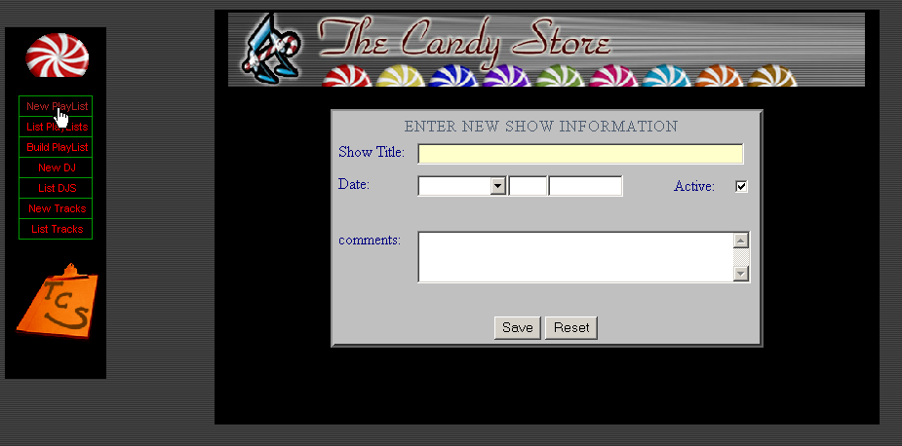

Selecting “New Play List “ will bring up the screen for creating a new play list/show.
- The show title (play list title) is a mandatory field. It will appear as the heading of each playlist. Also it will appear to visitors of the playlist page as a selectable playlist.
- The Date field = date of show for which playlist is being created. If left blank it will automatically be set to today’s date.
- Active = only playlist checked as active will be available to website visitors. If you do not want the playlist to be available uncheck this field.
- Comments are used for any other notes you wish to add to the playlist.

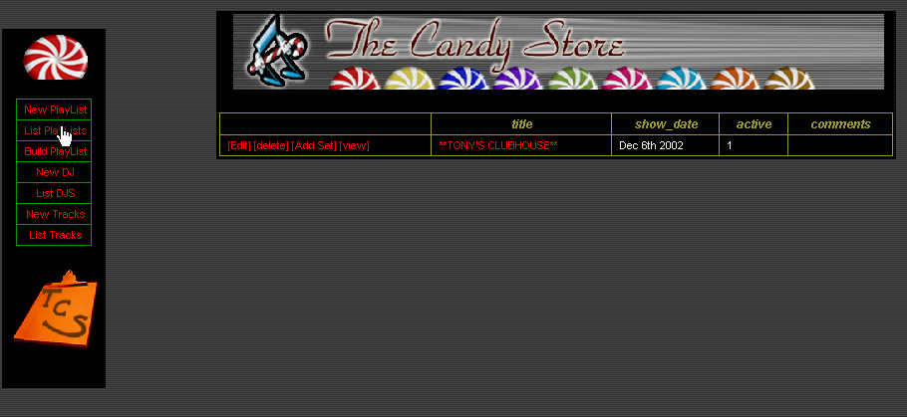

After the playlist is added you will be taken to the list playlist screen which will list all the play lists currently in the database.
- Edit – Opens up the playlist in edit mode. Allowing you to add sets tracks etc. (see the edit playlist below)
- Delete – will delete the current playlist for the database. (This should be used very carefully.)
- Add Set – Takes you to the Add New Set screen for the current playlist ( see below)
  - 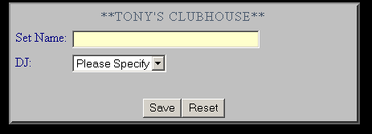
(Add New Set Screen)
  - Note: DJ’s must be added to the database using the Add new DJ screen prior to creating a set. See the Adding DJ’s Section.
- View – Opens the playlist in View mode (The mode which the website visitors will see it.)

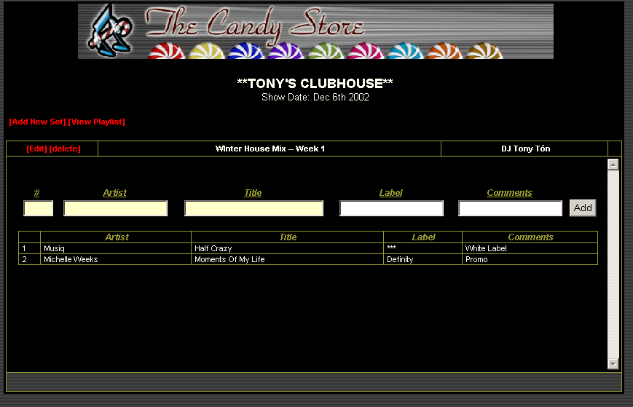
(Edit playlist Screen)

Enter the track information for the set very carefully.
- # : Row sequence number.

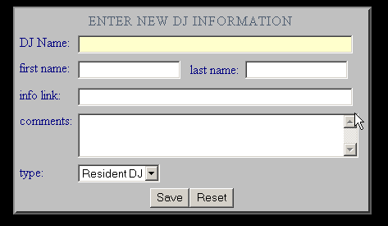
(New DJ)
- DJ Name: Mandatory Field
- Info Link: Link to the webpage of the dj. (note use full absolute link ie. http://www.tcats.com/sweet.html)
- Type: Resident DJ or Guest DJ

