**EMBEDDED SYSTEMS LABORATORY PROJECT**

**Topic:** Smart Dustbin

**Team Members:**

Akil Vishnu M 2018115010

Balasubramaniam M 2018115018

**Problem:**

People are lazy to drop dusts properly into the dustbin. People forcefully drop dusts though the bin is overflowing. These activities leads to many diseases and polluted environment.

**Solution:**

We designed an embedded system in a dustbin to overcome the above stated problem. This system will automatically sense a person or an object and opens and closes the lid. It also takes care of the overflow by sensing and sending an SMS to the concerned person who cleans the bin.

**Materials Used:**

* Arduino UNO 3
* Ultrasonic Sensors
* SIM900A GSM Module
* Servo Motor
* Jumpwer Wires

**Working Procedure:**

* Arduino UNO 3 is used in this project. We use 2 ultrasonic sensors. One for the detection of any nearby object which is placed at front and the other one is to check the status of the dustbin (dustbin is full or not) which is placed inside the lid. We use a servo motor for opening the lid of the bin. Also a SIM900A GSM module to send SMS when the bin is full, to the concerned person who cleans the bin.

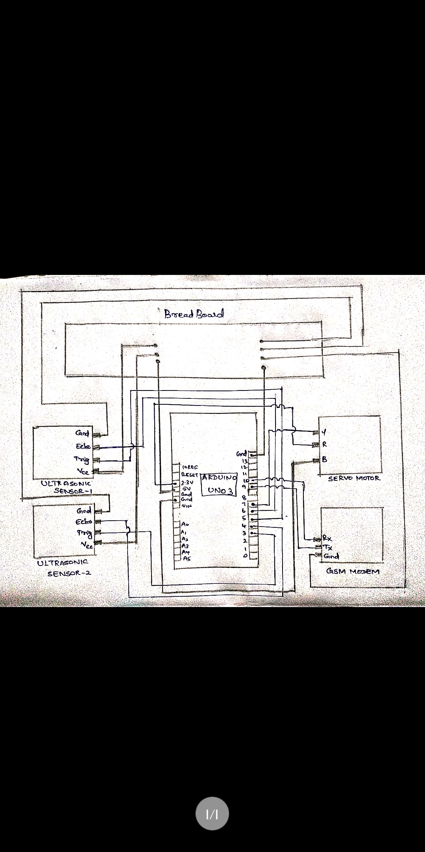

* All the above connections are made.
* We connect Arduino to the computer to upload Arduino sketches.
* All the pins are defined. A function called “setup” is written to initialise all the modules used. A function called “loop” is written next which runs repeatedly indefinite number of times. Inside the loop function, ultrasonic sensors 1’s trig pin is set to high and then low for certain time duration. Then the echo pin is monitored using “PulseIn” to get the distance of incoming object. The distance is then divided by two to get the actual distance between the bin and the object. The result is now again divided by 29.1 which is the pace of sound in dry air. This is the process of sensing the nearby object. This process of sensing is done thrice to get the accurate distance. The average of all three result is taken and then the final distance is checked with the threshold value (here 50) which indicates that an object is approaching the bin. If the final result is less than the threshold values, it denotes that a person is approaching the bin.
* As it identifies that a person or object is approaching the dustbin, it then checks whether the bin is full or not, by using the same sensing process done for identifying the incoming object. Here, the threshold value used is 5. If the final distance of the second ultrasonic sensor used inside the lid is greater than the threshold value, it then makes the servo motor to rotate by 150 degrees so that the lid opens. A delay of 3000 microseconds is set and so the lid which is opened previously will close after this delay.
* If the final distance of the second ultrasonic sensor used inside the lid is less than the threshold value, it denotes that the bin is full. So the servo motor is not set to rotate. Now, the function for sending SMS through SIM900A GSM module is called where “AT” command is used. “AT+CMGF =1” is used to set the modem’s mode to send SMS. Next, "AT+CMGS=\"**********\"\r"(where the ‘*’s are replaced by the phone number) is used to set the phone number of the concerned person who cleans the bin. Then the message to be sent is specified which is “Bin is full. You are requested to clean it. Thank you!”. Once the SMS is sent, the whole process is repeated again and again.
* Demo of the project has been shown and the recording is also attached.