# dt_dev_tools_color_white.png

# MASTER AUDIO PLUGIN V3.5 - By Dark Tonic, Inc. (c) 2012-2014

# Table of Contents

|  |  |
| --- | --- |
| 1. Solutions! Master Audio solves the following problems | 2 |
| 2. Quick Start: How to set up your scene to utilize Master Audio | 3 |
| 3. Triggering the Audio - "no coding" methods (includes all Unity 4.6 UI events!) | 8 |
| 4. Triggering the Audio - code methods | 13 |
| 5. Controlling the Audio - code methods | 15 |
| 6. Audio Groups: Fine-tuning through the Inspector panel | 16 |
| 7. Master Audio Prefab: Advanced Options | 23 |
| 8. Audio FX Filters: Reverb, chorus etc. | 28 |
| 9. Playlist Controller and Music Playlists | 29 |
| 10. Dynamic Creation and Modification of Sound Groups & Other Items | 34 |
| **11. Unity V5 Audio Features!** | 36 |
| 12. Sound Group Organizer (copy between DSGC / MA prefabs in different Scenes) | 37 |
| 13. Custom Events | 38 |
| 14. Persistent Settings (Global Music / SFX Volumes and more) | 39 |
| 15. Master Audio Clip Manager | 40 |
| 16. Playmaker Integration | 41 |
| 17. 2D Toolkit Integration | 42 |
| 18. NGUI Integration | 43 |
| 19. DF-GUI Integration | 43 |
| 20. **Other Plugins** that have Master Audio integration | 44 |
| 21. Installation Folder | 44 |
| 22. Preparing a project for Master Audio | 45 |
| 23. Localization (Multiple Language Support) | 46 |
| **24. Best Practices / Basic Setup Considerations** | 47 |
| 25. Preparing a Project With Existing Audio To Use Master Audio | 48 |
| 26. Audio Memory Allocations / Performance Tips! | 49 |
| 27. Using JavaScript / UnityScript | 50 |
| 28. Final Words | 50 |

This plugin was written to be the be-all end-all for video game audio management! We are always open to hearing your ideas for improvements, suggestions and problems. Email us any time at support@darktonic.com. Our forums are online at: <http://darktonic.freeforums.net> as well.

[For demo videos click here](https://www.youtube.com/watch?v=Ue9waU8g0c0&index=1&list=PLW6fMWQDKB24osBmTuJd0IG8R5tOim6eV).

**Make sure** to check out the multiple example scenes in the **ExampleScenes** folder in the package!

Full undo support exists on Unity 4.3+. Master Audio still supports Unity 3.5.7, but there is no full undo support before Unity 4.3.

Some code options are listed in various parts of this document. The **entire** Master Audio API documentation can be found here: <http://bit.ly/1bkiRei>

### This manual is not short. It's not intended to be read cover to cover but used as a reference for all the options. Please refer to the table of contents and read about the parts that interest you most first.

## 1. Solutions! Master Audio solves the following problems (and tons more)

1. Too many instances of the same audio clip playing simultaneously or near-simultaneously. For example, if an enemy has a death scream sound, you may kill 30 of them with a single blow. 30 audio clips playing simultaneously is not only unnecessary but it drags the CPU down, especially on mobile devices. Master Audio lets you specify the maximum number of each sound that can be playing at a single time.
2. The ability to randomize a certain sound to play from a pool of weighted variation sounds. This goes hand in hand with setting up the maximum number of each sound that can be played. All X sounds in a group can be the same, or variations. You have complete control over that.
3. Having to write code to trigger each sound. Master Audio eliminates the need for this in most cases by letting you specify sounds to play when certain events occur, including uGUI (Unity 4.6 UI), NGUI, Pool Manager, DF-GUI and Custom Events you can define and fire from various Unity (and Master Audio) events. No coding is needed to do this in most cases.
4. Not being able to play sounds when the Audio Source is attached to a game object that is being despawned or destroyed. What happens normally is that you hear a brief blip of the sound and then when the game object is gone, the sound abruptly stops. Master Audio keeps all its Audio Sources in a central location separate from your prefabs so that this doesn't happen.
5. Loading an audio clip from a Resource file, playing it, and then unloading it from memory so you don't have the memory taken up until the whole time. All with no coding!
6. Setting up multi-language Audio which automatically plays sounds in the user's language!
7. Being able to stop all currently playing instances of a certain sound. Since Master Audio knows where all its Audio Sources are at all times, it can trivially do this.
8. Adjusting the volume of categories of sound effects with a slider. Since Unity (pre-V5) does not have anything natively, we have included the concept of a pro mixer with buses. More on this later.
9. Music ducking. You can configure Master Audio to have the music "duck" (meaning get quieter and ramp back up) for whichever sound(s) you like with no coding needed. The amount of ducking is also configurable.
10. Music crossfading. You can set up multiple music Playlists that picks tracks that can shuffle, crossfade and auto advance. You can have any number of Playlist Controllers, each playing a Playlist and with crossfading, and they can optionally synchronize with each other.
11. Not being able to play music during a scene change. Simple to do with Master Audio!

## 

## 2. Quick Start: How to set up your scene to utilize Master Audio

1. From the Unity "Window" menu, select "Master Audio Manager". This is a small window that will help explain and set up what you need for Master Audio. It is important to use this window to create the prefab and not just drag them into the Scene from where are located. This way they will not be linked to the prefabs in the plugin folder, and so will not have their settings erased when you upgrade Master Audio to a newer version. It looks like this:

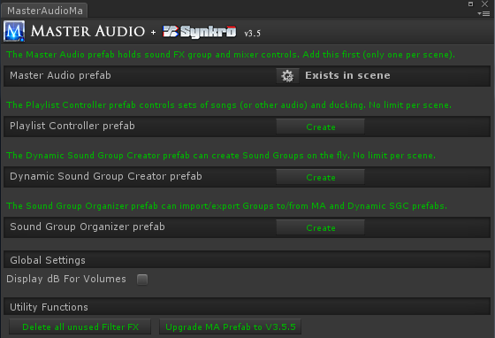

1. If you are a professional audio engineer, or prefer to use dB (decibels) for volume displays, check the "Display dB For Volumes" checkbox under Global Settings. This will show every single volume control as a dB number instead of the default Unity 0-1 range. This setting is stored in PlayerPrefs (technical information for programmers).
2. First, create the Master Audio prefab with the "Create" button. The position of the MasterAudio prefab will be used for any sounds that you don't provide a position to (usually only used with 2D sounds). The Master Audio game object will have a "M" icon in the Hierarchy.

**Note:** Do not reparent the Master Audio prefab. Leave it as top-level. Also do not move any of the sub-prefabs that get created under it anywhere else. They need to stay where they are for Master Audio to work properly.

1. To use music Playlists and crossfading, you can create 1 or more Playlist Controller prefabs with its "Create" button as well. Each Playlist Controller game object will have an icon with 2 blue 8th notes in the Hierarchy.
2. Dynamic Sound Group Creator are covered in their own section (Section 10) later in this document. It is used for per-scene audio and lets you specify them easily.
3. Configuring your first Sound Group. A Sound Group is usually a single sound effect, which consists of one or more Variations (different sounds).
   1. Click on the MasterAudio prefab in the Hierarchy. Your Inspector should now look something like this:

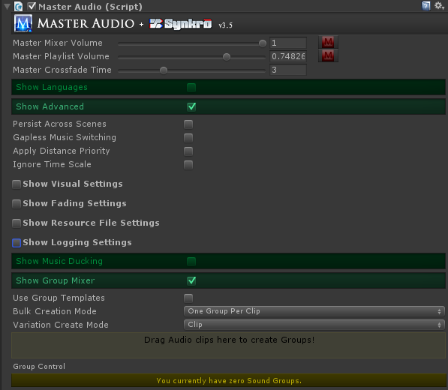

* 1. We’re going to use the Group Mixer section to create our first Sound Group.
     1. Drag your Scream audio clip into the colored rectangle area that says "Drag Audio clips...". It will automatically create a Sound Group for you that has controls below that.
  2. Now your Inspector should look something like this:

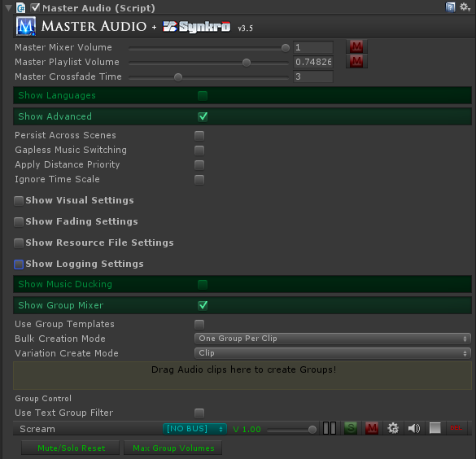

* 1. Notice the MasterAudio logo up top in most Inspectors. You can click on it to navigate to the Master Audio prefab in the Scene as a shortcut. Also notice the speaker and stop icons. These will appear in many places in Master Audio and allow you to preview the audio clip, as well as stop previewing.
  2. Notice that “Scream” now shows up under the last section. If you expand the MasterAudio prefab, you will see it now has a child prefab called Scream, and if you expand that, you will see a child prefab for each Variation (only one this time).
  3. Each of the Variations has an Audio Source component where you can individually tweak the pitch / pan / etc to create different Variations. You can also add effects such as Reverb or Distortion to individual Variations. Or you can drag entirely different Audio Clips in there for Variations as well.

**Note**: the prefab template for Variations can be found in the MasterAudio/Sources/Prefabs folder and is called GroupVariation. If you change any properties on the Audio Source in this prefab, it will carry over into all Master Audio Variations created afterward. So change it there first after you get the Doppler settings (and any others) working to your liking.

* 1. The Sound Groups listed in the “Show Group Mixer” section have a couple buttons for each group.
     1. Go – clicking this will select the Sound Group in the Hierarchy so you can make additional changes.
     2. Delete icon – clicking this will delete the Sound Group. Sometimes you might want to delete it and recreate it with a different number of children. It’s just faster that way.
     3. "S" for Solo. If any Sound Groups are soloed, only the soloed groups will be heard.
     4. "M" for Mute. This will mute the Sound Group. It will produce no audio while muted.

1. Configuring your additional Sound Groups.
   1. Drag your "blast" sound clip into the Audio Clip field. It will automatically create the "Blast" Sound Group.
   2. Click the gear (settings) icon on the mixer row for Blast. It will now take you to the Group settings.
   3. Change the Weight field to 6. This means that 6 Blast sounds will be able to be played simultaneously. More on this later.
   4. Click back to the Master Audio prefab. Note the controls above the mixer drag area.
      1. Show / Hide Group Creation. This button can get the Group Creation section out of your way if you want more screen real estate.
      2. Use Group Template - if you check this, a dropdown of Group Templates will appear underneath. Now whenever you drag in an Audio Clip, it will create a Sound Group and Variations based on the template selected in the dropdown. Bulk Creation Mode (described next) is disabled when using Group Templates because Group Templates take a single audio file and create 1 or more Variations of it based on the template). There are 19 templates, including:
         1. 25% Chance To Play
         2. Random Pitch Subtle
         3. Volume Falling
         4. Pitch Rising Chromatic

**Note:** you can create more templates and drop them in the folder: MasterAudio/Sources/Prefabs/GroupTemplates. If you make any cool templates, please do share them with Dark Tonic and we may include them in future updates! You create a template by doing the following:

1. Set up the Group as normal in the Master Audio game object in the Scene.
2. Note that you can name a Variation "Silence" to specify that this Variation should not have an Audio Clip when using the template.
3. Duplicate the Group (CTRL + D on Windows).
4. Drag the duplicate outside of the Master Audio game object and use this for the next step.
5. In this duplicated Group, remove all Audio Clips and all Filter FX in all Variations. Be extra careful that you don't leave or put any Audio Clips or filter FX into the templates themselves as they will take up audio memory even if you haven't created any Groups with the templates! We check that both of these aren't in the template up front, but if you add them to the template prefab later, we cannot catch that.
6. Now drag the Sound Group game object into the MasterAudio/Sources/Prefabs/GroupTemplates folder.
   1. Bulk Creation Mode: This is for quick Sound Group and Variation creation. You can click the lock icon at the very top right of the Inspector to enable selection of multiple clips from Project view without losing focus on the Inspector to use bulk mode. There are two choices in the dropdown:
      1. One Group Per Clip (the default) . Each clip will create a new Sound Group with 1 Variation, which is the clip.
      2. One Group With Variations. This will create a single Sound Group and each clip will become a Variation of the clip.
   2. Variation Create Mode - this is the 2nd dropdown and lets you choose between Resource File and Clip.
      1. Resource File - if you choose this, all Variations will be created with the Audio only available as you need it, not created when the Scene starts. It will also unload from memory after it is no longer being played.

If you are using a Resource File, another checkbox "Use Localized Folder" will appear. Read the Localization section near the end of this document for more information on that.

**Note:** when Resource File is chosen, you can drag a clip into a drag area that appears underneath to use its file name. This drag area appears everywhere that Resource Files can be used in Master Audio.

* + 1. Clip - if you choose this, the clip will be loaded immediately when the Scene starts.

## 3. Triggering the Audio - "no coding" methods

Now that you have sounds set up, let's see how to trigger them automatically. There are a few scripts to help out on this:

1. **ButtonClicker.cs** is a script that works with NGUI only. See NGUI Integration section. Add this to a prefab from the menu here: Component -> Dark Tonic -> Master Audio -> Button Clicker.
2. **EventSounds.cs** is a powerful and flexible script that you can attach to prefabs to trigger MasterAudio sounds (and manipulate Playlists, Sound Groups and Buses) for certain MonoBehavior, PoolManager / PoolBoss (Core GameKit) and other events. So even without Playmaker, you have a wide variety of "no code" actions you can do with Master Audio. Add this script to a prefab from the menu here: Component -> Dark Tonic -> Master Audio -> Event Sounds. There are events for:
3. OnStart
4. OnBecameVisible
5. OnBecameInvisible
6. OnEnable
7. OnDisable
8. OnCollisionEnter2D (this and the next three are only available on Unity 4.3+)
9. OnCollisionExit2D
10. OnTriggerEnter2D
11. OnTriggerExit2D
12. OnCollisionEnter
13. OnCollisionExit
14. OnTriggerEnter
15. OnTriggerExit
16. OnParticleCollision
17. OnMouseEnter (legacy). For this and the next 4, legacy means pre-Unity 4.6.
18. OnMouseExit (legacy)
19. OnMouseDown (legacy)
20. OnMouseDrag (legacy)
21. OnMouseUp (legacy) - (has options to fade or stop the OnMouseDrag sound, if you have one).
22. uGUI (Unity 4.6 UI) events: Slider Changed, Button Click, PointerEnter, PointerExit, PointerDown, PointerUp, Drag, Scroll, UpdateSelected, Select, Deselect, Move, InitializePotentialDrag, BeginDrag, EndDrag, Submit, Cancel. For these to show up, you must place Event Sounds on a Game Object that has a RectTransform component (any uGUI component).
23. For PoolManager and Core GameKit users, we also have OnSpawned and OnDespawned. To get these to show up, you must check the "Pooling Events" checkbox.
24. 5 NGUI events: NGUI Mouse Click, NGUI Mouse Down, NGUI Mouse Up, NGUI Mouse Enter, NGUI Mouse Exit. These can be shown by checking the "NGUI Events" checkbox up top.
25. There are 7 DF-GUI events as well if you install the optional DF-GUI package (mentioned later).
26. Mechanim State Entered - you can add any number of these. For each one, you specify the name of the Mechanim State that when entered will trigger your actions (only shows up in Unity V 4+).
27. Custom Event - you can add any number of Custom Event Receivers to Event Sounds. For each one, you specify which event you're receiving.

**Note:** The events that aren't plugin specific are Unity MonoBehavior events and descriptions of them can be found here: <http://docs.unity3d.com/ScriptReference/MonoBehaviour.html>

**Note:** OnBecameVisible (and OnBecameVisible) will only work on a Game Object that has a Renderer component inside it. In cases where batching will reassign or not use the Renderer (NGUI / 2D Toolkit, etc), you may opt to use the OnEnable / OnDisable / OnStart events instead (or the Pooling events). They don’t provide exactly the same functionality but it will work for most purposes.

Add events from the "Event to Activate" dropdown. Note that any Custom Events you have added will show up even when deactivated. You check the checkbox for the event to activate it for usage.

Event Sounds looks something like this:

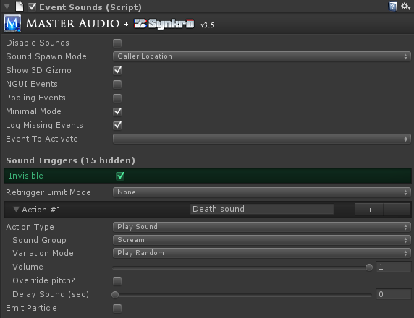

You can add a section for each event type in the Inspector. Each section can have any number of actions (starts with 1). You can add more actions using the Add button. Each action has a name you can edit - this is for your use only. All actions are executed from top to bottom when the event occurs. You can move the actions up and down using the arrow icons. The Del icon deletes an action.

**Note:** Doing a fade of a Sound Group followed by a Stop action on the same Group does not wait for the fade to finish before stopping the sound. The actions will start the action (fade), then immediately move to the next action.

At the event level, the following settings exist:

1. Retrigger Limit Mode - None is the default. Using another option allows you to stop the event from performing its actions again until a number of frames or seconds pass since the last time it performed the actions.
   1. If you choose frame-based, specify the minimum number of frames.
   2. If you choose time-based, specify the minimum number of seconds.

Each action has the following settings:

Action Type - with 5 choices.

1. Play Sound -the default. Play a sound, 2d or 3d, according to your Sound Spawn Mode setting.
   1. Sound Group dropdown (as before).
   2. Volume control to make the sound quieter
   3. Delay Sound (seconds) - this allows you to schedule a sound to be played X seconds from now. **Now available on Unity V3.5.7 as well!**
2. Group Control - choosing this will reveal a menu of Group Commands to perform various Sound Group actions, some of which have an additional field or two. There is also a checkbox "Do For Every Group?", which if checked will perform the command on every Sound Group.
   1. Fade To Volume
   2. Fade Out All Of Sound
   3. Mute
   4. Pause
   5. Solo
   6. Stop All of Sound
   7. Unmute
   8. Unpause
   9. Unsolo
   10. Stop All Sounds Of Transform (this and the next 6 all only affect sounds played by the same Transform).
   11. Stop Sound Group Of Transform
   12. Pause All Sounds Of Transform
   13. Pause Sound Group Of Transform
   14. Unpause All Sounds Of Transform
   15. Unpause Sound Group Of Transform
   16. Fade Out Sound Group Of Transform
   17. Refill Sound Group Pool
3. Buttons
   1. Mute/Solo Reset - clicking this will unsolo and unmute all Groups.
   2. Max Group Volumes - clicking this will reset all volumes to max.
   3. Use wide Mode - defaults to off. Turning this on makes the Group and Bus sliders 3 times as wide. Good for fine adjustments, but takes up a lot of screen real estate.
4. Bus Control - choosing this will reveal you a menu of Bus Command to perform various Bus actions, some of which have an additional field or two. There is also a checkbox "Do For Every Bus?", which if checked will perform the command on every Bus.
   1. Fade to Volume
   2. Mute
   3. Pause
   4. Solo
   5. Stop
   6. Unmute
   7. Unpause
   8. Unsolo
   9. Change Bus Pitch
5. Playlist Control - choosing this will reveal a menu of Playlist Commands to perform various Playlist actions, some of which have an additional field or two. There is also a checkbox "All Playlist Controllers?", which if checked will perform the command on every Playlist Controller. Not every command has this option. Playlist Controller Name is optional if you have only one of them.
   1. Change Playlist (by name)
   2. Fade to Volume
   3. Play Clip
   4. Play Random Song
   5. Play Next Song
   6. Pause
   7. Resume
   8. Stop
   9. Restart
6. Custom Event Control - choosing this will reveal a menu of Custom Event Commands.
   1. Fire Event - this will fire the event you specify, and all Custom Event Receivers in the Scene that are configured to receive the event will respond.

**Note:** when receiving Custom Events, if you are receiving multiple events in a single Event Sounds component, you can sort them alphabetically with a button in the top section labeled "Alpha Sort Custom Event Triggers".

1. Global Control - choosing this will reveal a menu of Global Commands. "Mixer" commands affect all Sound Groups in the mixer at once. "Everything" commands affect all Sound Groups and Playlists as well.
   1. Pause Mixer
   2. Unpause Mixer
   3. Stop Mixer
   4. Stop Everything
   5. Pause Everything
   6. Unpause Everything
   7. Mute Everything
   8. Unmute Everything

**Note**: if you have more than one Playlist Controller, you will need to select a Playlist Controller from the dropdown or select the "All Playlist Controllers" checkbox so Master Audio knows what to do.

If you have a Shuriken particle system attached to this object, you can emit particles as well with the other two properties there.

Additionally, the Trigger and Collision events have layer and tag filters. If you enable these, you can specify which layer(s) and / or tag(s) the object you’re colliding with must be to trigger the sound.

At the top are the following controls:

1. Sound Spawn Mode - 3 possible settings.
   1. Master Audio Location: The sound will emanate from MasterAudio's position.
   2. Caller Location: This will trigger the sound in 3D from the prefab's position.
   3. Attach To Caller: The default. This will not actually reparent the Variation prefab, but it will follow the location of the prefab that has the Event script. This way sounds won't get cut off or Variation objects destroyed when things despawn or get destroyed by Scene changes.
2. Disable Sounds: Checking this will disable all event sounds on this prefab.
3. Log Missing Events: defaults to on. If you create Custom Events at runtime (not configured in Master Audio prefab, turn this off to avoid false warnings in a "Type In" event in this script.
4. **EventCalcSounds.cs** is a script just like **EventSounds.cs**, with slightly more CPU-intensive operations. Add this script to a prefab from the menu here: Component -> Dark Tonic -> Master Audio -> Event Calc Sounds. It has one event type:
   1. AudioSourceEnded - This is only usable when you have an Audio Source component with a sound/music on your prefab. If you do, this can trigger a MasterAudio sound every time the Audio Source finishes playing. If your Audio Source is looped, this will keep happening every time the sound loops again.

4. **FootstepSounds.cs** is a more compact and focused version of **EventSounds.cs**, focused on playing different sounds for different collision / triggers on the same game object. Event Sounds doesn't let you play a different sound for a different tag or layer unless you add a new Event Sounds for each tag or layer. Add this script to a prefab from the menu here: Component -> Dark Tonic -> Master Audio -> Footstep Sounds. Settings are as follows:

1. Event Used: this dropdown defaults to None, which will not play any sounds or allow you to configure any. You can change it to Trigger Enter, Collision Enter, or their 2D equivalents. Then the rest of the controls will show up underneath.
2. Retrigger Limit Mode - works the same as the Custom Event setting of the same name.
3. Then you add any number of Footstep Sounds with the Add Footstep Sounds button. Each one has the following controls.
   1. Layer / tag filters - works the same as Event Sounds.
   2. Sound Group / Variation Mode / Volume / Override pitch / Delay Sound - work the same as Event Sounds.

## 4. Triggering the Audio - code methods

If you need to trigger any Sound Groups during times other than those provided by the included scripts, you can use the following single lines of code:

*MasterAudio.PlaySound(string soundGroupName, float volumePercentage, float? pitch, float delaySoundTime, string variationName);*

This plays the sound from the position of MasterAudio. All parameters after the 1st are optional. Volume percentage lets you play a lower volume version (0-1 is the range). Pitch, if specified, let you override the chosen Variation's pitch and random pitch and use the pitch parameter instead. Variation Name is optional and lets you play a specific Variation (or its clones created from Weight >1) by name. DelaySoundTime lets you schedule a sound to be played X seconds from now (Unity 4.X+ only).

There are many new methods for PlaySound and PlaySound3D in V3.3.4, listed below. The old PlaySound3D (not listed here) is considered deprecated and may be removed in the future. Please use one of the more specific methods instead. In fact, you cannot compile if you are using PlaySound3D. Consult the API Website for full details (link above on page 2).

1. *PlaySound*
2. *PlaySoundAndForget*
3. *PlaySound3DAtVector3*
4. *PlaySound3DAtVector3AndForget*
5. *PlaySound3DAtTransform*
6. *PlaySound3DAtTransformAndForget*
7. *PlaySound3DFollowTransform*
8. *PlaySound3DFollowTransformAndForget*
9. *PlaySound3DAndForget (used only by Playmaker Custom Action).*

These are the same as "PlaySound", but you are passing in the Transform object as well (or Vector3) so that the sound will trigger from its position. If you use the FollowTransform methods, the Sound Group's Variation will "follow" the caller.

Using the "AtVector3" methods is useful for 2D games where the Z of the object making the sound might not want to be used. You can alter is and use this.

The "AndForget" methods do not return a PlaySoundResult, and the rest do. If you don't need it, it is better for performance to not generate it. A PlaySoundResult object has the following properties:

1. SoundPlayed (boolean)
2. SoundScheduled (boolean) - false unless you scheduled a sound with the delaySoundTime field.
3. ActingVariation (SoundGroupVariation) - this will give you access to the actual Variation used, if a sound was played.

**Note:** You can use ActingVariation.audio to access the properties of the Audio Source for the Variation used. You should \*never\* set volume this way though, as it will not take into account all the other MasterAudio calculations for volume (Group / Bus / Variation / Mixer volume). If you do, it will appear that Master Audio is not working correctly. Instead, use *ActingVariation.AdjustVolume* for this.

You can also use the PlaySoundResult to be notified of when a sound is finished playing like this (make sure to check if it's null first!:

*var result = MasterAudio.PlaySound("Scream");*

*if (result != null && result.SoundPlayed) { // note: if you played the sound with a delay, use result.SoundScheduled*

*result.ActingVariation.SoundFinished += YourMethodToCall;*

*}*

Then simply add the following method to the same class to receive the Message Sent:

*void YourMethodToCall() {*

*// do something, like play an animation!*

*}*

**Note**: You do not need to worry about unsubscribing to the Event as all subscribers are cleared out every time the Variation is played.

The PlaySoundResult can also be used to fade a clip out early.

*var result = MasterAudio.PlaySound("Scream");*

*if (result.ActingVariation != null) {*

*result.ActingVariation.FadeOutNow(float fadeTime);*

*}*

If you do not specify the fadeTime parameter, it will use the Variation's fade out time value from the Inspector.

You can also write a Coroutine to "chain" several sounds together, like this:

*StartCoroutine(Play3Sounds()); // call the Coroutine below.*

*private IEnumerator Play3Sounds() {*

*yield return StartCoroutine (PlaySoundAndWaitUntilFinished("Arrow"));*

*yield return StartCoroutine(PlaySoundAndWaitUntilFinished("Blast")); // play "Blast" after.*

*yield return StartCoroutine(PlaySoundAndWaitUntilFinished("Scream")); // play "Scream" after.*

*}*

There are also commands like:

*MasterAudio.StopAllOfSound(string soundGroupName);*

This will stop all sounds of the given type instantly.

*MasterAudio.FadeOutAllOfSound(string soundGroupName, float fadeTime);*

This will fade out all Variations of the specified sound.

-You can always check the MasterAudio.SoundsReady property through code (returns true or false) if you want to check if MasterAudio has finished initializing. This is only needed in rare startup cases during Awake on objects that are present during Scene load. All the other methods check this anyway to make sure it is true. Generally try not to trigger sounds during Scene Awake as MasterAudio initializes itself then. Or you can use ScriptExecutionOrder and make MasterAudio.cs execute first.

**Note:** for your own code classes you may write, if you're on Unity 4, you can use the Custom Property Drawer "SoundGroupAttribute", so you can decorate public strings that are Sound Groups in your Inspectors like this:

*[SoundGroupAttribute] public string laserSound;*

This will show you the familiar Sound Group dropdowns used on all the Master Audio Inspectors!

## 5. Controlling the Audio - code methods

There are several methods you can call to modify the volume levels and mute/solo switches.

*1) MasterAudio.MasterVolumeLevel*  - can be read or set. Value between 0 and 1.

*2) MasterAudio.GetGroupVolume(string soundType) - returns a float.*

*3) MasterAudio.SetGroupVolume(string soundType, float volume)*

*4) MasterAudio.MuteGroup(string soundType)*

*5) MasterAudio.UnmuteGroup(string soundType)*

*6) MasterAudio.SoloGroup(string soundType) -* also unmutes the group.

*7) MasterAudio.UnsoloGroup(string soundType)*

*8) MasterAudio.GrabGroup(string soundType)* - in case you want to read or manipulate other properties of the group such as limit mode or Retrigger Percentage settings, grab the object here.

*9) MasterAudio.SetBusVolumeByName(float volume, string busName)* - this can change a bus volume.

*10) MasterAudio.GrabBusByName(string busName) -* you cangrab the Bus to read or change its properties.

*11) MasterAudio.GrabPlaylist(string playlistName) - grabs a Playlist by name.*

*12)PlaylistController.InstanceByName(string playlistControllerName) - grabs a Playlist Controller by name.*

There also are methods to pause or fade to a specified volume (over X seconds) a Bus, Group, Variation or the Playlist. Consult the Master Audio API document for details: <http://bit.ly/1bkiRei>. Playmaker Custom Actions exist for these as well.

## 6. Audio Groups: Fine-tuning through the Inspector panel

Additional settings are on each Sound Group (under then MasterAudio prefab). It allows you to quickly change the Variation clips and volumes.

1. The Inspector for a Sound Group looks like this:

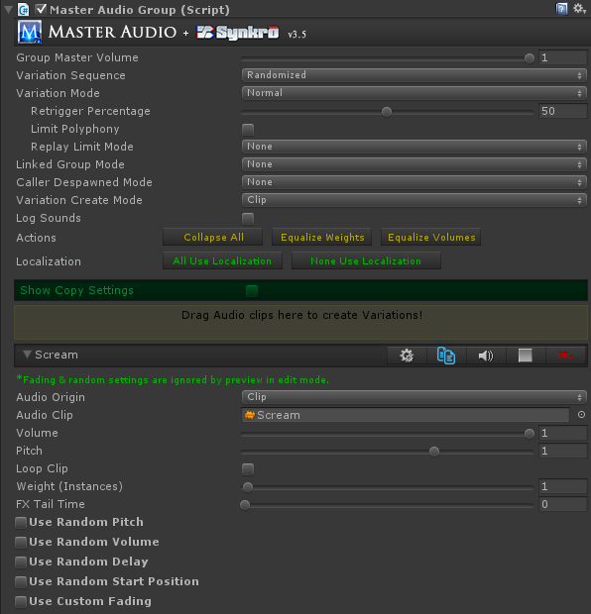

Controls are described below.

* 1. Group Master Volume. This allows you to make all clips under this Sound Group quieter without having to go into each clip and adjust. Its default setting of 1 is full volume. This is the one that shows up on the group mixer.
  2. Variation Sequence - two choices.
     1. Random (the default) - Variations are played randomly from a pool and refilled after all have been played.
     2. Top To Bottom - if you choose this, the Variations are played in alphabetical order and refilled after all have been played. If you have chosen this option, more fields appear.
        1. Refill Variation Pool After Inactive Time - if you check this box, the next field will be used to refill the pool after X seconds of not playing a sound from this Group. Note that the time is measure from the time a sound starts to play, not when it ends.
        2. Inactive Time (sec) - this is how long the pool will wait without any sound being played before it automatically refills the pool (and starts at the top Variation again next time it's played).
  3. Variation Mode - has three choices:
     1. Normal - the default. All Variations can be played simultaneously. There are additional voice and time limiting controls in this mode, described below.
     2. Looped Chain - with a looped chain, the Sound Group becomes something of a mini-Playlist. When you play a Variation, when it reaches the end of the clip, another Variation will be randomly played. It will continue to play random Variations until you stop the Sound Group. In this mode, only one Variation can be played at a time. Any attempt to play another Variation during the same time will stop the other chain that's already going so it can safely start a new chain. All Variation clips will automatically turn off their loop setting in this mode. This is useful for random ambience sound sequences.

**Note:** If you set a Custom Fade Out time for a Variation, the next clip in the chain will start playing when the fade out starts. So if you use both fade in and fade out time, you will have cross fading in your Looped Chain group. Like a mini-Playlist Controller!

* + 1. Dialog - this setting will also stop all other Variations in its Group every time you play one (there is a custom fade time setting that doesn't get cut off though - explained shortly), but with no other restrictions or side effects. Useful for a single character's dialog, to make sure he never says more than one thing at a time without you having to call StopAllOfSound every time you play something from the Group.
  1. If your Variation Mode is Looped Chain, you will see these fields.
     1. Loop Mode - Endless (default) or Number of Loops.
     2. Number of Loops - If you choose Number of Loops for your Loop Mode, you will see this field. Specify the number of times the entire group shall be played. The Group will stop playing after this number of loops.
     3. Clip Change Delay Min / Clip Change Delay Max - if you change these to non-zero, they will specify a range of random pausing before each subsequent chained clip is played.
  2. If your Variation Mode is Normal, you will see these fields.
     1. Retrigger Percentage - this setting will control the percentage of each clip in this Group that must be played before re-using the Variation is allowed. Anything lower than this percentage and the Variation is considered "busy" and cannot be used. 50% is the default. An example: If you set this to 100%, clips can never be interrupted.
     2. Limit Polyphony - this is an optional setting to limit the number of simultaneous Variations that can be played in this Sound Group. If you check this setting, the next setting will appear.

**Note:** Using Limit Polyphony and Bus Voice Limit controls will ignore the settings of Retrigger Percentage. In other words, if the current number of voices playing has reached their maximum for the Group or Bus, Master Audio will not check Retrigger Percentage and basically assume it is 100% or uninterruptible. This is due to code that checks all other Variations if the randomly chosen one is unavailable. This is a known issue and unfortunately not easily fixable.

* + 1. Polyphony Voice Limit - this is only visible and active if Limit Polyphony is checked. This limits the number of simultaneously playing Variations in the Sound Group. i.e. you can set this to 3 even though you have 10 Variations, and only 3 can play at the same time.

**Note:** the normal maximum of any Variation that can be played is its Weight. Polyphony Voice Limit can only **decrease** the amount of a Sound that can be played. If you want to **increase** the amount, do not use Polyphony Limit and increase your Weight fields instead.

* + 1. Replay Limit Mode. This can be used to limit the amount of retriggers of this Sound Group, either by time or frames since the last trigger by MasterAudio. It has 3 modes.
       1. ‘None’ is the default, which does nothing to limit retriggers.
       2. Frame Based will let you choose the number of frames to wait before retriggering is allowed.
    2. Time Based will let you set the amount of time to wait before retriggering is allowed.
  1. If your Variation Mode is Dialog, you will see these fields.
     1. Dialog Custom Fade? Checking box will show and use the next field.
     2. Custom Fade Out Time - the amount of seconds to fade out over when another Variation is played.
  2. Linked Group Mode - this lets you set up other sounds to be played whenever this Sound Group is played, for cool combos. To prevent an endless loop, no linked Groups will be played when a Group is played as a linked Group from another. There are three choices:
     1. None - no linked groups.
     2. Trigger Linked Groups When Requested - this will play the groups you set up in the below section whenever this Group is asked to play, even if it doesn't (due to voice limit / replay limits / etc).
     3. Trigger Linked Groups When Played - this will play the groups you set up in the below section whenever this Group is actually played. Not if it fails to play.
  3. Caller Despawned Mode - this allows you to control what happens to currently playing audio clips when the object "making the sound" is despawned or destroyed.
     1. None (default) - nothing happens. The sound will play until finished, or will loop indefinitely if you have loop clip selected.
     2. Stop - the sound will instantly stop.
     3. Fade Out - the sound will fade out over a period of X seconds. You specify the fade time in the field "Fade Out Time" that appears under this field only when this mode is selected.
  4. Use Clip Age Priority - This is the same as the setting of the same name under Master Audio, but this is for this Sound Group alone. Turn this on if you wish to periodically update the priority of a 3D sound effect based on its "oldness" as well.
  5. Variation Create Mode - this is the same as the one on the Master Audio prefab. Resource File or Clip are the choices.
  6. Always Highest Priority - this is only visible and working when you have Distance Priority turned on in the MA prefab. Checking it makes the priority of that Sound Group always highest priority (not calculated based on distance or clip age).
  7. Log Sounds - there is a global "Log Sounds" checkbox in the Master Audio Inspector's advanced setting, which is the same as checking this one under all Sound Groups. You can choose to only log certain Sound Group events using the one found here though, if the master one is unchecked.
  8. Load Resources Async (only available on Unity 4.5.3+ with a Pro license. **Unity 5 has removed this API so we cannot offer it on Unity 5!**) - the default is on. All Resources will be loaded asynchronously, which means in the background, so your game doesn't grind to a halt while the resource loads. It should mean smooth game play during resource loading. This is only visible if you have unchecked the master one in the Master Audio advanced section, which overrides this one.
  9. Expand All / Collapse all. This button will say either one depending on how many Variations are collapsed. Click this to collapse or expand all the Variations. This helps if you want to preview several without scrolling vertically.
  10. Equalize Weights button. This will set the Weight of all Variations in this Sound Group to one (equal weight). Weights control how often each Variation will be triggered in relation to the other Variations. More on this below.
  11. Equalize Variation Volumes - clicking this button will mathematically even the volume of all Variations in the Sound Group based on their average volume. It will move the volume sliders of the Variations to do this. No alternation of the sound clips is done.

**Note:** This function does not work on streaming, mp3 or compressed (OGGVORBIS) files. You will actually show an error in the console for these types and those files will be omitted from the volume leveling. The error is not trappable unfortunately.

* 1. Localization buttons - All Use Localization / None Use Localization. This will check or uncheck all "Use Localized Folder" checkboxes for Variations that use Resource files only.
  2. Show Copy Settings - if you have more than one Variation, you can expand this section to copy Random or other settings from one Variation to all others in this Group that are checked. A real time-saver! The steps are below.
     1. Select the Source Variation from the dropdown.
     2. Check all the Variations you want to copy to below. It's good to click the Collapse All button so you can see them all on one screen. Also use the Check All or Uncheck All buttons in this section if you like.
     3. Click one of the buttons to copy Random Volume settings only, or any other category of settings.
  3. Create New Variations – this section is used to create a new Variation. You drag 1 or more Audio clips into the colored rectangle to add Variations to the Sound Group. This is optional and the Variations will be played randomly from a pool.
  4. Variation Settings (Clip1 / Clip2 / etc). Here you can quickly fine tune your Variations without going into each Variation prefab.
     1. Icons:
        1. Arrow icon - clicking this will collapse and expand the Variation settings.
        2. Settings (gear icon) – takes you to the Variation prefab in the Hierarchy, so you can tweak additional settings. The same clip settings can be found on the clip prefab, however if you wish to modify the Audio Source properties itself, this is a shortcut.
        3. Clone (blue icon) - this will clone the Variation and create an exact copy, except the name will have a number added to the end. This is great for creating several similar Variations, then tweak them after creating many copies.
        4. Preview (speaker icon) - this will play the audio of the Variation for preview purposes. In edit mode, this will ignore fading and random settings. In play mode, it will not.
        5. Stop - stops a preview that's already playing.
        6. Delete button – deletes the Variation.

**Other per-Variation settings.**

* + 1. Audio Origin - you choose either Clip (the default) or Resource File. If you choose Resource File, you will type or paste the name of the file in Resources in the Resource Filename field.

**Note:** if you use Resource files, you can save on memory usage. Audio Clips from Resource fields are loaded when told to Play, simultaneously into all Variations referencing that Clip. Whenever one finishes playing or stops for another reason, if zero are playing, the Clip is unloaded from memory.

**Note:** you can make a "Silence" Variation by not assigning an Audio Clip. This can be used for a "25% chance to play" Sound Group by using a silence Variation with a weight of 3 and another Variation with a weight of 1 that has an Audio Clip. Silence Variations do not take up voices on the mixer / Group / Bus, but they do still show LED's on the mixer when triggered.

* + 1. Audio Clip – you can change the Audio Clip of the Variation by dragging and dropping here. Only visible for Audio Origin of Clip.
    2. Resource filename - only visible for Audio Origin of Resource Filename. Do not put the file extension here. i.e. for King.mp3 enter "King". You can also drag the file from a Resource folder into the drag area above this. It will populate the folder and filename automatically.
    3. Volume / pitch / loop - properties of the Audio clip.
    4. Weight – you can make each Variation trigger more or less often than the other Variations by changing this value. For example, if you have 2 Variations, and Variation A has a weight of 4 and Variation B has a weight of 1, then Variation A will be triggered 4 times as often. This saves you from having to create more Variations than you would need otherwise for duplicates. A weight of zero can be specified to not use the Variation but not delete it either.
    5. FX Tail Time - Y can specify an FX Tail Time here so that the FX tails (such as a reverb tail) don't get cut off when the sound is done playing.
    6. Use Random Pitch - Here you can specify the min and max pitch to randomly vary by each time the clip is played. Pitch Compute Mode has 2 modes:
       1. Add to clip pitch - the random pitch will be added to the clip's pitch when played.
       2. Ignore clip pitch - the random pitch will be the clip's pitch when played.
    7. Use Random Volume - same as random pitch, for volume instead.
    8. Random Delay section - if you enable this, whenever this Variation plays, it will delay for an additional X seconds, X is random between the min and max you specify. This is in addition to any delay you specified in the MasterAudio.PlaySound method parameters, EventSounds or Looped Chain random delay.
    9. Random Start Position - if you enable this, whenever this Variation plays, it will not start at the beginning of the clip, but instead at a random position between the Start % Min and Start % Max numbers you specify below. The min and max are percentages of the clip's play time.
    10. Custom fading section - if you enable this, whenever this Variation plays, it will use any fade in and fade out time you've specified. Fade out time is applied at the very end of the clip.
  1. MasterAudio will automatically play the clips under each Sound Group in random order. It will make sure, taking the Variation weights into account, that the “random pool” plays all weighted Variations before refilling the random pool. This will mean that you get an even distribution of your weighted sounds over time regardless of application.

**A few words on weights vs. Variations.**

MasterAudio will create additional Variation children for each weight greater than one once you press Play.

1. if you need the ability to play up to 5 of the SAME sound in a polyphonic manner, use a single Variation with a weight of 5.
2. If you need the ability to play different sounds in the same group, use more than one Variation. Each Variation can have its own weight, which will also have clones created at runtime for polyphonic purposes.

**Setting up a Group for a max number of voices:** Master Audio never uses AudioSource.PlayOneShot. This is because that method allows multiple overlapping samples to play on the same Audio Source. This would make the voice-limiting (polyphony) and the Retrigger Percentage code not work. However, the combination of weight + retrigger percentage gives you a "controllable" PlayOneShot in effect. By default a single Variation in a Group will have a weight of 1. Therefore you can only play one of that sound at the same time. If you want to allow 5 simultaneously, up the weight of that Variation to 5. Four additional clones of the Variation will be created at runtime. If you have 3 different Variations of the sound, but only want to allow 2 to play at the same time, keep the weight of all 3 at just 1, then set the Polyphony Voice Limit to 2. Master Audio will play each Variation randomly until all have been played, then "refill the pool" and start over the next time that Group is requested. When all Variation are "busy" per the Retrigger Percentage, nothing will be heard for this trigger. When the first random Variation is busy, the rest will be tried from least recently played to most recently played. This way usually the 2nd choice will succeed.

## 7. Master Audio Prefab: Advanced Options

Some additional settings on MasterAudio (top-level prefab) are:

1. Master Mixer Volume: this will control the volume of all sounds coming out of MasterAudio. The calculation is:

*clipVolume \* groupVolume \* busVolume \* masterMixerVolume.*

*Buses are explained shortly.*

You can also mute ALL Sound Groups with the mute button next to the slider!

1. Master Playlist Volume: this is the master volume for all Playlists. A Playlist clip volume is:

*clipVolume \* playlistVolume \* masterPlaylistVolume.*

1. Master Crossfade Time - this is the amount of time songs will crossfade when you change to a new song. You can override this per Playlist if you want to.
2. Show Languages - the fields under this heading are discussed along with the rest of the Localization controls in a separate section near the end. Check the Table of Contents for the exact page number.
3. Show Advanced - collapsible section with the following controls.
   1. Persist Across Scenes: Checking this will make it so the Master Audio prefab (and all Playlist Controller prefabs if you have them) not be destroyed when loading new scenes. If you are going to use this option, we recommend using a "bootstrapper" scene that only ever occurs once at the beginning. The Example Scenes "BootstrapperDemoScene" and "GameScene" show this working with per-Scene sounds. Play the Bootstrapper Scene in the editor for instructions on setup. There is code in the Awake event of both Master Audio and Playlist Controller prefabs to delete "extras" of those prefabs in case you choose not to use a bootstrapper scene and go back to the Scene with the persisted Master Audio.

**Note:** Make sure your Playlist Controllers don't have a parent Game Object in the Scene or they will not persist.

**Note:** If you use this option, you will likely want to use Dynamic Sound Group Creators to create temporary Sound Groups & buses for each scene. That way, only the Sound Groups that are used in all scenes would go in the Master Audio prefab and memory usage is not wasted. There is a section devoted to the Dynamic SGC later.

* 1. Gapless Music Switching - only visible and available for Unity 4 users since it uses a command that doesn't exist on Unity 3.5.7. Defaults to off because it generally will not be needed for users who use crossfading (which is the majority). If you turn it on, if you are using music Resource files, audio memory usage will be more as most amount of the time there will be 2 Resource files in memory simultaneously. Known issue: If you change (jump via code) the position of the current song into the crossfading portion at the end, the next song will arrive after the cross fade is complete. This should be ok since usually you will not use crossfading and gapless switching at the same time.
  2. Save Runtime Changes - defaults to off. If this is checked when you stop Playing and return to edit mode, any changes you made to the Master Audio prefab, mixer, Groups, Variations and PlaylistControllers will be persisted when you return to edit mode. Use this mode sparingly, because even volumes that are mid-fade when you press stop will be preserved at the mid-fade level. Basically it will save any changes to the game objects whether you made them manually or not (script side effect).
  3. Apply Distance Priority - defaults to off. If you check this, Master Audio will automatically calculate a priority to assign to each 3D Audio Source you play based on its distance from the AudioListener in the Scene. Further away objects will get a lower priority. All sounds played in a 2D manner will get a high priority, and all music in PlaylistControllers will get a high priority. The reason for this setting is that when there are more than 32 Audio Sources playing, Unity likes to mute Audio Sources that aren't in the highest 32 priorities. This gives you some control over which sounds will be muted.
     1. Reprioritize Time Gap - this defaults to 0.1 seconds and can range from 0.1 to 1.0 seconds. This value controls how often Master Audio will re-evaluate the distance of playing Variations and assign a new priority. This is only used for Variations that are following an object. Increasing this value will result in better performance, so play with it.
     2. Use Clip Age Priority - if you turn this on, even non-following sounds will have their priority recalculated every X seconds (using the setting above: Reprioritize Time Gap), taking into account the amount of time since the sound was started. Newer clips will get a higher priority. Old clips will be more likely to be muted. Turning this on will cost extra performance, so use with care on mobile and make sure you aren't using a faster Time Gap than you need! This is the global setting, and will turn this on for all Sound Groups. There's also a per-Sound Group setting found in the Sound Group's Inspector, with the same name.
  4. Ignore Time Scale. This is off by default. If you require the ability for things to work properly at zero time scale (actually at any time scale less than 1), turn this on. You shouldn't just always turn it on because the code that makes this work will cause some performance penalties on less powerful platforms such as mobile. However, leaving it off at zero time scale will not allow playlists to auto-advance, resources won't unload and a couple other minor things won't work until time scale is returned to a non-zero value.
  5. Show Visual Settings - this holds the following options.
     1. Show Variation Gizmos: defaults to on. This will display a "M" icon for each Sound Group Variation so you can see where it is in the Scene. Turn it off to hide the Gizmos.
  6. Show Fading Settings – this holds the following options.
     1. Buses – if you check this, when a bus is faded to zero volume, all audio on the bus will be stopped.
     2. Variations – if you check this, when a Variation is faded to zero volume, it will be stopped.
     3. Sound Groups – if you check this, when a Sound Group is faded to zero volume, it will be stopped.
     4. Playlist Controllers – if you check this, when a Playlist is faded to zero volume, it will be stopped.
  7. Show Resource File Settings - this holds the following options:
     1. Load All Resources Async (only available on Unity 4.5.3 with a Pro license) - the default is on. All Resources will be loaded asynchronously, which means in the background, so your game doesn't grind to a halt while the resource loads. It should mean smooth game play during resource loading. This is the master switch for all Master Audio. There are similar switches in each Sound Group and Playlist, but they only appear if you uncheck this one as this will override all of them when checked.
     2. Keep Paused Resources: these defaults to off. If you check this, you will be able to resume paused sound clips that are loaded from Resource folders. However, be advised that until you manually call Stop on Resource sounds that you pause, audio memory will not be released. This is not advised.
  8. Show Logging Settings - this holds the following options:
     1. Disable Logging - turn this on when you do a release and you're satisfied that you don't need to read logs any more. It will override Log Sounds and any per-Group log settings.
     2. Log Sounds - this will output things to console about which random child has been played, whether there were none available to play, and a lot more. Turn this on for debugging only. Messages are "info" level, so they're white.
     3. Log Custom Events - this will log to the console whenever a Custom Event is fired if checked. This can help you figure out what script is firing the Custom Event if you don't know.

1. To configure the sounds that cause Music ducking, click on MasterAudio in the Hierarchy. There is a section labeled "Show Music Ducking ". Expand that. To add a sound, click the "Add Duck Group" icon, then choose the MasterAudio Sound Groups from the dropdown list that appear below. That's it!
   1. There's also a setting for "Begin Unduck" for each Duck Group. This controls when the music volume ramping back up starts. It defaults to 50. That means that after 50% of the clip that caused the ducking has been played, then volume will start ramping back up over the remaining duration of the clip.
   2. Global settings:
      1. Default Begin Unduck - this will set the default for the previous Begin Unduck control for all new Groups added.
      2. Ducked Vol Multiplier - this controls the ratio of volume during the beginning of a duck. If you set this to .6 for example, the music will duck to 60% volume initially. The range is from 0 to 1. 0 would mean fully duck the music (music not audible) and 1 would mean no ducking at all (keep music volume the same).
2. When testing, pay attention to the music getting quieter during those sounds. Note, it may be hard to notice the effect on very quick sounds. Try it on longer sounds. To remove the last sound in this section, click the Del icon.
3. Pro Audio Mixer controls: this section in the MasterAudio Inspector is a mixer for your Sound Groups. It looks about like this:

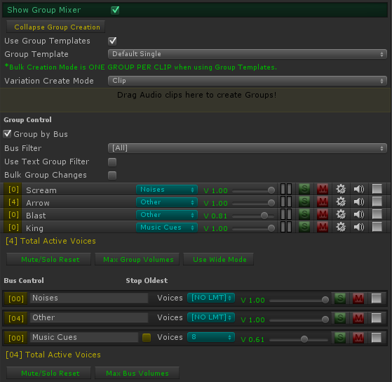

* 1. The slider is to control the master volume of that Sound Group.
  2. There's a colored LED strip that lights up for awhile and animates each time a Variation on that Sound Group starts playing. This is just for your information to see what's playing without having to go into Debug log mode. It does not give any indication of real volume.
  3. The yellow bracketed number at the left of each Group & Bus row is the number of active voices playing. Good to visualize how close you are coming to any limits you may have set up, or the Unity max (32). The number is red if you have a Bus' Voice limit has been reached or if all Variations in a Sound Group are busy. You can click the voice count to select all the Variations in the Hierarchy that make up that count.
  4. “S” is a solo switch.
  5. “M” is a mute switch.
  6. The gears icon (settings) will select the Sound Group in the hierarchy so you can tweak Variations and additional controls.
  7. “Del“ will delete the Sound Group and all Variations in it.
  8. When "playing" in the Unity editor, the Delete button is replaced by a speaker icon. You can click that to audition the Sound Group whenever you like.
  9. Quick buttons for deselecting all mute / solo switches and another for settings all group volumes to 1 (the maximum).
  10. For those of you who have not used a mixing board before, here’s an explanation of solo and mute switches.
      1. If you have zero soloed groups, all groups will produce sound except the ones that are muted.
      2. If at least one group is soloed, you will only hear the soloed groups – all non-soloed groups will not be heard.
      3. Selecting solo will deselect mute, and vice versa.
  11. Buses! The blue dropdown is for assigning Sound Groups to buses. This allows you to control the volume of several Sound Groups at once. In essence, it's a sound router.
      1. By default there are no buses. The text "[NO BUS]" means the Sound Group does not go to a bus.
      2. To create a bus, select "[NEW BUS]" from the dropdown. A new Bus Control section will show up under the Group Control section. It's still part of the Group mixer section of MasterAudio. You can type into the text field that says "[BUS NAME]" to change the name of the bus.
      3. Bus voice limit - this defaults to unlimited, but you can pick between 1-32 voices to limit the bus to. For example, if you have 10 character Sound Groups assigned to a "dialogue" bus, you could limit the bus voices to 5 so that in total only 5 Variations among those 10 Groups could be played at the same time. This helps you avoid hardware-based voice limits for mobile devices, etc. Some devices can only play 20-some odd voices for example.
         1. If you have set a Bus voice limit, a checkbox appears to the left of the Bus voice limit dropdown labeled "Stop Oldest". If you check it, the bus will stop the oldest playing sound if the voice limit is already reached.
      4. Each bus has a volume, solo and mute switches, and a delete button. These work as expected, except that the solo and mute switches actually solo or mute all Sound Groups assigned to the bus (to make things less confusing). At runtime, the delete button changed to a stop button, which will stop all audio going through the bus.

**Note:** if you mute or solo a bus, all Groups with that bus cannot have their mute and solo buttons pressed. This preserves the "bus mute" and "bus solo" status.

* + 1. When you have a lot of Sound Groups, it can be time-consuming to even locate a Group, so use the bus filter (below), or turn on "Use Text Group Filter", which allows you to type a few characters and filter out all non-matches, wildcard style (not case sensitive). For instance if you type "ar" you would match arrow, car, and parsnip.
    2. Bulk Group Changes - turning this on allows you to select one or more Groups in the mixer (checkboxes appear on the left of each row), then make changes to all selected Groups at once by adjusting any of the selected Groups. Changes that work in bulk are: mute, solo, volume adjustment and bus assignment.
    3. When you have at least one bus created, there will be additional controls above the mixer.
       1. A checkbox at the top of the Sound Group section to "group by bus". This is very helpful when you have a lot of sounds! It defaults to "on".
       2. A Bus filter dropdown. You can choose which Sound Groups appear in the mixer by selecting the bus they belong to. All buses is the first choice and the default.

**Note:** all mixer and bus controls work in real time during Editor play!

## 8. Audio FX Filters

All Unity FX Filters are part of Unity Pro (not part of Master Audio) and are available for use in Master Audio, and at the time of writing this is a Master Audio exclusive. They can be added in each Variation Inspector with the dropdown labeled "Add Filter Effect". You can also add them from the Component -> Audio menu. The filters are:

1. Audio Low-pass filter
2. Audio High-pass filter
3. Audio Reverb filter
4. Audio Chorus filter
5. Audio Distortion filter
6. Audio Echo filter

**Note:** Filters are only available on Unity Pro. When writing code, there are convenient lazy load properties in the SoundGroupVariation class you can use to grab each filter for manipulations.

**Note:** If you don't have Unity Pro, we have included an optional package for Unity 4+ users called "AudialManipulators-FreeSample". This is the free version of the Asset Store plugin [Audial Manipulators](https://www.assetstore.unity3d.com/#/content/17032), which gives you 10 effect filters to attach to any Sound Group Variation you like. If you enjoy this, the full version can be purchased on the Asset Store.

**Note:** Even unused and disabled filters take up audio memory, so only add them if you'll use them. There's a button to "Delete all unused Filter FX" in the Master Audio Manager window, which scans the current Scene's MasterAudio prefab.

## 9. Playlist Controller and Music Playlists

A Playlist is a collection of songs. A Playlist Controller acts as a host for one Playlist at a time and can crossfade between different songs. It can only play one song at a time, except during crossfading where 2 will be heard briefly.

**Music** **Playlists** - the (almost) last section in the MasterAudio prefab's Inspector. Here you can set up multiple Playlists of music tracks that MasterAudio uses for your soundtrack.

**Note:** In order to use the Playlist and/or ducking features, you will need to put a PlaylistController prefab in your scene. There is a button here to do that named "Create PlaylistController". Or use the Audio Manager window to add it.

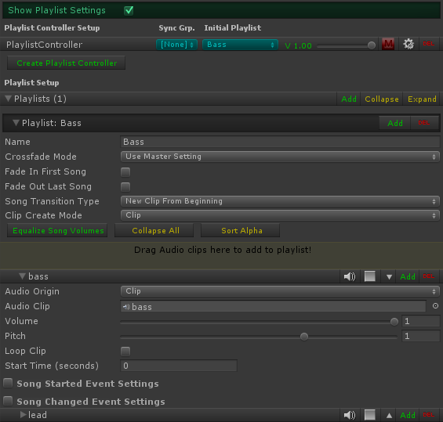

**Playlist Controller Setup**

This section lists your Playlist Controllers and lets you create more of them, assign the initial Playlist (blue dropdown), set the volume for the Controller, or mute it. If you click the settings icon (gear), you will see the Playlist Controller settings, shown below. Each Playlist Controller has its own settings as well, like this.

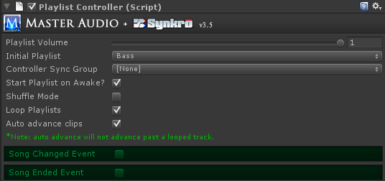

1. Playlist Volume - think of this as the volume of the Playlist Controller itself. This is a way to balance volumes between multiple Playlist Controllers' Playlists.
2. Controller Sync Group - this is off by default. It's optional and is a number 1-4. If you assign a number, then whenever a new song is played, it's time will be set to the first matching Playlist Controller's (with the same Sync Group and a clip playing) time marker. This will also help align layered Resource clips more precisely. This setting is only used with Playlists that have a Playlist Transition Mode of "Synchronized".
3. Initial Playlist - here you select a Playlist to start with.
4. Start Playlist on Awake - pretty self-explanatory. This will play the first clip in the selected Playlist as soon as the scene begins. If you have Shuffle mode, it will play a random clip instead.
5. Shuffle mode - if you turn this on, tracks in the current Playlist will be played in random order. All will be played before the random pool refills. If this is not turned on, the tracks will be played in order from top to bottom.
6. Loop Playlists - this defaults to on. This means that when there are no tracks left to play (with either shuffle mode or not), the song pool will refill and repeat. If you turn this off, the last song will fade out using your crossfade timing.
7. Auto advance clips - if you turn this on, as soon as a track ends, another will start playing. It will be the next track if you are not using shuffle, or a random track if you are.
8. Fire 'Song Changed' Event - if you expand this section, you can select a Custom Event to fire whenever the Song Changes (a new song starts). This feature can play "stinger" sounds for you on song transitions, which is a very popular technique in AAA games. Read more about Custom Events in their own section.
9. Fire 'Song Ended' Event - this is the same as Song Changed, except it occurs when a song ends (after crossfading out completely. If you have zero crossfade, both events will be fired at the same time.

**Playlist Controller Setup**

1. Equalize Song Volumes - clicking this button will mathematically even the volume of all songs in a Playlist based on their average volume. It will move the volume sliders of the songs to do this. No alternation of the sound clips is done. Note that compressed and streaming songs cannot be scanned, so they will be skipped.
2. The Music Playlists - you can add any number of clips here. They will play from top to bottom if you have not enabled shuffle mode. If you have more than one clip, up and down arrows will appear to change sequence of the clips. The settings for each Playlist are:
   1. Playlist name (for reference by name if you want to play a specific Playlist).
   2. Crossfade Mode - by default it uses the Master Setting (Master Crossfade Time). You can also choose Override and specify this Playlist's crossfade time with the next field.
      1. Crossfade time - the crossfade time to use when hosting this Playlist.
   3. Fade In First Song - check this box to fade in the first song (meaning when you play a song when no song is already playing).
   4. Fade Out Last Song - check this box to fade out the last song (meaning the Playlist is not looped and no song will play after this). Note that if you have not enabled auto-advance, every song is the "last" and will fade out and stop the playlist playing at the end of the song.
   5. Song Transition Type. Choices are as follows:
      1. New Clip From Beginning (the default). When playing the next or random song, the new song will start from the beginning. In this mode only, a field "Start Time (seconds)" appears under each song. This lets you tell Master Audio what part of the clip to start on.
      2. New Clip From Last Known Position. This will let each song always resume from the last position it was at before crossfading to another song. If no previous play of the song, it will start from the beginning.
      3. Synchronize Clips - with this setting, playing the next or random song will start the new clip at the same position (time) the previous clip was at. Very cool for crossfading between alternate version of the same track.

**Note:** if you use Synchronize Clips, auto-advance is disabled in any Playlist Controller using this Playlist and all clips in the Playlist will loop.

* 1. Clip Create Mode - same as the dropdown on Master Audio Group.
  2. Load Resources Async (only available on Unity 4.5.3 with a Pro license) - the default is on. All Resources will be loaded asynchronously, which means in the background, so your game doesn't grind to a halt while the resource loads. It should mean smooth game play during resource loading. This is only visible if you have unchecked the master one in the Master Audio advanced section, which overrides this one.

1. To create additional Playlists, click the Add button in Playlist one.
2. The Del icon on a Playlist row deletes the Playlist.
3. You can move the Playlist order (if you have more than one Playlist) by clicking the up and down arrow icons.
4. You can add songs to the Playlist by dragging one or more clips into the colored rectangle.
5. Options for each song include:
   1. Audio Origin, Audio Clip, Volume, Pitch, Loop Clip: all work the same as Sound Groups.
   2. Song Started Event Settings / Song Changed Event Settings: These work like the Song Changed / Song Ended Events for the Playlist Controller and allow you to fire a Custom Event per song, when the song starts or changes to another song. Good for "stingers".
6. Code options - to control the Playlist from code, you have the following options to call:

*MasterAudio.TriggerPlaylistClip(string clipName);*

*MasterAudio.ChangePlaylistByName(string playlistName, bool playFirstClip);*

*MasterAudio.ChangePlaylistByIndex(int playlistIndex, bool playFirstClip);*

*MasterAudio.StartPlaylist(string playlistName); // will start the playlist whether it's loaded or not.*

*MasterAudio.StopPlaylist(); // stops playing the current song and fades out to silence.*

*MasterAudio.QueuePlaylistClip(string clipName); // will play a song after the current song.Requires auto-advance to be on and it turns looping off for the current song.*

**Note:** The above methods work if you only have one Playlist Controller. If you have more than one, there are overloaded methods that take the Playlist Controller Name as a parameter as well. Some have an "all Playlist Controllers" method as well, so you can "pause all" etc.

**Events to subscribe to**

1. You can subscribe to the SongChanged event in the PlaylistController class to be notified when the song changes. That code looks like this:

*var controller = PlaylistController.InstanceByName("PlaylistControllerBass");*

*controller.SongChanged += SongChanged; // the name of your listener method*

*private void SongChanged(string newSongName) {*

*Debug.Log("Song changed to: " + newSongName);*

*}*

There's now also a SongEnded event that you can hook up to with the same type of code. You can use the DelayBetweenSongs script if you want to have a fixed or random pause between songs. You do have to turn off auto-advance for the Playlist Controller you're using this on. Just fill out the 3 properties in the Inspector and it works!

1. You can also execute a method when a gradual PlaylistFade you asked for is completed as well. That code is:

*PlaylistController.InstanceByName("PlaylistControllerDrums").FadeToVolume(.5f, 2f, delegate {*

*Debug.Log("done");*

*});*

**New Jukebox!** In Master Audio 3.0, we have a new Jukebox section that shows up when you press play in the editor. It is shown below - there is one shows for each Playlist Controller. It shows you the current Playlist, active song and fading song, plus time remaining on both. Also, there are controls for changing Playlist, stopping / pausing the song, going to next song and going to random song. You can change to a different clip in the Playlist by picking it from the dropdown. You also can adjust the Playlist volume and jump to a specific part of the song with the slider in the bottom row. Lastly, you can mute the playlist or jump to a specific part of the song by moving the lower slider.

**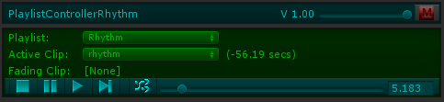**

## 10. Dynamic Creation and Modification of Sound Groups & Other Items

There is a prefab called DynamicSoundGroupCreator, which can be created from the Audio Manager window. You can use these to create Sound Groups, Playlists and Custom Events based on its settings. This is usually used to set up per-Scene sound effects that will delete themselves from the MasterAudio prefab when the Scene changes when in persist mode (or when the Dynamic SGC becomes inactive if you choose).

A second scenario these come in handy is when you're not sure which audio clips you will use before runtime - like if you wanted to change to a "audio skin" of different fire, jump, and run sounds based on user input selection for example (maybe for different player characters). Prefabs with Dynamic SGC's could then be spawned to put these sounds into Master Audio at runtime.

The Inspector looks like a stripped down version of the Master Audio prefab, and is basically a mini-MasterAudio prefab:

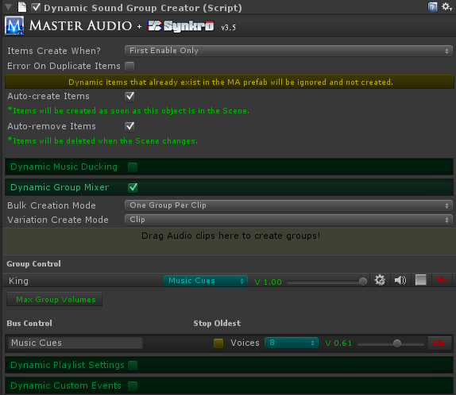

The settings are explained here.

1. Items Created When? Choices are First Enable Only (default) and Every Enable. If you choose the latter, every single time the DSGC is enabled, it will create the sound items in the Master Audio prefab. Otherwise, it's only the first time.
2. Error On Duplicate Items - Defaults to checked. If you turn it off, no errors will be logged for Groups, Playlists, Custom Events and Buses that already exist. They still won't be created if they exist. This is useful if you have more than one of the same Dynamic Sound Group Creator but don't want to see errors when you already created the items with the first one that spawned.
3. Auto-create Groups - if you check this, the Sound Groups specified in the lower section will be created in the OnStart method of the script. In other words, as soon as this prefab is Instantiated, it will create the groups. If you do not check this box, you will need to call the CreateGroups method yourself from a script.
4. Auto-remove Groups - If you check this box, the Sound Groups you create are temporary and will removed when this object is destroyed (normally this will be when the Scene changes). You can manually remove the groups by calling the RemoveItems method yourself from a script.

**Note:** do not check this box if your Master Audio prefab is not persisting and will be destroyed when the Scene changes as it will show false errors in the console.

1. Fire 'Items Created' Event - if you check this box, you can select a Custom Event to fire right after all the audio items are created. This is good for making sure that the items have been created before playing a sound.
2. Bulk Creation Mode: Same as this setting in the Master Audio prefab. Controls whether multiple clips dragged in at the same time create 1 or multiple Sound Groups.
3. Variation Create Mode - this is the same as Bulk Variation Mode in Master Audio, only it applies to non-bulk items added here as well as bulk items.
4. Dynamic Music Ducking - this is for specifying ducking settings for the Groups you create in this prefab.
5. Dynamic Sound Groups section. Here you specify settings for any number of Sound Groups to create. You also have full Variation support. This section looks and functions exactly the same as the Sound Group Variation Inspector.
   1. Buses have an additional choice in the dropdown labeled "Existing Bus" which allows you to use a bus that's already created in the Master Audio prefab. You must type the name in though.
   2. You can click the gears icon (settings) to edit the Dynamic Groups. Then you can click the gear icon there to edit the Dynamic Variations of the Group. Full Filter FX controls are under the Variation. To save on memory usage, filter FX components are deleted from the Dynamic Sound Group Creator's prefabs as soon as they are created under Master Audio at runtime.
6. Dynamic Playlist Settings - exactly the same as the Playlist settings in the Master Audio prefab, but here you only create temporary dynamic Playlists.
7. You can also create per-Scene Custom Events (which are explained in the next section) in this prefab. The controls are identical to the controls in the Master Audio prefab's Custom Event section, except that events you configure here can be auto-deleted when the Scene changes if you set it up that way.

## 11. Unity V5 Audio Features!

Unity V5 has a whole new audio implementation with Audio Mixers, Snapshots, Effect Sends, Ducking and more! There are 6 videos made by Unity covering this that you can [watch to get up to speed here](https://www.youtube.com/watch?v=vOaQp2x-io0&index=1&list=PLW6fMWQDKB27fVKi0APpACG6bujAvYMAI).

Master Audio has already completed Unity 5 integration ahead of the release! Here's a summary of how you link Master Audio up to the awesome Audio features in Unity 5.

1. First, create your Audio Mixer asset and create a couple Mixer Groups under it named the same thing as your buses.
2. Unity Audio Mixer Groups
   * Each Master Audio bus will have an Audio Mixer Group field under it (shown below). Assign each bus to the corresponding Mixer Group you just created on the Unity Audio Mixer.

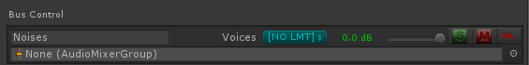

* + Each Playlist Controller will also have an Audio Mixer Group field under it. Assign it to a new Mixer Group you create called "Music". If you have layered music with more than one Playlist Controller, you may wish to create additional Mixer Groups for each Controller.

1. Audio 2D / 3D settings. In Unity 5, Audio Clips no longer have a setting to tell Unity they are meant to be 2D or 3D sounds. A similar setting for that is on each Audio Source instead. Master Audio will handle that for you with these controls.
   * For sound effects on the mixer, there's a dropdown called "Group Spatial Blend Rule", shown below. If you wish to globally set all sound effects to 2D, 3D or Custom (value between 0 and 1 where 0 is 2D and 1 is 3D), pick one of the first 3 options. Option 3 will allow you to pick the Spatial Blend (0-1). The last option will instead allow you to set a similar control on each Sound Group's settings (click the gear for that Group on the mixer to find it). Otherwise that control is not present on the Groups.



* + Playlists have a similar setting as the 4 choices above (the last one is Per Controller instead of Per Group). If you choose the last option, each Playlist Controller will have a similar control just for it. Otherwise that control is not present on the Controllers.

1. Event Sounds has a new Action Type for Unity 5 called "Unity Mixer Control". There are 2 Mixer Commands:
   * Transition to Snapshot - a single snapshot with a transition time.
   * Transition to Snapshot Blend - you can use any number of snapshots with weights and a transition time (as seen in the Snapshot video linked above).

## 12. Sound Group Organizer

The Sound Group Organizer prefab is meant to be a "master list" of all Sound Groups and Custom Events in all Scenes. You can use it to import / export Sound Groups (and Custom Events) from/to any Master Audio or Dynamic Sound Group Creator prefab in any Scene. Bus settings are not copied. To create a Sound Group Organizer, open the Master Audio Manager window, find the Sound Group Organizer row, and click Create. Now you will need to make your own prefab out of it by dragging it into Project View somewhere (do not drag into the DarkTonic folder but somewhere under "Standard Assets" is best). This needs a prefab because it shouldn't live in any playable Scene (too much memory usage).

There's a Transfer Mode dropdown at the top of the Organizer's Inspector. You can set it to Import or Export.

**Importing Sound Groups:** Set Transfer Mode to Import, select your source object (the MA prefab and any DGSC's in the Scene will show up in a dropdown here), check all the Sound Groups you want to import to the Organizer, and click Import.

**Exporting Sound Groups:** Set Transfer Mode to Export, select your destination object (populated with same objects as Import step), check all the Sound Groups you want to export from the Organizer, and click Export.

**Note:** This prefab should never be kept in a playable Scene because it would take up too much memory (all audio would be in memory at the same time). Because of a Unity limitation however, when you import Groups, you will have to place it in the Scene while you import. Then you can Apply changes to the prefab and remove it from the Scene. Exporting can occur from Project View.

**Tip:** The Organizer can be used to move Groups from a DSGC to a MA prefab or vice versa. It's also useful for creating similar MA prefabs in different Scenes without having to recreate anything manually.

**Importing / Exporting Custom Events:** same as Importing / Exporting Sound Groups, but change the Item Type dropdown from Sound Groups to Custom Events first.

## 13. Custom Events

In Master Audio, you can define Custom Events. These are useful to create complex reaction to a single event. You could for instance have different enemies make a different sound at their location whenever a player grabs a new weapon, and not need to write any code! Also used for music "stingers"!

You create them by giving them a name. Each Custom Event can have any number of Custom Event receivers. Master Audio automatically notifies all receivers when the event is fired so they can perform an action if they are configured to respond to that exact event. You can use EventSounds to fire a Custom Event (when another built-in event such as onInvisible happens), and EventSounds can also receive the event if you want to do a normal MasterAudio function such as Play a sound, change song in a Playlist, fade a bus, etc. The last section in the Master Audio Inspector is Custom Events. Here you create the events available to fire. You can also create per-Scene events in Dynamic Sound Group Creator.

**The interface -** all Custom Event Receivers (including EventSounds) must implement the ICustomEventReceiver interface. That way MasterAudio will keep track of the receiver and be able to automatically notify it when events are fired. There is a sample class that implements the interface called "MA\_SampleICustomEventReceiver" in the Example Scene. It's attached to the Main Camera prefab. You can look at that if you wish to respond to multiple events in a single receiver or perform more customized behavior for events.

To create an event:

1. Type the name of your new Event and click the Create New Event button. An event will be created and shown in a row underneath.
2. Choose an option from the Send To Receivers dropdown for the new event. This controls what happens each time the Custom Event is fired. The options are:
   1. Always - always send the event to all receivers. This is the default.
   2. Never - never send the event to any receivers (this disables the event without deleting).
   3. When Distance Less Than - only send the event to all receivers that are closer than the Distance Threshold. Cool for triggering sounds from enemies in range.
   4. When Distance More Than - only send the event to all receivers that are further away than the Distance Threshold.
3. Distance Threshold - the distance to use for When Distance Less / More Than.

During runtime in this Inspector, the number of receivers for each event will be shown on the event row. Buttons also appear then to select all receivers in the Hierarchy and to fire the Custom Event from the position of the MasterAudio prefab.

Typical Custom Event setup:

1. Create the event in either MasterAudio prefab or Dynamic Sound Group Creator prefab (the latter only if you want the event to be per-Scene instead of permanent.
2. Set up the Custom Event Receiver. Either use EventSounds script or create your own class implementing the ICustomEventReceiver class.
3. Be able to fire the event. You can use EventSounds (Custom Event Control mode) for this or you can call:

*MasterAudio.FireCustomEvent(string customEventName, Vector3 eventOrigin);*

The event original is normally the position of the Transform of the object that is firing the event. It will be used for distance calculations if you are using the distance-based modes.

## 14. Persistent Settings

If you wish to use more than one Master Audio prefab in your game (not just a single one that persists through every Scene), you will likely find MA's persistent settings API useful. They allow you to set (once and for all) the Master Playlist Volume (Music), Master Mixer Volume (SFX), as well as Sound Group & bus volumes. Settings "persistent volumes" means that you are setting the volume of ALL Master Audio prefabs in future Scenes as well as the one in the current Scene, if any. The API is as follows:

*PersistentAudioSettings.MixerVolume = 0.5f;* // Set Master Mixer Volume to 50%

*PersistentAudioSettings.MusicVolume = 0.7f;* // Set Master Playlist Volume to 70%

*PersistentAudioSettings.SetGroupVolume("Arrow", .4f);* // Set Sound Group "Arrow" volume to 40%

*PersistentAudioSettings.SetBusVolume("Dialogue", .8f);* // Set Bus "Dialogue" volume to 80%

## 15. Master Audio Clip Manager

There is a second window called Master Audio Clip Manager under the Window menu in Unity. It looks like this (below).

**Note:** Due to changes in the Unity 5 API which close off some of the AudioImporter properties, this window does not exist if you're on Unity 5 or above. However, Unity 5 has the ability to change import settings of Audio Clips in bulk, which is exactly what our Clip Manager was built for.

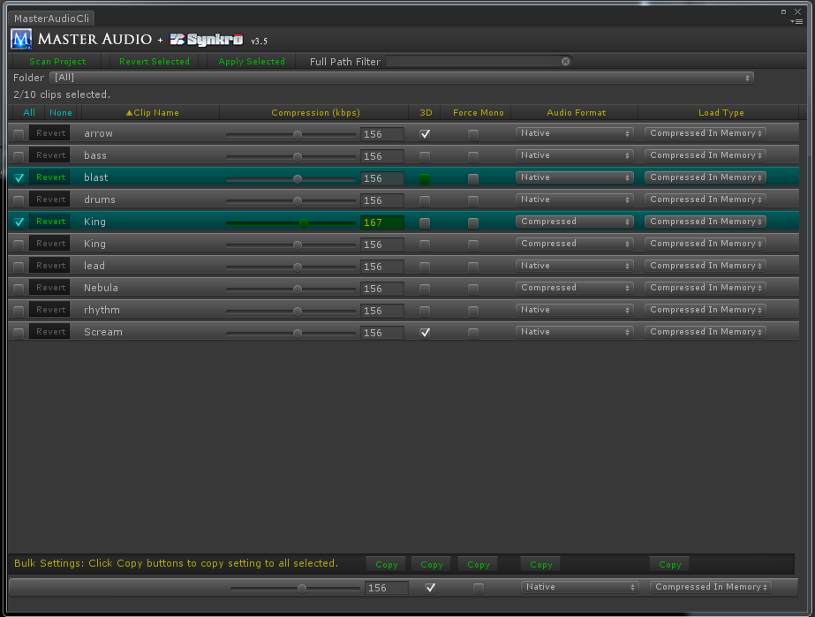

This window helps you to do bulk edits on your Audio files, such as changing the compression bit rate of 10 or all clips at once or setting all music to streaming. It also is useful because you can sort by any of the yellow column headers, and filter by name by wildcard as well.

If you change any field on an Audio Clip, the row will become selected, indicated by highlighting it. Also each field that has been changed will display in green background with yellow text. When you want to apply changes to all selected rows, click the "Apply Selected" button. Or you can Revert Selected as well.

Click on the yellow column headers to sort. Click again to alternate between ascending and descending sort, indicated by the yellow arrow in the column header.

Filters:

1. Typing in the Filter textbox will hide all clips whose folder + name doesn't contain the text. This is case-insensitive.
2. There is a Folder dropdown that contains a list of all folders containing Audio Clips. You can select a single folder to filter the list, or select [All] - the default.

The main section will scroll if there are more than about 16 clips. At the bottom is the bulk settings section. There is a Copy button for each field. That way you can copy just the compression bit rate to all selected clips. When you've copied all the fields you want from the bulk section, remember to click "Apply Selected" to actually make the changes take effect. This may take awhile as Unity processes everything.

Whenever you add or delete clip while Unity is open, if you want to see them in this window, you will need to click "Scan Project" again to grab them.

## 16. Playmaker integration

We have included the optional "MA\_PlaymakerActionsAndScene" package so that you don't have to write any code to integrate with Playmaker. There are 50 custom actions included, under the Audio category. These should cover every method you would call manually. Also included is a \*very\* simple scene with a PlaySound FSM set up. This is a list of the custom actions.

1. Master Audio Bus Fade
2. Master Audio Bus Mute
3. Master Audio Bus Pause
4. Master Audio Bus Set Volume
5. Master Audio Bus Solo
6. Master Audio Bus Stop
7. Master Audio Bus Unmute
8. Master Audio Bus Unpause
9. Master Audio Bus Unsolo
10. Master Audio Ducking Add Group
11. Master Audio Ducking Remove Group
12. Master Audio Ducking Toggle
13. Master Audio Everything Mute
14. Master Audio Everything Pause
15. Master Audio Everything Stop
16. Master Audio Everything Unpause
17. Master Audio Everything Unmute
18. Master Audio Fade Out All Of Sound
19. Master Audio Fire Custom Action
20. Master Audio Group Fade
21. Master Audio Group Mute
22. Master Audio Group Pause
23. Master Audio Group Set Volume
24. Master Audio Group Solo
25. Master Audio Group Toggle Mute
26. Master Audio Group Toggle Solo
27. Master Audio Group Unmute
28. Master Audio Group Unpause
29. Master Audio Group Unsolo
30. Master Audio Mixer Pause
31. Master Audio Mixer Stop
32. Master Audio Mixer Unpause
33. Master Audio Playlist Clip By Name
34. Master Audio Playlist Clip Next
35. Master Audio Playlist Clip Random
36. Master Audio Playlist Fade
37. Master Audio Playlist Get Current Clip Name
38. Master Audio Playlist Mute
39. Master Audio Playlist Pause
40. Master Audio Playlist Set Volume
41. Master Audio Playlist Start By Name
42. Master Audio Playlist Stop
43. Master Audio Playlist Toggle Mute
44. Master Audio Playlist Unmute
45. Master Audio Playlist Unpause
46. Master Audio Play Sound
47. Master Audio Set Master Volume
48. Master Audio Stop All Of Sound
49. Master Audio Stop Transform Sound
50. Master Audio Variation Change Pitch

## 

## 17. 2D Toolkit Integration

To make 2D Toolkit use Master Audio instead of its own tk2dUIAudioManager, simply install the optional package "MA\_Tk2d". It will overwrite these 3 files:

* TK2DROOT/tk2dUI/Code/Controls/tk2dUISoundItem.cs
* TK2DROOT/tk2dUI/Code/Core/tk2dUIAudioManager.cs
* TK2DROOT/tk2dUI/Editor/Controls/tk2dUISoundItemEditor.cs

This means that for a UISoundItem, the Inspector will allow you to select or type a Master Audio Sound Group from a dropdown. Note that if you have moved 2D Toolkit folders after importing it, you will need to move the Master Audio replacement files to the new location. Every time you upgrade 2D Toolkit, you will need to open the Master Audio 2D Toolkit package again to overwrite the new changes.

## 18. NGUI Integration

ButtonClicker script - this can trigger up to five MasterAudio Sound Groups based on built in NGUI events.

1. MouseDown
2. MouseUp
3. MouseClick
4. MouseHover Start
5. MouseHover End

If you have an NGUI button with a collider, go ahead and attach this script to it. You will notice that the Inspector has dropdowns in the ButtonClicker section. They each contain the list of Sound Groups in MasterAudio.cs.

This script also has checkboxes for resizing the button while clicking or hovering. If you use these, a hover will cause the button to shrink slightly during a hover. A click will cause the button to grow slightly during the click. An additional setting for "resize all siblings" will appear as well if you're using the resize settings. Checking this will also resize all other child Game Objects of the same parent as this Game Object. This helps to resize button text and other small graphics at the same level instead of just the button.

## 19. DF-GUI (Daikon Forge GUI) Integration

To install the DF-GUI Integration features, open the included MA\_DFGUI package. It will install the following:

1. DF\_ButtonClicker script - this can trigger up to five MasterAudio Sound Groups based on built in DF-GUI events (it's exactly the same as the NGUI ButtonClick script above, but for DF-GUI).
   1. MouseDown
   2. MouseUp
   3. Click
   4. MouseEnter
   5. MouseLeave
2. The following DF-GUI events will be added to the EventScript list of events:
   1. DFGUI Click
   2. DFGUI Double Click
   3. DFGUI Mouse Down
   4. DFGUI Mouse Up
   5. DFGUI Mouse Enter
   6. DFGUI Mouse Leave
   7. DFGUI Drag Start
   8. DFGUI Drag End

## 20. Other Plugins that have Master Audio Integration

The list is small currently, but we will see it grow over time.

1. [Behavior Designer](https://www.assetstore.unity3d.com/en/#!/content/15277) - this powerful AI / behavior plugin is extremely easy to use and is in many cases a faster performing replacement for Playmaker. We have included an optional package with our download that features a demo version of Behavior Designer, including a conversion of all existing Master Audio Playmaker custom actions for Behavior Designer! It's in the 3rd party folder. There's also an optional package with just the MasterAudio Tasks for Behavior Designer if you already have the full version of Behavior Designer.
2. [AI for Mechanim](https://www.assetstore.unity3d.com/en/#!/content/13761) - a very versatile tool that uses Mechanim-looking graphs to accomplish AI with no code writing necessary! Has integration with most of the top plugins!
3. [Dialogue System](https://www.assetstore.unity3d.com/en/#!/content/11672) - this powerful quest / dialogue system has incorporated Core GameKit support (as well as tons of other plugins) in their latest version. Has integration with tons of the top plugins!

## 21. Installation Folder

Installation folder path - by default, it is Assets/DarkTonic/MasterAudio. If you want to relocate Master Audio to a different folder, do the following.

1) Drag the entire DarkTonic folder (not just the MasterAudio subfolder) into a different folder (such as Assets/Packages).

2) Open MasterAudio.cs and change that path in the variable at the top of that file to be the same as the path of the MasterAudio folder. Here it is shown:

*public const string MasterAudioFolderPath = "Assets/DarkTonic/MasterAudio";*

So if your DarkTonic folder is now under Assets/Packages, then you should change that line to:

*public const string MasterAudioFolderPath = "Assets/Packages/DarkTonic/MasterAudio";*

And you're good to go!

## 22. Preparing a project for Master Audio

## If you already have existing audio in your project, Master Audio includes a tool that can help prepare it for Master Audio to take over all audio control. To open it, from the Unity "Window" menu, select " Master Audio Sound Upgrader ". It looks like this:

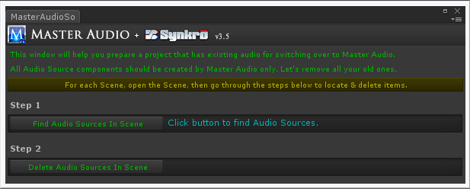

Use of the tool is straightforward. It will find all Audio Sources in your Scene, which you then take notes on. Then it will delete all the Audio Sources in the Scene. Then you are free to import Master Audio and start doing sound design, first configuring the sounds that the tool removed.

The tool can also be used after importing Master Audio. It will safely ignore any Audio Sources that are controller by Master Audio. A couple gotchas are:

* It can be used from edit mode only. So it will not be able to find Audio Sources that aren't in the Hierarchy at edit time. That means Game Objects that spawn after the Scene begins will not be found. If you have any that have Audio Sources, unfortunately you will need to look through your prefabs in Project view and remove their Audio Sources manually. Or you can pull all those prefabs into the Scene temporarily, use the tool to remove their Audio Sources, then go click "Apply" on each prefab that had an Audio Source.
* After doing the steps above, all Audio Clips stored in Audio Sources will be eliminated. However, Audio Clips that may be in variable fields in scripts attached to Scene objects or prefabs cannot be found, and will take up audio memory whenever they are in the Scene. It is recommended that you look through all Scene objects and prefabs to remove any Audio Clips stored in variables of scripts (set the clip to "None"), if you have any scripts like that.
* After you do these steps, Master Audio will control all audio in your project. Make sure not to add Audio Source components to any Game Objects in the future, and do not populate any Audio Clip variables in any non-Master Audio scripts. Master Audio will automatically create any Audio Sources it needs.

## 23. Localization (Multiple Language Support)

Localization is an optional feature. When you are using Resource file clips for sound effects, you can automatically play clips in the user's language that they've set on their device if you follow these steps. For localization in Master Audio, you must create a top-level folder (under a folder named "Resources") for each language you will support, i.e. (English / German). Resource files are used to reduce the memory used (only the language your user needs will be loaded when they need to be played, then unloaded after they're done playing). This section will walk you through how to set up multi-language audio. Check out the LocalizationScene included in the ExampleScenes folder for a preview.

1. Click on your Master Audio prefab. Expand the Show Languages section up top to see the settings. The following fields are under that:
   1. Supported Languages - here you select the languages you want to support (i.e. German / French / Chinese / English). Make sure to then create a folder with the same name as each language you selected under a folder called "Resources" (i.e. Resources/English, Resources/German, etc). Use the Add and Del icons to add or delete a new language to the list.
   2. Default Language - this language will be used if a user has their device set to a language that you don't support. The Default Language should be one of the languages you selected in Supported Languages. For example, let's say you have selected German and English, with German as the default language. Now a user has their iPad set to French. Since you don't support French, it will use English as the language.
   3. Language Mode - this has 3 choices.
      1. Use Device Setting - this will try to use the language the user has selected on their device. This is the normal setting you would use for releasing games. If it's one of languages you support, it will load clips of that language. If it's not, it will load clips of your default language instead. The user's default language will be retrieved from **Application.systemLanguage** at runtime.
      2. Specific Language - if you select this, another field "Use Specific Language" will show up underneath, allowing you to tell Master Audio "always use this language". This is useful for test listening to another language. Make sure to switch it back before you release if you want multiple languages to be supported again!
      3. Dynamically Set - if you select this, you must tell Master Audio which language to use via code (maybe you are allowing the user to select from a few languages). The code to set the language is as follows:

*MasterAudio.DynamicLanguage = SystemLanguage.German*

**Note:** The limitation on this is that you must set the language in a previous Scene that doesn't share the same Master Audio prefab. i.e. a Main Menu scene. In the next Scene, the other Master Audio prefab will pick up the language you have set during the Awake event.

1. Obtain or create sound files (for each language you support) for each audio clip you want to localize. All clips of the same meaning must have the same file name and should be placed in the correct language-named folder. That's the limitation to make it work. So if you are making 3 versions of a "Hello" sound clip, you might place one in all of:
   1. Resources/German/Hello.wav
   2. Resources/English/Hello.wav
   3. Resources/French/Hello.wav
2. Go back to the Master Audio prefab and set Variation Create Mode (under the Mixer section) to Resource File.
3. Create a new Sound Group called Hello by dragging in one of the 3 Hello.wav files in your language-named Resource folders. Now click on the gear (settings icon) in the mixer for your new Hello group. Notice that the "Use Localized Folder" checkbox is checked because Master Audio recognized that you dragged a file from a language-named folder ("English", "French", or "German" are the ones you have).
   1. When the Use Localized Folder checkbox is checked, this Variation is now considered localized and Master Audio will attempt to play the correct language audio clip when you preview or play that Variation at runtime. If you are missing an audio file for that language an error will be logged letting you know. For example, if you forgot to make Resources/French/Hello.wav and played the Hello sound using the French language, you would get an error.
4. In the case that you have a Dynamic Sound Group Creator prefab in a Scene that has no Master Audio prefab (common with Bootstrapper Scene setup), Dynamic SGC will have a "Preview Language" field so that you can preview your audio in a certain language. At runtime, the Dynamic SGC will populate its configured items into the persisted Master Audio prefab, so you can preview or play as normal from the Master Audio prefab during runtime.

**Note**: You cannot change the Localization Options in the Master Audio prefab during runtime. You are locked into one language based on your settings and configuration. This is a small limitation and is not hard to work around. It is due to the way Resource file names are mapped to all Audio Sources they might play on during startup. However, you can work around this with the "Dynamically Set" Language Mode described above.

## 24. Best Practices / Basic Setup Considerations

Here are some best practices for using Master Audio!

1. Take a look at where your Audio Listener component is (this is a Unity component). By default it is on the Main Camera's Game Object. If you're using 2D sound, you may want to place the Master Audio prefab at the same position as the Audio Listener (if the listener doesn't move) so you don't have to adjust the 3D settings of your sound effects too often - this also will help avoid your sound effects being too quiet, which can happen when they are too far away. Note that when you play sounds at the position of a Game Object or following a Game Object, this is not an issue. When you just "PlaySound" without giving a location (or caller), this is a consideration though.
2. Normally, all music in Playlists would be set as 2D sounds (this is done in Project View or in bulk with the Master Audio Clip Manager) so that you don't have to worry about 3d settings (i.e. distance of the Playlist Controller from the Audio Listener affecting volume). Note that in Unity 5, this setting is not on Audio Clips any more. See the Unity 5 section for more details.
3. Determine if you will need to play music or sound effect across Scene changes.
   * If you don't need that, you will put a Master Audio (MA) prefab and Playlist Controller (PC) prefab in each Scene that you want audio in.
   * If you do need that, put a Master Audio prefab with "persist across scenes" checked in your Bootstrapper Scene (a "loading" Scene that is never revisited after startup). Only put Sound Groups in the MA prefab that you will need in every Scene as all Audio Clips in the prefab will be constantly taking up audio memory (Resource files will not though).
     + Tip: you can create all Playlists for all Scenes in this persistent MA prefab if you are using all Resource files for songs and no audio memory will be used except by songs that are playing at that time. If you are not using Resource files, this is a bad idea and you should use the Dynamic SGC to populate "temporary" playlists in each Scene (more below).
     + Each other Scene will not need a Master Audio or Playlist Controller prefab, because the MA and PC prefabs from the Bootstrapper Scene will carry over when you play from the Bootstrapper Scene.
     + Use one or more Dynamic Sound Group Creators in each subsequent Scene to temporarily populate the persistent MA prefab with its contents until the Scene changes again. Dynamic SGC prefabs dynamically fill and empty the MA prefab with sounds, buses, playlists and Custom Events. This helps a lot with memory management!
     + For ease/speed of testing, you can add an "empty" & non-persistent MA & PC prefab to each Scene for the Dynamic SGC to populate when you play that Scene directly. When you play from the Bootstrapper Scene, MA will detect and delete the non-persistent prefabs when it loads the next Scene when a persistent MA prefab is carrying over, so it's not a problem to keep the empty ones there always.

## 25. Preparing a Project With Existing Audio To Use Master Audio

If you already have audio in your game and want to switch it over to Master Audio, you should use the **Master Audio Sound Upgrader** window to do most of the work for you.

1. Open it from the Window menu in Unity. It has buttons to find all existing Audio Sources in a Scene and then delete them so there won't be any audio not controlled by Master Audio. This needs to be done in each Scene. You can also use it even after configuring Master Audio in your Scene, to find any forgotten Audio Sources not controlled by Master Audio. It will safely ignore the ones that are controlled by Master Audio.
2. One other thing you will want to do is to find any Audio Clips assigned to non-Master Audio Game objects in each Scene and delete them so that they don't take up audio memory. Unfortunately this is not possible to do via script so this is a manual task. Usually they are only in Audio Sources, which have already been cleaned up via the tool, but if you have any custom scripts that use Audio Clips, you will need to clear them out (set Audio Clip to 'None') manually.
3. Lastly, you will replace the removed Audio Sources and Audio Clips using Master Audio functionality. That's the fun part!

## 26. Audio Memory Allocations / Performance Tips!

Here are some tips and facts on Master Audio memory allocation usage and optimization. Master Audio has been highly optimized for allocations / garbage collections and uses 0 bytes for most uses. When not using an "AndForget" method to play sounds, only 16 bytes will be allocated. This means it's extremely stable and lightweight and can be safely used on mobile without eating much of your resources.

Unless you are using Resource files (see below for more info), then the amount of memory used by Master Audio will remain constant per Scene. It's not dynamic. All Sound Group Variation audio clips (that aren't Resource files) are loaded into memory when the Scene starts. All playlist clips that are not Resource files will also take up audio memory. Extra clones of Variations take up zero memory because they're the same audio clip. Playing a sound does not make the audio memory change (unless it's a Resource file).

Typically, to optimize memory usage, we do the following:

1. If the target platform is mobile, we resample all audio clips to 22050Hz so they're smaller. We can't tell the difference in sound. For pure speech sounds, you can get away with an even lower sample rate. We use .wav files for all sound effects, although some users report success with .ogg files as well. Use the Master Audio Clip Manager window to convert any mp3's to wav's quickly.
   1. Make sure to NEVER use mp3's or "stream from disc" for sound effects (Sound Group Variations). A single call to AudioSource.Play() with an mp3 file will take about 2.4ms. Whereas AudioSource.Play() with a wav file takes about 0.02 seconds. That's 120 times faster! It can drastically affect your frame rate if you have a lot of sound effects playing! For playlists it's fine to use mp3's because you don't fire off many each second like sound effects.
2. Set all music clips to compressed and streaming which takes up very little memory (although the profiler doesn't show this correctly when running inside Unity - make sure to run Profiler against the build on the actual target device). But don't stream more than one audio clip at a time, that's terrible on performance.
   1. Sometimes large streaming clips can cause performance hiccups in Unity when the next streaming song starts playing. If you are having a spike in performance, try turning off streaming and/or using Resource files instead.
   2. If you have more than a couple music clips, it's worth setting up all music clips as Resource files instead to compare audio memory usage. It may use far less memory, especially with layered music.
3. Set up infrequently used sounds in a Resources folder and configure the Audio Origin as "Resource File" so they will be loaded only when played and promptly unloaded after done playing.
4. If you only need certain sounds in certain Scenes, set up a separate Master Audio per Scene only with needed sounds, or use the Dynamic Sound Group Creator prefab to populate those sounds in each Scene if you have a "persist across Scenes" Master Audio.
5. On Unity 5, only use Filter effects (available only with Pro Unity) on Unity Audio Mixer Groups, and not on individual Variations. It will save a lot of memory.
6. Each "clone" of a Variation (from weight > 1) will take about 0.8 Kb of audio memory on Unity 3 & 4 (plus more memory for each Filter effect on it, if any). So adding 700 clones of various sounds for polyphony reasons would increase your audio memory usage by about 0.6Mb. It's not very significant, but there's the numbers if you were wondering. On Unity 5, the extra clones take up zero audio memory due to extensive audio optimizations in the new audio engine.

## 27. Using JavaScript / UnityScript

You will need to move the Assets/DarkTonic/MasterAudio/Scripts folder into the Assets/Plugins folder so that it will compile in the right order and be accessible from other scripting languages. It's wise to also rename the "Scripts" folder to "MasterAudio" so you know what they are after moving.

## 28. Final Words

Support is available by emailing <support@darktonic.com> or in the Unity forum thread [here](http://forum.unity3d.com/threads/168074-Master-Audio-RELEASED-Complete-audio-setup-amp-control-tool), or on the official Dark Tonic forums here: <http://darktonic.freeforums.net>. Again, the Master Audio programming API documentation can be found here: <http://bit.ly/1bkiRei>

Make sure to check out our other top-notch plugins such as Core GameKit at <http://www.darktonic.com/p/developer.html>. Thank you!

-All at Dark Tonic