# DECLARATION

I declared that I’m Student of IPRC Tumba in Department of Information Technology (IT), and this kind of document is entirely my own work during my internship I had successfully completed at Rwanda Energy Group/Energy utility Corporation Limited (REG/EUCL). I had gained different skills about networking, ICT operation and development of communication with employees.

Declared by

Name: NSENGIMANA Elyse

Reg No: 20RP11582

Contact: 0781049197 & 0724255014

Signature: .......................

Supervisor name: NSHIMIYIMANA Alexis

Supervisor contact: 0785195153

Signature: .......................

Date:18th November 2022

**Abstract**

This report is about my Industrial attachment which was conducted at Rwanda Energy Group/Energy utility Corporation Limited in the Department of ICT from 17th October 2022 to 18th November 2022.

This industrial attachment helped me to develop the field towards an interest of working in a high institute and well equipped. This report explains clearly the work done within this period of time.

This report includes an Introduction to REG/EUCL, Represents the ICT Department in which I was assigned during my Practical Training, Description of Activities undertaken during Industrial attachment where I did my Practical Training. It also describes the Lessons, experience and skills that gained in industrial attachment. And also describe the Challenges, limitations, and areas for improvements finally, it includes Conclusions and Recommendations whereby I tried to highlight some of the events necessary for the smoothness of Practical Training.

This industrial attachment helped me achieve my goals as I mentioned above in implementing some of what I had learned at IPRC Tumba I had not implemented before, as well as training to be a professional in the field of technology as well as in implementing what I have learned and achieved. I have done everything to learn how to apply what I have learned in practical, I did all from 17th October to 18th November, 2022.

DECLARATION 2

2. Objectives of industrial attachment 6

**4.** **Description of Activities undertaken during Industrial attachment** 8

**4.1.** **Introduction** 8

**4.2.** **Network Troubleshooting** 8

**4.2.1.** **Network Cabling** 9

**4.2.2.** **Cutting, stripping, Terminating RJ45 and Sorting Wires** 9

**4.2.3.** **Testing Cable** 9

**4.3.** **Computer Maintenance** 9

**4.3.1.** **Tool Box** 10

**4.3.2.** **Disassembling the computer system** 10

**4.3.2.1.** **Unplug the power cable** 10

**4.3.2.2.** **Remove the Cover** 10

**4.3.2.3.** **Remove the memory module** 11

**4.3.2.4.** **Remove the hard disk drive** 11

**4.3.2.5.** **Remove the power supply** 11

**4.3.2.6.** **Remove the motherboard** 12

**4.3.3.** **Assembling the computer system** 12

**4.4.** **Routine end-user IT support** 13

8. Conclusion 16

Figure 1. Network Cable 9

Figure 2. Tool Box 9

Figure 3: Remove the Cover 10

Figure 4: Remove the Memory Module 10

Figure 5: Remove the hard disk drive 11

Figure 6: Remove the power supply 11

Figure 7: Remove the motherboard 12

Figure 8: Disassembling and assembling of laptop 12

1. **Background**
   1. **Introduction**

The industrial attachment training is an essential component of the curriculum of the University of IPRC Tumba. It is essential for certificates, diplomas and degree students for completion and award of degrees in advanced diploma for diploma students, and certificates for students in information communication and technology

An internship can help you gain skills that can be applied to future jobs. Internships may be paid or unpaid, and they tend to last about the length of a school semester or a summer break. If you are entering a new career, there are many benefits to completing an internship.

Most employers want you to have some experience before they hire you. If you’ve never held a job, your application for a job may not be received by many employers due to not attending an internship. Having an internship on your CV gives you a chance to gain the needed experience.

The Information Systems sector continues to play a major role in the economic development of Rwanda. The government has put in place policies and strategies to ensure the country’s economy is based on a knowledge base if it has to grow rapidly. It is in that regard that Rwanda has introduced a department of Information Systems to contribute to the country’s knowledge base in economic development. As a student in the Information Technology field of study, it’s very important to undertake an internship. This helps us to gain hands-on skills for the theory we have studied in school. In this context, I would like to say thanks to REG/EUCL for accepting and supporting me in my Internship program.

The internship was conducted in a nine weeks’ period from 19th September to 18th November 2022.

## Objectives of industrial attachment

Trainees will be able to:

* Appreciate the importance of human relationships and work attitudes.
* Understand the constraints of working life and functional relationships within and between organization
* Be oriented towards work processes
* Apply theoretical concepts and school-based skills to practice
* Develop work attitudes like curiousness, self-confidence, mutuality and self-reliance
* Obtain knowledge of potential careers and develop new areas of interest

Employers will be able:

* Know future skills availability
* Improve the training delivered at training institutions for industrial relevance.
* Influence the training of future generations of employees.

1. **Information of Industrial Attachment Company (EUCL)**

The Government of Rwanda has undertaken reforms in the Energy and water sector which have been concretized by the separation of energy from water operations. The main objectives being to have sector focused and efficient operations; attract more investment; improve planning and accountability; and increase access to services by the population to drive sector performance towards the targets envisaged in the EDPRS II and other national goals to this end government adopted the corporatization model as a vehicle to implement the required reforms.

The Rwanda Energy Group Limited (REG) and its two subsidiaries; the Energy Utility Corporation Limited (EUCL) and the Energy Development Corporation Limited (EDCL) entrusted with energy development and utility services delivery while the water and sanitation corporation (WASAC) has the mandate to develop and operate water and sanitation infrastructure and deliver related services in the country.

The object of creating these subsidiaries amongst others was to ensure focused attention to enhancing efficiency in utility operations on one hand and ensure more timely and cost efficient implementation of development projects on the other. Moreover, the REG holding structure provides the overall.

**The Energy Utility Corporation Limited (EUCL)** was incorporated to have devoted attention in providing energy utility services in the country through operations and maintenance of existing generation plants, transmission and distribution network and retail of electricity to end –users

1. **Description of Activities undertaken during Industrial attachment**
   1. **Introduction**

This industrial attachment allowed me to understand in deep the working environment especially how the activities are done in larger company and how it obtained from the field in this chapter provide the description of how network activities and computer maintenance are done in ICT department unit in which I was trained and understanding how to do so.

* 1. **Network Troubleshooting**
     1. **Network Cabling**

There are two types of network cables commonly used in PC networks: Straight-through cable and Cross-over cable. A cross-over cable is used to connect two computers via their NICs, without using a Hub or Switch and also connect same devices. Straight-through cables are used for a variety of connections and connect different devices. Let's start with a straight-through cable and then we will get fancy with a cross-over cable.

* + 1. **Cutting, stripping, Terminating RJ45 and Sorting Wires**

Assume that you have a long cable to use in Local Area Network; you must cut it into different parts according to the length that satisfy the distance between host-port and Network-socket.

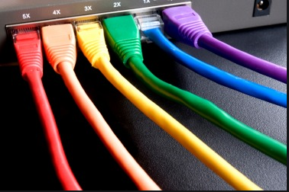

Figure 1. Network Cable

* + 1. **Testing Cable**

Once your cable is finished, you should test it to make sure it works. Insert the two ends of the cable into the jacks on the tester and watch the lights. If they all light up, you have a good connection for each wire and the cable checks out.

* 1. **Computer Maintenance**

They are different tool we had been used for compute computer maintenance as:

* + 1. **Tool Box**

**Tool Box:** is a box which contain many tools used in computer maintenance

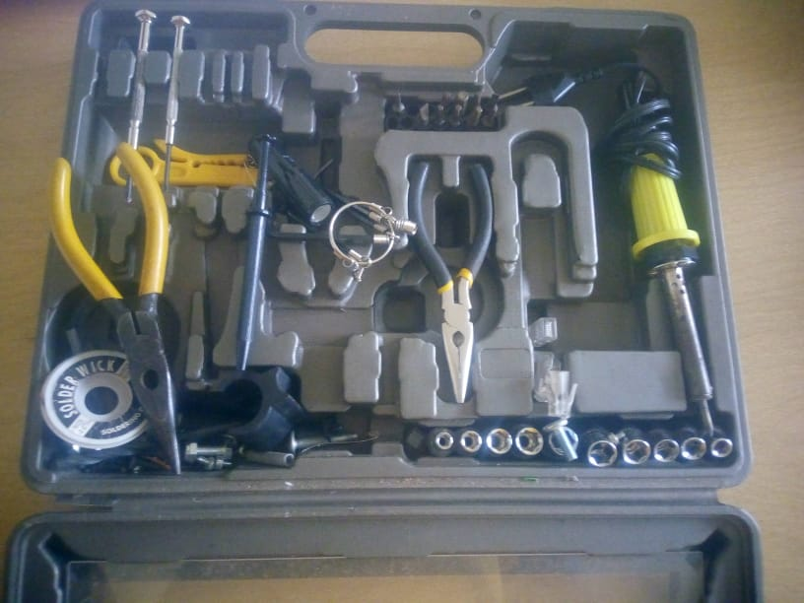

Figure 2. Tool Box

* + 1. **Disassembling the computer system**
       1. **Unplug** **the power cable**

The disassembling of the computer system starts with externally connected device detachment. Make sure the computer system is turned off, if not than successfully shut down the system and then start disconnect the external devices from the computer system. It includes removing the power cable from electricity switchboard, then remove the cable from SMPS (switch mode power supply) from the back of the CPU Cabinet. Do not start the disassembling without disconnecting the power cable from computer system. Now remove the remaining external devices like keyboard, mouse, monitor, printer or scanner from the back of CPU cabinet.

* + - 1. **Remove the Cover**

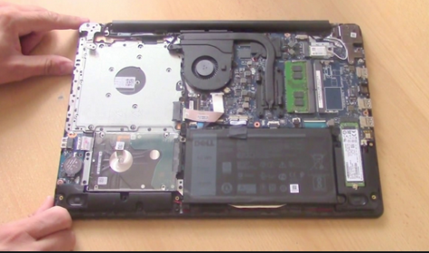

Figure 3: Remove the Cover

The standard way of removing tower cases used to be to undo the screws on the back of the case, slide the cover back about an inch and lift it off. The screw drivers as per the type of screw are required to do the task.

* + - 1. **Remove the memory module**

Memory modules are mounted on motherboard as the chips that can be damaged by manual force if applied improperly. Be careful and handle the chip only by the edges.

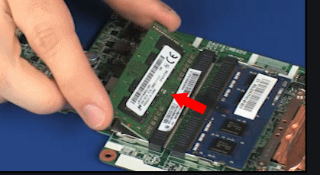

Figure 4: Remove the Memory Module

* + - 1. **Remove the hard disk drive**

the hard disk drive is the one of the storage of computer which is main important for storing permanently the files, folders and even all the software programs installed in the computer, it is a device which is very important in the computer apart from the CPU. it has its slot on the motherboard where it must be connected.

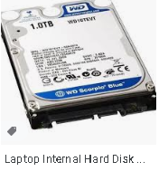

Figure 5: Remove the hard disk drive

* + - 1. **Remove the power supply**

The power supply is attached into tower cabinet at the top back end of the tower. Make sure the power connector is detached from switch board. Start removing the power connector connected to motherboard including CPU fan power connector, cabinet fan, front panel of cabinet power buttons and all the remaining drives if not detached yet.

Now remove the screws of SMPS from the back of the cabinet and the SMPS can be detached from tower cabinet.

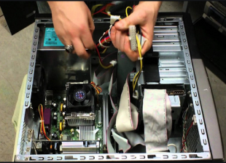

Figure 6: Remove the power supply

* + - 1. **Remove the motherboard**

Before removing all the connectors from motherboard, make sure u memorize the connectors for assembling the computer if required, as that may require connecting the connectors at its place. Remove the screws from the back of the motherboard and you will be able to detach it from the cabinet. Now remove the CPU fan from the motherboard.

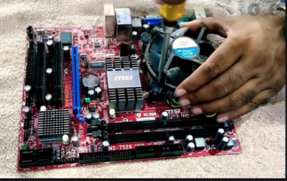

Figure 7: Remove the motherboard

* + 1. **Assembling the computer system**

The assembling of the computer system is exactly the opposite of disassembling operation. Before starting assembling the computer system, make sure you have the screws and a screw driver for those.

Connect the external devices with CPU at its appropriate socket. It includes mouse and keyboard at PS2 or USB connectors. Monitor at the video output socket. Connect the power cable to the back of tower in SMPS. Plug in the power cable to electric board.

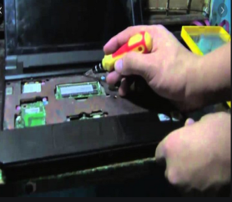

Figure 8: Disassembling and assembling of laptop

* 1. **Routine end-user IT support**

All the mentioned activities are done on a routine basis and are still ongoing. In addition to these specific tasks performed during the internship, other activities include the usual REG/EUCL Computer users’ IT support. These activities include but not limited to;

* Solving internet connection problems
* Solving printer related problems
* Troubleshoot system and network problems, diagnosing and solving hardware or software faults.
* Installing, updating and maintaining Computer and printers and windows updates.

1. **Lessons, experience and skills.**
   1. **Introduction**

It is an opportunity that employers offer to students interested in gaining work experience in particular industries. With this primer, learn more about what internships are and why students benefit from them.

* 1. **Practical skills**

Means skills performed by hand or with human intervention using equipment, tools or technology requiring guidance.

* 1. **Theoretical knowledge**

During my internship period in the Middle Eastern Technology upgrade my theoretical knowledge, when I have been learning the course of PC maintenance, Internet of Things, Computer Networks and multimedia and animation in the classroom.

* 1. **Interpersonal communication skills**

During my industrial attachment period the Interpersonal skills, which are the life skills I use every day to communicate and interact with other people, individually and others. Not only how I communicate with others, but also I got experienced in Problem solving, decision making. Through this internship, I found that I am mature and I gained many new perspectives, such as problem solving skill, diversity, effective communication, teamwork and service recovery, time management, personal empowerment, self-confidence, responsibility and cultural sensitivity

1. **Challenges, limitations,** **and areas for improvements.**
   1. **Introduction**

## As I was new to everything during the internship, I face many challenges. There are chances that I can complete my internship smoothly but I have found some of the internship problems and their solutions to help navigate through it all

* 1. **Coping with Unfamiliar Office Culture**

It takes time to understand the organizational culture since it varies from office to office. While some have a rigid structure, others are flexible and trying to observe organizational structure during the first weeks of socializing poses a challenge for many.

**Solution:** Whether you are starting a new position at your current place of employment or a completely new company, you may be experiencing the fear of the unknown. However, it’s imperative to recognize cultural differences at work; that way, colleagues can avoid taking a simple misunderstanding to heart.

You must stay calm and have the attitude that you will perform your best and, by doing so, you will impress.

* 1. **Competition from Co-Interns**

If you're not the only intern working at a company, you might experience a competitive environment. Often, it’s not that your co-interns are competitive and trying to outdo you but they're just being hardworking and high-spirited.

**Solution:** So instead of taking it for granted, try to work harder as your competition will make your internship much better and People will want to work with you because you're enjoyable to work with and have a good attitude.

* 1. **I was Afraid to Ask Questions**

At the first time in the company, I was seeing that everything is new to me in working environment, as well as the company was large institution

**Solution:** Never assume something's right. Always check if you're not sure. You will avoid silly mistakes.

1. **Recommendation**
   1. **Recommendation to REG/EUCL**

All the work I have done at REG/EUCL, I have found there is a lot of work and it is a big job because of the many jobs a student in an industrial internship can't get to all the right courses because there is not enough time for him or her, so I recommend to do enough flow up to the next interns.

* 1. **Recommendation to IPRC Tumba**
* I recommend IPRC TUMBA to increase the time of industrial attachment in order to help students to get more time for improving their skills in different companies. As you see, our industrial attachment time was too short, it was difficult to practice all our skills we gained at school in this time we have given. So, it will be better if next year IPRC TUMBA increases the time of industrial attachment.
* My second recommendation to IPRC TUMBA is to search for student powerful companies which have a department related to data science in order to help students to increase their skills through those companies.
* Finally, I recommend for students to attend regularly internship as they are allowed to do internship and have discipline and try to improve their knowledge by asking the understandable things especially during their internship.

## Conclusion

At first the attachment period was not enjoyable since I had to familiarize myself with both workmates and the working environment. As time went by it turned out to be very fruitful. I gained experience and skills which are required in Information technology. I also learnt that theory without practice is dead, to be patient and tolerant. I am now a better person due to the attachment experience both at work and personal level. However, I wasn’t exposed to some areas like the claims department which could have equipped me with other skills which I did not learn, I saw the practice of some lessons I have learnt.