April 7, 2023

**C964: Computer Science Capstone**

By: Austin Kim

Task 2 – Parts A, B, C, D, E

Part A: Project Proposal for Business Executives 3

Letter of Transmittal 3

Project Recommendation 3

Problem Summary 3

Application Benefits 3

Application Description 3

Data Description 3

Objectives and Hypothesis 4

Methodology 4

Funding Requirements 4

Data Precautions 4

Developer’s Expertise 4

Part B: Project Proposal 5

Problem Statement 5

Customer Summary 5

Existing System Analysis 5

Data 5

Project Methodology 5

Project Outcomes 5

Implementation Plan 6

Evaluation Plan 6

Resources and Costs 6

Timeline and Milestones 6

Part C: Application 7

Part D: Post-implementation Report 8

A Business (or Organization) Vision 8

Datasets 8

Data Product Code 9

Objective (or Hypothesis) Verification 11

Effective Visualization and Reporting 11

Accuracy Analysis 11

Application Testing 11

Application Files 11

User Guide 12

Summation of Learning Experience 12

Part E: Sources 12

# Part A: Project Proposal for Business Executives

## Letter of Transmittal

April 7, 2023

Gigi Ruten, CTO

TastyFish

111 Freedom Road

Dallas, Texas, 92922

Dear Mrs. Ruten,

Our organization faces a critical problem. The time it takes for our fish to travel from fishing boats to clients’ warehouses is too long. We all know that due to the unstable motion of fishing boats, fishers cannot weigh fish individually. The sea’s waves prevent accurate weight measurements. Our problem lies in the company’s method of weighing fish. Currently, it is letting each fish dry and then placing each fish on a scale. This proves to be inefficient because the shelf life of the fish lowers when waiting for it to dry and also during the weighing process.

A solution we would like to recommend is to implement a prediction system that learns from previous fish data and calculates the weight of all our future catches. Since our fishers are already required to measure five length dimensions of each fish they catch, we could use that information to predict its weight . This is possible using a method in computer science called “machine learning.” Machine learning is when a computer is able to mimic human intelligence and learn from a set of data. The computer is then able to solve a problem without being told exactly what it has to do.

This solution would benefit TastyFish because it would completely remove the need to dry and weigh each fish individually. The machine learning would be able to predict the weight of the fish using only the five length measurements. This would improve our throughput, labor needs, time, and costs. Since selling fish is what we do, this solution would essentially let us bring the fish to clients in less time.

Our team has calculated an estimate total cost to fully implement this solution into our company. The cost would be $536, 350. This cost includes all hardware, software, data, staff, and upkeep used during the creation and maintenance of the solution.

Having studied machine learning and software development in my undergraduate studies, I have developed a strong ability to complete this task. My experience both inside and outside the classroom have prepared me for this project. My 2.5 years of internship experience has developed my ability to work in a professional environment. The completion of my bachelor's degree will be soon and having completed most of my coursework, I believe I had sufficient knowledge to accomplish this task.

I hope that our solution will be turned into a real product that saves our company’s stagnation. Thank you for your time in advance. I hope to hear back from you soon.

Sincerely,

Austin Kim



## Project Recommendation

### **Problem Summary**

The Project:

* The project will include gathering currently existing data about fish and converting that into something that our machine learning tool can learn from. We will use the weight of the fish and also five different length measurements in the training process. Our machine learning tool with use math to teach itself how to predict the weights. Once we have trained our machine learning tool to accurately predict the weight of a fish using that data, we will create a user friendly interface that can communicate with the trained tool. The interface will be allow users to use the tool and input length measurments to receive a predicted weight.

Setting & Need for Project:

* The current setting that TastyFish is in shows a huge need for this project. TastyFish is in a circumstance where it is bleeding money during the fish processing stage. Other competitiors have adopted advanced technologies and robotics to automate and enhance their businesses. On the other hand, TastyFish remains in a state of stagnation. TastyFish will soon fail if it does not dramatically evolve its business processes to keep up with the competition.
* This project is needed because TastyFish is risking the company’s profits and prosperity through its inaction. The solution would provide an immense increase in the supply, quality, and delivery of fish. This boost in TastyFish’s core product would provide TastyFish with enough momentum to bring large profits for many years.

Business Needs:

* This project addresses TastyFish’s business needs because TastyFish’s core mission is to provide quality fish to its clients. Factors that contribute to the success of this mission include the rate of fish being delivered and also the freshness of the fish. Both aspects are addressed in the proposed solution because the machine learning tool allows the weight of the fish to be predicted without the fish sitting in nonideal conditions.

Delivery Goals:

* This project aims to deliver a tool that predicts the weight of the fish using machine learning. This solution will achieve results that allow TastyFish to improve its business operations and lead to an overall boost in productivity, quality, and profits.

### **Application Benefits**

Business Needs:

* As mentioned before, “This project addresses TastyFish’s business needs because TastyFish’s core mission is to provide quality fish to its clients. Factors that contribute to the success of this mission include the rate of fish being delivered and also the freshness of the fish. Both aspects are addressed in the proposed solution because the machine learning tool allows the weight of the fish to be predicted without the fish sitting in nonideal conditions.”
* In addition, TastyFish is required to weight the fish for tracking its inventory. It is crucial to track certain data about fish as it can help lead to discovering certain trends. Examples of trends would be one that shows fish are heavier during summer seasons due to the increased food supply. Also, the weight of the fish is critical when considering the client’s neeed for such details. Our clients are mass buyers of fish and so our business operations require us to weigh many fish at all times of the year. This solution will meet the needs of the business because it will facilitate the integrity of records and inventory information. The trends that are studied will be more readily available as it becomes easier to weight many fish at once.

Benefit from Solution:

* The business will benefit from the implementation of the machine learning tool because of the way it allows many other processes. Instead of wasting time, energy, and resources on weighing the fish, the preparation and delivery of the fish can occur early. This will allow TastyFish to sell a more fresh product that arrives to clients directly from the sea and in a short amount of time.

### **Application Description**

Technical Details:

* The application will solve the problem by using machine learning. The problem is that the wieght of fish needs to be predicted using the five length measurements that exist. The application will contain a method of predicting the weight of a given fish using machine learning.
* The machine learning tool will be an offline application that can be utilized through any text interface. When the user starts the application, the user will navigate the menu to reach the input section. Here, they will enter the five measurements from any fish into the application. The application will then return the predicted weight.
* The technical details are mostly in the internal steps that happened after the input of lengths and before the output of the weight. In these steps, the tool that can predict the weight exists. The tool will be made to learn from existing fish data. The exact way it does this is by using complex mathematical calculations to predict the weight of a fish using various real measurements. The formula for calculating the prediction changes itself with each success and error. The tool does this repeatedly until it is able to achieve a prediction accuracy that is suitable for this task. This how the tool will be created.
* Now, the inputted measurements are given to the tool. The tool takes these numbers and uses its customized formula to calculate a predicted weight. The weight is then given to the user.
* These steps outline how the application will solve the problem. The problem is that the fish need to be weighed in a more efficient manner. The application is a tool that can calculate the weight of a fish without having to wait for it to dry or place it on a scale. Thus, the technical details of this application prove that the tool is able to accurately predict the weight of the fish and solve the problem of needing to manually weigh each fish on a scale.

### **Data Description**

Origins of Raw Data:

* The raw data will be sourced from a data set from this link (<https://www.kaggle.com/datasets/aungpyaeap/fish-market>).
* The raw data consists of the various fish. The data includes the fish species, weight, and five length measurements.

Type of Data:

* The weight and the five length measurements are quantitiative data. Each of these six data points are a number represented by centimeters or grams.
* The species of the fish is considered nominal data. This is because the species of a fish does not correlate with an number and does not correlate with any certain order.
* The data structure which hold all this data can best be described as a 2-D array. An array is an ordered list of objects. A 2-D array is an ordered list of arrays. This would best describe the data.
* However, the raw data is stored in a csv file which means that each value is separated by commas and each set of values is separated by rows.
* This format follows the conventional format that Excel files use to store information in each cell.

Variables:

* The independent variables include the 5 length measurements and the species name.
* The dependent variable is the weight of the fish.

Anomolies & Limitations:

* Anomolies in the data include one of the fish which is a Roach weighing 0 grams but having length measurments of 19, 20.5, 22.8, 6.4, and 3.3. Other anomolies in the data include examples where a specific numerical data point is strangely low or high compared to the other values.
* Limitations in this data include the lack of entries. With less than 200 sets of fish measurements, it will be somewhat less accurate due to the lack of training data.

### **Objectives and Hypothesis**

Desired Outcomes:

* The desired outcome of the project is to have a functioning application that uses machine learning to predict the weight of a fish given five length measurements. To explain, the application will hopefully contain a machine learning tool that will be trained using sufficient data. The data will hopefully be credible data containing previously inputted fish weights and length dimensions. The tool will hopefull be able to output the predicted weight in an accurate and quick manner.

Hypothesis:

* The hypothesis of the project is “The application will use a trained machine learning tool to accurately predict the weight of a fish when given five length measurements.”

Desired Prediction Accuracy:

* In all cases, it is desirable for the prediction accuracy to be as close to 100%. It is sometimes impossible to achieve this but the goal for this project is to achieve an prediction accuracy rating of 80%.

### **Methodology**

Development Methodology:

* The methodology used to develop and implement this project will be the Agile methodology.
* The Agile methodology is appropriate because our solution will involve the creation of a user interface, the creation of a machine learning tool, the training of the machine learning tool, and the creation of software to support the interface. These steps do not need to be done in sequential order. The training of the machine learning tool can start simultaneously with the designing of the user interface. Because the formula that the machine learning tool uses will need to be tweaked, it is important that our project development methodology uses an iterative approach so that the machine learning tool can constantly be improved. As the tool improves, it is important that the team has the ability to use feedback from TastyFish to implement any changes. The core significance of the Agile approach is that it allows the project to receive constant feedback from the stakeholders and constantly improve the product in each step. This is important because there will be the development of a user interface, which will be catered to how TastyFish would like it to look. The constant improvement to the application will help create a stronger and more accurate prediction tool.

Agile Methodology Phases:

* To explore the phases of the Agile Methodology, we will use an article titled “Beginner’s Guide to Agile Project Management” that has been published by Adobe (Adobe Communications Team).
* First is the “Project Planning” phase. Here the project’s overall purpose, goal, value, etc. will be determined. The scope of the project is determined but because it is Agile, all these things are able to be changed if necessary in the future.
* Second is the “Product Roadmap Creation” phase. Here, the project backlog is created that has all the deliverables that will be created in each sprint.
* Third is the “Release Planning” phase. Due to Agile’s iterative nature, the sprints will be releasing features at the end of each cycle. Thus, the releases are planned ahead of time and can be revised at the beginning of each sprint.
* Fourth is the “Sprint Planning” phase. Before each sprint, stakeholders hold a meeting to determine workload and methods of action.
* Fifth is the “Daily Stand-ups” phase. Here, there are short meetings at the beginning of each day that highlight each person’s previous day accomplishments and planned work for the day.
* Sixth is the “Sprint review and Restrospective” phase. At the end of each sprint, the team holds a sprint review meeting to show stakeholders the finished work. Another meeting is held to discuss everyone’s performance during the sprint and changes to the next sprint that can avoid any problems.
* These are the phases of the Agile methodology that are based around the iterative sprints and constant communication with the client. Changes are welcomed in this project management methodology.

### **Funding Requirements**

|  |  |  |
| --- | --- | --- |
| **Item** | **Details** | **Cost** |
| Data for our tool to learn from | The fish data that our proposed solution will used to train itself to predict correctly. | $0 |
| Upkeep of servers that train the machine learning solution. | The machine learning solution will require a lot of time to train using various types of data. | $3,350 |
| New staff | The implementation of our solution will require the hiring of functional experts in machine learning. | $300,000 |
| New hardware and software licenses for staff | The new staff will require new hardware and software licenses for mandatory company work. | $23,000 |
| Server rooms for fish warehouses | The machine learing solution will be stored on-site so our warehouses will need to accommodate new hardware. | $90,000 |
| Industry experts who can train all current staff in using the new solution | Our current employees will have to learn how to use this solution in order to reap all benefits | $120,000 |
| **Total Cost** | | $536,350 |

### **Data Precautions**

Senstitive or Protected Data:

* Our solution will not be using any sensitive or protected data. Thus, there are no general guidelines to review nor any necessary protocols required.
* The fish data that is being utilized has been sourced from Kaggle under a GNU General Public License. This public dataset remains freely usable by anyone.

### **Developer’s Expertise**

Developer Qualifications:

* Having studied machine learning and software development in my undergraduate studies, I have developed a strong ability to complete this task. My experience both inside and outside the classroom have prepared me for this project. My 2.5 years of internship experience has developed my ability to work in a professional environment. The completion of my bachelor's degree will be soon and having completed most of my coursework, I believe I had sufficient knowledge to accomplish this task.
* My qualification includes my future Bachelor of Science degree in Computer Science.

# Part B: Project Proposal

The project proposal should target your client’s technically savvy IT (Information Technology) professional leadership. Use appropriate industry jargon and sufficient technical details to describe the proposed project and its application. Remember, you’re establishing the technical context for your project and what it will accomplish for the client. Typically, this section is 8 – 10 pages. **Write everything in the future tense.**

## Problem Statement

Problem:

* The problem is that due to the unstable motion of fishing boats, fishers are unable to weigh each fish individually. The sea’s waves prevent accurate weight measurements. The company’s current method of weighing a fish is to let it dry and then place it on a scale. This proves to be inefficient because the shelf life of the fish is lowered when waiting for it to dry and also during the weighing process.

## Customer Summary

Client/Customers:

* The project is being funded and developed by TastyFish and the client for this project is also TastyFish. This is because the project is aimed at improving the internal operations of TastyFish. Essentially this project is by TastyFish and for TastyFish.
* The clients that TastyFish serve include seafood distributors. Our company works with bulk distributors and not individual customers. Thus, our clients are the big corporations that deal with moving and selling fish.

Solving of Problem:

* This project will resolve our company’s core business problem successully because it strives to improve one of the biggest downfalls of the company’s process. TastyFish relies on its commercial fishing operations to fund the company. The processing of the fish afterwards is the most difficult part of the entire operation. The business problem focuses on the need to deliver a product that arrives to our clients faster and in better quality. TastyFish needs to outshine other competitiors who have already implemented the newest technology in their fish harvesting processes. Thus, by potentially implementing machine learning into our business model, we would be able to boost productivity and throughput time. Our fish quality would increase as well, leading to a more valuable product for TastyFish to sell.

## Existing System Analysis

Current Tools:

* TastyFish currently does not use many applications or tools from the modern times. The employees at the headquarters use basic laptops that connect to the company’s local servers. Windows 7 and Mozilla Firefox are used for most work. Gmail is used for communication. Excel is used for database storage. The fish measurements are gathered through handwritten documents and employees are tasked with transfering the data into csv files.
* There are countless shortcomings of this current technological environment. The operating system is outdated and many of the information is recorded on paper before being converted into a digital form. The most shocking fact is that the company uses shared Excel files to collect and store data. Without a relational database, the company struggles to maintain modern data standards.
* Our solution is needed because in an already slow and dying environment, the machine learning tool will drastically improve the throughput of the fish products. Due to TastyFish’s avoidance of modern technologies, it is crucial that the company starts modernizing somewhere in their operations. A complete hardware and software overhaul will be extremely difficult considering the 200 locations that TastyFish has. In addition, this machine learning solution is easily transferrable to all platforms and devices. Thus, TastyFish will not have to worry about modernizing or modifying our solution.

## Data

Raw Data:

* The raw data is a csv file downloaded from Kaggle. It includes seven columns of data points. These columns include the fish species, weight, and five length measurements. There is over 100 entires of data.

Data Handling:

* The data will be collected through a download link from Kaggle. The data will be processed by eliminating unnecessary columns. The data will be managed by ensuring the application has access to the data to train the model. The data will remain in the same directory as the application.
* During the development stage of the application development life cycle, the data will be collected and processed to train the linear regression model of our solution’s machine learning model.
* During the maintenance stage of the application development life cycle, the data will remain in the same file directory as the main python application in order to ensure the python file has access to the csv file.

Data Anomolies:

* If necessary, any erroneous rows will be deleted from in the csv data that holds the raw data.

## Project Methodology

Agile Development:

* The Agile project management methodology is great for solutions that require iterative work like ours. Constantly having to train a machine learning model requires iteration which would align with the project steps. In addition, having to work with TastyFish to approve the user interface will definitely bring about many changes even after designs are published.
* Because our user interface will use a console to relay text, it will not be too difficult to respond to TastyFish’s change requests. If the front end of our application had been developed using a complex stack including Angular or jQuery, it would have been troublesome to use the Agile methodology.

Development Plan Using Agile:

* As mentioned earlier, we will be using a reference to Adobe’s online article to standardize the step we will take using Agile methodology.
* First is the “Project Planning” phase. We will discuss the projects goals and scope here. Our initial goals and scopes should include machine learning but any mention of linear regression or Python’s “scikit-learn” library is unnecessary.
* Second is the “Product Roadmap Creation” phase. The backlog will be created using the various deliverables that are decided. The primary deliverables that will be listed include the console user interface, the functional Python files, etc.
* Third is the “Release Planning” phase. Here, we will plan on the features that will be release for the various sprints. Features such as those involving the “sklearn.metrics” module will be grouped to ensure relevant development occurs simultaneously
* Fourth is the “Sprint Planning” phase. The work and method of action for each sprint will be decided here. It is integral that each spring planning includes a metric to track the accuracy of the linear regression model. It is also important that any planned developments receive their own branch in the GitHub repository.
* Fifth is the “Daily Stand-ups” phase. The daily meetings that explain each contributors work and their upcoming obstacles will be necessary. With new hires, some of the software that our company uses will need to be teached to the new hires. Various documentation on our company’s internal code reviews will be needed to ensure standups remain relevant to the sprint and not the new hires’ onboarding troubles.
* Sixth is the “Sprint review and Restrospective” phase. At the end of each sprint, the team will review the work and any necessary improvements to the next sprint. All pull requests in the GitHub repository must be accepted and merged into the main branch.
* This outline details the necessary phases. All important details like timelines, contracts, deliverables will be assesed in the project planning phase.

## Project Outcomes

* Provide descriptions of all deliverables. For example:
  + The finished application.
  + A user guide.

Deliverables

## Implementation Plan

* Provide an outline of how the project will be implemented. This description might include the following:
  + General strategy.
  + Phases of the rollout.
  + Dependencies.
  + Details for testing and distribution.

## Evaluation Plan

* Describe the verification method(s) to be used at each stage of development.
* Describe the validation method to be used upon completion of the project.

## Resources and Costs

1. Itemize hardware and software costs.
2. Itemize estimated labor time and costs.
3. Itemize estimated environment costs of the application, e.g., deployment, hosting, maintenance, etc.

## Timeline and Milestones

* Provide a projected timeline, including start dates and end dates for each milestone (a table is acceptable).

# Part C: Application

Submitted Files:

* The project files do not require any links. All necessary files are located in the fish-weight-estimation.zip file. After unzipping the file, the folder will contain all project files, documentation, writeups, visuals, etc.
* The two files necessary to run the application are the main.py file and the fish_data_processed.csv file. The environment and additional software will be the responsibility of the user. Directions will be provided in the “User Guide” section of Part D.

Components of the Project:

* The project contains three visualizations that are located in this document, in the visuals folder, and also inside the application. The application is able to generate the three visuals.
* The three descriptive methods in the project include the histogram, the scatter plot, and the graph displaying the prediction error of the regression model.
* The one non-descriptive method in the project is the linear regression algorithm that is included in the project’s code in the main.py file.
* The application of machine learning is seen through the non-descriptive method. The linear regression model is trained using the data set in order to improve its ability to predict the weight of a fish using its dimensions.
* An interactive dashboard is provided through the console in the IDE. Using text, the user interface mimics a navigatable menu using commands such as “A”, “B”, and “end”. The user is able to interact with the machine learning model by inputting fish dimensions to receive a predicted fish weight.
* The user interface is user-friendly because the “User Guide” section from Part D explains 23 steps to installing and using the application. There are images provided in almost all 23 steps to provide further clarification. There are links provided that give information about the software used in situations requiring troubleshooting.
* The application is able to run using only two files: the csv file and the python file. Because of this, all operations are done locally and do not require a constant network connection. The offline nature of the application protects it from external attacks because it will never require any contact with an outside source after it has been installed on a device. Thus, the security of the application remains strong.

# Part D: Post-implementation Report

## A Business (or Organization) Vision

Description of Company:

* TastyFish is a company that catches and sells fish for consumption. Due to laws and regulations for commercial fishing, the fishers are required to measure various lengths of each fish they catch. If the dimensions fall below a certain threshold, the fish must be released to ensure the younger population can breed.

The Problem:

* The problem was that due to the unstable motion of fishing boats, fishers were unable to weigh each fish individually. The sea’s waves prevented accurate weight measurements. The company’s previous method of weighing fish was letting it dry and placing it on a scale. This proved to be inefficient because the shelf life of the fish was lowered when waiting for it to dry and also during the weighing process.

How the Application Solved the Problem:

* The application solved the problem by using machine learning to predict the weight of each fish. A linear regression algorithm was applied to the machine learning model and by training the model on existing fish data, the model was able to learn how to predict the weight of a fish given its vertical length, diagonal length, cross length, height, and diagonal width.

Use of Application to Solve the Problem:

* A user can use the application to predict the weight of a fish without weighing it. If the user possesses the five dimensions of the fish, the user can input those dimensions into the trained linear regression model to predict the weight of the fish in grams. An example would be if the user inputted the string “23.2, 25.4, 30, 11.52, 4.02”, then the model would provide a predicted weight of 325.23 grams.

Screenshot of Application Console Output

## Datasets

The Raw and Processed Data

* The raw data is a csv file that contains seven columns. The columns consist of the fish species, weight, vertical length, diagonal length, cross length, height, and diagonal width.
* The processed data is a csv file that contains six columns. The columns are the same as the raw data except the first column for fish species is removed.

Processing of Raw Data

* The raw data was processed by removing the first column for fish species. Little processing was needed because the raw data was minimalistic and contained mostly necessary columns. The data in its raw form was already accessible to the algorithm but processing the raw data removed the need for the dataframe object to iterate over an unused index in the array. Thus, a miniscule amount of processing power was saved by removing the first index of the arrays in the csv file. The algorithm would have returned the same results if the raw data was used with the appropriate array indexes changed.

Examples of the Raw and Processed Data

* Below is the first three rows from the raw data file named “fish_data_raw.csv”
  + Species,Weight,Length1,Length2,Length3,Height,Width
  + Bream,242,23.2,25.4,30,11.52,4.02
  + Bream,290,24,26.3,31.2,12.48,4.3056
* Below is the first three rows from the processes data file named “fish_data_processed.csv”
  + Weight,Length1,Length2,Length3,Height,Width
  + 242,23.2,25.4,30,11.52,4.02
  + 290,24,26.3,31.2,12.48,4.3056

Access to Datasets:

* The original dataset is available for download from this link:
  + <https://www.kaggle.com/datasets/aungpyaeap/fish-market>
* The dataset contained a single csv file.
* The “fish_data_raw.csv” file is the exact dataset that was downloaded from the link.
* The “fish_data_processed.csv” file is the only dataset that was used throughout the project.

## Data Product Code

Review of Code Functionality:

* In the analysis and development of the application, the code was used to execute a variety of functions.
* Overall, the product does exactly as it is supposed to do. It takes in five numbers that represent various measurements of a fish and predicts the weight of the fish using a trained linear regression model.
* Because the raw data was preprocessed manually, the code never touched the raw data. Only the processed data was touched by the code. This is because the processing only involved the deletion of one column in a csv file. This saved the code from having to iterate over that one column, which is an insignificant saving of processing power. The processing of data allowed the code to use all columns of the data.
* The code provided visualizations of data using imported libraries. These visualizations were localized to the “visuals()” function in the “main.py” file. The project used the “matplotlib” library to allow all three visualizations to appear on the screen in their individual windows. These three visualizations were the histogram, scatter plot, and graph displaying the prediction error of the regression model. The “metrics” module from the “scikit-learn” library was used to create the prediction error graph. The “pandas” library was used to create the histogram and scatter plot.
* The code aided in the development of the descriptive methods because as mentioned earlier, the the histogram, scatter plot, and graph displaying the prediction error of the regression model, were all genereated using Python libraries. A descriptive method is anything that describes data. The histogram described the distribution of each variable in the csv file. The data showed that there were certain numbers more prevelant than others in each variable. The scatter plot showed the correlation of each variable in the csv file. As each variable’s measurement increased, the scatter plot showed a positive correlation with all other measurements. The diagonal across the scatter plot displayed the histogram data. The graph displaying the prediction error of the regression model showed the difference between the predicted weight values and the actual weight values. It showed that the extreme ends of the weight predictions were more prone to error than the predictions of weight values near 200 to 700 grams.
* The code aided in the development of the non-descriptive methods because the “scikit-learn” library provided many machine learning modules to train a linear regression model. The “pandas” library was used to create the data structure for the model. After that, the “scikit-learn” library had modules to create linear regression models, train the models with data, and provide predictions with new data.
* The data analysis done through the visuals and reviewing of the csv file helped created correlations between the independent variables that lead to the prediction of the dependent variable. Seeing that there was a positive correlation between the independent variables and the dependent variable, it helped choose the scatter plot because the data points allowed one to realize that as the independent variables increased, the dependent variable increased as well.
* The analysis of the data lead to the creation and improvement of the histogram. Because of the data reviews, it was seen that the model could predict values more accurately when there was more existing data numerically similar to an input.
* This leads to the creation and improvement of the graph that displays the prediction error of the regression model. Due to the histogram showing trends in the existing data, the prediction error followed the histogram. This means that as the variables increased in quantity around a certain numerical range, the prediction error was decreased. This proves the use of the prediction error in showing that the histogram data was relevant in prediciting the accuracy of the model.

Non-Descriptive Method:

* The non-descriptive method of the project was the machine learning algorithm. The project used a supervised learning algorithm. Instead of a classification algorithm, a regression algorithm was utilized because a linear regression algorithm was used to predict the weights.
* The linear regression model was developed by using a Python library called “scikit-learn”. It was also improved using methods within that Python library.
* This use is justified because the independent variables and dependent variable were all numerical. With the five independent variables and one dependent variable, a numerical prediction called for the use of the linear algorithm. Because it was numerical and not qualitative, a logistitic regression algorithm was not used as the prediction was not a binary choice.
* The linear regression model was trained using the dataset and also tested using the dataset. The “test_size” variable was set to 0.33 which meant ~33% of the dataset was used to train the model and ~66% of the dataset was used to test the model. Using the existing variable data, the model was trained to predict the weight of the fish given five other measurements.
* The training process was appropriate because the default “test_size” variable is 0.25 and in any machine learning model, you need data to both train and test the prediction algorithm. Thus, the process of the algorithm development followed a reasonable plan with adequate justification.

The “test_size” Variable



Project Source Code:

* Because the project is a standalone app that is run in an IDE, the project only requires the “main.py” file and the “fish_data_processed.csv” file in order to provide full functionality. The submission of this project will include these files, which should be run in an IDE (ideally PyCharm).

The 2 Most Important Project Files

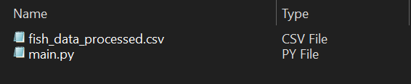

## Objective (or Hypothesis) Verification

Project Objective:

* The objective of the project was to create a machine learning model that would learn from existing fish data and be able to predict the weight of a fish given its five independent measurement variables.
* The objective was met because the resulting project was a linear regression model that used supervised learning to train from the fish dataset. As of April 5, 2023, the R-squared value of the linear regression model was 0.91. Thus, the linear regression model is able to predict the weight of a fish with some margin of error.
* “R-Squared (R² or the coefficient of determination) is a statistical measure in a regression model that determines the proportion of variance in the dependent variable that can be explained by the independent variable. In other words, r-squared shows how well the data fit the regression model (the goodness of fit)” (Taylor).

## Effective Visualization and Reporting

Non-Descriptive Development Process:

* The development process behind creating and training the linear regression model was supported by the visualizations and descriptive methods. At the most basic level, the development process by first exploring the data. The dataset was explored using various visualization tools to identify trends. Once it was observed that the weight and all five other measurements of the fish has a positive correlation, a linear regression model was seen as an appropriate approach. During the data exploration, it was clear that the five independent variables positively influenced the dependent variable.
* During the analysis of the data, it was clear that the linear regression model would be better suited when using measurements that were close to the mode (highest frequency) of the data. This helped when developing the non-descriptive method (the linear regression model), because it identified that altough the R-squared value might be 0.91, there was a higher prediction error in the upper and lower ranges of the weight predictions.
* The data summaries included the three visualizations and the R-squared value. These four data summaries provided a better insight into how the linear regression model would perform in certain situations.
* The three visualizations (the histogram, scatter plot, and graph displaying prediction error) are shown below. For a clearer image, refer to the “visuals” folder in the project directory for the image files.

Histograms

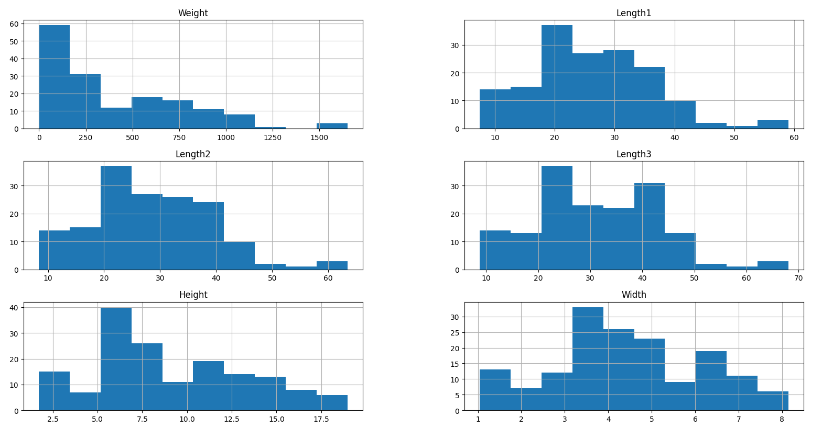

Scatter Plots

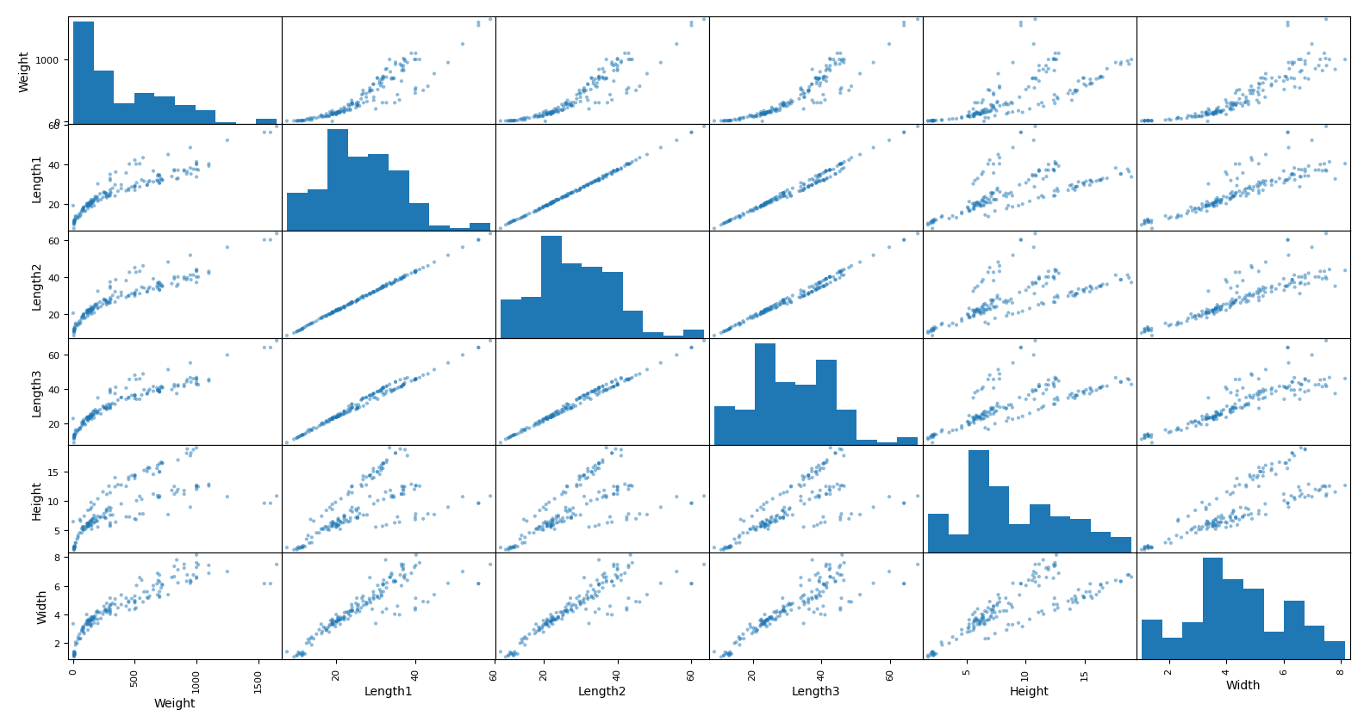

Prediction Error of Regression Model

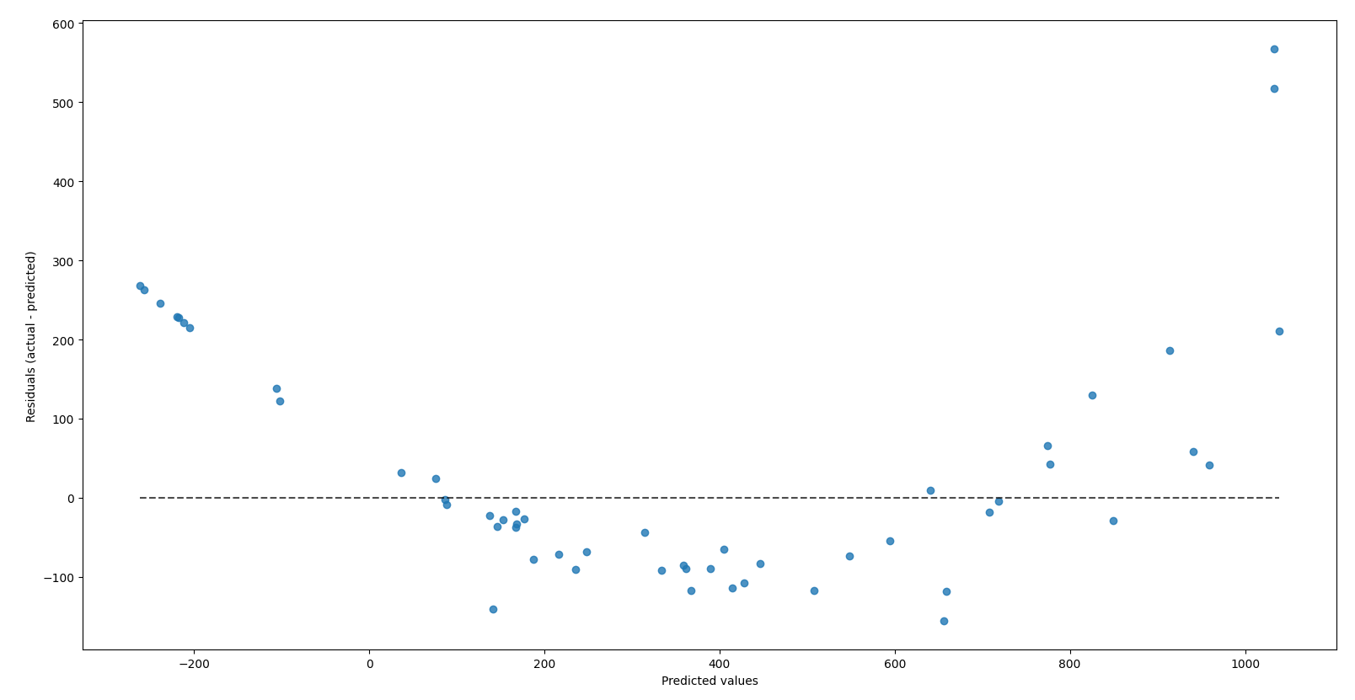

## Accuracy Analysis

The Model’s Accuracy Metric:

* The metric used to assess the accuracy of the linear regression model was a R-squared value.
* “R-Squared (R² or the coefficient of determination) is a statistical measure in a regression model that determines the proportion of variance in the dependent variable that can be explained by the independent variable. In other words, r-squared shows how well the data fit the regression model (the goodness of fit)” (Taylor).
* The R-squared value is a decimal number that ranges from 0.0 to 1.0. Our product returned a R-squared value of 0.91.
* Below is an example of the R-square value calculation in the project code. The calculation began with the non-descriptive method (linear regression model) predicting the weights of the fish using the test data of five measurements. Then, the predicted weight values were compared against the correct weight values. This variance was the R-squared value and illustrated the variance in the regression model versus the actual data.
* This metric was very accurate in proving the linear regression model’s accuracy because it calculated the variance of the true data against the predicted data. When dealing with numerical variables like in this project, it was the only way to display how accurate the regression model was.

Code Screenshot: Calculation of R-squared Value

## Application Testing

Testing Methods, Process, and Results:

* The application was tested only by me. The testing process included using a variety of valid and invalid inputs for the linear regression algorithm. In addition, the menu navigation in the console was also tested to account for various errors and situations.
* The results of the testing were signficant because it led to many changes in the code that improved the final product. The first tests involved inputting various combinations of the five numerical inputs for the linear regression algorithm. The outputs were compared to the actual data to identify similarities and to ensure that the final prediction was not outlandishly inaccurate.
* The testing of the application’s user interface also brought about many changes. By testing the application in the end user’s perspective. The graphical interface was altered to improve visiblity. The print statements were altered to inclue newline operators. If the linear regression algorithm was fed an invalid input, the appropriate error message was given. By testing the variety of inputs, the code was able to improve by including “try except” statements. These prevented errors from the algorithm receiving too few or too many numbers. In addition, if any of the inputs included a non-numerical value, a corresponding error was displayed.
* The use of the “A”, “B”, and “end” inputs were added after testing showed that it was not possible to maneuver between the reporting section and the calculation section of the application. This led to the improvement of the code where the aforementioned three strings allowed the user to navigate between the program’s different functionalities without having to terminate the program and start over again.
* There were various parts of the application that displayed error messages if the program was terminated while waiting for an input. To prevent this, a “ try except” statement included a “KeyboardInterrupt” error case where the program would quit instead of displaying an unnecessary error.

## Application Files

Location of Files:

* The 8 files mentioned below will all be located in the provided “zip” file. All files are located directly inside the directory.

Required Files:

* The project requires only two files to execute properly. Because the entire project and associated documentations are located inside the project folder, everything mention in this section can be accessed through the provided “zip” folder. The necessary files to execute the application are the following:
  + main.py (run this file in PyCharm IDE to access the console UI)
  + fish_data_processed.csv (place this file with “main.py” for regression model training)

Not Required Files:

* There are supplementary files that are not necessary to access the application. These files only serve to improve the viewer’s understanding of the project. They are not needed to execute the program. These files are the ones mentioned below:
  + “visuals” folder
  + task_1_writeup.docx
  + task_2_documentation.docx
  + fish_data_raw.csv
  + README.md

## User Guide

Installation and Use Guide:

* If any of the following software is already installed and configured, you can skip that step.
* The following directions apply to a Windows 10 machine.
  + - 1. Download the fish-weight-estimation.zip file onto your computer.



* + - 1. Unzip the fish-weight-estimation.zip file. You can use this link (<https://www.7-zip.org>) to install a file unarchiver tool to unzip it. Refer to this link (<https://www.7-zip.org/faq.html>) if any issues arise during the installation of 7-Zip.

* + - 1. Download and install PyCharm Community Edition from this link (<https://www.jetbrains.com/pycharm/download>). Refer to this link (<https://www.jetbrains.com/help/pycharm/installation-guide.html>) if any issues arise during installation of PyCharm.

* + - 1. Download and install Python from this link (<https://www.python.org/downloads>). Refer to this link (<https://wiki.python.org/moin/BeginnersGuide/Download>) if any issues arise during installation of Python.

* + - 1. Open PyCharm.



* + - 1. In PyCharm, go to File -> Open . . . -> select the unzipped fish-weight-estimation folder. Click “OK”.

* + - 1. With the project opened in PyCharm, open the main.py file in the IDE.

* + - 1. In PyCharm, configure the Python interpreter for this project using the Python installation from step 4. Use this link (<https://www.jetbrains.com/help/pycharm/configuring-python-interpreter.html>) if any issues arise during interpreter configuration.

* + - 1. In the main.py file, ensure lines 1 – 4 are not showing errors. If they are showing errors, it means that the required Python libraries are not installed. On each error line, right-click the problematic import and click “Show Context Actions”. Choose the option to install the corresponding Python library. Repeat this for all four lines of imports

* + - 1. After the libraries are installed, run the main.py file.

* + - 1. The console should appear now. In the console, type in “B” and press ENTER.

* + - 1. The console will generate the R-squared value of the linear regression model.

* + - 1. Three windows will appear showing the prediction error of the regression model, a histogram, and a scatter plot. These three visuals will be discussed in this document. Enlarged versions are available in the “visuals” folder and also in the “Effective Visualization and Reporting” section of Part D.

* + - 1. After closing all three windows, the console will automatically return to the main menu.

* + - 1. In the console, type in “A” and press ENTER.

* + - 1. The console will generate the menu to use the trained linear regression model that predicts the weight of a fish given five numers (the vertical length, diagonal length, cross length, height, and diagonal width).

* + - 1. In the console, type in “23.2, 25.4, 30, 11.52, 4.02” and press ENTER to test the model.

* + - 1. The output will return the predicted weight of the fish in grams.

* + - 1. Use this menu to repeatedly test variations of fish measurements.
      2. When want to close the program, type “end” in the console and press ENTER.

* + - 1. Again, in the console type in “end” and press ENTER.

* + - 1. The program is now terminated.
      2. Return to step 10 to start the program again.

## Summation of Learning Experience

Application of Previous Knowledge and Experience:

* This project was made easier because of my previous experience in Western Governors University’s (WGU) coursework. During my experience earning my Bachelor of Science in Computer Science degree, I learned many hard and soft skills. I learned how to better use various IDEs like PyCharm and IntelliJ. The practical experience using these IDEs in previous projects brought me the knowledge of various aspects. Things like configuring the project’s interpreter, installing the appropriate compilers, and creating a proper project structure were all thing that I learned through WGU.
* The use of version control using Git was also integral in this projects development. Ensuring that there were safe backups of my work in the cloud brought an extra layer of confidence to my work. In addition, the ability to rollback any changes brough comfort when changing and improving my code. WGU helped me develop my skills in Git because of the many projects that need to be developed during the coursework. In addition, working with the virtual machines in previous projects required me to be competent in Git.
* Previous projects that included developing code and solving a business need helped me understand the steps I needed to take to solve a solution with software. Using Python in this project was easy since I already had experience using Java in courses like “Software I” and “Software II”.

Application of New Knowledge:

* Additional knowledge was definitely needed to complete this project. The topic of machine learning was explored in my previous courses but never practically used to the extent of this project.
* I needed to learn various topics like supervised learning, unsupervised learning, reinforced learning, regression algorithms, and classification algorithms. These topics of machine learning were important in understanding the final product and how I was going to achieve it.
* I also needed to learn how to use various Python libraries such as the “scikit-learn” library in order to implement linear regression into my data. I needed to learn how to use the “pandas” library to implement “dataframe” structures that help csv data. I also needed to learn the “matplotlib” library to be able to create visuals from my data and model.
* I learned more about the application of visuals in data sets and regression models to create the visuals.
* I needed to expand my knowledge about the”try except” statement and the keyboard input error when creating my user interface.
* I needed to learn about descriptive methods and non-descriptive methods so that I could properly implement a way to describe my data and also infer new knowledge from it.

Project Contribution to Lifelong Learning:

* My definition of lifelong learning is “the continual pursuit of new knowledge that will improve one’s expertise in a subject matter”.
* When I analyze this experience for its contributions to my lifelong learning, I believe it has opened up a new pathway for me to develop a better understanding of machine learning. Prior to this project, I had no ambition for machine learning and the concept was very foreign to me. However, this project has caused me to become interested in the topic. This will lead me to pursue more opportunities and learning moments where I can expand my knowledge on machine learning.

# Part E: Sources

Adobe Communications Team. “Beginner’s Guide to Agile Project Management”. Adobe Experience

Cloud Blog, 18 Mar. 2022, https://business.adobe.com/blog/basics/agile#what-are-the-6-steps-in-

agile-project-management.

Taylor, Sebastion. “R-Squared”. Corporate Finance Institute, 4 Mar. 2023,

https://corporatefinanceinstitute.com/resources/data-science/r-squared.