**Neighborhood Analysis in Hong Kong**

**Arailym Akimova**

**Introduction: Business Problem**

* To analyze the difference between neighborhoods in Hong Kong
* To help decide if people should come to Hong Kong to live and where to stay

**Data**

* Hong Kong neighborhood data from 2019 district council election
* https://www.elections.gov.hk/dc2019/eng/p_cs.html
* Location data from Geopy package

**Three main areas**

* Red – Hong Kong Island
* Blue – Kowloon
* Green – New Territories
* The neighborhoods distributed uniformly around the urban areas

**Methodology**

* Determination of k
* Distortion means the within-cluster sum of squared errors
* At the elbow point, k ~ 12
* Thus, the best k should be around 12

**Results**

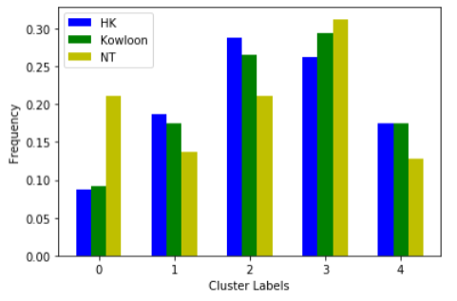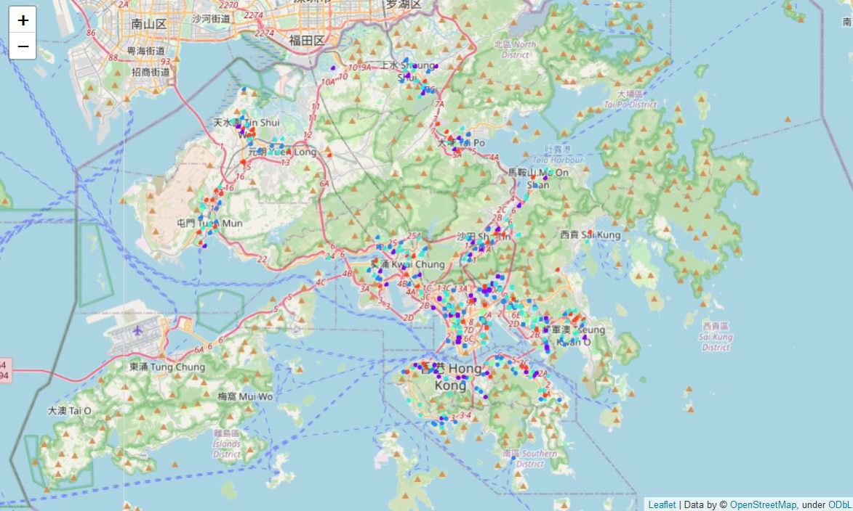

Generally, the structures of HK and Kowloon neighborhoods are close to each other. Cluster 2 and 3 are more common than others. Cluster 2 slightly more common in HK while Cluster 3 in Kowloon.

* Cluster 0 is more common in NT than in HK and Kowloon
* Cluster 1, 2 and 3 less common in NT
* NT has more cluster 0 and 3, which show larger frequencies of Chinese
* restaurants and fast food restaurant, while fewer venues like coffee shops
* Light rail station is typical in NT, which appears in top 5 of Cluster 0 Different clusters can be visualized on this Folium map
* E.g. In Tuen Mun, more cluster 0 can be found, while fewer cluster 1
* This map can help decide where to stay in Hong Kong

**Conclusion** **[¶](http://localhost:8888/notebooks/Capstone_The-Battle-of-the-Neighborhoods%20(2).ipynb" \l "Conclusion-)**

* The neighborhoods in Hong Kong island and Kowloon are close to each other, probably due to the similar urbanization history
* Hong Kong is a convenient city where supermarket and shopping malls are distributed in many neighborhoods around the city
* Chinese restaurants and fast food restaurants are the most common venues in Hong Kong, which may be related to the eating habit in this city.