Development Application Figures

Anthony Kimpton

02 March, 2021

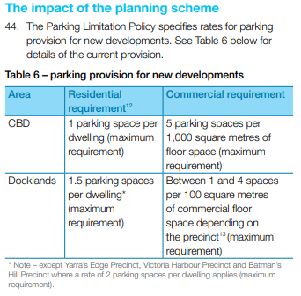

Figure 1. Parking Maximums Zoning ([CoM 2008](https://www.melbourne.vic.gov.au/SiteCollectionDocuments/cbd-docklands-parking-plan-2008-2013.pdf))

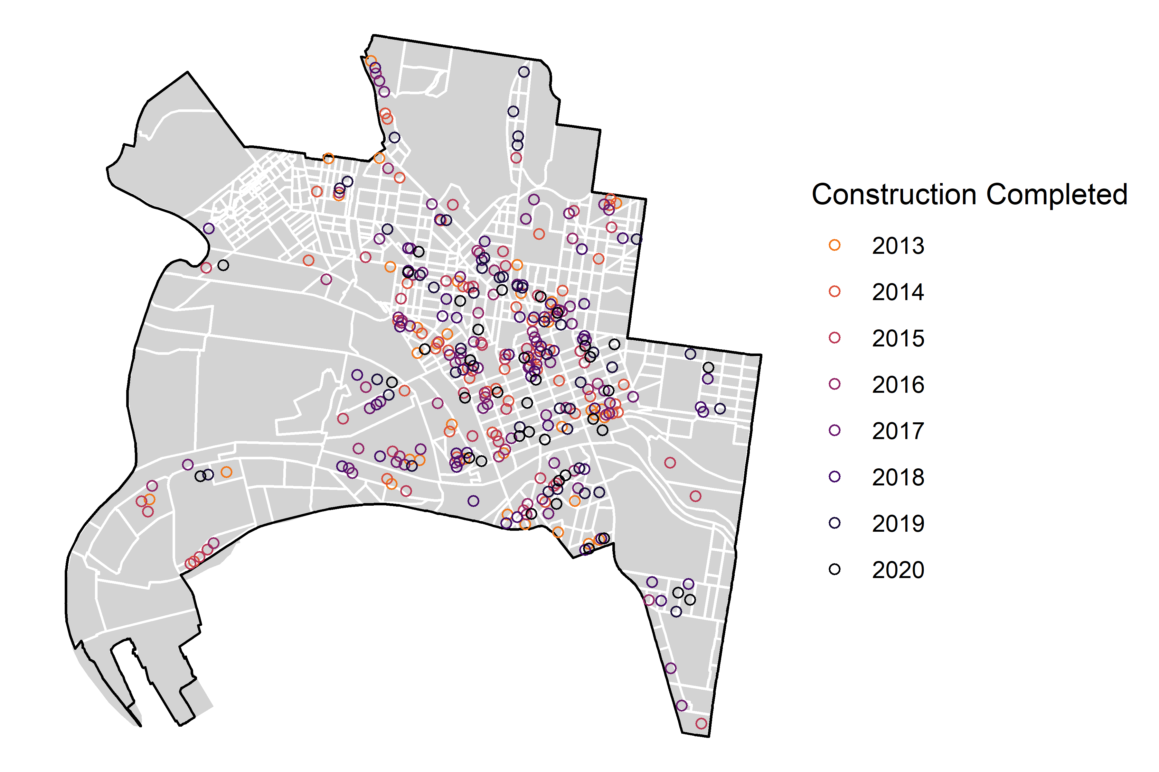

Figure 2. Development Applications by Year

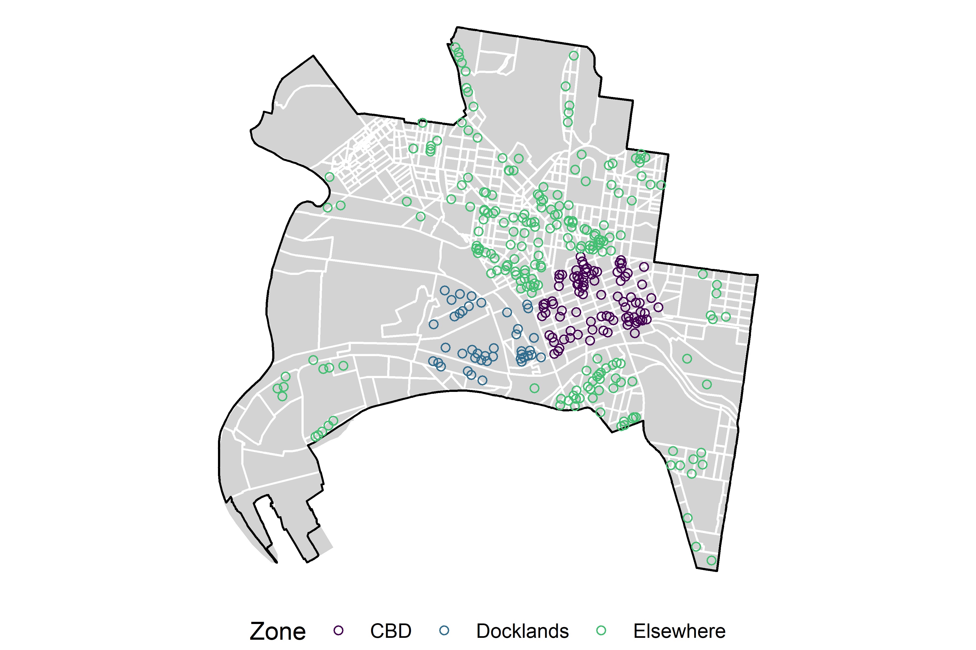

Figure 3. Development Applications by Zone

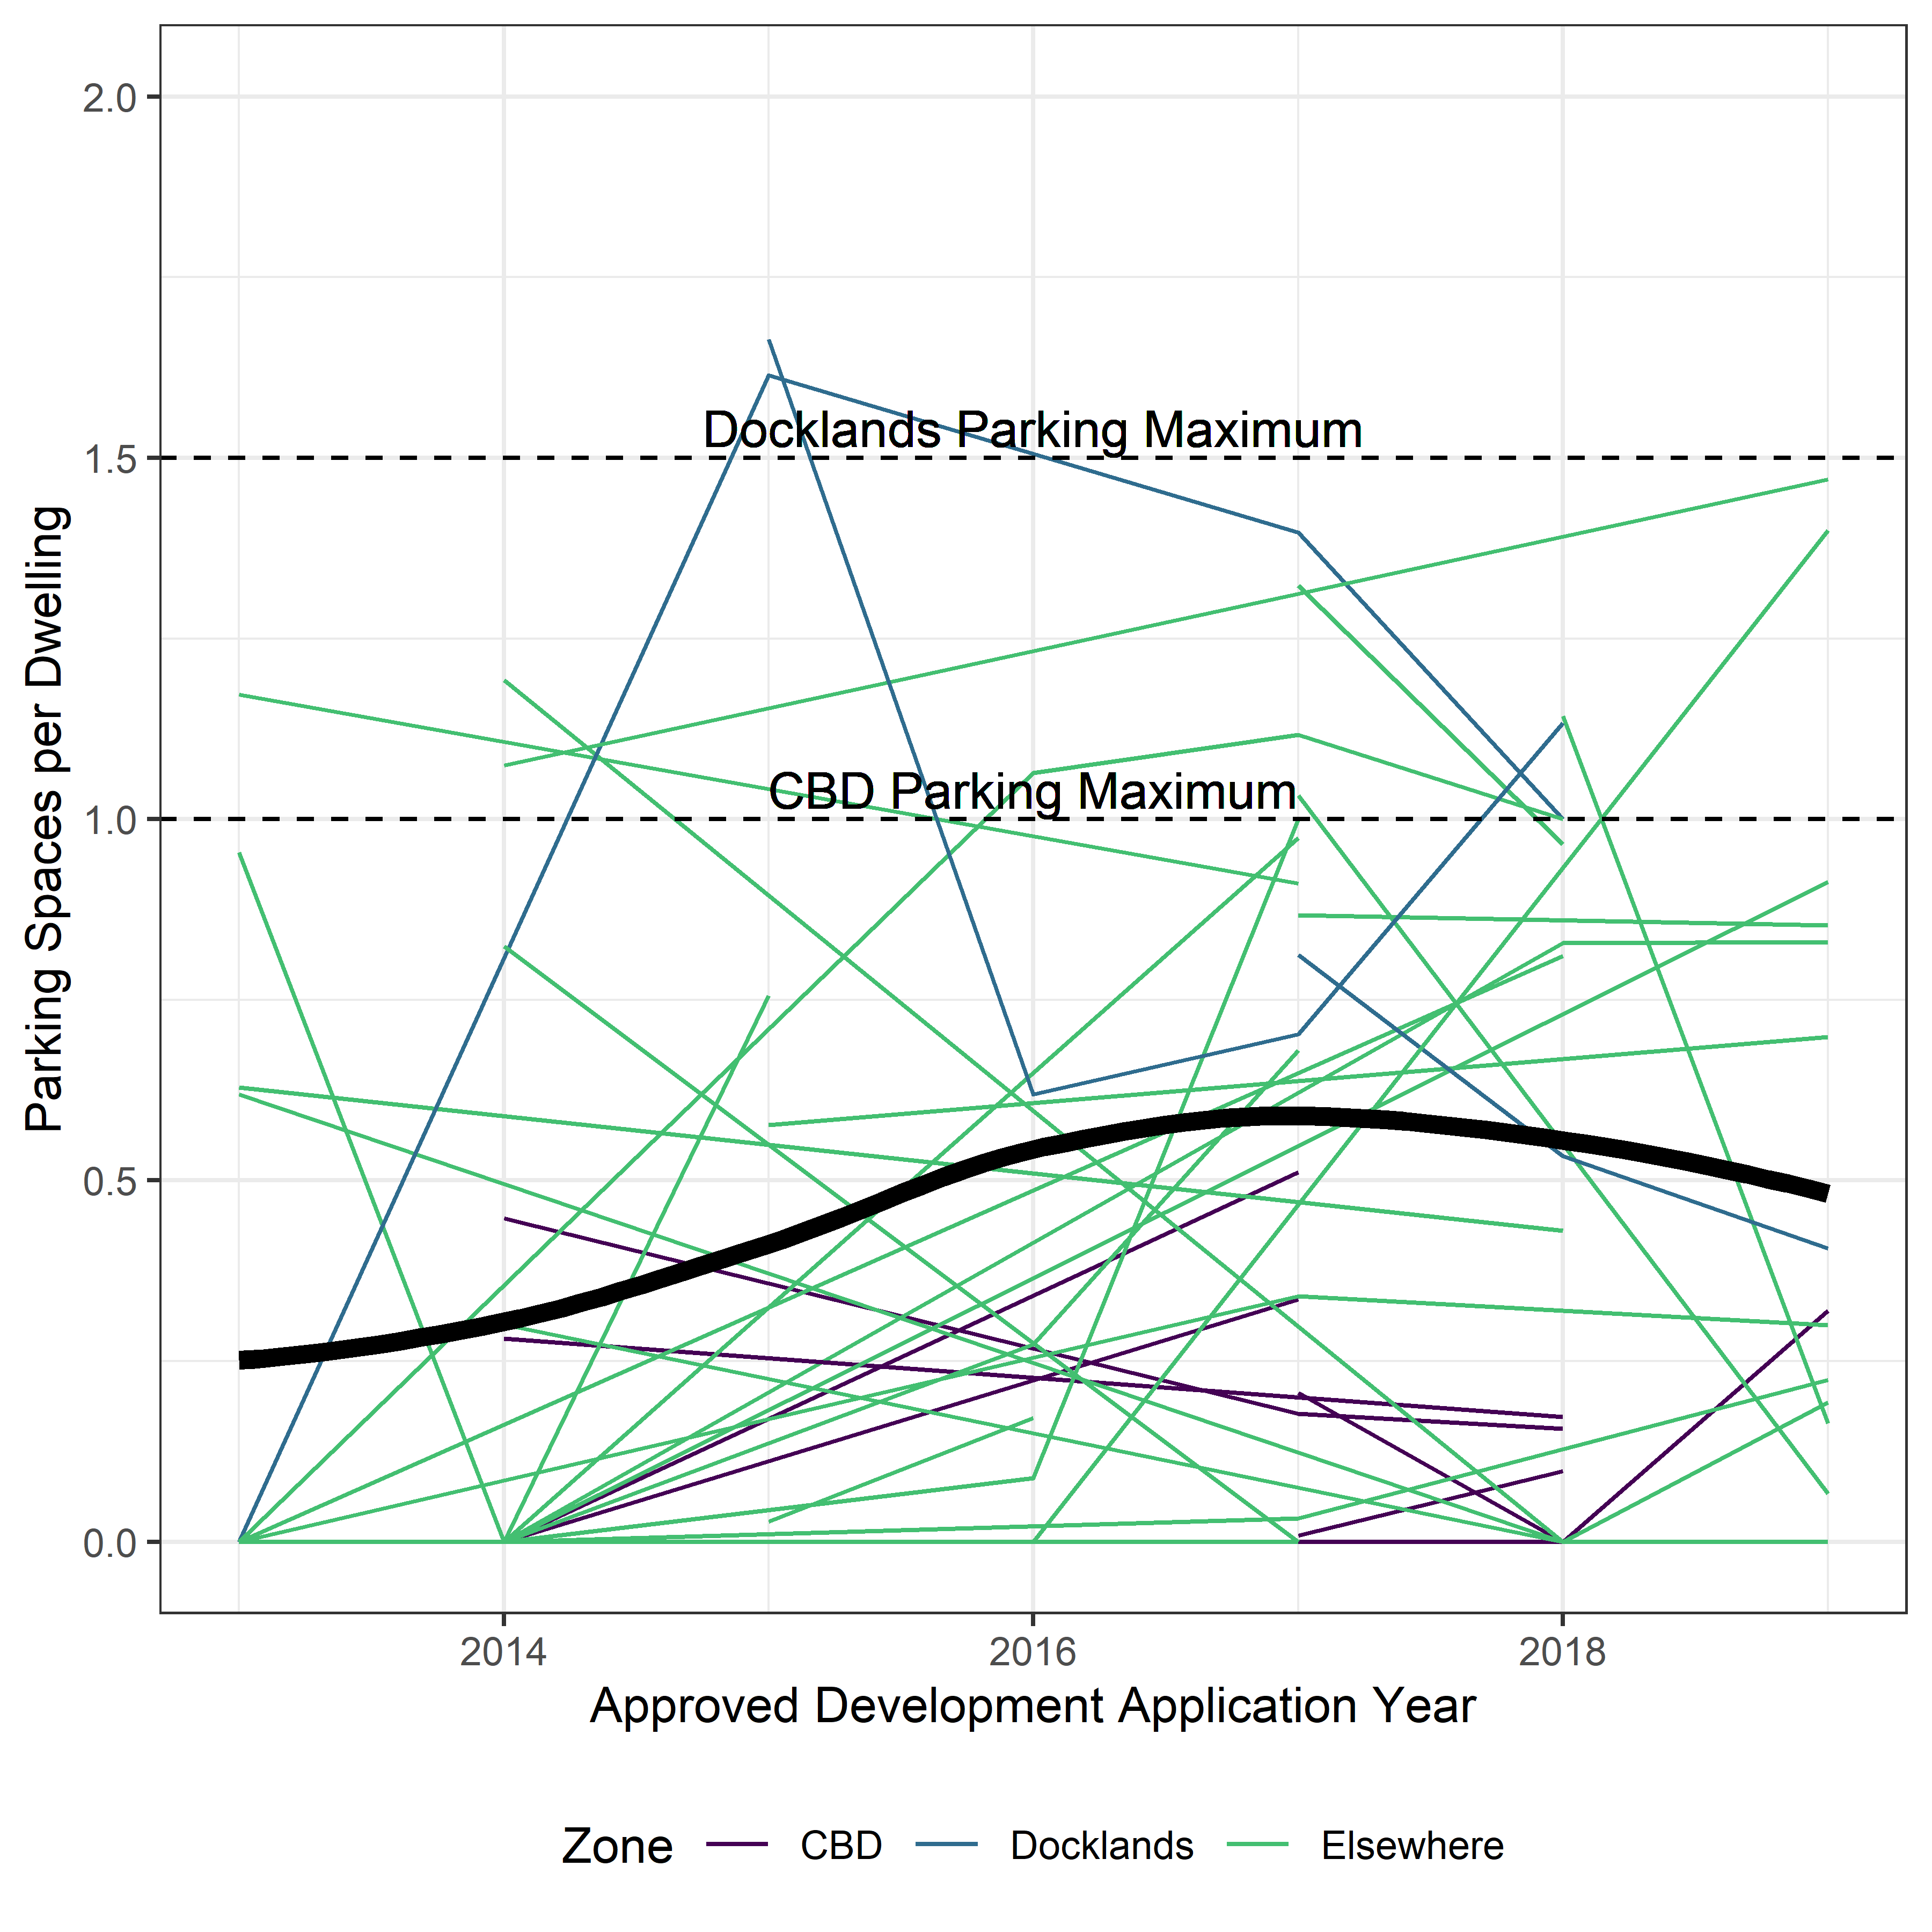

Figure 4. Parking Supply by CLUE Block over time