**Analytical Excellence Is All about Speed**

**Career advice to guide data analysts to the top**

In [*Data Science’s Most Misunderstood Hero*](http://bit.ly/quaesita_hero)*,* I described the excellences of each of the three areas in data science. An analyst’s excellence is speed.

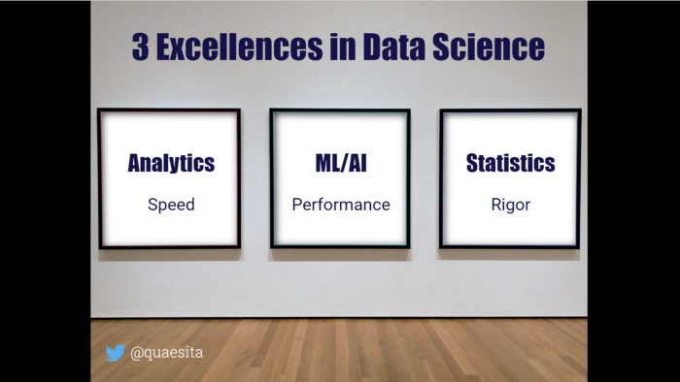

Learn more in my [article on excellence in data science](http://bit.ly/quaesita_hero). Image by the author.

Don’t misinterpret this to mean that analysts are good at running around like headless chickens, bumping into insights through some kind of bumbling Brownian motion. The excellence of speed is much deeper and more nuanced.

Analytics is an acceleration engine.

Analytics is an acceleration engine. A good analyst makes everything around them faster by discovering (inspiring!) new approaches, [uncovering opportunities and threats](http://bit.ly/quaesita_hbrrisk) that their colleagues didn’t even know were worth asking questions about. Theirs is the one eye in the kingdom of the blind.

Don’t be fooled by a simplistic interpretation of speed. A sloppy analyst who keeps falling for shiny nonsense “insights” will only slow everyone down in the long run.

To produce this inspiration efficiently, analysts explore data while trying to waste as little of their own time (and the [decision-maker’s](http://bit.ly/quaesita_valueanalyst)!) in the process. For the best *time-to-inspiration* payoff, they must master many different forms of speed, including:

* Speed of getting data that’s promising and relevant. (***Domain knowledge.***)
* Speed of getting data ready for manipulation. (***Software skills.***)
* Speed of getting data summarized. (***Mathematical skills.***)
* Speed of getting data summaries into their own brains. (***Data visualization skills.***)
* Speed of getting data summaries into stakeholders’ brains. (***Communication skills.***)
* Speed of getting the decision-maker inspired. (***Business acumen.***)

That last point is plenty nuanced (and also the most important one on the list), so let me spell it out for you.

When thinking about your decision-maker’s time, remember that beautifully visualized and effectively communicated trivia are a waste of time. Exciting findings which turn out to be misinterpretations are a waste of time. Red herrings are a waste of time. Unactionable discoveries that miss the bus are a waste of time. Meticulous forays into garbage data sources are a waste of time. Irrelevant anecdotes are a waste of time. Anything an analyst brings decision-makers that they don’t find to be worth their time… is a waste of time.

The analytics game is all about optimizing inspiration-per-minute.

Analysts *will* waste the decision-maker’s time — that’s part of exploration — so the analytics game is all about wasting as little of it as possible. In other words, optimizing ***inspiration-per-minute*** (of their time *and* yours, subject to some exchange rate related to how valuable each of you is to your organization).

Don’t be fooled by a simplistic interpretation of speed. A sloppy analyst who keeps falling for shiny nonsense “insights” will only slow everyone down in the long run.

Understanding this is a major hurdle for newbies, which is why it rounds out my list of 10 differences between an amateur and a professional analyst. We covered the first 9 in detail in my previous articles [[1]](http://bit.ly/quaesita_realanalyst) [[2]](http://bit.ly/quaesita_careeranalyst) [[3]](http://bit.ly/quaesita_realisticanalyst) [[4](http://bit.ly/quaesita_valueanalyst)] [[5]](http://bit.ly/quaesita_timeanalysts) and now we’re ready to cross the finish line.

**Data pro vs amateur difference #10 - Nuanced view of excellence**

Unlike amateurs, professional analysts don’t view speed as a dirty word but rather as a nuanced concept that guides how they think of their work, how they prioritize, how they [assess performance](http://bit.ly/quaesita_speed), and how they develop their skills. Their work is to accelerate others; to do it well, they must accelerate themselves first. Their craft is speed in all its forms and they take it seriously.

Speed is not a dirty word.

As part of this, analysts are ruthless prioritizers. Since everything takes time — and time is so precious! — they refuse to do something *better* unless there’s evidence that the “something” is worth doing in the first place. This isn’t a personality trait that comes naturally to everyone, so let’s do a little self-test: ***do you finish all the books you start reading?***

An expert analyst wouldn’t. Reading carefully from the first word to the last word is how you’d read if you lived in the dark ages and all the literature you’d ever have access to could fit in a lunchbox. But since there are more books than you’d ever have time to read, the most efficient approach is iterative: before you commit to reading carefully, you need a process for discovering promising books that are worth committing to, plus the discipline to stop and switch with a minimum of your life wasted. Analysts are like that with [data](http://bit.ly/quaesita_hist) — there’s always more to look at than you have time for — and an intelligent discovery process is key.

Analysts aren’t afraid to start simple.

Analysts are also ruthless prototypers. They’d never *start* with the most time consuming tool, no matter how shiny or sophisticated, until they’ve had a signal — usually from trying the simpler approach first — that it’s a good investment of their time. Great analysts are not only unafraid of starting simple, they’re secretly laughing at those who don’t. It should go without saying that they know better than to waste time on reinventing a wheel… or code/tool/method.

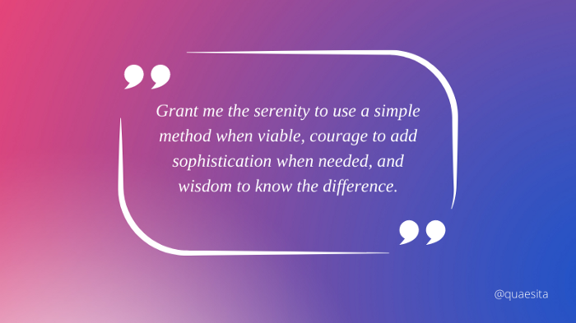

A solid wish for [data scientists](http://bit.ly/quaesita_datascim): “Grant me the serenity to use a simple method when viable, courage to add sophistication when needed, and wisdom to know the difference.” Created with Canva.

The same logic applies to teamwork: don’t try to do it all yourself if you don’t need to. If you have teammates whose unique perspectives and skills can accelerate your work, work with them. Don’t skulk in a corner trying to be some kind of incomprehensible know-it-all badass, you don’t have time for that. And you don’t have time to get tripped up by your blind spots, so learn to collaborate!

Make speed your north star for skills development.

As a professional analyst, speed is also your north star for skills development. It’s true that the data landscape is changing rapidly, so you can’t afford to stagnate. The tools you use today won’t stick around for long. Keep sharpening your claws, but don’t chase the buzzwords. There are a lot of insecure people who don’t know how to make themselves useful so they put all their effort into titles, certificates, badges and other baubles. You’re better than that.

Stop asking: *“Should I learn this tool/method/technique that all the cool kids are talking about?”*  
Start asking: *“Will learning this make me faster?”*

Learn whatever makes you faster (in all the ways that matter). Since your work involves accelerating others, start by accelerating yourself.

Since your work involves accelerating others, start by accelerating yourself.

That’s it for the series! Hope you enjoyed it. Don’t forget to share it if you found it useful; here is the full set of articles:

**Data pro vs amateur differences #1-#3**

Software skills; handling lots of data with ease; immunity to data science bias. Covered in [part 1](http://bit.ly/quaesita_realanalyst).

**[Becoming a “real” data analyst](https://towardsdatascience.com/becoming-a-real-data-analyst-dcaf5f48bc34" \t "_blank)**

**[10 differences between amateurs and professional analysts](https://towardsdatascience.com/becoming-a-real-data-analyst-dcaf5f48bc34" \t "_blank)**

[towardsdatascience.com](https://towardsdatascience.com/becoming-a-real-data-analyst-dcaf5f48bc34" \t "_blank)

**Data pro vs amateur differences #4–#6**

Understanding the career; refusing to be a data charlatan; resistance to confirmation bias. Covered in [part 2](http://bit.ly/quaesita_careeranalyst).

**[Shifting your mindset from amateur to professional analyst](https://towardsdatascience.com/shifting-your-mindset-from-amateur-to-professional-analyst-61383f913408" \t "_blank)**

**[The journey to becoming a “real” data analyst](https://towardsdatascience.com/shifting-your-mindset-from-amateur-to-professional-analyst-61383f913408" \t "_blank)**

[towardsdatascience.com](https://towardsdatascience.com/shifting-your-mindset-from-amateur-to-professional-analyst-61383f913408" \t "_blank)

**Data pro vs amateur differences #7**

Realistic expectations of data. Covered in [part 3](http://bit.ly/quaesita_realisticanalyst).

**[How to form realistic expectations about data](https://kozyrkov.medium.com/how-to-form-realistic-expectations-about-data-622e85ab62cb" \t "_blank)**

**[The journey to becoming a “real” data analyst](https://kozyrkov.medium.com/how-to-form-realistic-expectations-about-data-622e85ab62cb" \t "_blank)**

[kozyrkov.medium.com](https://kozyrkov.medium.com/how-to-form-realistic-expectations-about-data-622e85ab62cb" \t "_blank)

**Data pro vs amateur differences #8**

Knowing how to add value. Covered in [part 4](http://bit.ly/quaesita_valueanalyst).

**[How to Add Value as a Data Analyst](https://towardsdatascience.com/how-to-add-value-as-a-data-analyst-8a6ae900b82a" \t "_blank)**

**[The journey to becoming a “real” data analyst](https://towardsdatascience.com/how-to-add-value-as-a-data-analyst-8a6ae900b82a" \t "_blank)**

[towardsdatascience.com](https://towardsdatascience.com/how-to-add-value-as-a-data-analyst-8a6ae900b82a" \t "_blank)

**Data pro vs amateur differences #9**

Thinking differently about time. Covered in [part 5](http://bit.ly/quaesita_timeanalysts).

**Data pro vs amateur differences #10**

Scroll to the top if you missed it. If you didn’t, consider exploring what happens when you click the clap icon more than once…

**Liked the author? Connect with Cassie Kozyrkov**

Let’s be friends! You can find me on [Twitter](https://twitter.com/quaesita), [YouTube](https://www.youtube.com/channel/UCbOX--VOebPe-MMRkatFRxw), [Substack](http://decision.substack.com), and [LinkedIn](https://www.linkedin.com/in/kozyrkov/). Interested in having me speak at your event? Use [this form](http://bit.ly/makecassietalk) to get in touch.