Andrew Kim

Section 1

Homepage

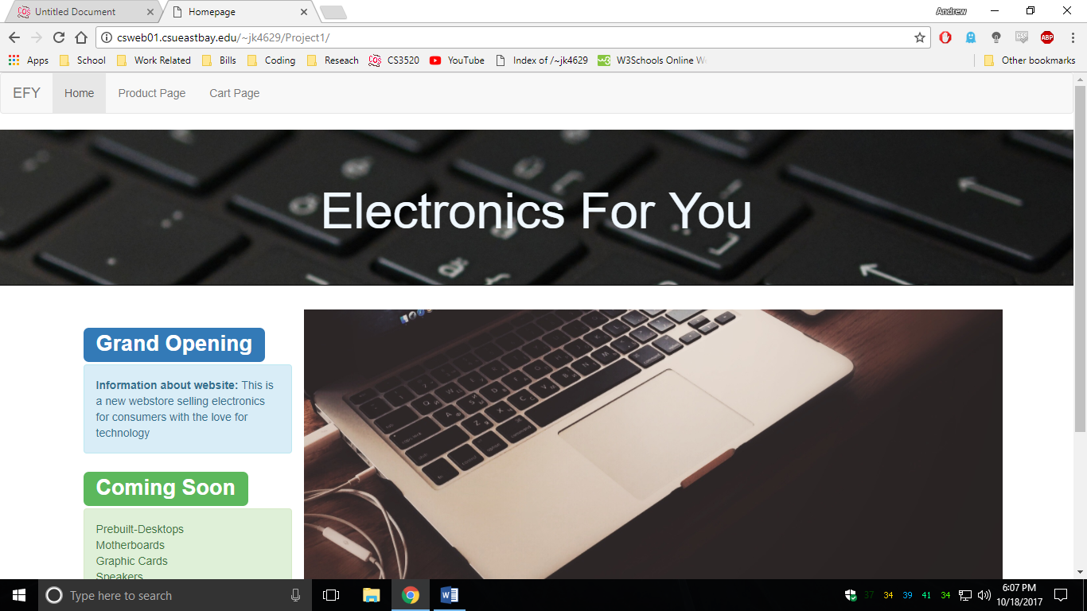

Product Page

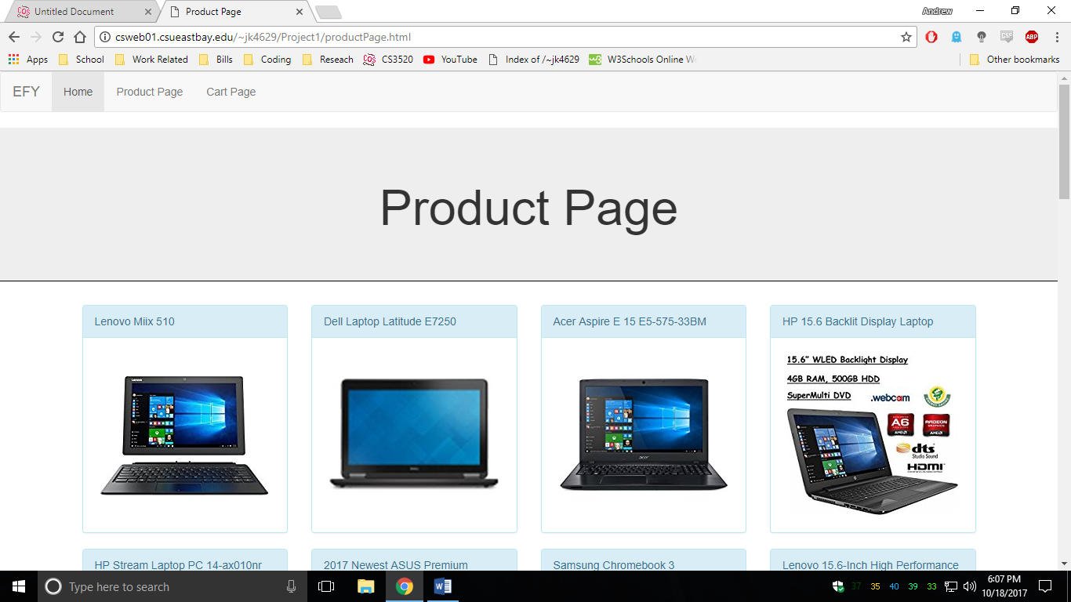

Product Page (Individual)

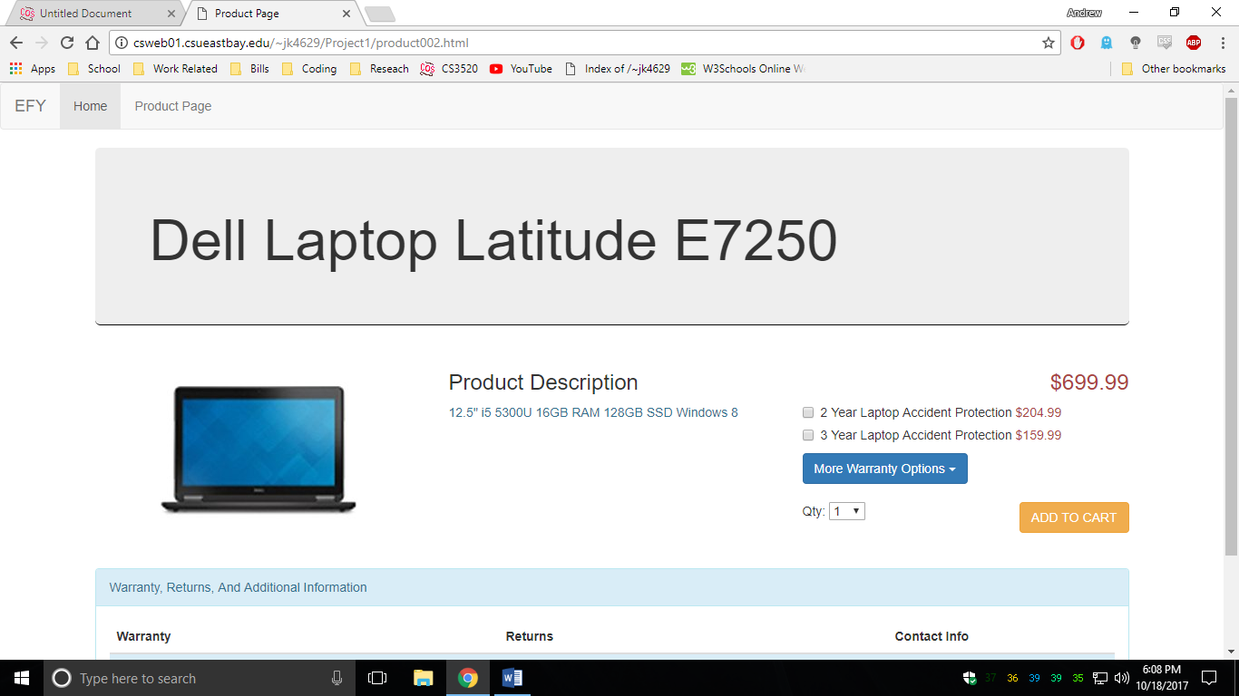

Cart Page

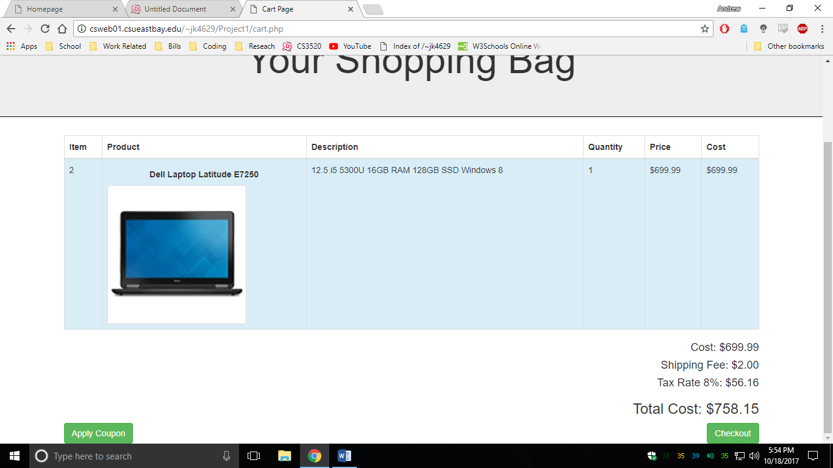

User Information Page

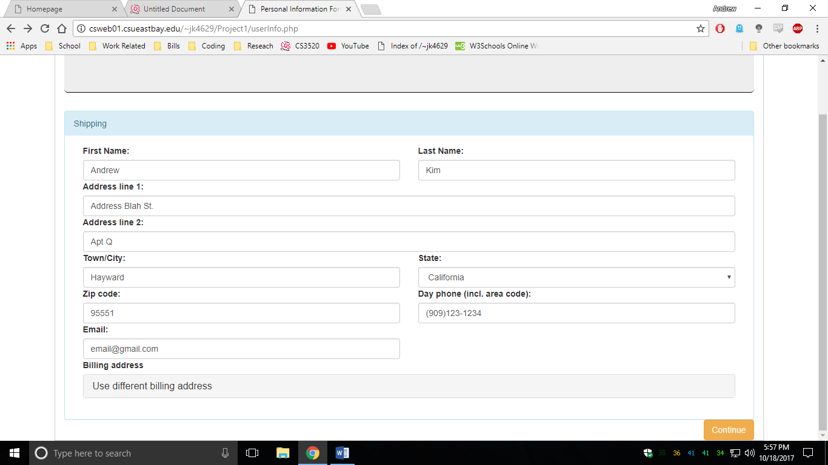

Payment Information Page

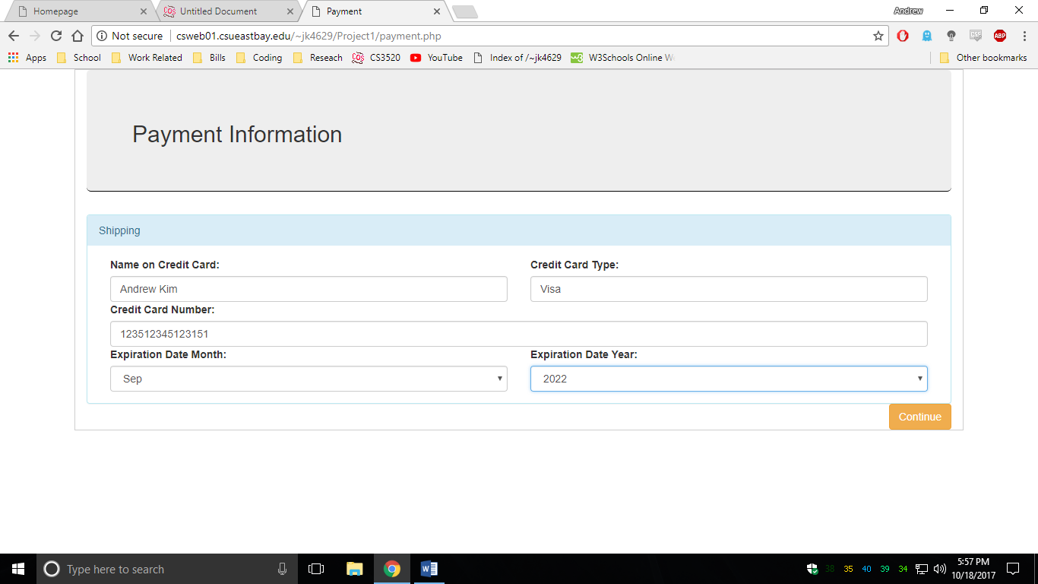

Order Summary #1

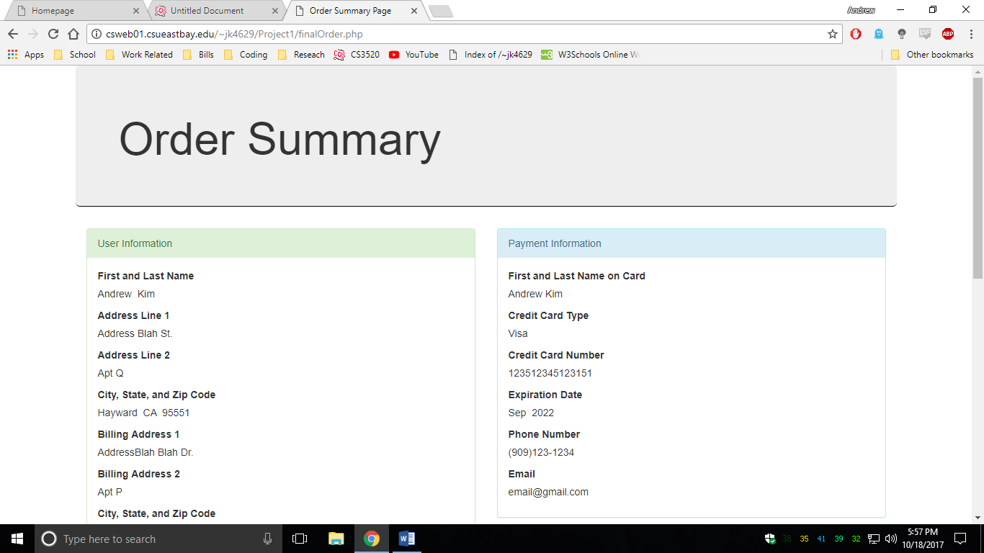

Order Summary #2 (Same Page)

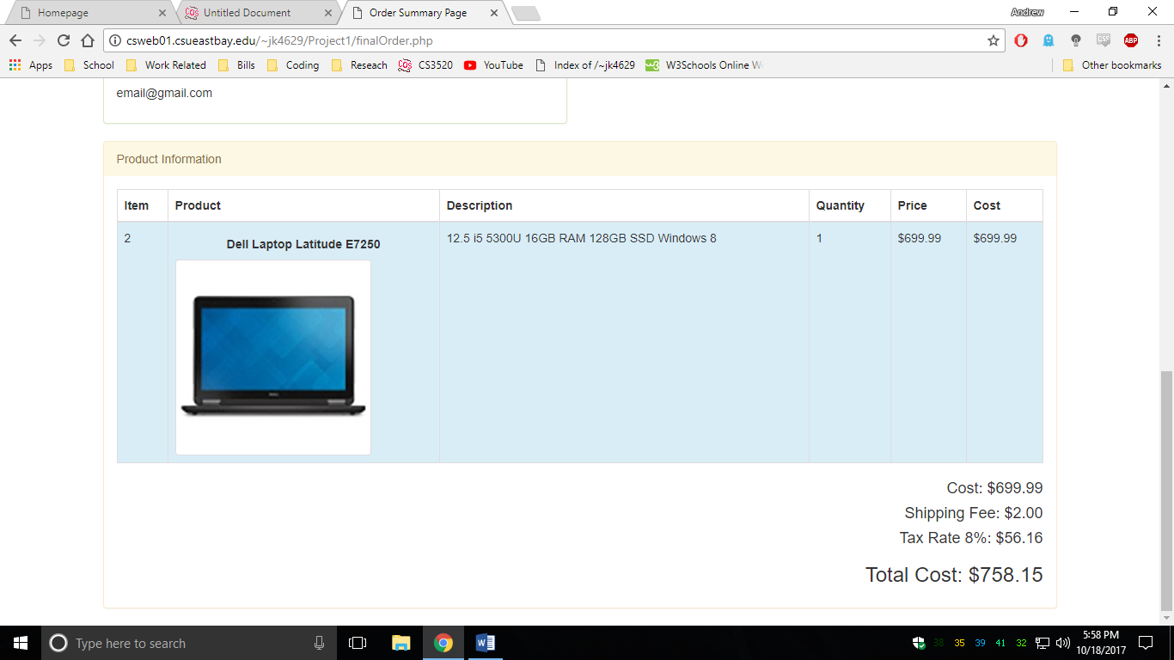

Section 2 – Status

1. Homepage
   1. All Implemented
2. All Product Page
   1. All Implemented
3. Product Page Individuals
   1. All Implemented
4. Cart Page
   1. Everything implemented except the extra credit where you can remove the product from cart.
5. User Information Page
   1. All Implemented
6. Payment Page
   1. All Implemented
7. Order Summary Page
   1. All Implemented

Section 3 – Added to Cart Process

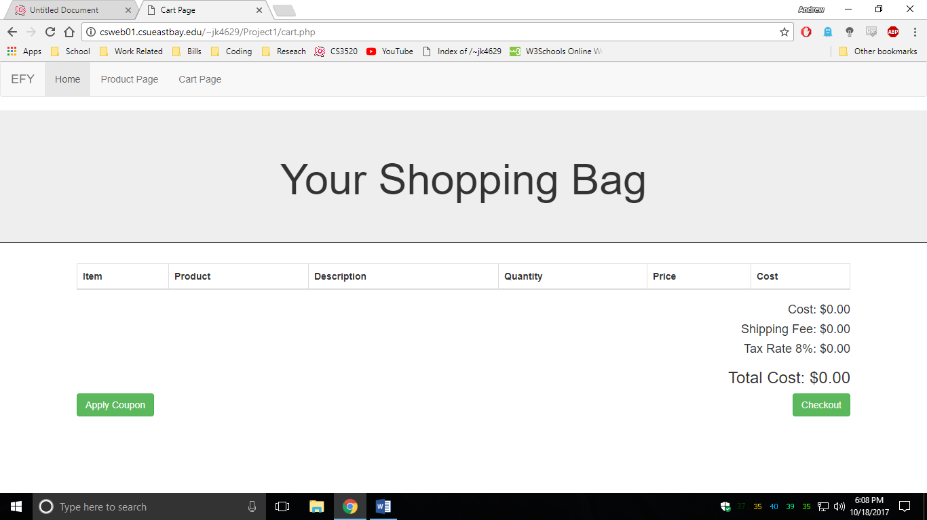

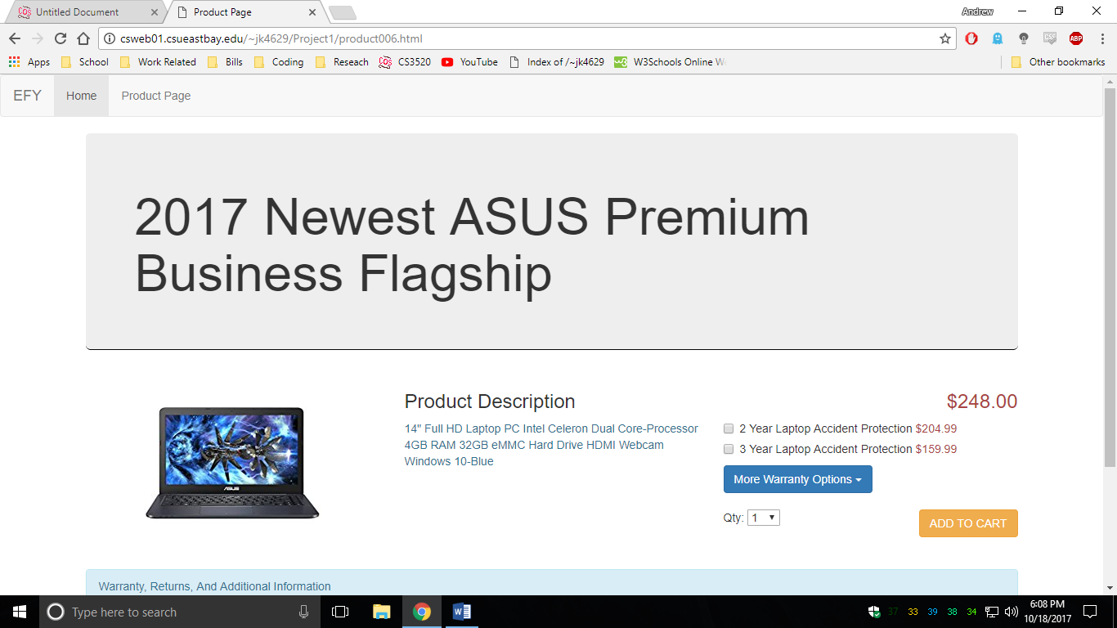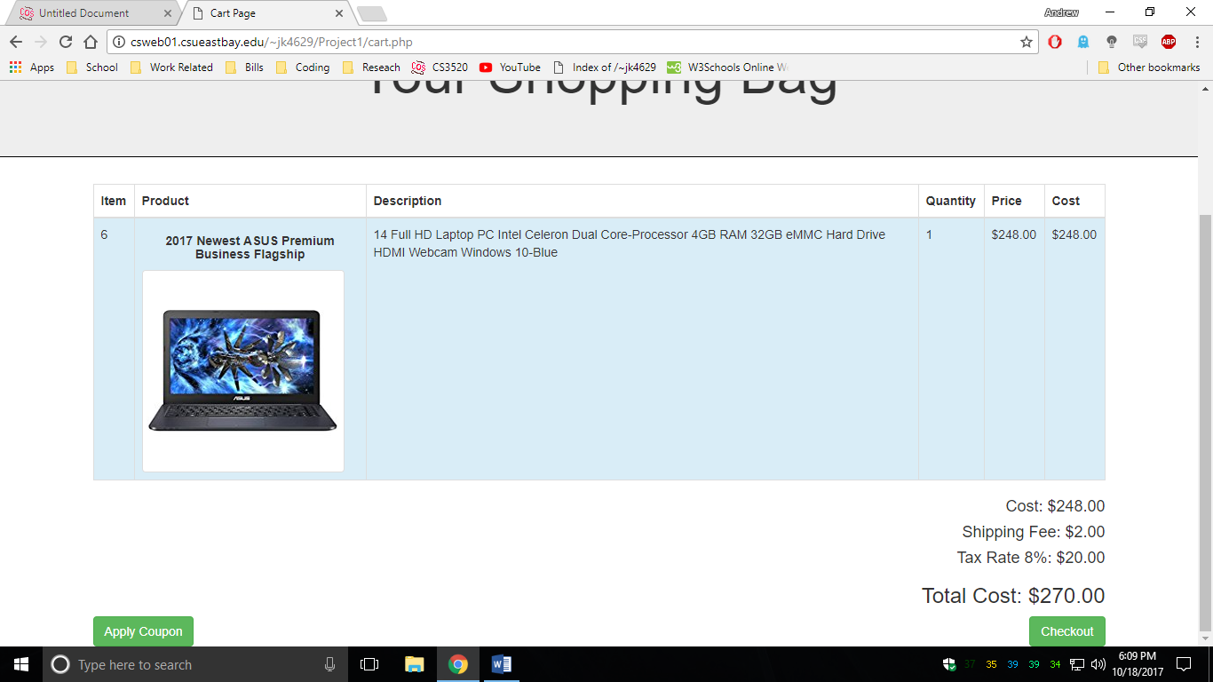

Section 4 – Checkout Process

