Editor
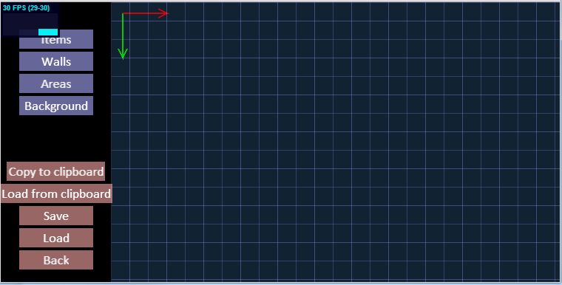

Scrolling / moving around the map
Only in ”Background” mode,

Background mode
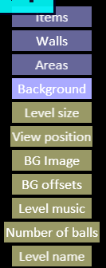
The ”canvas” can be moved / scrolled around in this mode..
Changing level size is possible (the image size is level size automatically, and the origo is 0,0 always.. in theory it is possible to create bigger background than what is the level size, and by using BG offsets, the background could go to negative sides.. this will give the benefit of ”background not ending abrubtly).
View position sets the current canvas position, if you have scrolled to somewhere impossible ( 10000000, 10000000 ) .. then using View position, you can go back to 0x0.
Other features in this mode is Zooming ( + , - , * ) .. + will zoom in and - zoom out, while * will reset zoom level to 1.
Level music is the url for the musicfile that will be looped in the background.
Number of balls, is the number of balls that player starts with this level.
Level name, is the level name, a string.

Items mode
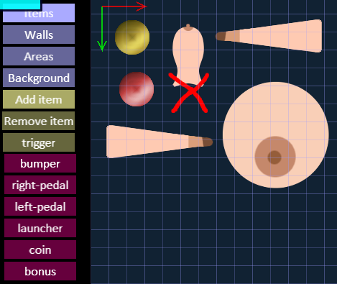
The items mode lets you add, remove and move the items around...
Different items have origo in different places, usually it is in the middle of the object, though, the launcher has origo at the base of the launcher. Selected item has a red cross marking the selection currently.
Trigger button allows you to specify what triggers an action on the selected object, currently the objects that have ”action” are pedals and launcher, a list of ”action events” is given, when trigger button is pressed.
(TODO! add origos and bounding boxes to the editor, so it is obvious).

Walls mode
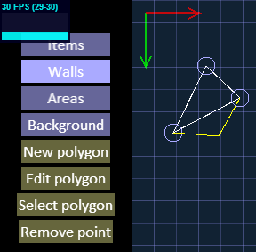
By clicking anywhere on the ”canvas” the currently selected polygon is split, from the line indicated by red bold line.. the splitting is emulated with thin yellow lines while mouse button is down, once mousebutton is released, the line is split and new vertex is added.
Vertexes can be moved by clicking moused down inside the vertex circle in ”Edit Polygon” mode, the vertex will then be moved with the mouse, and when mouse up, the vertex stays there.
Remove point works the same way as vertex editing, it just removes the point.
Use ”New polygon” to create separated polygons.
NOTE! No undo or Redo yet (TODO!)
Drawn walls are impenetrable, the ball will not go through a line. (also these lines are not visible in game). Use ”Select polygon” to select the currently editable polygon.

Areas mode
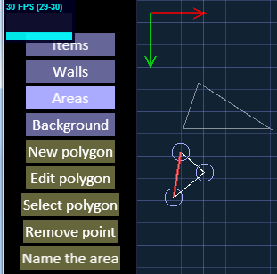
Areas are sensor areas, where something special happens when the player gets there, like ”fail”, ”retry” and ”bonus”. The game receives ”start” and ”end” events when the ball hits these areas, and can do anything with this knowledge.
The workings of the polygon editor is identical to ”walls editor”, new button ”Name the area” lets you define the function of the area.
Currently implemented keywords are ”fail” which when the ball hits, will trigger ”LOOSE_BALL” event and the ball will dissapear. ”retry” area is usually placed under the launcher, when the player fails to provide enought force, the ball falls back to launched and retries. ”bonus” area, could give the player extra points.

Load Save and clipboard
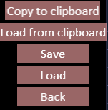
The Copy to clipboard does not work very well, Chrome autocorrects the text inputted and screws the data ( :(( ). For this reason _all_ clipboard things are also outputted to the console.
Loading should work fine.
The data is in json format text, so editing it in some json compliant thing, shouldnt be a problem.

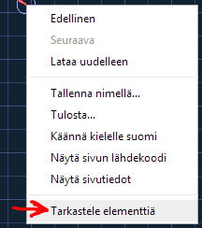
Accessing the console

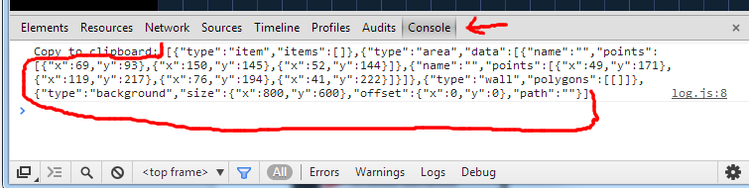

Example level
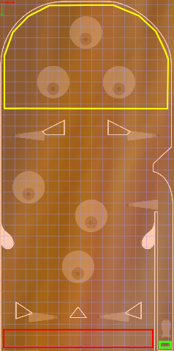
[{"type":"item","items":[{"type":"launcher","position":{"x":764,"y":1545},"angle":0,"scale":1},{"type":"right-pedal","position":{"x":521,"y":1441},"angle":0,"scale":1},{"type":"left-pedal","position":{"x":211,"y":1443},"angle":0,"scale":1},{"type":"bumper","position":{"x":363,"y":1215},"angle":0,"scale":1},{"type":"bumper","position":{"x":138,"y":854},"angle":0,"scale":1},{"type":"bumper","position":{"x":423,"y":983},"angle":0,"scale":1},{"type":"right-pedal","position":{"x":654,"y":932},"angle":0,"scale":1},{"type":"right-pedal","position":{"x":136,"y":619},"angle":0,"scale":1},{"type":"left-pedal","position":{"x":661,"y":619},"angle":0,"scale":1},{"type":"bumper","position":{"x":399,"y":151},"angle":0,"scale":1},{"type":"bumper","position":{"x":250,"y":376},"angle":0,"scale":1},{"type":"bumper","position":{"x":550,"y":377},"angle":0,"scale":1}]},{"type":"area","data":[{"name":"fail","points":[{"x":16,"y":1501},{"x":705,"y":1500},{"x":704,"y":1574},{"x":15,"y":1574}]},{"name":"retry","points":[{"x":730,"y":1551},{"x":787,"y":1550},{"x":786,"y":1585},{"x":730,"y":1586}]},{"name":"extra","points":[{"x":18,"y":274},{"x":43,"y":177},{"x":83,"y":117},{"x":173,"y":45},{"x":273,"y":15},{"x":504,"y":15},{"x":571,"y":35},{"x":651,"y":78},{"x":725,"y":150},{"x":773,"y":251},{"x":780,"y":279},{"x":779,"y":498},{"x":16,"y":499}]}]},{"type":"wall","polygons":[[{"x":9,"y":1595},{"x":11,"y":1110},{"x":27,"y":1133},{"x":50,"y":1133},{"x":69,"y":1116},{"x":75,"y":1107},{"x":70,"y":1092},{"x":56,"y":1074},{"x":33,"y":1053},{"x":18,"y":1032},{"x":13,"y":1011},{"x":12,"y":276},{"x":29,"y":203},{"x":54,"y":152},{"x":82,"y":113},{"x":118,"y":76},{"x":172,"y":43},{"x":235,"y":20},{"x":272,"y":14},{"x":524,"y":12},{"x":575,"y":28},{"x":652,"y":70},{"x":710,"y":123},{"x":748,"y":168},{"x":775,"y":221},{"x":787,"y":275},{"x":787,"y":670},{"x":705,"y":748},{"x":704,"y":782},{"x":726,"y":790},{"x":752,"y":807},{"x":780,"y":851},{"x":796,"y":925},{"x":794,"y":1593},{"x":725,"y":1593},{"x":724,"y":964},{"x":713,"y":965},{"x":710,"y":1009},{"x":702,"y":1037},{"x":687,"y":1053},{"x":667,"y":1072},{"x":654,"y":1089},{"x":647,"y":1108},{"x":660,"y":1124},{"x":680,"y":1134},{"x":701,"y":1124},{"x":712,"y":1105},{"x":712,"y":1544},{"x":711,"y":1597}],[{"x":79,"y":1373},{"x":156,"y":1428},{"x":78,"y":1450}],[{"x":651,"y":1372},{"x":576,"y":1426},{"x":652,"y":1453}],[{"x":299,"y":549},{"x":197,"y":598},{"x":214,"y":615},{"x":298,"y":615}],[{"x":499,"y":549},{"x":601,"y":599},{"x":586,"y":614},{"x":498,"y":614}],[{"x":361,"y":1398},{"x":405,"y":1447},{"x":320,"y":1447}]]},{"type":"background","size":{"x":800,"y":1600},"offset":{"x":0,"y":0},"path":"http://icegem.net/flip/configs/boob_level.jpg"}]

The areas are indicated in this picture with green ”retry”, yellow ”bonus” and red ”fail”. The walls are traced (they are physics objects, so they are not traced pixel perfectly) along the walls indicated in the background.

