Policy-Grounded Versus General-Purpose AI for Orthopedic Surgery Appeals. A Paired Comparison on 167 Simulated Denials

Abstract
Background. Patients and physicians increasingly turn to AI chatbots to fight insurance denials. General-purpose chatbots do not always have access to the health plan's medical policy and can hallucinate criteria that the policy does not contain. OrthoAppeals retrieves the plan's governing policy from a curated directory and drafts the appeal from the policy's own text. We compared it with the flagship models behind ChatGPT, Claude and Gemini.
Methods. We generated 167 simulated denials based on real denial scenarios, spanning 51 jurisdictions, 73 insurers and 14 orthopedic operations. Each case was answered by OrthoAppeals and by ChatGPT, Claude and Gemini with web search. For every case we measured whether the system identified the plan's governing policy and whether its appeal letter quoted that policy accurately, hallucinated policy text or a policy that did not exist, stated the filing deadline and appeal route, and was ready to send. Every letter was checked by code against the actual policy text. Systems were compared with Cochran's Q, exact McNemar, Friedman and Wilcoxon signed-rank tests with Holm adjustment.
Results. OrthoAppeals identified the governing policy in 167 of 167 (100%) cases, ChatGPT in 106 of 167 (63%), Claude in 140 of 167 (84%) and Gemini in 138 of 167 (83%) (each versus OrthoAppeals, P < 0.001). Where the plan published criteria, OrthoAppeals quoted a criterion answering the denial in 119 of 120 (99%) letters, Gemini in 109 of 120 (91%), Claude in 80 of 120 (67%) and ChatGPT in 30 of 120 (25%) (P < 0.001). Hallucinated quotations, text attributed to the policy that the policy does not contain, appeared in 0 OrthoAppeals letters and in 8% of ChatGPT, 46% of Claude and 42% of Gemini letters (P < 0.001). Where no policy existed, Gemini cited a policy that did not exist in 19 of 35 (54%) cases. OrthoAppeals stated the filing deadline in every letter, the chatbots in 14% to 95%.
Conclusions. OrthoAppeals identified the governing policy and quoted it accurately in nearly every case. The chatbots missed the policy in 16% to 37% of cases and hallucinated policy text in up to 46% of letters. An appeal built on criteria the plan never wrote can be denied on that basis alone, so patients and physicians who rely on general-purpose chatbots risk submitting appeals that misstate the plan's own rules. Grounding the appeal in the plan's published policy removes that failure.

Methods

Design
We compared four systems on the same 167 simulated denials. Every system answered every case, so each comparison is between two answers to the same case. No patient data were used.

Cases
Each case was a simulated denial of one orthopedic operation, modeled on real denial scenarios. It included the denial letter, with the reason for denial, the appeal deadline and the member and reference numbers, and a one-page clinical summary of a patient who met the usual criteria for the operation. The 167 cases covered 51 jurisdictions, 73 insurers (152 commercial, 15 Medicaid) and 14 operations. The denial reasons were based on the reasons recorded in real denials at a single institution, namely inadequate conservative treatment (42 cases), imaging not supporting surgery (42), not medically necessary (42) and incomplete documentation (41).

Why cases were grouped by what the plan publishes
An appeal can only quote the plan's criteria if the plan makes them public, and what counts as a correct answer changes with that. We therefore grouped cases into three strata. In stratum A the plan, or the review company it uses, publishes the criteria for the operation (n = 120), and the correct answer is to cite and quote them. In stratum B the plan's published policy names the operation but applies licensed criteria (InterQual, MCG or TurningPoint) that are not public (n = 12), and the correct answer is to cite the policy and ask the plan for the criteria. In stratum C the plan publishes no policy for the operation (n = 35), and the correct answer is to say so and ask for the criteria in writing. In stratum C, naming a specific policy as the governing one is a hallucination. The governing document for every stratum-A case (46 distinct documents) was checked against the full policy text before scoring.

Systems
OrthoAppeals looks the plan and operation up in its policy directory, pulls the plan's own criteria for that operation word for word, and drafts a first-person appeal from those criteria, the denial letter and the clinical summary using a language model (Claude Opus 5). Automated checks then flag any rule, number or quotation the letter attributes to the plan that is not in the criteria, and the letter is revised once. The comparators were the flagship models behind ChatGPT (GPT-5.6), Claude (Sonnet 5) and Gemini (3.5 Flash) in September 2026, each given web search and page reading and the same instructions, mimicking the free patient experience. Each chatbot was asked to find the plan's governing policy and then to write the appeal letter in the same conversation.

What we measured
For every case we recorded whether the system identified the governing policy. A citation counted if it was the policy in the answer key, another edition of the same publisher's guideline, or an accepted alternate. For every letter we recorded whether it quoted a criterion that answered the reason for denial, whether every quotation it attributed to the policy actually appeared in the policy (a quotation that did not is a hallucination), whether it invented a policy number or effective date, whether it stated the filing deadline and where to send the appeal, and whether it was ready to send, meaning the member and reference numbers were present and no placeholder remained. In stratum C we also recorded whether the letter asked the plan for its criteria and whether it cited a policy that did not exist. Code checked each of these against the policy text and the denial letter. A separate model rated each letter's completeness from 0 to 4. We also counted how many web searches and page visits each chatbot made per case.

Statistical analysis
Proportions are given with Wilson 95% confidence intervals. Differences among the four systems on each yes-or-no measure were tested with Cochran's Q, followed by all six pairwise exact McNemar tests on discordant pairs, with the difference in proportions and a bootstrap 95% CI from 10,000 resamples. Completeness and effort were compared with the Friedman test and pairwise Wilcoxon signed-rank tests. Within each system, identification was compared across strata and plan types with chi-square or Fisher's exact tests. P values were Holm-adjusted within each family of pairwise tests. All tests were two-sided at α = 0.05. Analyses used Python 3.10 and SciPy.

Results

Policy identification
OrthoAppeals cited the governing policy in 167 of 167 (100%, 95% CI 98–100%) cases, ChatGPT in 106 of 167 (63%, 95% CI 56–70%), Claude in 140 of 167 (84%, 95% CI 77–89%) and Gemini in 138 of 167 (83%, 95% CI 76–88%) (Cochran's Q = 81.5, P < 0.001, Fig. 2a). OrthoAppeals was correct where the chatbot was not in 61 cases against ChatGPT, 27 against Claude and 29 against Gemini, with no discordant pair in the other direction (each P < 0.001, Table 1). Claude and Gemini did not differ (P = 0.86). Both exceeded ChatGPT (P < 0.001 and P < 0.001).
Systems differed where criteria were published (stratum A, Q = 121.4, P < 0.001) and where no policy existed (stratum C, Q = 39.4, P < 0.001) but not where criteria were vendor-held (stratum B, Q = 2.0, P = 0.57). In stratum A, ChatGPT found the policy in 61 of 120 (51%) cases, returning no document in 42. Claude found it in 102 of 120 (85%) and Gemini in 110 of 120 (92%). In stratum C, ChatGPT correctly reported that no policy existed in 34 of 35 (97%) cases and Claude in 27 of 35 (77%), whereas Gemini did so in 16 of 35 (46%) and hallucinated a governing policy in 19 of 35 (54%) (Q = 39.8, P < 0.001, versus OrthoAppeals P < 0.001, versus Claude P = 0.007, versus ChatGPT P < 0.001). Within systems, identification varied by stratum for ChatGPT (P < 0.001) and Gemini (P < 0.001) but not Claude (P = 0.81), and by plan type for ChatGPT (P = 0.004) and Gemini (P < 0.001) but not Claude (P = 1.00, Table 3).

Accuracy of the appeal letter
In stratum A, the letter quoted a criterion answering the denial reason in 119 of 120 (99%) OrthoAppeals cases, 109 of 120 (91%) Gemini, 80 of 120 (67%) Claude and 30 of 120 (25%) ChatGPT (Q = 176.0, P < 0.001, Fig. 2b). Every pairwise difference was significant (all Holm-adjusted P ≤ 0.002, Table 2). Hallucinated quotations, text attributed to the policy that appeared in neither the governing document nor the document the system itself cited, appeared in 55 of 120 (46%) Claude letters, 51 of 120 (42%) Gemini, 9 of 120 (8%) ChatGPT and 0 OrthoAppeals (95% CI 0–3%, Q = 107.9, P < 0.001). Claude and Gemini did not differ (P = 0.66). Each exceeded ChatGPT (P < 0.001 and P < 0.001) and OrthoAppeals (both P < 0.001). A hallucinated policy number or effective date appeared in 34 of 167 (20%) Gemini, 32 of 167 (19%) Claude, 8 of 167 (5%) ChatGPT and 0 OrthoAppeals letters (Q = 61.8, P < 0.001).

Deadline, appeal route and readiness to send
OrthoAppeals stated the filing deadline in 167 of 167 (100%) letters, Claude in 159 of 167 (95%), ChatGPT in 76 of 167 (46%) and Gemini in 23 of 167 (14%) (Q = 313.0, P < 0.001, Fig. 2c). Where to send the appeal was stated in 165 of 167 (99%), 166 of 167 (99%), 113 of 167 (68%) and 154 of 167 (92%) letters respectively (Q = 114.2, P < 0.001). ChatGPT's letter was not ready to send in 15 of 167 cases. The other systems' letters were ready in every case (Q = 45.0, P < 0.001). Where no policy existed, OrthoAppeals, ChatGPT and Claude asked the plan for its criteria in every letter and Gemini in 2 of 35 (6%) (Q = 99.0, P < 0.001).

Completeness and effort
Completeness (0 to 4) averaged 3.99 for OrthoAppeals, 3.38 for Claude, 3.00 for ChatGPT and 2.91 for Gemini (Friedman χ² = 203.1, P < 0.001). OrthoAppeals exceeded each chatbot (all P < 0.001), Claude exceeded ChatGPT (P < 0.001) and Gemini (P < 0.001), and ChatGPT and Gemini did not differ (P = 0.40, Table 3). The chatbots made a median of 12 (IQR 9–16) web searches per case for ChatGPT, 17 (8–28) for Claude and 46 (28–77) for Gemini (Friedman P < 0.001, all pairwise P < 0.001), and 5, 8 and 4 page visits (Friedman P < 0.001, Fig. 2d). OrthoAppeals performed no search.

Automated correction in OrthoAppeals
OrthoAppeals' checks flagged 45 of 167 (27%) first drafts for a rule, number or quotation attributed to the plan that was not in the policy criteria. Of these, 43 were revised, and no delivered letter contained such a statement.

Tables
Table 1. Pairwise comparisons of policy identification (exact McNemar test on discordant pairs)
Comparison | First only / second only | Difference, points (95% CI) | Holm-adjusted P
All cases (n = 167), Cochran's Q = 81.5, P < 0.001
OrthoAppeals vs ChatGPT | 61 / 0 | +37 (+29 to +44) | P < 0.001
OrthoAppeals vs Claude | 27 / 0 | +16 (+11 to +22) | P < 0.001
OrthoAppeals vs Gemini | 29 / 0 | +17 (+12 to +23) | P < 0.001
ChatGPT vs Claude | 11 / 45 | -20 (-29 to -13) | P < 0.001
ChatGPT vs Gemini | 20 / 52 | -19 (-29 to -10) | P < 0.001
Claude vs Gemini | 16 / 14 | +1 (-5 to +8) | P = 0.86
Stratum A (n = 120), Cochran's Q = 121.4, P < 0.001
OrthoAppeals vs ChatGPT | 59 / 0 | +49 (+40 to +58) | P < 0.001
OrthoAppeals vs Claude | 18 / 0 | +15 (+9 to +22) | P < 0.001
OrthoAppeals vs Gemini | 10 / 0 | +8 (+4 to +13) | P = 0.004
ChatGPT vs Claude | 2 / 43 | -34 (-43 to -25) | P < 0.001
ChatGPT vs Gemini | 1 / 50 | -41 (-50 to -32) | P < 0.001
Claude vs Gemini | 4 / 12 | -7 (-13 to -1) | P = 0.08
Stratum B (n = 12), Cochran's Q = 2.0, P = 0.57
OrthoAppeals vs ChatGPT | 1 / 0 | +8 (+0 to +25) | P = 1.00
OrthoAppeals vs Claude | 1 / 0 | +8 (+0 to +25) | P = 1.00
OrthoAppeals vs Gemini | 0 / 0 | +0 (+0 to +0) | P = 1.00
ChatGPT vs Claude | 1 / 1 | +0 (-25 to +25) | P = 1.00
ChatGPT vs Gemini | 0 / 1 | -8 (-25 to +0) | P = 1.00
Claude vs Gemini | 0 / 1 | -8 (-25 to +0) | P = 1.00
Stratum C (n = 35), Cochran's Q = 39.4, P < 0.001
OrthoAppeals vs ChatGPT | 1 / 0 | +3 (+0 to +9) | P = 1.00
OrthoAppeals vs Claude | 8 / 0 | +23 (+9 to +37) | P = 0.02
OrthoAppeals vs Gemini | 19 / 0 | +54 (+37 to +71) | P < 0.001
ChatGPT vs Claude | 8 / 1 | +20 (+6 to +34) | P = 0.08
ChatGPT vs Gemini | 19 / 1 | +51 (+31 to +69) | P < 0.001
Claude vs Gemini | 12 / 1 | +31 (+14 to +49) | P = 0.01
First only / second only are the cases the first system had correct and the second wrong, and the reverse. Difference is first minus second with bootstrap 95% CI. P values are Holm-adjusted within each stratum. Proportions by system and stratum are shown in Figure 2a.

Table 2. Appeal-letter outcomes and pairwise comparisons (exact McNemar test on discordant pairs)
Outcome and comparison | First only / second only | Difference, points (95% CI) | Holm-adjusted P
Quotes a criterion answering the denial reason (stratum A) (n = 120). OrthoAppeals 99%, ChatGPT 25%, Claude 67%, Gemini 91%. Cochran's Q = 176.0, P < 0.001
OrthoAppeals vs ChatGPT | 89 / 0 | +74 (+66 to +82) | P < 0.001
OrthoAppeals vs Claude | 39 / 0 | +33 (+24 to +41) | P < 0.001
OrthoAppeals vs Gemini | 10 / 0 | +8 (+4 to +13) | P = 0.002
ChatGPT vs Claude | 10 / 60 | -42 (-52 to -30) | P < 0.001
ChatGPT vs Gemini | 3 / 82 | -66 (-75 to -56) | P < 0.001
Claude vs Gemini | 2 / 31 | -24 (-32 to -16) | P < 0.001
Hallucinated quotation (stratum A) (n = 120). OrthoAppeals 0%, ChatGPT 8%, Claude 46%, Gemini 42%. Cochran's Q = 107.9, P < 0.001
OrthoAppeals vs ChatGPT | 0 / 9 | -8 (-12 to -3) | P = 0.008
OrthoAppeals vs Claude | 0 / 55 | -46 (-55 to -37) | P < 0.001
OrthoAppeals vs Gemini | 0 / 51 | -42 (-52 to -33) | P < 0.001
ChatGPT vs Claude | 4 / 50 | -38 (-48 to -28) | P < 0.001
ChatGPT vs Gemini | 5 / 47 | -35 (-45 to -25) | P < 0.001
Claude vs Gemini | 25 / 21 | +3 (-8 to +14) | P = 0.66
Hallucinated policy number or effective date (n = 167). OrthoAppeals 0%, ChatGPT 5%, Claude 19%, Gemini 20%. Cochran's Q = 61.8, P < 0.001
OrthoAppeals vs ChatGPT | 0 / 8 | -5 (-8 to -2) | P = 0.02
OrthoAppeals vs Claude | 0 / 32 | -19 (-25 to -13) | P < 0.001
OrthoAppeals vs Gemini | 0 / 34 | -20 (-26 to -14) | P < 0.001
ChatGPT vs Claude | 3 / 27 | -14 (-20 to -8) | P < 0.001
ChatGPT vs Gemini | 3 / 29 | -16 (-22 to -10) | P < 0.001
Claude vs Gemini | 16 / 18 | -1 (-8 to +5) | P = 0.86
States the filing deadline (n = 167). OrthoAppeals 100%, ChatGPT 46%, Claude 95%, Gemini 14%. Cochran's Q = 313.0, P < 0.001
OrthoAppeals vs ChatGPT | 91 / 0 | +54 (+47 to +62) | P < 0.001
OrthoAppeals vs Claude | 8 / 0 | +5 (+2 to +8) | P = 0.008
OrthoAppeals vs Gemini | 144 / 0 | +86 (+81 to +91) | P < 0.001
ChatGPT vs Claude | 3 / 86 | -50 (-58 to -41) | P < 0.001
ChatGPT vs Gemini | 66 / 13 | +32 (+22 to +41) | P < 0.001
Claude vs Gemini | 137 / 1 | +81 (+75 to +87) | P < 0.001
States where to send the appeal (n = 167). OrthoAppeals 99%, ChatGPT 68%, Claude 99%, Gemini 92%. Cochran's Q = 114.2, P < 0.001
OrthoAppeals vs ChatGPT | 52 / 0 | +31 (+24 to +38) | P < 0.001
OrthoAppeals vs Claude | 1 / 2 | -1 (-3 to +1) | P = 1.00
OrthoAppeals vs Gemini | 13 / 2 | +7 (+2 to +11) | P = 0.01
ChatGPT vs Claude | 0 / 53 | -32 (-39 to -25) | P < 0.001
ChatGPT vs Gemini | 9 / 50 | -25 (-33 to -16) | P < 0.001
Claude vs Gemini | 13 / 1 | +7 (+3 to +12) | P = 0.005
Ready to send (n = 167). OrthoAppeals 100%, ChatGPT 91%, Claude 100%, Gemini 100%. Cochran's Q = 45.0, P < 0.001
OrthoAppeals vs ChatGPT | 15 / 0 | +9 (+5 to +14) | P < 0.001
OrthoAppeals vs Claude | 0 / 0 | +0 (+0 to +0) | P = 1.00
OrthoAppeals vs Gemini | 0 / 0 | +0 (+0 to +0) | P = 1.00
ChatGPT vs Claude | 0 / 15 | -9 (-14 to -5) | P < 0.001
ChatGPT vs Gemini | 0 / 15 | -9 (-14 to -5) | P < 0.001
Claude vs Gemini | 0 / 0 | +0 (+0 to +0) | P = 1.00
Asks the plan for its criteria (stratum C) (n = 35). OrthoAppeals 100%, ChatGPT 100%, Claude 100%, Gemini 6%. Cochran's Q = 99.0, P < 0.001
OrthoAppeals vs ChatGPT | 0 / 0 | +0 (+0 to +0) | P = 1.00
OrthoAppeals vs Claude | 0 / 0 | +0 (+0 to +0) | P = 1.00
OrthoAppeals vs Gemini | 33 / 0 | +94 (+86 to +100) | P < 0.001
ChatGPT vs Claude | 0 / 0 | +0 (+0 to +0) | P = 1.00
ChatGPT vs Gemini | 33 / 0 | +94 (+86 to +100) | P < 0.001
Claude vs Gemini | 33 / 0 | +94 (+86 to +100) | P < 0.001
Cites a policy that does not exist (stratum C) (n = 35). OrthoAppeals 0%, ChatGPT 3%, Claude 20%, Gemini 54%. Cochran's Q = 39.8, P < 0.001
OrthoAppeals vs ChatGPT | 0 / 1 | -3 (-9 to +0) | P = 1.00
OrthoAppeals vs Claude | 0 / 7 | -20 (-34 to -9) | P = 0.05
OrthoAppeals vs Gemini | 0 / 19 | -54 (-71 to -37) | P < 0.001
ChatGPT vs Claude | 1 / 7 | -17 (-31 to -3) | P = 0.14
ChatGPT vs Gemini | 1 / 19 | -51 (-69 to -31) | P < 0.001
Claude vs Gemini | 1 / 13 | -34 (-51 to -17) | P = 0.007
Difference is first minus second with bootstrap 95% CI. P values are Holm-adjusted within each outcome.

Table 3. Completeness, effort and within-system tests
Measure and comparison | Medians (first, second) | Mean difference (95% CI) | Holm-adjusted P
Completeness, 0 to 4 (Friedman χ² = 203.1, P < 0.001)
OrthoAppeals vs ChatGPT | 4, 3 | +1.01 (+0.89 to +1.13) | P < 0.001
OrthoAppeals vs Claude | 4, 3 | +0.61 (+0.51 to +0.71) | P < 0.001
OrthoAppeals vs Gemini | 4, 3 | +1.08 (+0.95 to +1.21) | P < 0.001
ChatGPT vs Claude | 3, 3 | -0.40 (-0.54 to -0.25) | P < 0.001
ChatGPT vs Gemini | 3, 3 | +0.07 (-0.11 to +0.26) | P = 0.40
Claude vs Gemini | 3, 3 | +0.47 (+0.34 to +0.60) | P < 0.001
Web searches per case (Friedman χ² = 213.9, P < 0.001)
ChatGPT vs Claude | 12, 17 | -6.1 (-8.1 to -4.2) | P < 0.001
ChatGPT vs Gemini | 12, 46 | -39.6 (-44.3 to -35.0) | P < 0.001
Claude vs Gemini | 17, 46 | -33.5 (-37.4 to -29.7) | P < 0.001
Page visits per case (Friedman χ² = 91.2, P < 0.001)
ChatGPT vs Claude | 5, 8 | -3.4 (-4.3 to -2.6) | P < 0.001
ChatGPT vs Gemini | 5, 4 | +1.1 (+0.6 to +1.5) | P < 0.001
Claude vs Gemini | 8, 4 | +4.5 (+3.7 to +5.3) | P < 0.001
Within-system tests (correct/total per subgroup, chi-square or Fisher's exact test)
Identification by stratum (A / B / C), OrthoAppeals | 120/120 / 12/12 / 35/35 | no variation | —
Identification by stratum (A / B / C), ChatGPT | 61/120 / 11/12 / 34/35 | chi-square | P < 0.001
Identification by stratum (A / B / C), Claude | 102/120 / 11/12 / 27/35 | chi-square | P = 0.81
Identification by stratum (A / B / C), Gemini | 110/120 / 12/12 / 16/35 | chi-square | P < 0.001
Identification by plan type (commercial / Medicaid), OrthoAppeals | 152/152 / 15/15 | no variation | —
Identification by plan type (commercial / Medicaid), ChatGPT | 91/152 / 15/15 | Fisher exact | P = 0.004
Identification by plan type (commercial / Medicaid), Claude | 128/152 / 12/15 | Fisher exact | P = 1.00
Identification by plan type (commercial / Medicaid), Gemini | 133/152 / 5/15 | Fisher exact | P < 0.001
Completeness and effort were compared with the Friedman test across systems and pairwise Wilcoxon signed-rank tests, with a bootstrap 95% CI for the paired mean difference. Within-system P values are Holm-adjusted across the four systems.

Figures
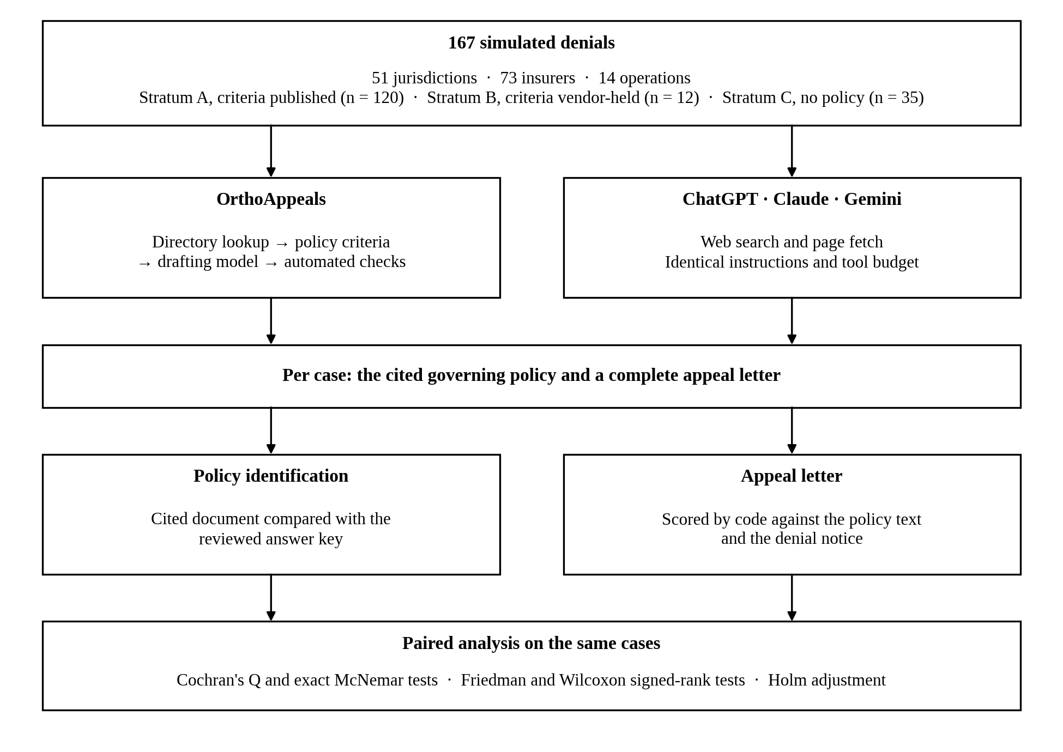
Figure 1. Study design. Every case was answered by all four systems, and every comparison is paired on the same case.
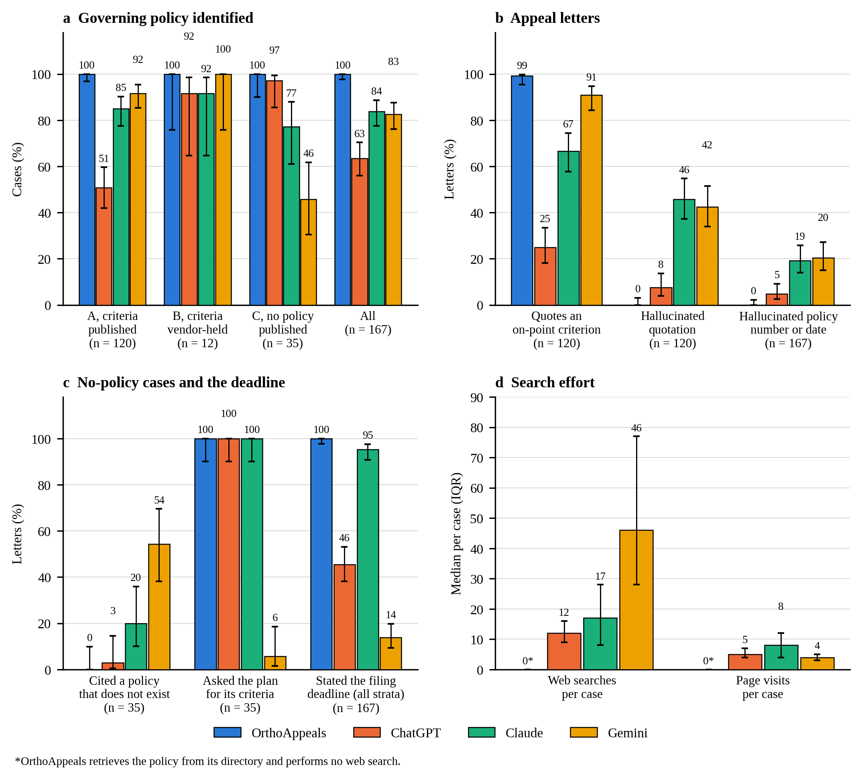
Figure 2. Policy identification, letter accuracy and effort. (a) Correct identification of the governing policy by stratum and overall. (b) Stratum-A letters quoting a criterion that answers the denial reason, letters with a hallucinated quotation, and letters (all strata) with a hallucinated policy number or date. (c) Stratum-C letters citing a policy that does not exist or asking the plan for its criteria, and letters (all strata) stating the filing deadline. (d) Median web searches and page visits per case. Bars show proportions with Wilson 95% CIs (a to c) or medians with interquartile ranges (d).

