Trans. data analysis(R) Assignment 1

2331609 刘畅

2023-11-03

## Question 1

Load your own .csv file into R, report the dimension of your data frame, then generate a scatter plot using the plot() function.

data("ChickWeight")  
dim(ChickWeight)

## [1] 578 4

df <- ChickWeight[ChickWeight$Chick == 1, ]  
plot(df$Time, df$weight)

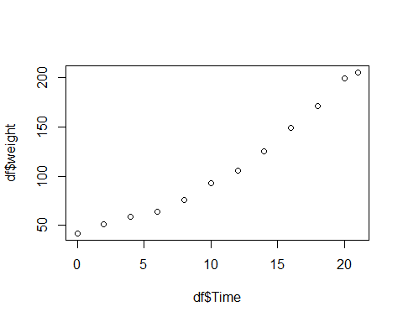

## Question 2

Write a loop to calculate the mean value of a random numeric vector of length 50.

vec1 <- rnorm(50)  
mean(vec1)

## [1] -0.08211527