INTERACTIVE ANALYSIS AND VISUALIZATION OF CANCER RISK FACTORS ACRPOSS DIFFERENT CANCER TYPES

INTRODUCTION
Cancer is a major global health concern, with its risk influenced by demographic, lifestyle, dietary, genetic, health, environmental and occupational factors that may vary across different cancer types. The increasing availability of health-related data provides opportunities to examine these factors through data analytics and visualization. However, the large number of variables in cancer datasets can make patterns and differences difficult to identify through conventional tables. Power BI provides an interactive approach for presenting and exploring such data through visualizations, comparisons and filters. Therefore, this project focuses on developing an interactive Power BI dashboard to examine cancer-risk factors generally and across breast, colon, lung, prostate and skin cancer.

PROBLEM STATEMENT
Cancer-risk data contains multiple demographics, lifestyle, dietary, health, genetic and environmental variables, making it difficult to identify and compare patterns when the information is presented through conventional tables or static reports. Differences in risk-factor patterns across cancer types may also be difficult to observe when the data are examined as a single dataset.
There is therefore a need for an interactive approach that brings these variables together and allows users to examine cancer-risk patterns at both the general and individual cancer-type levels. This project addresses this problem by developing a Power BI dashboard for visualizing and comparing cancer risk factors across different cancer types and risk levels.

AIMS AND OBJECTIVES
Aim
To develop an interactive Power BI dashboard for exploring and visualizing patterns in demographic, lifestyle, dietary, genetic, health, environmental, and occupational factors associated with cancer risk across different cancer types.
Objectives
- To visualize the demographic characteristics of individuals in the dataset based on age, age category, and gender.
- To examine the distribution of different cancer types within the dataset.
- To visualize lifestyle-related risk factors, including smoking, alcohol use, physical activity, and obesity-related scores, across different cancer types and risk levels.
- To explore dietary risk-factor patterns, including red-meat consumption, salt and processed-food consumption, fruit and vegetable intake, and calcium intake.
- To visualize genetic and health-related factors, including family history, BRCA mutation, H. pylori infection, and body mass index (BMI), across different cancer types and risk levels.
- To examine environmental and occupational exposure patterns, particularly air pollution and occupational hazards, across different cancer types.
- To examine the relationship between body mass index (BMI) and cancer risk.

PRESENTATION OF FINDINGS

General Cancer Risk Dashboard
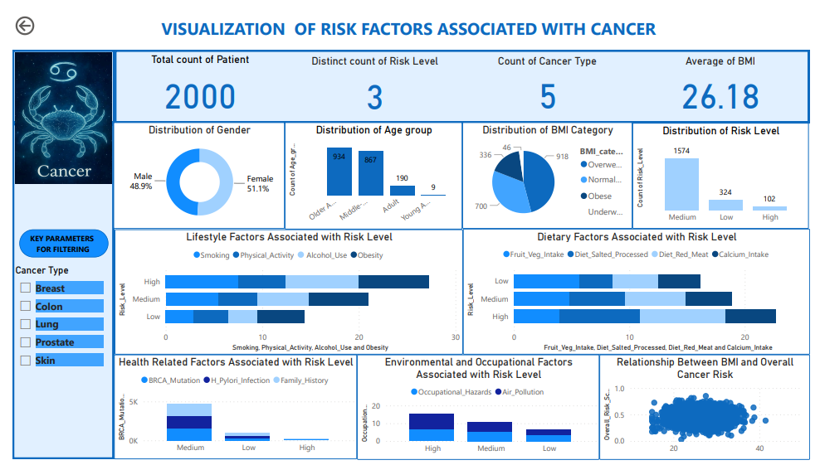
Figure 1: General Cancer Risk Power BI Dashboard
The general dashboard presents the distribution of cancer-risk factors across an overall sample of 2,000 observations. It covers demographic characteristics, BMI categories, overall cancer-risk levels and lifestyle, dietary, health, environmental and occupational factors. The gender distribution was relatively balanced, with females accounting for 51.1% and males 48.9% of the observations. The age distribution was concentrated mainly among older adults (934) and middle-aged adults (867), while adults accounted for 190 observations and young adults for only 9.
The BMI distribution was mainly made up of overweight individuals, who accounted for 918 (45.9%) observations, followed by normal-weight individuals with 700 (35.0%). Obese individuals accounted for 336 (16.8%), while 46 (2.3%) were underweight. The overall risk classification was dominated by the medium-risk category with 1,574 observations, followed by low risk with 324 and high risk with 102.
The lifestyle results show higher scores among the high-risk group. Smoking and alcohol use both recorded a score of 7.52 in the high-risk group, compared with 5.48 and 5.30, respectively, in the medium-risk group and 2.83 and 2.98 in the low-risk group. The obesity scores also increased from 4.82 in the low-risk group to 6.12 in the medium-risk group and 7.27 in the high-risk group. Physical activity scores were 3.67, 4.03 and 4.92 for the low, medium and high-risk groups, respectively.
The dietary results show that the high-risk group recorded the highest red-meat consumption score (7.36) and salted or processed-food score (7.04). These were higher than the corresponding scores in the medium-risk group (5.30 and 4.75) and the low-risk group (3.97 and 2.89). Fruit and vegetable intake recorded the highest score in the low-risk group (5.67) and decreased to 4.84 in the medium-risk group and 3.91 in the high-risk group. Calcium intake showed smaller differences, ranging from 3.65 in the low-risk group to 4.32 in the high-risk group.
The health-related indicators were displayed according to the risk categories, with family history, H. pylori infection and BRCA mutation each recording 1,574 observations in the medium-risk category, 324 in the low-risk category and 102 in the high-risk category. These values follow the overall risk-level distribution and should therefore be interpreted according to the coding of the underlying variables rather than as evidence of an independent relationship between each factor and cancer risk.
Environmental and occupational factors also showed higher scores among the high-risk group. Air pollution recorded a score of 8.54 and occupational hazards 6.99 in the high-risk group. The corresponding scores were 5.60 and 5.18 in the medium-risk group and 2.95 for both factors in the low-risk group. Overall, the general dashboard shows higher scores for several lifestyle, dietary and environmental factors among individuals in the high-risk category.

Breast Cancer Dashboard
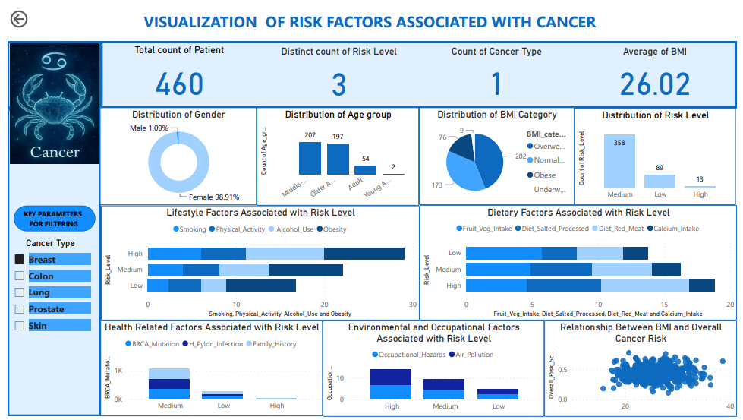
Figure 2: Breast Cancer Power BI Dashboard
The breast cancer dashboard presents the demographic, BMI, risk-level and risk-factor distribution for breast cancer observations. The dashboard contained 460 observations, with an average BMI of 26.02. The age distribution was concentrated among middle-aged adults (207) and older adults (197), while adults accounted for 54 and young adults for 2. The BMI distribution was dominated by overweight individuals (202), followed by normal-weight individuals (173), obese individuals (76) and underweight individuals (9).
The medium-risk category contained the largest number of observations, with 358, followed by the low-risk category with 89 and the high-risk category with 12.
The lifestyle results show higher scores for alcohol use and obesity in the high-risk group. Alcohol use recorded a score of 8.85 and obesity 9.08 in the high-risk group. The corresponding scores in the medium-risk group were 5.57 and 8.34, while the low-risk group recorded 2.82 and 7.87. Smoking also increased from 2.36 in the low-risk group to 4.02 in the medium-risk group and 6.00 in the high-risk group.
The dietary results show higher red-meat and salted or processed-food scores in the high-risk group. Red-meat consumption increased from 3.54 in the low-risk group to 6.69 in the high-risk group, while salted or processed-food consumption increased from 2.61 to 5.62. Fruit and vegetable intake was highest in the low-risk group (5.78) and decreased to 4.90 in the medium-risk group and 4.62 in the high-risk group. Calcium intake showed relatively low scores across the three groups, ranging from 1.85 to 2.17.
The health-related indicators followed the risk-level distribution, with family history, H. pylori infection and BRCA mutation each recorded as 358 in the medium-risk group, 89 in the low-risk group and 13 in the high-risk group.
Environmental and occupational factors recorded higher scores in the high-risk group. Air pollution had a score of 7.15 and occupational hazards 6.85, compared with 2.13 and 2.78, respectively, in the low-risk group. Overall, the breast cancer dashboard shows that obesity, alcohol use, smoking, red-meat consumption, salted or processed foods, air pollution and occupational hazards had higher scores among the high-risk observations.

Colon Cancer Dashboard
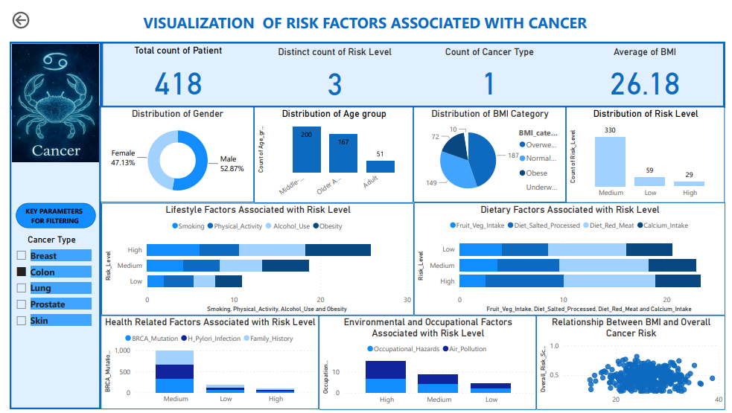
Figure 3: Colon Cancer Power BI Dashboard
The colon cancer dashboard presents 418 observations with an average BMI of 26.18. The gender distribution was relatively balanced, with 221 males and 197 females. The observations were concentrated mainly among middle-aged adults (200) and older adults (167), followed by adults (51). The BMI distribution was dominated by overweight individuals (187), followed by normal-weight individuals (149), obese individuals (72) and underweight individuals (72).
The medium-risk category contained the largest number of observations, with 330, followed by the low-risk category with 59 and the high-risk category with 29.
The lifestyle results show higher scores among the high-risk group. Smoking increased from 1.97 in the low-risk group to 4.15 in the medium-risk group and 6.03 in the high-risk group. Alcohol use increased from 2.58 to 4.98 and 7.62 across the three groups, while obesity increased from 3.02 to 5.33 and 7.55.
The dietary results show a strong difference across the risk categories. The high-risk group recorded the highest red-meat score (8.83) and salted or processed-food score (7.59). The medium-risk group recorded scores of 7.54 and 6.01, while the low-risk group recorded 7.54 and 4.51. Fruit and vegetable intake decreased from 4.05 in the low-risk group to 3.65 in the medium-risk group and 2.48 in the high-risk group. Calcium intake remained relatively similar across the groups, ranging from 4.34 to 4.53.
The health-related indicators were distributed according to the risk categories, with family history, H. pylori infection and BRCA mutation each recorded as 330 in the medium-risk group, 59 in the low-risk group and 29 in the high-risk group.
Environmental and occupational exposure scores were higher in the high-risk group. Air pollution increased from 2.10 in the low-risk group to 4.45 in the medium-risk group and 8.07 in the high-risk group. Occupational hazards also increased from 2.36 to 4.44 and 6.90 across the three groups. Overall, the colon cancer dashboard shows particularly high scores for red-meat consumption, salted or processed foods, alcohol use, obesity, air pollution and occupational hazards among the high-risk observations.

Lung Cancer Dashboard
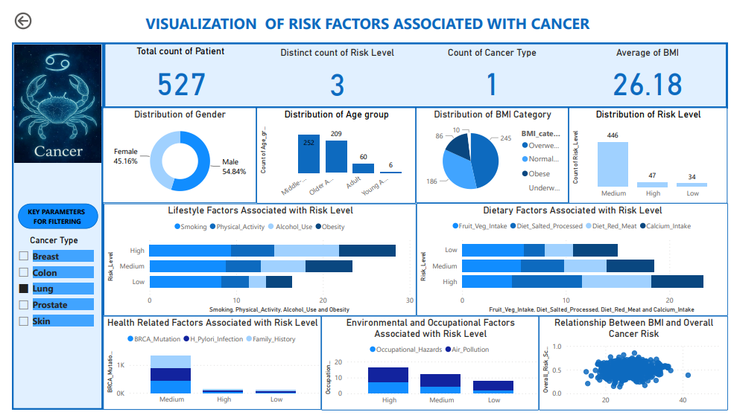
Figure 4: Lung Cancer Power BI Dashboard
The lung cancer dashboard presents 527 observations with an average BMI of 26.18. The observations were mainly distributed among middle-aged adults (252) and older adults (209), followed by adults (60) and young adults (6). The risk classification was dominated by the medium-risk group with 446 observations, followed by the low-risk group with 47 and the high-risk group with 34.
Smoking was the most prominent lifestyle-related factor in the lung cancer dashboard. The smoking score was 9.40 in the high-risk group, 8.83 in the medium-risk group and 8.32 in the low-risk group. Alcohol use also increased from 2.03 in the low-risk group to 5.16 in the medium-risk group and 7.51 in the high-risk group. The obesity score increased from 2.94 to 5.36 and 6.45 across the three risk categories.
The dietary results show higher salted or processed-food and red-meat scores in the high-risk group. Salted or processed foods recorded 6.83 in the high-risk group compared with 2.03 in both the low- and medium-risk groups. Red-meat consumption increased from 2.71 in the low-risk group to 4.08 in the medium-risk group and 6.66 in the high-risk group. Fruit and vegetable intake was highest in the low-risk group (5.97) and decreased to 5.67 in the medium-risk group and 4.77 in the high-risk group. Calcium intake was highest in the high-risk group (5.02).
The health-related indicators followed the risk-level distribution, with family history, H. pylori infection and BRCA mutation each recorded as 446 in the medium-risk group, 47 in the low-risk group and 34 in the high-risk group.
Environmental factors showed a clear difference across the risk categories. Air pollution recorded the highest score among the high-risk group (9.30), followed by the medium-risk group (7.56) and the low-risk group (5.91). Occupational hazards also increased from 2.21 in the low-risk group to 4.37 in the medium-risk group and 6.96 in the high-risk group. Overall, smoking and air pollution were the most prominent factors in the lung cancer dashboard, with both showing higher scores among the high-risk group.

Prostate Cancer Dashboard
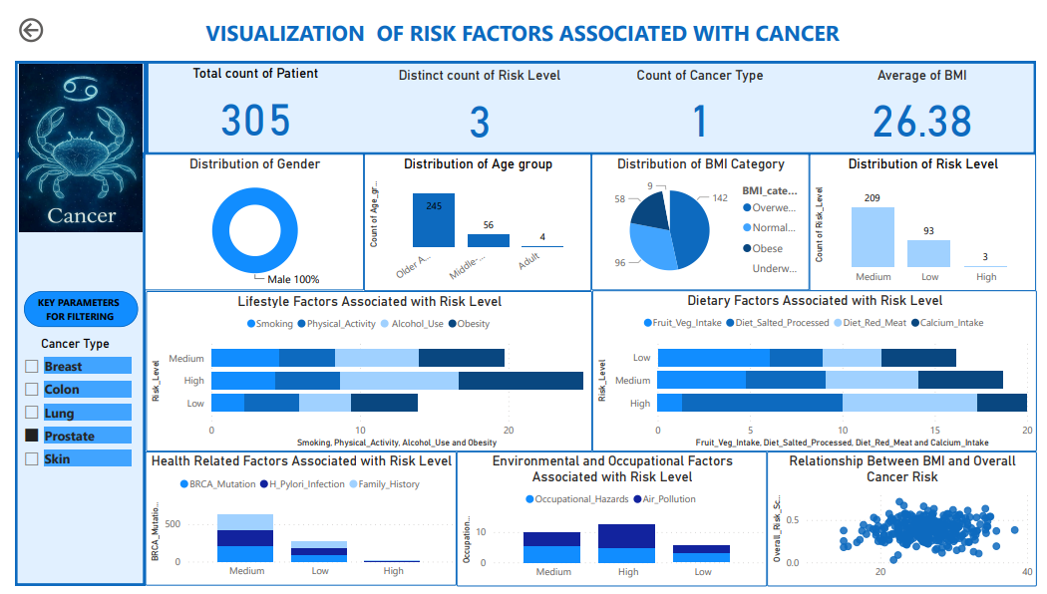
Figure 5: Prostate Cancer Power BI Dashboard
The prostate cancer dashboard presents 305 observations with an average BMI of 26.38. The observations were concentrated mainly among older adults (245), followed by middle-aged adults (56) and adults (4). The BMI distribution was dominated by overweight individuals (142), followed by normal-weight individuals (96), obese individuals (58) and underweight individuals (9).
The medium-risk group contained 209 observations, followed by the low-risk group with 93 and the high-risk group with 3.
The lifestyle results show relatively high obesity and alcohol-use scores across the risk categories. The medium-risk group recorded the highest alcohol-use score (8.00) and obesity score (8.33). The high-risk group recorded scores of 5.67 for alcohol use and 5.75 for obesity, compared with 3.55 and 8.00, respectively, in the low-risk group. Smoking also recorded a higher score in the high-risk group (4.56) than in the low-risk group (2.25).
The dietary results show a marked difference in the high-risk group. Salted or processed-food consumption recorded a score of 8.67 and red-meat consumption 7.33. The corresponding scores in the low-risk group were 2.86 and 3.15. Fruit and vegetable intake was 1.33 in the high-risk group compared with 6.10 in the low-risk group. Calcium intake was 2.67 in the high-risk group and 4.02 in the low-risk group.
The health-related indicators followed the risk-level distribution, with family history, H. pylori infection and BRCA mutation each recorded as 206 in the medium-risk group, 93 in the low-risk group and 9 in the high-risk group.
The environmental results showed that occupational hazards had a score of 5.44 in the high-risk group, compared with 4.67 in the medium-risk group and 3.25 in the low-risk group. Air pollution recorded its highest score in the medium-risk group (7.67), followed by 4.28 in the high-risk group and 2.45 in the low-risk group. Overall, the prostate cancer dashboard shows high scores for salted and processed foods, red meat and lifestyle factors among the high-risk observations, while the observations were largely concentrated among older adults.
Skin Cancer Dashboard
Figure 4.6: Skin Cancer Power BI Dashboard
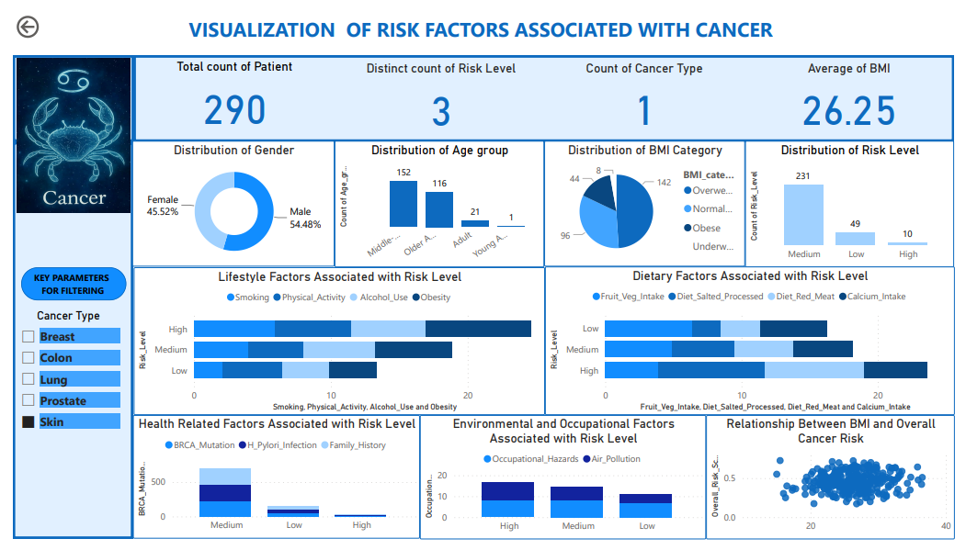
The skin cancer dashboard presents 290 observations with an average BMI of 26.25. The age distribution was concentrated mainly among older adults (152) and middle-aged adults (116), followed by adults (21) and young adults (1). The BMI distribution was dominated by overweight individuals (142), followed by normal-weight individuals (96), obese individuals (44) and underweight individuals (8).
The medium-risk group contained 231 observations, followed by the low-risk group with 49 and the high-risk group with 10.
The lifestyle results show that the high-risk group recorded the highest scores for smoking, physical activity, alcohol use and obesity. The obesity score was 7.70, followed by physical activity at 5.60, smoking at 5.90 and alcohol use at 5.40. In comparison, the low-risk group recorded scores of 3.47 for obesity, 4.37 for physical activity, 2.12 for smoking and 3.37 for alcohol use.
The dietary results show higher salted or processed-food and red-meat scores in the high-risk group. Salted or processed-food consumption increased from 2.10 in the low-risk group to 4.61 in the medium-risk group and 7.80 in the high-risk group. Red-meat consumption increased from 2.90 to 4.29 and 7.30 across the three groups. Fruit and vegetable intake was highest in the low-risk group (6.39) and decreased to 4.89 in the medium-risk group and 3.90 in the high-risk group. Calcium intake showed smaller differences across the groups.
The health-related indicators followed the risk-level distribution, with family history, H. pylori infection and BRCA mutation each recorded as 231 in the medium-risk group, 49 in the low-risk group and 10 in the high-risk group.
Environmental and occupational factors were prominent in the skin cancer results. Occupational hazards recorded scores of 8.30 in the high-risk group and 8.19 in the medium-risk group, compared with 4.67 in the low-risk group. Air pollution also recorded a high score of 8.40 in the high-risk group, compared with 6.16 in the medium-risk group and 4.33 in the low-risk group. Overall, the skin cancer dashboard shows higher scores for obesity, smoking, alcohol use, salted and processed foods, red meat, occupational hazards and air pollution among the high-risk observations.
Summary of Findings
The interactive dashboards provide a comparison of cancer-risk factor patterns across the selected cancer types. The general dashboard shows that the higher-risk category is generally characterized by higher scores for several lifestyle, dietary and environmental factors.
The individual cancer dashboards show differences in the factors that are most prominent for each cancer type. Smoking is particularly pronounced in the lung cancer dashboard. Obesity and alcohol-use scores are prominent in the breast cancer results, while red-meat and salted or processed-food scores are particularly high in the colon and prostate cancer dashboards. Environmental and occupational exposure scores are also high in several cancer types, with air pollution being particularly prominent in the lung and colon cancer results and occupational hazards being notable in the skin cancer results.
The Power BI dashboard therefore provides an interactive means of comparing cancer types, risk levels and associated factor scores within the dataset. The results describe patterns and differences in the observed data and should not be interpreted as establishing causal relationships between individual risk factors and cancer.

CONCLUSION
This project developed an interactive Power BI dashboard for the visualization and exploration of cancer risk factors across different cancer types. The dashboard brought together demographic characteristics, BMI categories, risk levels, lifestyle factors, dietary factors, health and genetic indicators, and environmental and occupational factors within an interactive analytical platform.
The results showed differences in risk-factor patterns across the general dashboard and the individual cancer types. Higher-risk groups generally recorded higher scores for several lifestyle, dietary and environmental factors. Differences were also observed between cancer types, with some factors being more prominent in particular cancer groups. The dashboard therefore provided a clearer way of comparing cancer-risk factor patterns than presenting the variables through isolated tables.
The project demonstrates the usefulness of Power BI for transforming cancer-related data into interactive visual information. Users can select cancer types and risk levels and examine the corresponding patterns in the available risk factors. This makes the information easier to explore, compare and communicate.
Overall, the developed dashboard provides a practical data-visualization tool for exploring cancer-risk factors and comparing patterns across different cancer types. It can also serve as a foundation for further analysis involving statistical testing, predictive modelling and more detailed investigation of individual cancer-risk factors.

