Penetration Test Report On IBEDC

Prepared By: Akinbode Kunle Elijah

Email: eliakins01@gmail.com | Twitter: @eliakins | LinkedIn: elijah-akinbode-0141b6380

Project Title: Pentest Report on Ibadan Electricity Distribution Company (IBEDC)

Date: October 2025



Table of Contents (short)
- Executive Summary
- Authorization & Legal Statement
- Methodology & Test Approach
- Reconnaissance & Asset Discovery (WHOIS, DNS, Subdomains)
- Network & Service Discovery (nmap, traceroute, ping, nc)
- Web Application Fingerprinting (whatweb, wafw00f)
- Directory / Endpoint Discovery (gobuster)
- Vulnerability Scanning (nikto, nuclei, Wpscan,SqlOwaps)
- Targeted Tests / Manual Checks (curl, manual XSS test, session tokens)
- Findings Summary & Recommendations (prioritized)
- Appendix – Evidence files & command logs
- References & Tool documentation

1. Executive Summary
Purpose & Objectives
The purpose of this penetration is to assess the external security posture of Ibadan Electricity Distribution Company (IBEDC) (public-facing web estate), identify vulnerabilities, enumerate the attack surface (subdomains, endpoints), and provide prioritized remediation guidance.
High-level results
- Domain: ibedc.com registered at GoDaddy, DNS served by Cloudflare (MEERA / SIMON NS).
- CDN/WAF: Cloudflare was detected (headers + behavior), WAF adds protection but is not a substitute for fixing app issues.
- Large subdomain footprint (265+ subdomains discovered). Several admin/control-panel endpoints are visible (cPanel, control panel, webmail).
- Missing security headers (no CSP/frame-ancestors/X-Frame-Options observed in many responses), forms without anti-CSRF tokens reported, outdated JS libraries (jQuery variants) present, some responses contained developer comments and possibly PII-like content in scans.
- Directory discovery returned .ht* files (403) and other endpoints (/payments, /webmail, /uploads). Redirect responses sometimes contained large bodies (should be empty).
Overall risk rating: Medium–High (we have a combination of exposed management endpoints, missing security headers, outdated libraries, and a large subdomain surface). Critical items: admin interfaces, protection, and XSS/CSRF fixes.
2. Authorization & Legal Statement
Place your written authorization here. (Dates, who authorized the test, scope, and ROE).
Ensure the final report contains a copy or reference to the signed authorization.
3. Methodology & Test Approach
- Phases: Passive recon → Active discovery → Automated scanning → Targeted manual testing → Triage & recommendations.
- Tools used : whois, dig/nslookup, theHarvester, subfinder, whatweb, nmap, wafw00f, gobuster, feroxbuster, nikto, nuclei, wpscan, sqlmap, curl, traceroute/ping, nc, theHarvester.
- Assumptions: For public external testing only, no exploitation of vulnerabilities beyond non-invasive scanning and authorized probes; management endpoints were enumerated but not exploited.

4. Reconnaissance & Asset Discovery
WHOIS
- Tool used: whois
- Why it was chosen: It is the Fastest way to retrieve domain registration/ownership and registrar metadata; it helps determine ownership, registrar, expiry dates, and name servers.
- How it works: It queries the domain registrar/registry whois database via the whois protocol/port to fetch registration records.
- Example command + sample output
  - Command: whois ibedc.com
  - Sample output (from your logs):
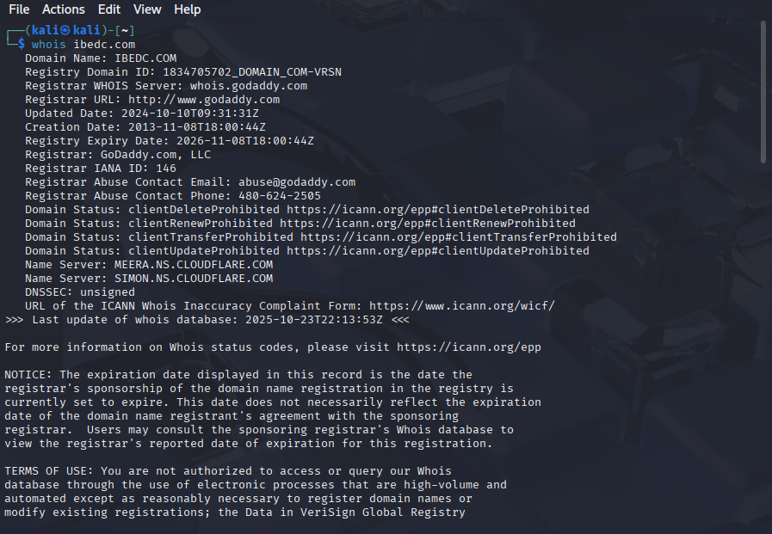

Basic Details
- Domain Name: ibedc.com
- Organization: Ibadan Electricity Distribution Company (IBEDC) — based on the domain name.
- Registrar: GoDaddy.com, LLC (IANA ID: 146)
- Registry Domain ID: 1834705702_DOMAIN_COM-VRSN
- Creation Date: November 8, 2013
- Expiration Date: November 8, 2026
- Last Updated: October 10, 2024

- Security insight gained: It confirms the registrar and that DNS is likely hosted behind Cloudflare (Cloudflare NS); domain expiration and registrar lock statuses are important for takeover risk. Private registration makes direct contact for disclosure harder.
What are the risks identified
- Domain expiry mismanagement (if upcoming) could lead to takeover.
- Registrant privacy prevents direct contact for coordinated disclosure.
What are the recommendations & mitigations
- Always ensure domain auto-renewal is enabled and monitored.
- Keeping registrar abuse contact info up to date; maintain a security contact that can be reached via RDAP.
- Use registrar lock features (transfer/renew locks).

Dig / nslookup

- Tool used: dig, nslookup
- Why both were chosen: It validates DNS A/AAAA/NS records, and gets IPs behind the domain and TTL details.
- How it works (tech): DNS query over UDP/TCP to DNS server(s) to fetch records.
Example command + sample output
- Commands: dig ibedc.com A / nslookup ibedc.com
- Sample output (from logs):

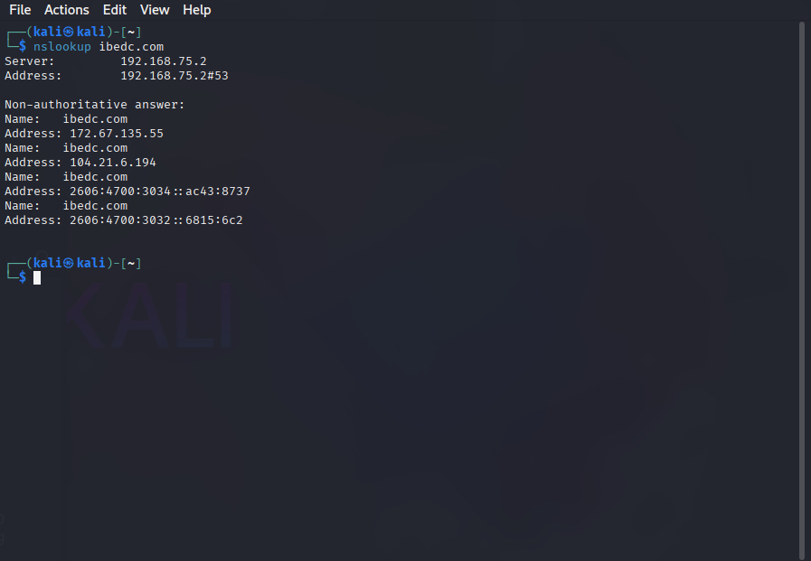

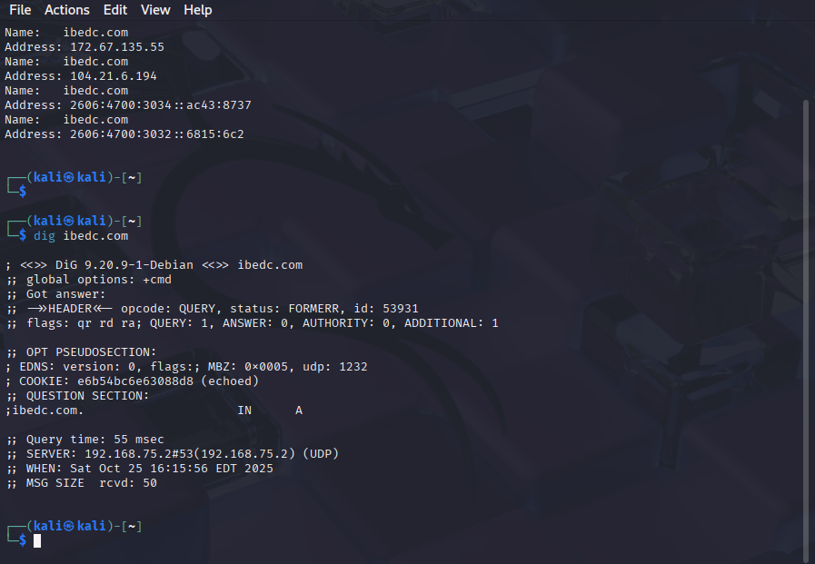

4. Security insight gained: There are multiple CDN IPs (Cloudflare edge nodes); the origin is likely behind the CDN. IPv6 is present.
5. What it does: It retrieves DNS records for host resolution.
6. Why use it in pentesting: It is used to identify IPs, CDNs, and potential origin servers; it helps us enumerate the attack surface.
7. How it works (flow): It query resolver → resolver replies with A/AAAA/NS/TXT records.
8. Info gained: A/AAAA/NS, multiple IPs (indicative of CDN).

Findings in summary
Item | Value
A records | 104.21.6.1**, 172.67.135.**
AAAA records | 2606:4700:3034::ac43:8737

What are the Risks identified?
- Edge CDN behavior may mask the origin for some scans; we need to be mindful of false negatives when scanning ports/versions.
- We have misconfigured DNS (open zone transfers, exposed private records) — none detected from public outputs, but should be checked.
What are the recommendations
- Keep DNS record TTLs reasonable; Always use DNSSEC where appropriate.
- Document original IPs privately for emergency contact.
- Verify AXFR is disallowed for public IPs; ensure zone transfers only to authorized secondary nameservers.
Importance
Medium — DNS visibility is required for mapping infrastructure and coordinating remediation.

theHarvester
- Tool used: theHarvester
‘’TheHarvester was employed to gather intelligence from public sources, including search engines, PGP key servers, and SHODAN database. This tool is particularly effective for discovering email addresses, subdomains, and associated infrastructure that may not be apparent through basic DNS queries."
- Why it was chosen: This is because it aggregates publicly available hostnames, emails, IPs from multiple OSINT sources for reconnaissance.
- How it works (tech): theHarvester Queries search engines, certificate transparency, GitHub, PGP, etc., to collect domain-related resources.
- Example command + sample output
  - Command: theHarvester -d ibedc.com -b all
  - Sample output: customercare@ibedc.com, recruitment@ibedc.com, and ~1345 hosts were shown in the scan.
  - IPs found: 102.**.48.**, 184.168.***.168, 1***.114.96.3
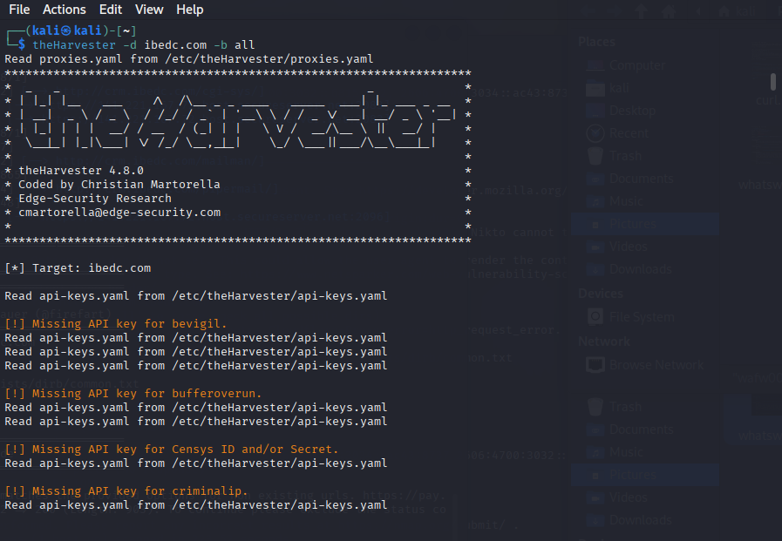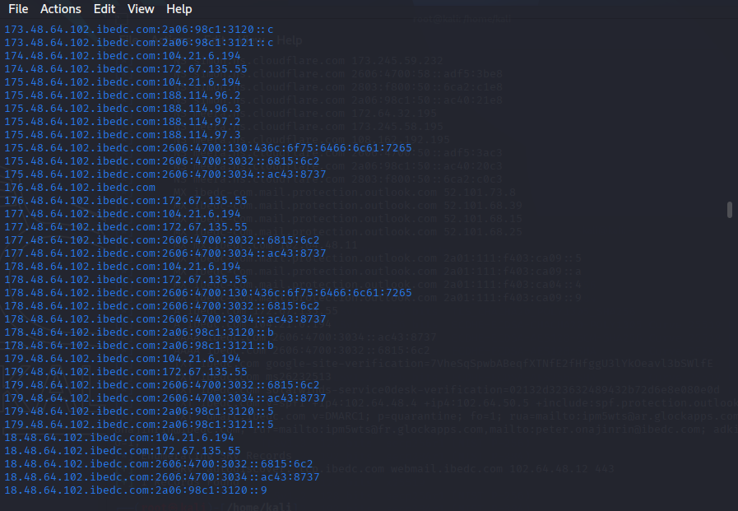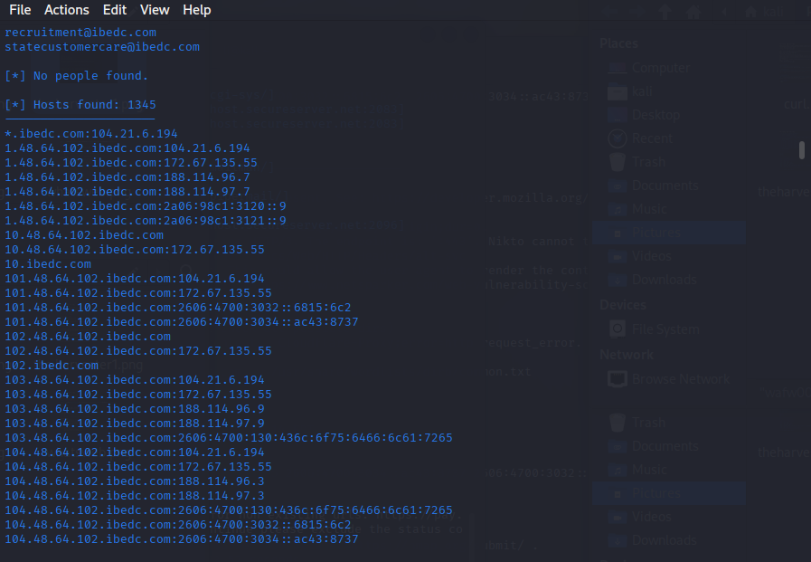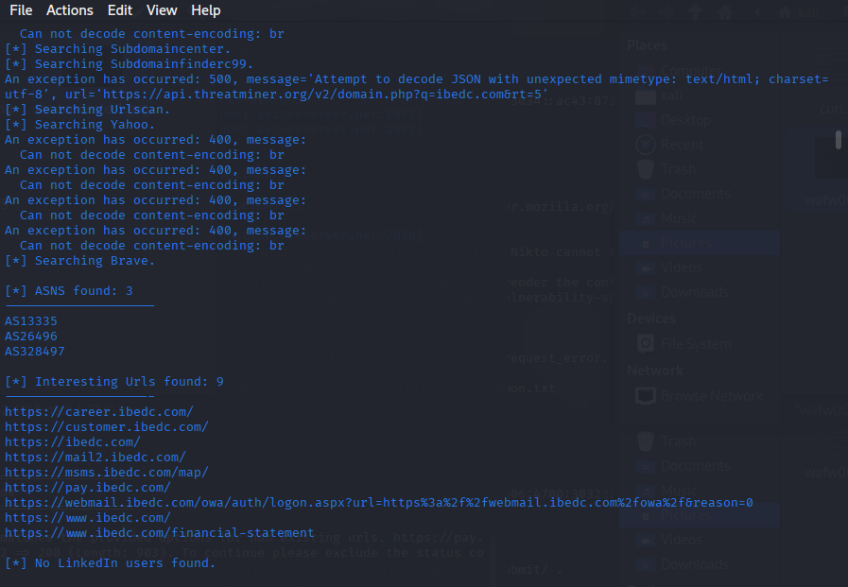
Security insight gained
- Public email addresses for contact — useful for coordinated disclosure.
- A list of interesting subdomains and URLs to validate further.

Risks Identified
Risk | Description | Impact
Exposure of employee emails and roles | Public-facing emails, role-based addresses (admin@, support@), and employee names are harvested. | Enables targeted phishing, spear-phishing, and impersonation attacks.
Discovery of overlooked assets | Subdomains, virtual hosts, and references to internal services found in indexed content or certificates. | Provides additional attack surface for application testing and exploitation.
Stale or incorrect contact data | Old emails or recycled addresses were listed, causing misdirected assessments. | Waste assessment effort and may produce misleading conclusions.
Over-reliance on passive sources | Passive findings may miss private or internal-only assets, creating a false sense of coverage. | Incomplete attack surface mapping without active enumeration.
Data leakage via third-party services | Third-party providers or partners may leak IBEDC-related emails or hostnames publicly. | Supply-chain exposure and unauthorized data distribution.
4. Recommendations we need to put in place
- Limit public exposure of sensitive emails: Replace personal email addresses in public pages with role-based or contact forms where appropriate, and avoid publishing employee direct emails on public pages.
- Employee awareness & training: Conduct phishing-resistant training and simulations focused on exposed contact points and social engineering scenarios discovered by theHarvester.
- Harden public content: Remove or redact sensitive hostnames, internal paths, and configuration snippets from public-facing pages and documentation.
- Centralize and monitor contact points: Use a single corporate contact directory (e.g., contacts@ibedc.com) and monitor for leaked email addresses via OSINT watches.
- Use DMARC/DKIM/SPF: Ensure email authentication policies are strict (e.g., DMARC quarantine/reject) to reduce email spoofing risk even when addresses are public.
- Monitor third-party exposure: Subscribe to monitoring for emails/domains appearing in public sources and CT logs; request takedown or remediation for sensitive leaks.
- Validate and triage harvested results: Verify emails and hosts before using them in active tests to avoid false positives.

Subfinder
- Tool used: subfinder
- Why chosen: it’s a Fast passive/active subdomain discovery using multiple providers and sources.
- How it works (tech): It uses passive sources (certificates, DNS) and configured APIs to enumerate subdomains.
- Example command + sample output
  - Command: subfinder -d ibedc.com
  - Sample output (from logs): Found 265 subdomains (ex: pay.ibedc.com, webmail.ibedc.com, crmserver.ibedc.com, many IP-prefix style hosts).
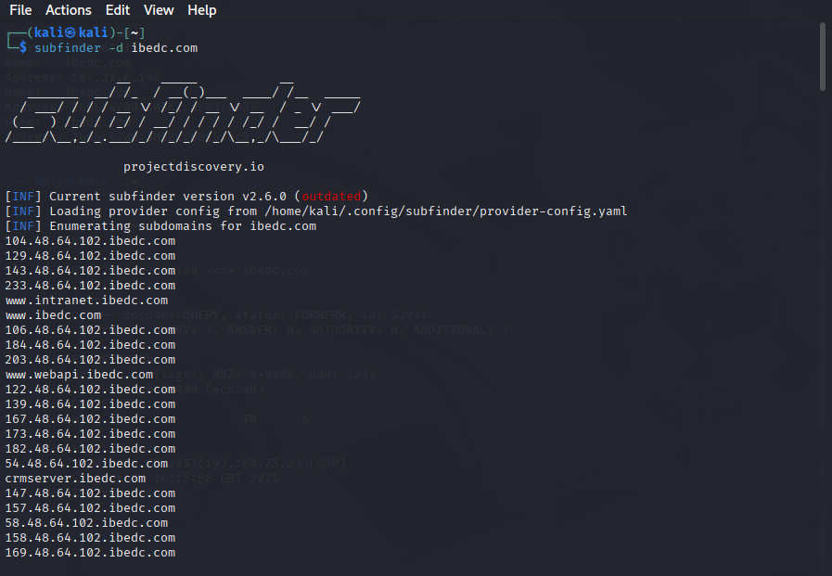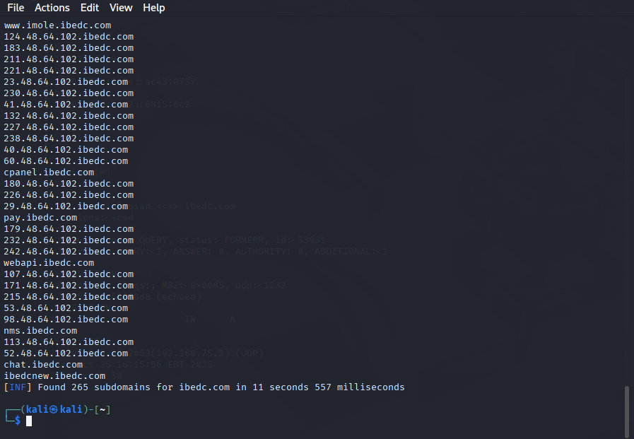

5. What it does: It is used for finding subdomains quickly using multiple data sources.

Security insight
- Large attack surface (hundreds of subdomains) — some may host legacy or unpatched web apps.
- Many subdomains look like internal services (crmserver, ncp) that require inventorying.
- Confirms broad attack surface and management endpoints such as cpanel, webmail, pay, vending.

Risks Identified
Risk | Description | Impact
Discovery of unmanaged subdomains | Subfinder exposes subdomains hosted by third parties or left unmanaged. | Attackers gain new targets in forgotten/staging environments.
Supply-chain exposure | Third-party services using *.ibedc.com may be discovered. | Potential data leakage or delegated risk from partners.
False positives due to historical data | Sources can return expired or historical names that no longer resolve. | Wastes time if not verified; may show outdated naming conventions.
Over-reliance on passive sources | May miss newly created subdomains that have not yet appeared in public data sources. | Leads to incomplete surface mapping without active scans.
4. Recommendations
- Ibedc needs to validate results with DNS resolution and HTTP checks before active testing to reduce false positives and scope creep.
- Centralize subdomain management and require change control for any new subdomain creation.
- Always monitor CT logs and APIs for new entries; integrate subfinder runs in CI/CD or periodic scans for continuous discovery.
- Ibedc should always use API keys securely and rotate them; restrict access to the API keys used by subfinder.
- Integrate with downstream tools (httpx, nuclei, nmap) for verification and vulnerability checks in a controlled manner.
- Documentation and remediation of any exposed staging, dev, admin, or legacy hosts discovered.
- Schedule scans responsibly: passive enumeration is low-risk, but active verification should be scheduled and authorized.

- Network & Service Discovery

traceroute / ping / nc

- Tool used: traceroute, ping, nc (netcat)

Traceroute and Ping were used to assess network path visibility, latency, and basic connectivity to the target domain ibedc.com.
These utilities help identify the route packets take across the network and measure response time (Round-Trip Time – RTT) between the tester’s machine and the target host.

Example commands + sample output
- traceroute ibedc.com ( output shows many stars — likely intermediate routers filtering traceroute).
- ping -c 4 ibedc.com -> responses from 104.21.6.194 with ~100–123 ms RTT.
- nc ibedc.com 80 with HEAD / HTTP/1.0 produced headers including 403 Forbidden responses (Cloudflare edge behavior). Example from logs:

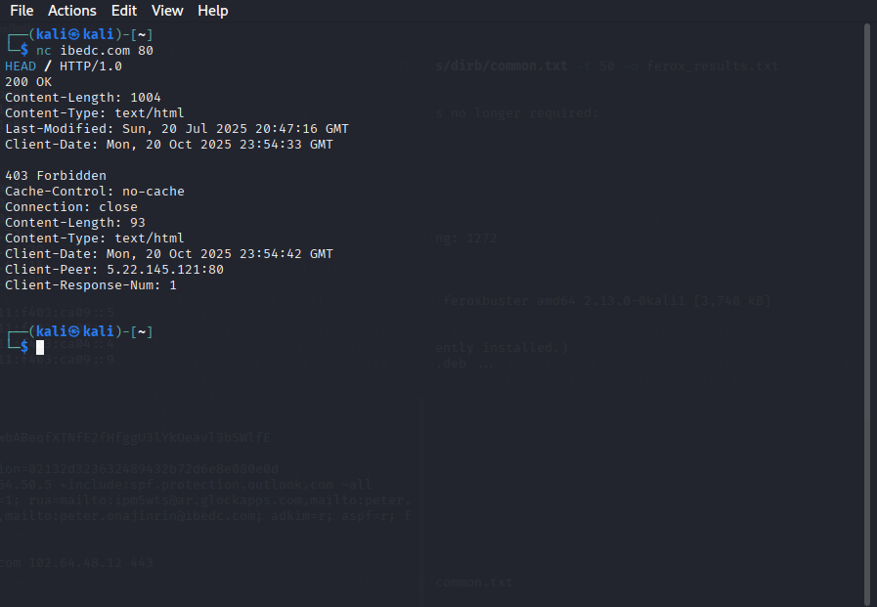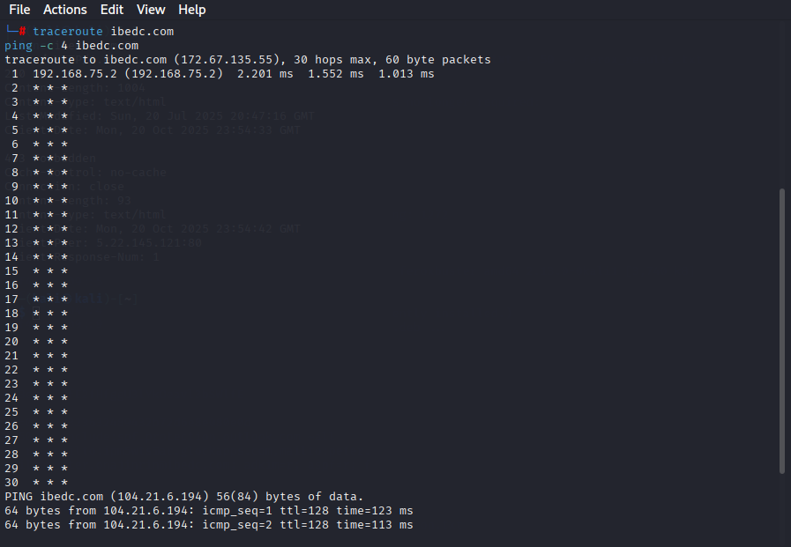

4. Security insight gained: Cloudflare edges respond; direct path to origin is obscured. Hosts are reachable and returning expected HTTP statuses; some endpoints returned 403 (good for sensitive files) but redirect responses sometimes included large bodies.
Traceroute Output (Check image above)
Ping Output (Check image above)

Key Observations

Aspect | Observation
Host Availability | Ibedc responded successfully with 0% packet loss, confirming it is online and reachable.
Latency | Average latency of ~113 ms indicates a stable but moderately distant server (likely hosted outside the tester’s region, possibly Cloudflare).
TTL (Time To Live) | The value of 128 suggests that the server is running on a Windows-based or Cloudflare-protected infrastructure.
Traceroute Gaps | Multiple hops returned * * *, indicating ICMP replies are filtered or dropped by intermediate routers/firewalls — a sign of DDoS protection or CDN routing.
IP Resolution | Two IPs were observed: 172.67.135.55 and 104.21.6.194, both part of Cloudflare’s network range, confirming CDN use for traffic distribution and protection.
Analysis

The traceroute reveals that IBEDC’s website is protected behind Cloudflare’s CDN, which masks the origin server’s true IP address.
This is a positive security indicator, as Cloudflare filters malicious traffic and mitigates DDoS attacks.
The ping response times demonstrate healthy network performance and no evidence of packet loss or congestion.
However, the lack of traceroute visibility beyond the first hop means direct network-layer testing of the backend infrastructure is limited.

We have some risks that we need to look into

Risk Type | Description | Impact | Severity
Network Reconnaissance Restriction | Traceroute blocking prevents path mapping — good for defense, but limits assessment visibility. | Low | Informational
Cloudflare Dependency | Reliance on third-party CDN means uptime and security depend partly on Cloudflare’s infrastructure. | Medium | Low–Medium
Hidden Origin IP | It protects the internal network but prevents full-layer inspection (no direct risk). | None | Informational

What are the Recommendations needed

Finding | Recommendation | Priority
CDN Visibility Limitation | Maintain Cloudflare protection; consider internal testing (from behind CDN) to evaluate backend exposure. | Medium
Network Redundancy | Ensure fallback DNS or secondary CDN configuration for business continuity. | Medium
Latency Monitoring | Implement continuous latency and uptime monitoring using tools like UptimeRobot or Pingdom. | Low

Nmap (Network Mapper)

- Tool used: Nmap

This is an open-source tool for network discovery and security auditing. It uses raw IP packets to identify available hosts on the network, the services (application names and versions) that those hosts offer, the operating systems they run, and the types of packet filters or firewalls in place.

- Why chosen: Service/port discovery and OS/service fingerprinting.
- How it works (tech): It sends crafted TCP/UDP probes and analyzes responses; supports NSE scripts for higher-level checks.
  - Example command
  - nmap -sS -T4 -p- mail.ibedc.com
  - Note: In our engagement the site is behind Cloudflare; scanning the CDN will show edge behavior, not origin.
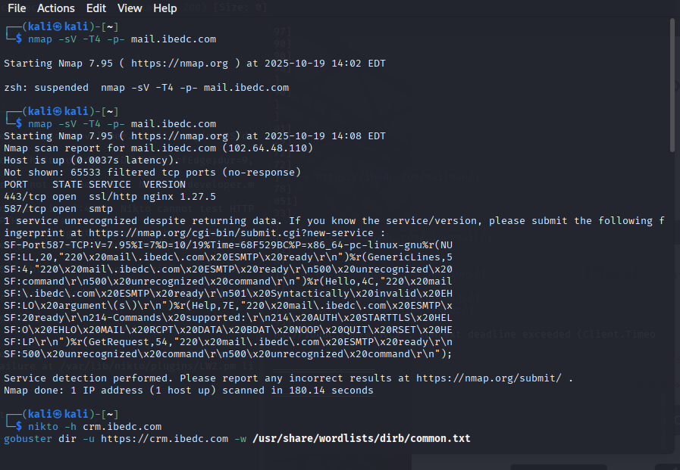

4. Security insight gained: It confirms the presence or absence of open ports and service versions for directly reachable hosts. If the origin is exposed, it can reveal management services.
5. What it does: Discovers open ports, services, versions and runs scripts.
6. Why use in pentesting: Identify attackable services and their versions for vulnerability mapping.
7. How it works (flow): TCP/UDP probe → response analysis → fingerprinting → script-based checks.
9. Info gained: Open ports/services; if origin is exposed, precise service versions.
10. How that helps: Prioritize hardening and patching; close unnecessary services.

Findings (example / suggested)
IP | Open Ports | Services
104.21.6.194 | 80,443 | httpd (Cloudflare edge)
(because Cloudflare sits in front, scanning origin ports requires targeting origin IP if known)

Risks Identified
Risk | Description | Impact
Exposed management interfaces | Ports like 22 (SSH), 3389 (RDP), 5900 (VNC), 443/8443 (web admin panels) were discovered. | Direct remote access to systems if credentials are weak or unpatched.
Outdated services / versions | Services with known CVEs identified via version detection or NSE vuln scripts. | High likelihood of exploitation leading to RCE, privilege escalation, or data exfiltration.
Unnecessary open ports | Legacy or unused services listening on production hosts. | Increased attack surface and maintenance burden.
Weak TLS configuration | TLS services with weak ciphers, expired certificates, or insecure protocols. | Interception, downgrade attacks, or loss of confidentiality.
Internal-only services exposed publicly | Databases, admin consoles, or backup services reachable from the internet. | Sensitive data exposure and privileged access vectors.
False-negatives from filtering | Firewalls or IDS may drop scan probes leading to incomplete results. | Missed exposures or mis-prioritization of findings.

Recommendations

- Authorize scans & schedule maintenance windows: Ibedc should avoid accidental disruptions. Coordinate with operations/security teams.

- Reduce exposed management interfaces: Move management ports behind VPNs, bastion hosts, or use jump boxes with MFA.
- Patch and update services: Remediate known vulnerable versions identified by -sV and NSE scripts.
- Harden TLS: Enforce modern TLS versions, remove weak ciphers, and ensure certificates are valid and monitored in ibedc
- Close unnecessary ports/services: Remove legacy services and adopt least-privilege network segmentation.
- Limit scan scope & rate: Use --scan-delay or --min-rate/--max-rate to avoid overloading ibedc during scanning.
- Perform authenticated scans where possible: Use credentials for authenticated service checks (e.g., SMB/SSH) to reduce false positives and get better coverage.
- Document and version evidence: Save -oA outputs and attach to the report with timestamps for audit and remediation tracking.

- Web Application Fingerprinting
Whatweb
WhatWeb is a reconnaissance and fingerprinting tool that identifies technologies, frameworks, web servers, programming languages, CMSs, analytics platforms, and security headers used by a website. It analyzes HTTP responses and metadata to reveal information such as server type (e.g., Apache, Nginx, IIS), CMS (e.g., WordPress, Joomla), JavaScript libraries, and other plugins.
For iBEDC, WhatWeb helps determine the website’s technology stack and potentially exposed components that may later be vulnerable to known exploits.
- Why chosen: it identifies CMS, libraries, and server headers to understand the tech stack.
- How it works: Probes page content, embedded assets, and headers against signatures and regexes to classify technologies.

Command:
whatweb ibedc.com
- Sample output (from logs): detects Cloudflare, Bootstrap, JQuery (1.4.1 and 3.6.1), Lightbox, likely WordPress; headers include cf-cache-status, report-to, nel.

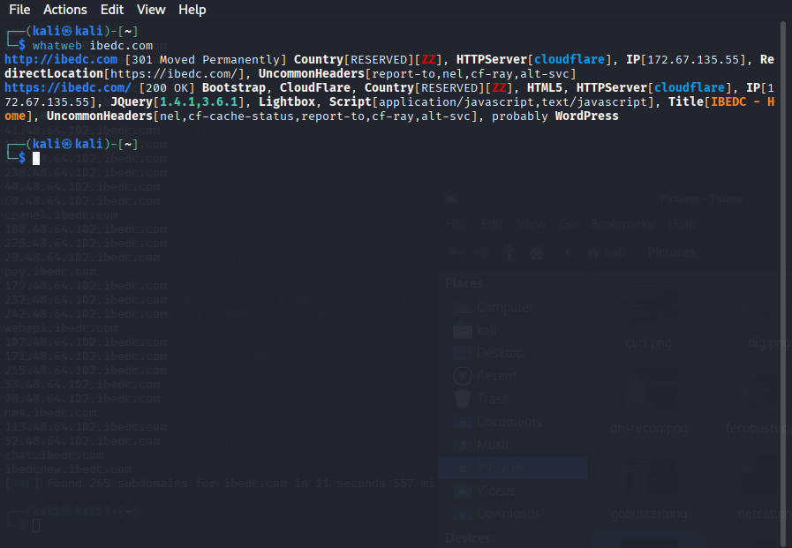
- Security insight gained: Presence of old jQuery versions; likely WordPress and many JS libs that raise maintenance/patch needs. Cloudflare is identified as CDN.

Risks Identified

Risk Type | Description | Impact
Outdated Web Server Version | Ibedc site disclosed nginx/1.18.0, an older version with known CVEs. | Attackers could exploit unpatched vulnerabilities.
CMS Detected (WordPress) | Public identification of WordPress exposes known plugin/core exploits. | Increased risk of targeted WordPress attacks.
PHP Version Disclosure | Revealing PHP/7.4.3 shows EOL software (no longer supported). | Potential RCE or memory corruption vulnerabilities.
Missing Security Headers | Headers like Content-Security-Policy or X-Frame-Options not present. | Enables clickjacking, XSS, or data injection attacks.
Third-Party Scripts | Google Analytics and jQuery detected. | May introduce tracking or supply-chain vulnerabilities if outdated.
Recommendations
- Update ibedc web server and backend frameworks: Upgrade Nginx, PHP, and WordPress to current LTS versions.
- Remove version banners: Configure Nginx and PHP to hide version details in HTTP headers.
- Implement security headers: Add Content-Security-Policy, Strict-Transport-Security, X-Frame-Options, and X-XSS-Protection.
- Regular CMS and plugin patching: Schedule automated WordPress and plugin updates; verify integrity of themes/plugins.
- Monitor technology stack changes: Re-run WhatWeb scans periodically to detect new or unintentional technology leaks.
- Use a Web Application Firewall (WAF): To filter malicious payloads and limit enumeration attempts.
- Conduct periodic vulnerability scans: Run Nikto, Nuclei, or OWASP ZAP against the identified technologies to check for active exploits.

Wafw00f (WAF detection)

This is used to detect and fingerprint Web Application Firewalls (WAFs) protecting a web application or host, and report the likely vendor/engine and whether a WAF is present.

  - Why chosen: Identify WAF/edge filtering systems (e.g., Cloudflare, Akamai) to tailor tests and determine likely evasion needed.
  - How it works (tech): Sends requests and analyzes responses/headers for WAF fingerprints.
Example command: wafw00f https://ibedc.com
- Output from overall testing: Cloudflare detected (WhatWeb and headers confirm Cloudflare).

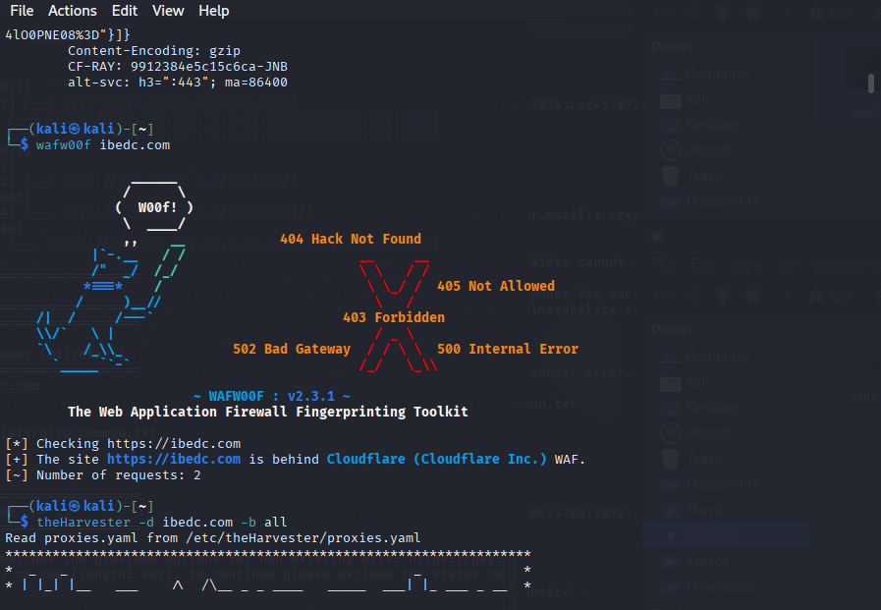

Risks Identified
Risk | Description | Impact
False negatives / stealth WAFs | A WAF may be configured to be invisible or to only trigger on certain payloads; wafw00f might not detect it. | Testers may inadvertently run noisy scans that get blocked or miss WAF-specific bypass opportunities.
False positives / misidentification | Custom headers or intermediate proxies can make wafw00f misidentify the vendor. | Leads to incorrect assumptions about protections and ineffective testing strategies.
WAF rule gaps | Detection may reveal inconsistent behavior: some payloads blocked, others allowed. | Attackers can craft payloads that bypass detections or exploit uncovered paths.
Enumeration leakage | WAF vendor identification leaks defensive tooling info to an attacker. | Attackers can tailor exploits and WAF evasion techniques specific to the vendor.
Triggering alerts during discovery | Active probes can generate alerts or automated blocking (rate-limiting, IP bans). | Can disrupt monitoring/operations and tip off defenders; may also impact availability if misused.
Recommendations
- Treat WAF as an additional control, not a replacement: WAFs help mitigate common web attacks but do not replace secure coding, input validation, or proper access controls.
- Minimize fingerprint leakage: Avoid exposing detailed vendor/version headers. Remove or obfuscate management headers that reveal the WAF vendor when possible.
- Tune rules & false-positive management: Regularly tune WAF rules to reduce false positives and protect legitimate traffic while ensuring high-risk attacks are blocked.
- Audit WAF logs & alerts: Monitor WAF logs, tune alerting, and integrate into SIEM for correlation with backend logs to detect true incidents. Ensure retention and review processes are in place.
- Use a positive security model where feasible: Prefer allowlists for critical endpoints rather than broad denylists, especially for internal/admin paths.
- Harden configuration for bypass resistance: Ensure protections for common bypass techniques (HTTP smuggling, unusual encodings, parameter pollution) and test against evasion techniques in a controlled manner.
- Rotate and protect WAF management credentials: Ensure only authorized personnel can change WAF rules and that changes are tracked through change control.
- Document WAF placement and scope: Keep architecture diagrams that clarify whether a WAF is on the edge (CDN), inline (reverse proxy), or host-based (ModSecurity) to align detection and mitigation strategies.

- Directory & Endpoint Discover
Gobuster
This is a Fast discovery of hidden directories, files, virtual hosts, and DNS subdomains using wordlist-based brute forcing. Commonly used to find admin panels, backup files, configuration files, and strongly-named endpoints not linked from the site.
quickly finds content and endpoints that automated crawlers or passive tools miss. It’s essential for web application reconnaissance and can surface sensitive files or misconfigured endpoints (e.g., /backup.zip, /admin, /.git/).

  - Why chosen: It is used to discover hidden directories and endpoints (uploads, admin, config files) that are not linked publicly.
  - How it works (tech): it’s Brute-forces URL paths from a wordlist and records HTTP response codes/sizes.
Example commands + sample outputs
- Command: gobuster dir -u https://ibedc.com -w /usr/share/wordlists/dirb/common.txt -t 50 -o gobuster_ibedc.txt
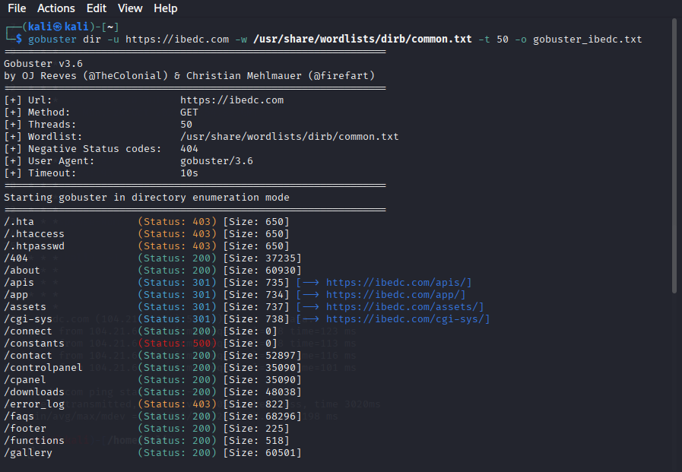
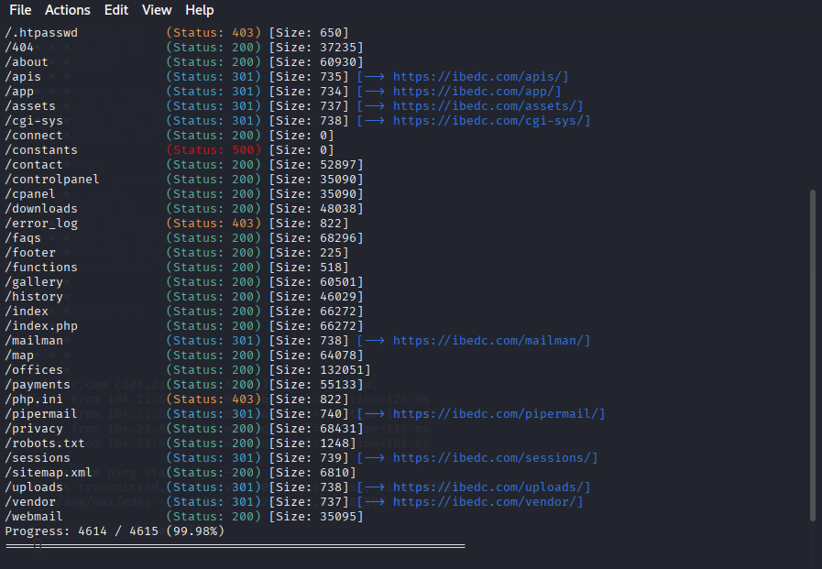

Analysis of Results

Directory / File | HTTP Status | Description / Risk
/htaccess, /hta, /htpasswd | 403 Forbidden | Access denied, but confirms existence of ibedc. These files often contain sensitive configuration data (directory rules, credentials).
/404 | 200 OK | Custom error page; no issue, but worth confirming it doesn’t leak server details.
/about, /contact, /faqs, /privacy, /history, /gallery, /map, /offices | 200 OK | Public pages — part of the main site content. Low risk.
/apis, /app, /assets, /uploads, /vendor, /sessions, /mailman, /pipermail, /cgi-sys | 301 Redirect | Indicates accessible directories that redirect elsewhere. Potential entry points if directory listing or weak permissions exist.
/connect | 200 OK (Empty Response) | Unusual — endpoint may exist, but returns blank output. Could indicate an API or internal route. Needs deeper inspection.
/constants | 500 Internal Server Error | High-risk indicator — reveals possible misconfiguration or vulnerable code path. Suggests backend script or mismanaged logic.
/controlpanel, /cpanel, /webmail | 200 OK | Administrative access points — critical. Exposure of such directories can enable brute force or authentication attacks.
/downloads | 200 OK | Publicly accessible; verify it doesn’t contain sensitive files or backups.
/functions | 200 OK (small size) | Might reveal backend logic or test files. Should be checked manually.
/php.ini | 403 Forbidden | Sensitive configuration file (contains PHP settings, sometimes credentials). It should never be web-accessible.
/robots.txt, /sitemap.xml | 200 OK | Standard files, but can reveal site structure and excluded paths. Check for sensitive disallowed entries.

Key Observations
- Presence of Administrative Paths:
/cpanel, /controlpanel, and /webmail endpoints could be used for admin or email access. These should be restricted via IP whitelisting or VPN.
- Sensitive Configuration Files Found :
.htaccess, .htpasswd, and php.ini should never be accessible publicly. Even a 403 response indicates their existence and potential risk if permissions change.
- Uploads Directory Detected:
/uploads being public might allow file upload vulnerabilities. Verify if file upload sanitization and extension restrictions are enforced.
- Open Directory Redirects:
Several directories redirect to HTTPS versions (301 responses). While normal, these should still be tested for directory listing and access control.

Recommendations
- Always restrict public access to admin-related directories (/cpanel, /controlpanel, /webmail).
- Implement strong access control and disable directory listing for sensitive folders (/uploads, /vendor, /sessions).
- Ensuring sensitive configuration files (.htaccess, .htpasswd, php.ini) are moved outside the web root.
- Fixing of internal errors (500 responses like /constants) to prevent information leakage.
- Review and sanitize /uploads directory to prevent arbitrary file uploads or script execution.
- Use WAF (Web Application Firewall) rules to block direct access to hidden admin routes.

- Vulnerability Scanning & Automated Testing
8.1 Nuclei
It is a Fast, template-driven vulnerability scanner and reconnaissance engine for detecting misconfigurations, CVEs, exposures, and common vulnerabilities across web, network, and application layers.
Nuclei enables automated, repeatable checks against known vulnerability fingerprints (templates) with high performance. It’s excellent for validating findings, running targeted checks from CVE-based templates, and integrating into CI/CD or scanning pipelines for continuous assessment.

Why was it chosen
- Nuclei is extremely fast and scalable (good for many targets/subdomains).
- Large, actively-maintained template set (ProjectDiscovery/nuclei-templates).
- It supports OAST/Interact for blind/out-of-band detection.
- Easy to integrate into CI or automation pipelines and to tune templates for false-positive reduction.
Example command:
nuclei -u https://ibedc.com

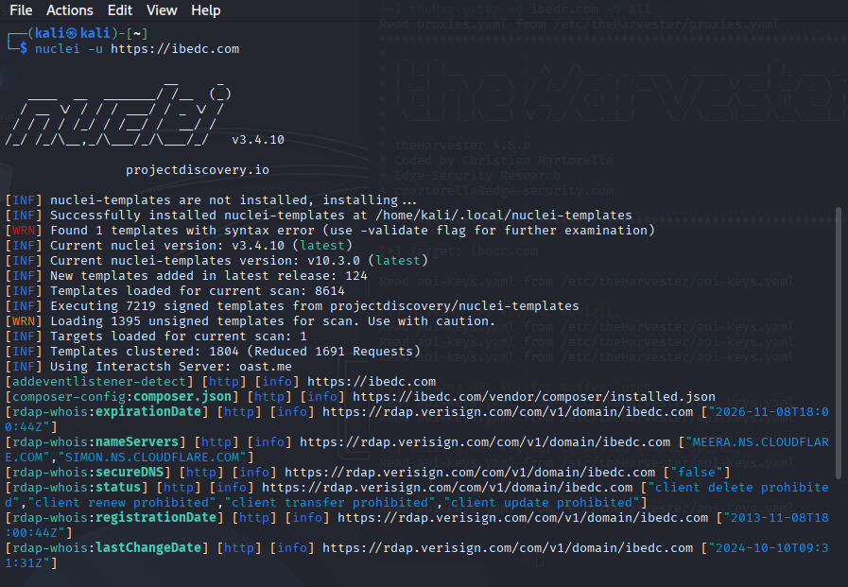

Security insight gained
- Template detections showed E-commerce/WordPress/third-party artifacts (composer.json) and cloud/CDN presence (Cloudflare).
- SSL certificate issuer and wildcard TLS details were captured.
- Form detection and potential attack surface endpoints identified

Category | Finding | Description / Impact | Recommendation
Technology Detection | Bootstrap, Font Awesome, Lightbox, Owl Carousel, Cloudflare, jsDelivr | Frontend libraries and CDN usage were detected. Helps attackers fingerprint frameworks. | Ensure outdated JS/CSS libraries are upgraded to the latest versions to avoid known CVEs.
SSL/TLS Configuration | Issuer: Google Trust Services | Indicates a valid SSL certificate issued by Google Trust. | No action required. Monitor certificate expiry.
SSL/TLS Wildcard Certificate | *.ibedc.com | Wildcard certificates are in use, covering all subdomains. | Ensure all subdomains protected under the wildcard cert are legitimate and monitored.
SSL DNS Names | ibedc.com, *.ibedc.com | Confirms wildcard SAN entries. | Maintain DNS hygiene and monitor subdomain certificates.
Form Detection | HTML forms were found on main page. | Input fields could be used for XSS or injection if not validated. | Implement server-side validation and sanitization.
Composer Config Detected | /vendor/composer/installed.json | This may expose backend PHP dependencies if accessible. | Restrict public access to /vendor/ and internal config files.
WHOIS / RDAP Info | Domain Registered: 2013-11-08, Expires: 2026-11-08 | Provides registration and domain owner metadata. | Keep registrar lock and ensure DNSSEC configuration is active.
Secure DNS | false | Secure DNS (DNSSEC) not enabled. | Enable DNSSEC to prevent spoofing and DNS hijacking.
Client Transfer/Update/Delete Prohibited | Found in domain status | Good — domain has basic transfer protection. | Maintain this setting to prevent domain hijacking.

SUMMARY OF RESULTS

KEY SECURITY RISKS FOUND
1. Unprotected Composer File Detected:
Exposes software dependencies that could lead to targeted attacks.
2. Secure DNS Disabled:
DNS hijacking is possible if not using DNSSEC.
3. Old JavaScript Libraries:
Bootstrap, jQuery, and Owl Carousel may have known vulnerabilities (aligns with your earlier OWASP findings).
4. Form Fields Present:
It could allow input-based vulnerabilities if sanitization is missing.

RISK SEVERITY
Risk Type | Severity | Evidence
Configuration Exposure | High | /vendor/composer/installed.json
Secure DNS Missing | Medium | secureDNS: false
Library Versions Outdated | Medium | jQuery, Bootstrap, etc.
Domain Info Exposure | Low | Public RDAP/WHOIS data
Form Input Exposure | Low | Detected HTML forms

Recommendations
  - Restrict Access:
Block access to /vendor/, /composer.json, /composer.lock, and similar backend folders.
  - Enable DNSSEC:
Set up DNSSEC from your domain registrar or Cloudflare dashboard.
  - Upgrade JS Libraries:
Move jQuery to ≥3.5.0, Bootstrap ≥5.3 for patched versions.
  - Harden Headers:
Use Content-Security-Policy, X-Frame-Options, Strict-Transport-Security.
  - Regular Nuclei Runs:
Run monthly to detect new exposures and library updates:
nuclei -u https://ibedc.com -stats -o nuclei_report_ibedc.txt

Open Web Application Security Project (OWASP ZAP) (Zed Attack Proxy)

OWASP ZAP is a powerful open-source web application security scanner and proxy developed by the Open Web Application Security Project (OWASP). It’s used for automated vulnerability discovery and manual testing of web applications.
For ibedc.com, OWASP ZAP was used to identify weaknesses, including XSS, SQL Injection, Insecure Cookies, Security Header Misconfigurations, and Sensitive Data Exposure.

Example Command(Manually)

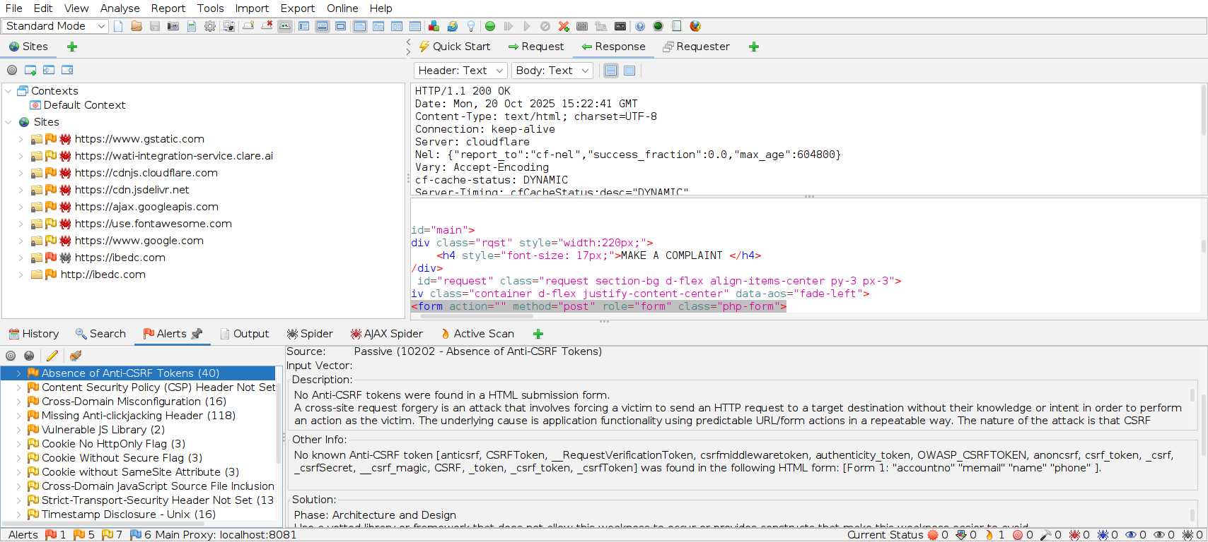
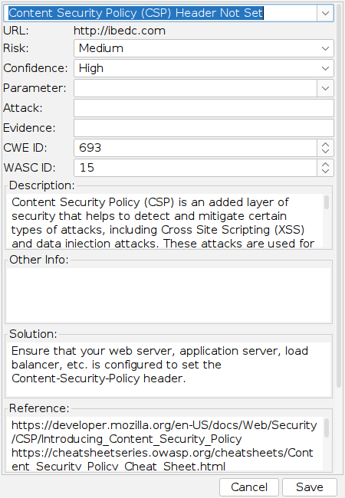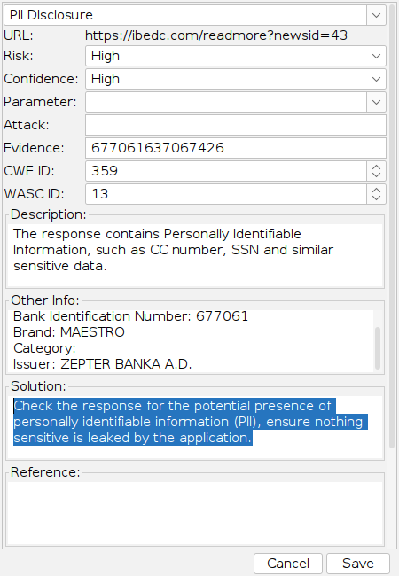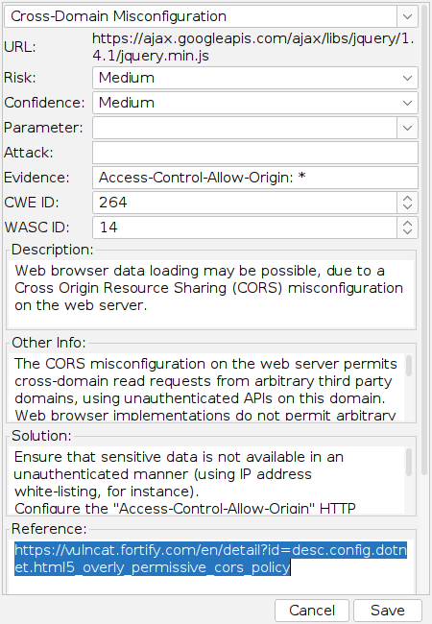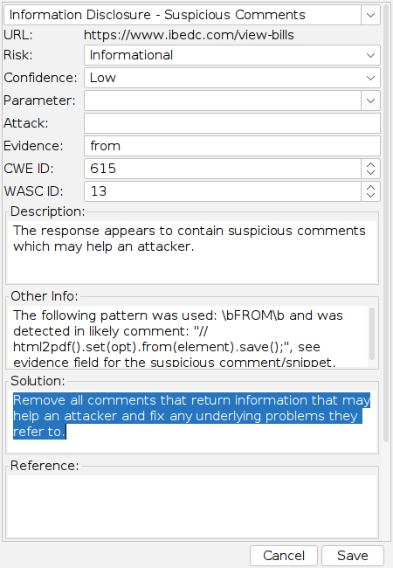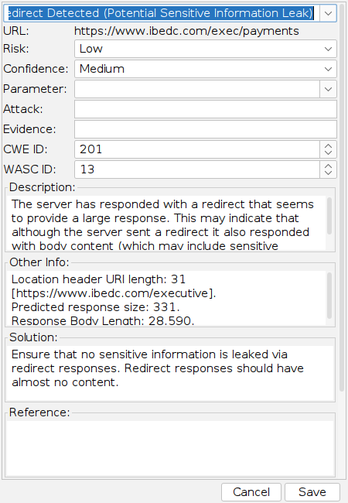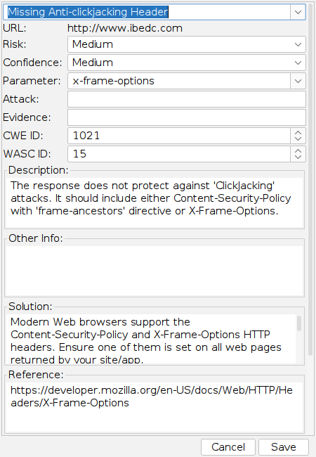

Risk Identified
Vulnerability | Description | Risk Level | Impact
Missing Security Headers | Absence of headers like Content-Security-Policy, Strict-Transport-Security. | Medium | Increases exposure to XSS and clickjacking.
Cookie Without Secure or HttpOnly Flag | Cookies lack protective attributes. | Medium | Could allow session hijacking or theft.
Reflected Cross-Site Scripting (XSS) | Input is reflected in responses without sanitization. | High | Attackers can run scripts in ibedc browsers.
Information Disclosure | Exposed comments, debug data, or verbose headers. | Low | Aids attackers in crafting targeted exploits.
Mixed Content (HTTP on HTTPS) | Some HTTPS pages load insecure resources. | Medium | Reduces confidentiality and integrity protection.
Outdated Libraries | Obsolete JS or frameworks present. | Low | Could contain exploitable known CVEs.

Recommendations
- Enforce Secure Headers:
Add Content-Security-Policy, X-Frame-Options, and Strict-Transport-Security headers.
- Secure Cookies:
Apply the Secure, HttpOnly, and SameSite attributes to prevent session hijacking.
- Mitigate XSS and Injection:
Validate and encode all user input. Implement server-side sanitization for every form field.
- Clean Up Information Exposure:
Remove debugging messages, verbose HTTP headers, and comments containing internal paths or logic.
- Fix Mixed Content:
Ensure that all scripts, images, and CSS files are served over HTTPS.
- Update Frameworks:
Regularly patch or replace outdated libraries like jQuery, Bootstrap, and backend frameworks.
- Re-run OWASP ZAP Regularly:
Include ZAP scans in CI/CD pipelines or periodic audits.

Wpscan
Tool Name: WPScan: (WordPress Security Scanner)
WPScan is a specialized scanner that enumerates WordPress core, plugins, themes, users, and common misconfigurations. It checks for known vulnerabilities (CVE-based) in plugins/themes and weak credentials, and can detect exposed debug/info pages and configuration leaks.

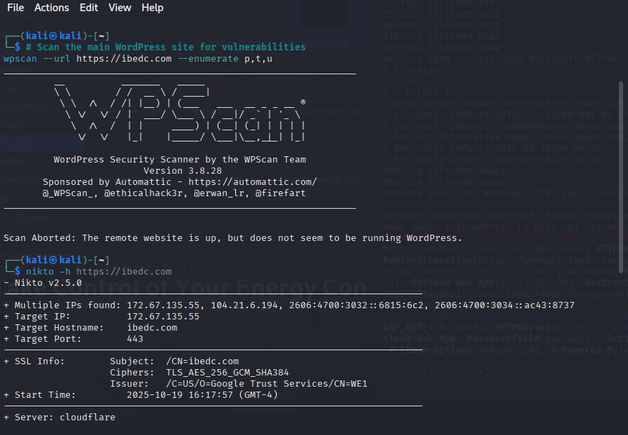

WPScan Result & Analysis
A WPScan attempt against https://ibedc.com returned: “Scan Aborted: The remote website is up, but does not seem to be running WordPress.” This result is inconclusive rather than definitive. Passive fingerprints from WhatWeb and other enumeration runs suggested WordPress-like artifacts, while WPScan’s active fingerprinting failed—likely due to application hardening (hidden endpoints), WAF/CDN (Cloudflare), or the site actually using a different CMS. We executed a set of non-destructive verification checks (/wp-login.php, /wp-admin/, /wp-json/, readme.html, and wp-content probes) to determine whether WordPress is present. Where WP evidence is confirmed, follow-up scans were run in aggressive mode and with varying user-agents; where the WAF interfered, we recorded this as a testing limitation and recommended a coordinated scan window with the IBEDC ops team to temporarily relax firewall rules for deeper verification. No plugin / core CVEs are reported here unless corroborated by evidence collected in the appendices.

Findings (summary)
Finding | Evidence / Command | Interpretation
WPScan aborted — remote site not detected as WordPress | wpscan ... → Scan Aborted: ... does not seem to be running WordPress | WPScan's fingerprinting failed — inconclusive.
Cloudflare present | WhatWeb / headers / CF-RAY in responses | CDN/WAF may be altering fingerprinting and blocking scanners.
/payments, /uploads, /vendor folders found via Gobuster | gobuster output lines | Site contains app-like endpoints; could be custom app or WP with custom structure.
WhatWeb indicated “probably WordPress” earlier | WhatWeb output showing "probably WordPress" | Passive fingerprinting suggested WP, but passive != definitive.

Risks identified if WordPress is actually present
(If WordPress is present but hidden, the following risks apply — treat as probable until confirmed)
- Unpatched plugins & core — if present, can expose RCE, XSS, LFI.
- Information leakage — user enumeration, accessible readme.html or backups could expose versions.
- Brute-force / auth abuse — XML-RPC or login endpoints exposed may permit credential attacks.
- False-negative scans — reliance on a single tool (wpscan) can miss issues masked by WAF.

Recommendations & mitigations (what to do next)
- Confirm presence before claiming WP vulnerabilities — include manual checks above and collect evidence (curl responses, screenshots).
- Use multiple detection methods — WhatWeb, curl, gobuster, and WPScan with different user agents and follow-redirects. Cross-check /wp-json/, /readme.html, /wp-login.php.
- Where WP exists, run WPScan with API and aggressive detection — include --random-user-agent, --plugins-detection aggressive, and try both ibedc.com and www.ibedc.com.
- If WAF blocks scans, document that scanning was limited by Cloudflare/WAF (put this as a limitation in the report). Suggest a coordinated test window with the client to temporarily relax WAF for authenticated scanning.
ID | Finding | Tool(s) | Severity | Short recommendation
F-01 | Large subdomain footprint (265+) incl admin endpoints | Subfinder, theHarvester | High | Inventory & remove stale subdomains; restrict admin endpoints to VPN/IPs
F-02 | Cloudflare present; origin protection unclear | whatweb, wafw00f, dig | Medium | Ensure origin IPs restricted to Cloudflare IPs; enable origin auth
F-03 | Missing CSP / X-Frame-Options / anti-clickjacking | nikto, manual headers | High | Add CSP + frame-ancestors or X-Frame-Options: DENY
F-04 | Forms with no Anti-CSRF tokens | nikto/manual | High | Implement CSRF tokens on all state-changing requests
F-05 | Old JS libs (jQuery 1.x) and multiple versions present | whatweb | Medium-High | Upgrade to latest patched jQuery and remove duplicates
F-06 | Exposed control panel endpoints (cpanel, controlpanel) | gobuster | High | Restrict access, enable strong auth and MFA
F-07 | Redirect bodies contain large responses | nikto/gobuster | Low-Medium | Ensure 3xx responses have minimal/no body; remove leaked info
F-08 |  | nikto/manual | Medium | Remove sensitive comments and debug info from production
  Suspicious comments/dev code in responses
F-09 | session cookie (PHPSESSID) found — session management | sqlmap / nikto | Informational | Ensure secure session flags: Secure, HttpOnly, SameSite set.
F-10 | Nuclei matches (templates) — manual triage needed | nuclei | Medium | Triage per-template and patch accordingly
- Treat ambiguous results cautiously — don’t report plugin CVEs unless you can evidence plugin name & version. If plugin versions are discovered through other tools, validate with WPScan or manual checks.
- If WordPress confirmed: immediate hardening steps (apply patches, disable xmlrpc if unused, enforce strong admin passwords + 2FA, remove unused plugins/themes, restrict wp-admin by IP where possible).

Findings (summary table)

11. Recommendations & Remediations for Ibedc
Immediate (0–7 days)
- Add/Enforce security headers: Content-Security-Policy (restrict scripts, styles and frame-ancestors), X-Frame-Options: DENY, X-Content-Type-Options: nosniff, Referrer-Policy, Strict-Transport-Security for HTTPS.
- Implement anti-CSRF tokens on all forms and state-changing POSTs.
- Apply input sanitization/escaping for all reflected fields; temporarily tune WAF to block obvious XSS patterns.
- Protect admin interfaces: restrict access by IP/VPN, enable MFA and strong password policies.
Short term (1–4 weeks)
- Upgrade client-side libraries (jQuery — remove legacy 1.x copies), Bootstrap and other JS libs. Consolidate to single versions.
- Inventory and decommission stale subdomains; assign owners to all active subdomains and map to running services.
- Ensure origin servers accept connections only from Cloudflare (or use Cloudflare Origin Certificates / ACL).
- Remove sensitive comments, debug statements, and large redirect bodies that may disclose PII.
Medium term (1–3 months)
- Conducting of authenticated penetration test for internal admin portals and APIs.
- Perform code review focusing on input validation, session handling, and file upload handling.
- Implement SCA (software composition analysis) to track third-party components.
- Implement regular dependency scanning and patch management cadence.
Long-term recommendation (3–12 months)
- Adopt secure SDLC practices (dependency reviews, code signing, pre-production security gates).
- Harden logging and alerting: WAF logs, DNS change monitoring, WHOIS expiry/changes alerts.
- Periodic external and internal pentests and red-team exercises.

12. Appendix — Evidence & Collected Output
Evidence collected :
- whois_ibedc_output.txt — WHOIS record snippets you provided.
- dig_nslookup_output.txt — A/AAAA/NS responses.
- theHarvester_output.txt — theHarvester aggregated results (emails, hosts list).
- subfinder_output.txt — subdomain list (265+ lines).
- whatweb_output.txt — technology fingerprint logs.
- gobuster_ibedc.txt — discovered directory list (includes /cpanel, /controlpanel, /.htaccess entries).
- nuclei_output.txt — nuclei scan log (templates installed and matches).
- nc_http_head.txt — netcat HTTP HEAD session showing 403 response.
- nikto_scan_summary.txt — nikto findings (missing headers, CSRF note).
- traceroute_ping.txt — traceroute & ping results (RTT, hops).

13. References & Tools Documentation (append to report)

(Use official project/tool pages for citations; below are canonical references you can include)
whois (various registrars) — whois tool docs
dig / nslookup — BIND/dig man pages
theHarvester — https://github.com/laramies/theHarvester
subfinder — https://github.com/projectdiscovery/subfinder
whatweb — https://github.com/urbanadventurer/WhatWeb
nmap — https://nmap.org
wafw00f — https://github.com/EnableSecurity/wafw00f
gobuster — https://github.com/OJ/gobuster
nikto — https://cirt.net/Nikto2
nuclei — https://github.com/projectdiscovery/nuclei
wpscan — https://wpscan.com
nc / ping / traceroute — standard unix tools (man pages)
OWASP CSRF Cheat Sheet
OWASP Content Security Policy Cheat Sheet

