<https://blogs.sas.com/content/graphicallyspeaking/2013/03/09/parametric-bar-charts/>

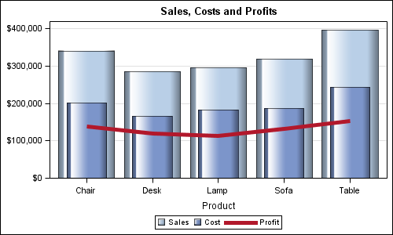

The plot gives a visual effect of a significantly larger sales value by representing the sales data by using bars with greater area while the actual data is indicated by the height of the bars.

<https://pure.uvt.nl/ws/files/3008016/Heijink_measuring_17_01_2014.pdf>

<https://pure.uvt.nl/ws/files/3008016/Heijink_measuring_17_01_2014.pdf>

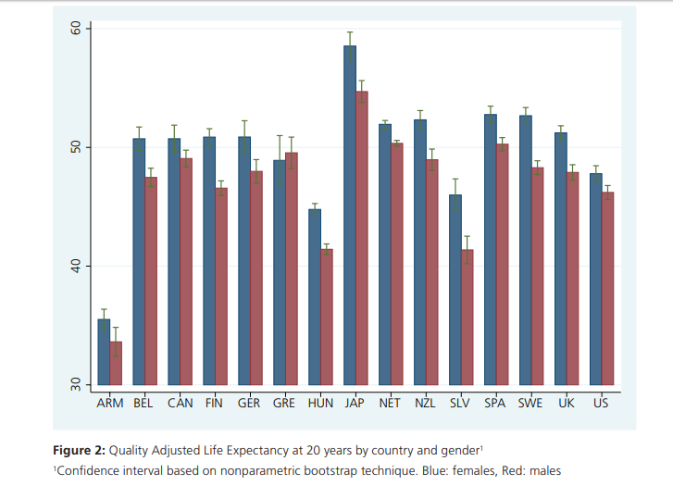

The scale on the y-axis does not start from zero, and the colour of the bars makes it difficult to see the lower limit of the error bars.