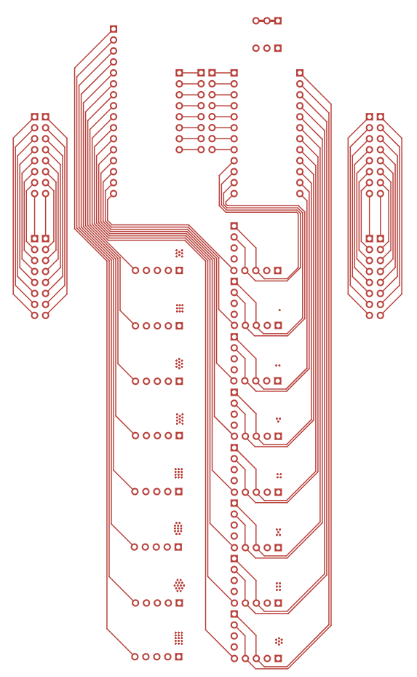
#include <FS.h>
#include <Wire.h>
#include <ArduinoJson.h>
#include <Adafruit_SSD1306.h>
#include <Adafruit_SH110X.h>
#include <Adafruit_seesaw.h>
#include <DFRobot_GR10_30.h>
#include <DFRobot_MAX17043.h>
#include <DFRobot_VisualRotaryEncoder.h>
#include <DFRobot_BloodOxygen_S.h>
#include <SparkFun_Qwiic_Keypad_Arduino_Library.h>
#include <PN532_I2C.h>
#include <NfcAdapter.h>

const String version = "8";
const int devicesCount = 8;
const int programsCount = 9;

String action = "";
int channelsCount;
int surfacesCount;

#include "./engine/Storage.h";
Storage storage = Storage();

#include "./engine/I2C.h";
I2C i2c = I2C();

#include "./engine/Program.h";
Program * programs[programsCount];

#include "./engine/Device.h";
Device * devices[devicesCount];

#include "./engine/OLED.h";
#include "./engine/Port.h";
#include "./engine/Channel.h";
Channel * channels;

#include "./engine/Surface.h";
Surface * surfaces;

#include "./engine/Menu.h";
Menu menu;

#include "./devices/AM.h";
AM accelerometer = AM(0x1D);

#include "./devices/GV.h";
GV gv = GV();

#include "./devices/HRS.h";
HRS hrs = HRS(0x57);

#include "./devices/RE.h";
RE re = RE(0x55);

#include "./devices/Gamepad.h";
Gamepad gamepad = Gamepad(0x51);

#include "./devices/Keypad.h";
Keypad keypad = Keypad();

#include "./devices/GD.h";
GD gd = GD();

#include "./devices/NFC.h";
NFCDevice nfcDevice = NFCDevice();

#include "./programs/Batterfly.h";
#include "./programs/Gravity.h";
#include "./programs/VV.h";
#include "./programs/Logo.h";
#include "./programs/Telephone.h";
#include "./programs/I2c.h";
#include "./programs/Contacts.h";
#include "./programs/NFC.h";
#include "./programs/Battery.h";

void setup() {
Serial.begin(9600);
storage.init();
i2c.init();

const String path = "/config/surfaces/" + version + ".json";
JsonArray & config = storage.load(path);
surfacesCount = config.size();
channelsCount = Channel::count(config);

channels = new Channel[channelsCount];
for (int i = 0; i < channelsCount; i++) {
channels[i].init(i);
}

devices[0] = &accelerometer;
devices[1] = &gv;
devices[2] = &hrs;
devices[3] = &re;
devices[4] = &gamepad;
devices[5] = &keypad;
devices[6] = &gd;
devices[7] = &nfcDevice;
for (int i = 0; i < devicesCount; i++) {
devices[i]->init();
}

surfaces = new Surface[surfacesCount];
for (int i = 0; i < surfacesCount; i++) {
Surface * surface = Surface::create(config[i]);
surface->init();
surfaces[i] = *surface;
}

programs[0] = new Batterfly();
programs[1] = new Gravity();
programs[2] = new VV();
programs[3] = new Logo();
programs[4] = new Telephone();
programs[5] = new I2c();
programs[6] = new Contacts();
programs[7] = new NFCProgram();
programs[8] = new Battery();

menu.init();
}

void loop() {
for (int i = 0; i < devicesCount; i++)
devices[i]->tick();

for (int i = 0; i < surfacesCount; i++)
surfaces[i].tick(devices[4]);

for (int i = 0; i < programsCount; i++)
if (programs[i]->active)
programs[i]->tick();

menu.tick();

for (int i = 0; i < surfacesCount; i++)
surfaces[i].clear();

for (int i = 0; i < programsCount; i++)
if (programs[i]->active)
programs[i]->draw();

for (int i = 0; i < surfacesCount; i++)
surfaces[i].draw(menu.level);
}
