Beaks and Flippers
  - How Beak Shape and Wing Structure Vary Across Penguin Genera
Table of contents

# OWNER: All
library(tidyverse)
library(knitr)
library(patchwork)
library(flextable)
# Color-blind-friendly palette (adapted from Paul Tol), one color per genus
genus_cols <- c(
"Aptenodytes" = "#2299CC", # medium blue
"Eudyptes" = "#AA3377", # purple
"Eudyptula" = "#CCBB44", # yellow
"Megadyptes" = "#228833", # green
"Pygoscelis" = "#004488", # dark navy
"Spheniscus" = "#EE6677" # red/pink
)
# Define symbols by genus, to support Colour-blind-friendly choices.
genus_shapes <- c(
"Aptenodytes" = 16, # Filled circle
"Eudyptes" = 17, # Filled triangle
"Eudyptula" = 15, # Filled square
"Megadyptes" = 18, # Filled diamond
"Pygoscelis" = 3, # Plus sign (+)
"Spheniscus" = 8 # Asterisk
)
# Define size for each shape
genus_sizes <- c(Aptenodytes = 2.5, Eudyptes = 2.5, Eudyptula = 2.5,
Megadyptes = 3.5, Pygoscelis = 2.5, Spheniscus = 2.5)
# OWNER: Stephanie
# Load data
penguins <- read_csv("data/many_penguins.csv")
# rename `hand-wing.index` to hwi
penguins <- penguins |>
rename(hwi = 'hand-wing.index')
# make genus, species and sex factors
penguins <- penguins %>%
mutate(across(c(genus, species, sex), factor))

Introduction
# OWNER: Stephanie
# table: number of penguins and species per genus (sample sizes)
# table: number of F, M and U per genus (sex ratio)
# % missing per variable
# Variables used in the analyses
analysis_vars <- c("beak.length_culmen", "beak.length_nares", "beak.width", "beak.depth", "tarsus.length", "hwi")
# Missing values in the beak measurements, by genus
missing_by_genus <- penguins %>%
group_by(genus) %>%
summarise(penguins = n(),
# sum NAs per measurement variable
across(all_of(analysis_vars), ~ sum(is.na(.x))),
# sum all the unknown sex values
sex_unknown = sum(sex == "U"))
# OWNER: Stephanie
missing_by_genus %>%
flextable() %>%
set_header_labels(genus = "Genus", penguins = "Penguins",
beak.length_culmen = "Culmen length",
beak.length_nares = "Nares length",
beak.width = "Beak width", beak.depth = "Beak depth",
tarsus.length = "Tarsus length", hwi = "Hand-wing index",
sex_unknown = "Unknown sex") %>%
italic(j = "genus", part = "body") %>%
fontsize(size = 11, part = "all") %>%
padding(padding.left = 2, padding.right = 2, part = "all") %>%
align(j = -1, align = "center", part = "all") %>%
width(j = 1, width = 1.0) %>% # Genus column (inches)
width(j = 2:9, width = 0.68) %>% # the eight number columns
set_table_properties(layout = "fixed")
Table 1: Number of missing values in the variables used in our analyses, by genus
Genus | Penguins | Culmen length | Nares length | Beak width | Beak depth | Tarsus length | Hand-wing index | Unknown sex
Aptenodytes | 10 | 0 | 1 | 0 | 0 | 2 | 2 | 1
Eudyptes | 36 | 0 | 3 | 0 | 1 | 0 | 7 | 15
Eudyptula | 7 | 0 | 3 | 0 | 0 | 1 | 3 | 7
Megadyptes | 4 | 0 | 0 | 0 | 0 | 0 | 0 | 2
Pygoscelis | 17 | 0 | 5 | 0 | 0 | 4 | 5 | 0
Spheniscus | 19 | 0 | 3 | 0 | 0 | 2 | 3 | 17

Question 1: Do penguin genera differ in beak shape?

Introduction
For this question we explore if penguins from the same genus have similar beak shapes that set them apart from other genera, and which part of the beak contributes most to these differences. The dataset includes four beak measurements: beak length (using two different measures), beak width, and beak depth. Together, they give a good picture of overall beak shape. We also use genus to group the penguins and tarsus length as a proxy for body size, so we can check whether differences in beak shape remain once size is removed. Moreover, since beak shape is closely related to diet and how an animal feeds, looking at these differences across genera may suggest how each group has adapted to find food in the ocean.

Approach
We used Principal Component Analysis (PCA) on three beak measurements: culmen length, beak width and beak depth, using only penguins with all three measurements (complete cases; see Table 1 and the Analysis section for how we handled missing values). We log-transformed the measurements, which is standard for allometric data (Glazier, 2021), and scaled them so that no single measurement had too much weight. To check whether differences between genera were mainly due to size, we also ran the PCA on size-corrected data, using the residuals from regressing each log beak measurement on log tarsus length (a proxy for body size). Because the sign of a PC is arbitrary, we reversed PC1 and PC2 in the size-corrected PCA so that both analyses point in the same direction.
The bar chart of the loadings (Figure 1) shows how much each beak measurement contributes to each PC. A bar chart is well suited for this because the lengths of the bars can be compared along a common scale, which is easy to read accurately (Cleveland & McGill, 1984), so the measurement that drives each PC stands out. Figure 2 shows two PCA biplots, one above the other: the original PCA and the size-corrected PCA. Each biplot is a scatterplot of the PC scores of each penguin, with genera identified by a colour-blind-friendly palette and a different symbol, so they can be told apart without relying on color alone. Arrows are overlaid to show the loadings: each arrow points in the direction in which that beak measurement increases, so penguins located towards an arrow tend to have larger values of that measurement, and longer arrows indicate measurements that are better represented by the two PCs shown. Combined, the points and arrows show whether penguins of the same genus cluster and which measurements explain these clusters.

Analysis
# OWNER: Maria
# Numbers for inline code in the Approach
r_nares <- cor(penguins$beak.length_culmen, penguins$beak.length_nares,
use = "complete.obs")
n_nares_missing <- sum(is.na(penguins$beak.length_nares))
n_depth_missing <- sum(is.na(penguins$beak.depth))
# Missing nares lengths and sample size for the two most affected genera
eudyptula <- missing_by_genus %>% filter(genus == "Eudyptula")
pygoscelis <- missing_by_genus %>% filter(genus == "Pygoscelis")
# keep penguins with all 3 beak measurements
# Vector with the variable names of the four beak measurements
pca_vars <- c("beak.length_culmen","beak.width", "beak.depth")
# Data frame for analyses: completecases and log transformation
pca_dta <- penguins %>%
# select variables for PCA analysis
select(all_of(pca_vars), genus) %>%
# just keep coplete cases
filter(complete.cases(.)) %>%
# log-transform the three beak measurements
mutate(across(all_of(pca_vars), log, .names = "log_{.col}"))
# Vector with the log transformed variable names
pca_vars_log <- c("log_beak.length_culmen","log_beak.width", "log_beak.depth")
Before running the PCA, we explored missing values in the four beak measurements (Table 1). While culmen length and beak width were complete, beak depth was missing for 1 penguin, and nares length was missing for 15 penguins, with the highest proportions in Eudyptula (3 of 7) and Pygoscelis (5 of 17). Because nares length was strongly correlated with culmen length (r = 0.85), which also measures beak length, we excluded this measure to avoid losing these penguins. We considered imputing their values, but imputation would add little new information and could make genera appear more distinct than they are. Therefore, we ran the PCA on culmen length, beak width and beak depth, using only penguins with all three measurements (complete cases, n = 92).
# OWNER: Maria (original PCA)
# PCA o the log transformed 3 measurements variables (not size-corrected)
pca_orig <- prcomp(pca_dta[,pca_vars_log], scale=T)
# Percentage of variance explained by each PC
var_pc <- summary(pca_orig)$importance["Proportion of Variance", ] * 100
# Summary of the explained variance per component
summ_pca_var_nonsize <- summary(pca_orig)$importance
# Loadings of the PCs
summ_pca_load_nonsize <- pca_orig$rotation
# OWNER: Stephanie (size-corrected PCA)
# residuals of each log beak measurement on log(tarsus_length)
# Log-transform the beak measurements and tarsus length.
pca_size_dta <- penguins %>%
select(all_of(pca_vars), tarsus.length, genus) %>%
filter(complete.cases(.)) %>%
mutate(across(all_of(c(pca_vars, "tarsus.length")), log, .names = "log_{.col}"))
# Regress each log beak measurement on log tarsus length.
size_lm <- lm(as.matrix(pca_size_dta[, pca_vars_log]) ~ log_tarsus.length,
data = pca_size_dta)
# Take the residuals: what's left of each beak measurement after removing
# the part explained by body size.
beak_resid <- resid(size_lm)
# Run the PCA on the residuals.
pca_size <- prcomp(beak_resid, scale. = TRUE)
# Flip PC1 and PC2 signs (arbitrary in PCA) so panel B reads like panel A
pca_size$x[, 1:2] <- -pca_size$x[, 1:2]
pca_size$rotation[, 1:2] <- -pca_size$rotation[, 1:2]
# Percentage of variance explained by each PC
var_pc_size <- summary(pca_size)$importance["Proportion of Variance", ] * 100
# Summary of the explained variance per component
summ_pca_var_size <- summary(pca_size)$importance
# Loadings of the PCs
summ_pca_load_size <- pca_size$rotation
For the size-corrected PCA, we used only penguins with all three beak measurements and tarsus length (n = 83), compared with 92 penguins in the original PCA, because tarsus length is also missing for some individuals.
# Table of variance explained by each PC
# kable(summ_pca_var_nonsize, digits = 2,
# caption = "Variance explained by each principal component
# (PCA on log-transformed beak measurements, not size-corrected)") %>%
# kable_styling()
summ_pca_var_nonsize %>%
as.data.frame() %>%
tibble::rownames_to_column("Statistics") %>%
flextable() %>%
colformat_double(digits = 2) %>%
fontsize(size = 11, part = "all") %>%
autofit()
Table 2: Variance explained by each principal component (PCA on log-transformed beak measurements, not size-corrected)
Statistics | PC1 | PC2 | PC3
Standard deviation | 1.27 | 0.99 | 0.63
Proportion of Variance | 0.54 | 0.33 | 0.13
Cumulative Proportion | 0.54 | 0.87 | 1.00
We observed that, together, PC1 and PC2 explained the 86.75% of the total varation (PC1: 53.86%; PC2: 32.89%). PC3 explained the remaining: 13.253% (Table 2).
# Loadings bar chart function: same design for the original and size-corrected PCA
make_loadings_plot <- function(pca, title) {
# Percentage of variance explained by each PC
var <- summary(pca)$importance["Proportion of Variance", ] * 100
# Loadings of PC1 to PC3 in long format (one row per measurement and PC)
loadings_long <- as.data.frame(pca$rotation[, c("PC1", "PC2", "PC3")]) %>%
rownames_to_column("measurement") %>%
mutate(measurement = c("Culmen length", "Beak width", "Beak depth")) %>%
pivot_longer(c(PC1, PC2, PC3), names_to = "PC", values_to = "loading") %>%
mutate(PC = paste0(PC, " (", round(var[PC], 1), "%)"))
# Bars of loadings: measurement on the y-axis, loading on the x-axis
ggplot(loadings_long, aes(x = loading, y = measurement)) +
# Grey vertical line at zero to separate positive and negative loadings
geom_vline(xintercept = 0, colour = "grey50", linewidth = 0.4) +
# One bar per measurement, in grey (colour is reserved for genus)
geom_col(fill = "grey45", width = 0.6) +
# Loading value at the end of each bar
geom_text(aes(label = round(loading, 2),
hjust = ifelse(loading < 0, 1.15, -0.15)),
size = 3.5, colour = "grey25") +
# One panel per PC
facet_wrap(~ PC) +
# Same range for all panels, with room for the value labels
scale_x_continuous(limits = c(-1.3, 1.3), breaks = seq(-1, 1, by = 0.5)) +
labs(title = title, x = "Loading", y = NULL) +
# Clean white theme with readable text size
theme_minimal(base_size = 12) +
# Light vertical gridlines only; bold panel and plot titles
theme(panel.grid.major.y = element_blank(),
panel.grid.minor = element_blank(),
panel.grid.major.x = element_line(colour = "grey93", linewidth = 0.3),
strip.text = element_text(face = "bold"),
plot.title = element_text(face = "bold", size = 12))
}
# OWNER: Maria
# Figure 1: bar charts of the PCA loadings
p_load_orig <- make_loadings_plot(pca_orig, "Original")
p_load_size <- make_loadings_plot(pca_size, "Size-corrected")
# One above the other, with panel tags A and B
p_load_orig / p_load_size + plot_annotation(tag_levels = "A")
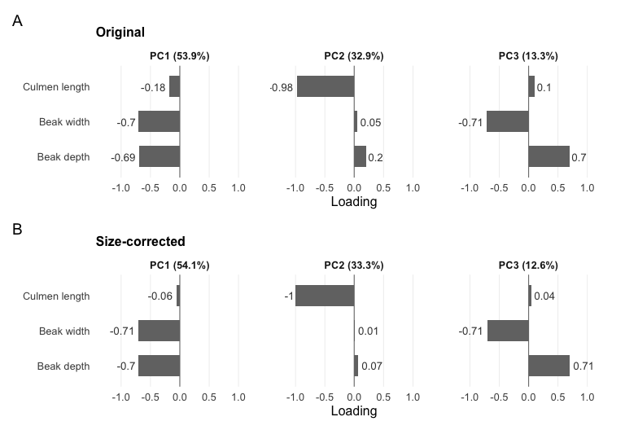
Figure 1: Loadings of the three log-transformed and scaled beak measurements on each principal component: (A) original PCA; (B) size-corrected PCA. Signs of PC1 and PC2 in (B) were reversed to match (A); signs in PCA are arbitrary.
The loadings show that each principal component reflects a different dimension of the beak, and that this structure is almost the same before and after size correction (Figure 1). In both PCAs, PC1 is dominated by beak width (original: -0.7; size-corrected: -0.71) and beak depth (-0.69; -0.7), so it represents how wide and deep (thick) the beak is. PC2 is almost entirely determined by culmen length (-0.98; -1) and therefore represents beak length, while PC3 contrasts beak width and depth, which load with opposite signs. The main difference is that culmen length contributes even less to PC1 after size correction (-0.18 vs. -0.06), so PC1 becomes an almost pure measure of beak thickness once size is removed. Together, PC1 and PC2 explain most of the variation in both PCAs (86.7% and 87.4%), while PC3 explains little (13.3% and 12.6%), so the biplots (Figure 2) show only PC1 and PC2.
# OWNER: Stephanie
# Linear discriminant analysis: how well can genus be predicted from the beak?
# use the same four log beak measurements (predictors) as the PCA, plus genus
# (grouping variable to predict)
# MASS package does lda
# Leave-one-out cross-validation (CV = TRUE): each penguin is classified by a model fitted without that penguin, so the accuracy isn't over-optimistic
lda_cv <- MASS::lda(x = pca_dta[, pca_vars_log],
grouping = droplevels(pca_dta$genus),
CV = TRUE)
# table of actual vs predicted genus: table(actual, predicted) - no figure?,
# we already will have two figures (PCA + loadings)
# % correct overall and per genus
actual <- droplevels(pca_dta$genus)
predicted <- lda_cv$class
# Table of actual vs predicted genus (rows = actual, columns = predicted)
cm <- table(actual, predicted)
cm
predicted
actual Aptenodytes Eudyptes Eudyptula Megadyptes Pygoscelis Spheniscus
Aptenodytes 9 0 0 0 1 0
Eudyptes 0 32 0 0 3 0
Eudyptula 0 0 7 0 0 0
Megadyptes 0 0 0 0 1 3
Pygoscelis 0 2 0 0 15 0
Spheniscus 0 0 0 0 0 19
# % correct overall
overall_pct <- sum(diag(cm)) / sum(cm) * 100
overall_pct #equivalent: mean(predicted == actual) *100
[1] 89.13043
# % correct per genus (diagonal / row total, because rows = actual)
per_genus_pct <- diag(cm) / rowSums(cm) * 100
round(per_genus_pct, 1)
Aptenodytes Eudyptes Eudyptula Megadyptes Pygoscelis Spheniscus
90.0 91.4 100.0 0.0 88.2 100.0
# Biplot function: same design for the original and size-corrected PCA
make_biplot <- function(pca, genus, labels, title, arrow_scale = 2.5) {
# Percentage of variance explained by each PC
var <- summary(pca)$importance["Proportion of Variance", ] * 100
# PC1 and PC2 scores of each penguin, with its genus
scores <- as_tibble(pca$x[, 1:2]) |> mutate(genus = genus)
# Loadings, stretched so the arrows are visible next to the points
arrows <- as_tibble(pca$rotation[, 1:2] * arrow_scale) |>
mutate(measurement = c("Culmen", "Width", "Depth"),
# Mostly horizontal arrow (TRUE) or mostly vertical (FALSE)
horiz = abs(PC1) >= abs(PC2),
# Label just beyond the arrow tip
lab_x = PC1 * 1.06,
lab_y = PC2 * 1.06,
# Horizontal: text starts at the tip and runs outwards;
# vertical: text centred on the arrow
hjust = ifelse(horiz, ifelse(PC1 < 0, 1, 0), 0.5),
# Horizontal: the higher label is nudged up and the lower one down,
# so labels of arrows pointing the same way do not overlap;
# vertical: label above or below the tip
vjust = ifelse(horiz,
ifelse(PC2 >= mean(PC2[horiz]), 0.2, 0.8),
ifelse(PC2 < 0, 1, 0)))
ggplot(scores, aes(x = PC1, y = PC2)) +
# Grey lines at zero (centre of each PC)
geom_hline(yintercept = 0, colour = "grey50", linewidth = 0.4) +
geom_vline(xintercept = 0, colour = "grey50", linewidth = 0.4) +
# Penguins as points, coloured, shaped and sized by genus
geom_point(aes(colour = genus, shape = genus, size = genus)) +
# Arrows from the centre to each beak measurement's loading
geom_segment(data = arrows, aes(x = 0, y = 0, xend = PC1, yend = PC2),
arrow = arrow(length = unit(2, "mm")),
colour = "grey25", linewidth = 0.7) +
# Measurement names next to the arrow tips, with a white halo (no box);
# force = 0 keeps them exactly where placed
ggrepel::geom_text_repel(data = arrows,
aes(x = lab_x, y = lab_y, label = measurement,
hjust = hjust, vjust = vjust),
size = 3.5, colour = "grey25", fontface = "bold",
bg.colour = "white", bg.r = 0.15,
force = 0, force_pull = 0, segment.colour = NA,
seed = 1) +
# Rounded white box with the genus name (right edge at label_x)
geom_label(data = labels,
aes(x = label_x, y = label_y,
label = paste0(genus, " "), colour = genus),
hjust = 1, fontface = "italic", size = 3.4, fill = "white",
label.r = unit(0.5, "lines"),
label.padding = unit(0.3, "lines")) +
# Genus symbol at the right end inside the box
geom_point(data = labels,
aes(x = label_x - 0.17, y = label_y,
colour = genus, shape = genus, size = genus)) +
# Genus colours, shapes and sizes (same in every figure)
scale_colour_manual(values = genus_cols) +
scale_shape_manual(values = genus_shapes) +
scale_size_manual(values = genus_sizes) +
# Same limits in both panels so they have the same shape and align;
# equal scale on both axes so distances are not distorted
coord_equal(xlim = c(-4.2, 4.2), ylim = c(-4.2, 2.5), clip = "off") +
# Panel title and axis titles with % of variance
labs(title = title,
x = paste0("PC1 (", round(var["PC1"], 1), "%)"),
y = paste0("PC2 (", round(var["PC2"], 1), "%)")) +
# Clean theme, light grid, no legend
theme_minimal(base_size = 12) +
theme(panel.grid.major = element_line(colour = "grey93", linewidth = 0.3),
panel.grid.minor = element_blank(),
plot.title = element_text(face = "bold", size = 14),
legend.position = "none")
}
# OWNER: Maria (figure), Stephanie (size-corrected PCA)
# Label positions (right edge of each box), original PCA
genus_labels <- tibble(
genus = c("Eudyptes", "Eudyptula", "Aptenodytes",
"Spheniscus", "Pygoscelis", "Megadyptes"),
label_x = c(-0.45, 3.85, 2.65, 2.6, 2.05, -0.55),
label_y = c(1.8, 1.5, -2.6, 0.35, -0.85, -1.05)
)
# Label positions (right edge of each box), size-corrected PCA after flipping
genus_labels_size <- tibble(
genus = c("Eudyptes", "Eudyptula", "Aptenodytes",
"Spheniscus", "Pygoscelis", "Megadyptes"),
label_x = c(-2.0, 4.5, 3.0, 3.6, -1.2, 2.6),
label_y = c(1.5, -0.7, -2.6, -1.9, -1.4, 2)
)
# The two biplots
p_orig <- make_biplot(pca_orig, pca_dta$genus, genus_labels, "Original", arrow_scale = 3.5)
p_size <- make_biplot(pca_size, pca_size_dta$genus, genus_labels_size, "Size-corrected", arrow_scale = 3.5)
# Side by side, with panel tags A and B
p_orig / p_size + plot_annotation(tag_levels = "A")
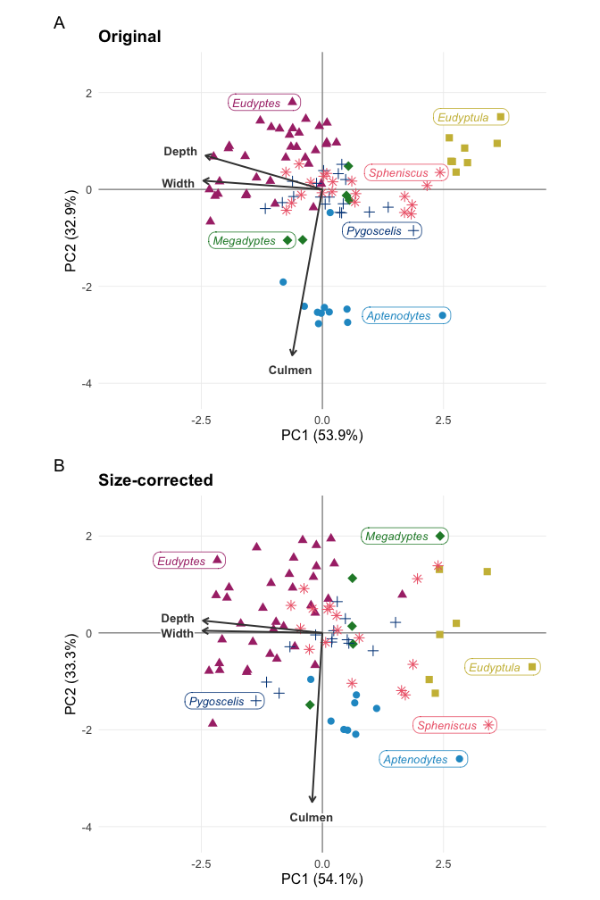
Figure 2: PCA biplots of beak shape across penguin genera: (A) log-transformed beak measurements; (B) after removing the effect of body size (residuals on log tarsus length). Each point is one penguin, coloured and shaped by genus; arrows show the loadings of the beak measurements. Percentages show the variance explained by each PC.
Original PCA. Some genera form distinct groups in the biplot (Figure 2). Aptenodytes separates along the culmen length arrow, indicating longer beaks, while Eudyptula lies opposite the width and depth arrows (narrower, shallower beaks). Eudyptes lies along width and depth arrows direction (wider, deeper beaks). Pygoscelis, Spheniscus and Megadyptes overlap in the centre. Because this PCA was not corrected for size, the extreme positions of the largest (Aptenodytes) and smallest (Eudyptula) penguins may partly reflect body size.
Size-corrected PCA. After removing the effect of body size, the same overall pattern remains, although the groups are less compact and overlap more (Figure 2 B). Aptenodytes still lies along the culmen length arrow, but closer to the centre, which suggests that its long beak is partly, but not only, explained by its large size. Eudyptula still lies opposite the width and depth arrows, so its beak remains relatively thin for its size, and Eudyptes still lies towards wider, deeper beaks. Pygoscelis, Spheniscus and Megadyptes continue to overlap in the centre. Overall, differences in beak shape between some genera persist once size is removed, so they are not simply a consequence of body size.

Discussion
Our PCA showed that penguin beak variation is organised along two largely independent dimensions: beak thickness (width and depth, PC1) and beak length (PC2), which together explained 86.7% of the variation. Although we expected that PC1 would reflect overall beak size, culmen length contributed little to PC1. This means that penguins with thicker beaks do not necessarily have longer beaks. This suggests that beak length and thickness may have evolved somewhat independently across penguins, possibly in relation to different feeding demands, although our data cannot test this directly. Because we used only three beak measurements, a simple scatterplot of beak length against depth would show a similar pattern, but the PCA confirmed that width and depth vary together while length varies independently.

Question 2: Does the hand-wing index still vary among penguin genera?

Introduction

Approach

Analysis
# OWNER: Andrew
# Filter out missing values
q2_data <- penguins |>
filter(!is.na(hwi), !is.na(genus))
# summary per genus: n, mean, sd, median, 95% CI of the mean
q2_summary <- q2_data |>
group_by(genus) |>
summarise(
n = n(),
mean = mean(hwi),
sd = sd(hwi),
median = median(hwi),
se = sd / sqrt(n),
ci_low = mean - qt(0.975, df = n - 1) * se,
ci_high = mean + qt(0.975, df = n - 1) * se,
.groups = "drop"
) |>
arrange(desc(mean))
q2_summary
# A tibble: 6 × 8
genus n mean sd median se ci_low ci_high
<fct> <int> <dbl> <dbl> <dbl> <dbl> <dbl> <dbl>
1 Megadyptes 4 7.1 1.23 7.2 0.615 5.14 9.06
2 Eudyptes 29 5.84 1.15 5.7 0.214 5.40 6.28
3 Pygoscelis 12 5.73 1.52 5.65 0.439 4.77 6.70
4 Eudyptula 4 5.62 1.67 5.7 0.834 2.97 8.28
5 Spheniscus 16 4.16 0.724 4 0.181 3.77 4.54
6 Aptenodytes 8 3.7 0.568 3.65 0.201 3.22 4.18
# OWNER: Andrew
# ANOVA or Kruskal-Wallis, and the effect size (eta- or epsilon-squared)# q2-test
# Kruskal-Wallis test (non-parametric, no normality assumption)
kw <- kruskal.test(hwi ~ genus, data = q2_data)
kw
Kruskal-Wallis rank sum test
data: hwi by genus
Kruskal-Wallis chi-squared = 33.878, df = 5, p-value = 2.518e-06
# effect size: epsilon-squared = H / (n - 1)
eps_sq <- unname(kw$statistic) / (nrow(q2_data) - 1)
eps_sq
[1] 0.470531
# Justification checks
q2_data |>
group_by(genus) |>
filter(n() >= 3) |>
summarise(shapiro_p = shapiro.test(hwi)$p.value)
# A tibble: 6 × 2
genus shapiro_p
<fct> <dbl>
1 Aptenodytes 0.666
2 Eudyptes 0.140
3 Eudyptula 0.975
4 Megadyptes 0.186
5 Pygoscelis 0.995
6 Spheniscus 0.0648
bartlett.test(hwi ~ genus, data = q2_data)
Bartlett test of homogeneity of variances
data: hwi by genus
Bartlett's K-squared = 11.791, df = 5, p-value = 0.03777
# OWNER: Andrew
# geom_boxplot + geom_jitter, colour and shape = genus, n per genus
q2_labelled <- q2_data |>
add_count(genus, name = "n") |>
mutate(genus_n = fct_reorder(paste0(genus, "\n(n = ", n, ")"),
hwi, .fun = median))
ggplot(q2_labelled, aes(x = genus_n, y = hwi)) +
geom_boxplot(outlier.shape = NA, fill = NA, colour = "darkgrey", width = 0.5) +
geom_jitter(aes(colour = genus, shape = genus),
width = 0.15, alpha = 0.7, size = 2.5) +
scale_y_continuous(name = "Hand-wing index") +
scale_x_discrete(name = "Genus (sample size)") +
scale_colour_viridis_d(guide = "none") +
scale_shape_manual(values = rep(c(16, 17, 15, 18, 3, 4), length.out = n_distinct(q2_data$genus)),
guide = "none") +
theme_minimal()
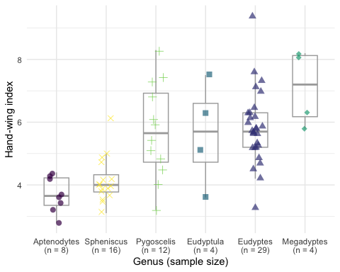
Figure 3: caption for Figure 3
# OWNER: Andrew
# geom_pointrange (mean and 95% CI per genus)
q2_summary |>
filter(!is.na(ci_low)) |>
mutate(genus = fct_reorder(genus, mean)) |>
ggplot(aes(x = mean, y = genus, colour = genus)) +
geom_pointrange(aes(xmin = ci_low, xmax = ci_high), size = 0.7) +
scale_x_continuous(name = "Mean hand-wing index (95% CI)") +
scale_y_discrete(name = "Genus") +
scale_colour_viridis_d(guide = "none") +
theme_minimal(base_size = 12)
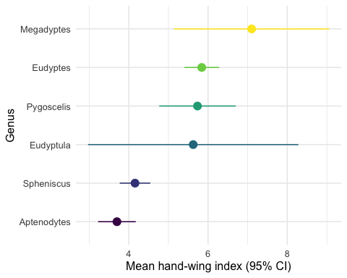
Figure 4: caption for Figure 4
# OWNER: Stephanie
# Exploratory checks for possible reasons why the hand-wing index varies (no figures)
# 1. body size: Spearman correlation between hwi and tarsus_length
# 2. components of the index: mean kipps_distance and wing_length per genus
# (small table), to see which part drives any differences
# 3. sex: refer to the sex-ratio table from the Introduction; note any genus
# dominated by one sex

Discussion

References

AI Disclosure
Maria Sans-Fuentes: Claude (Anthropic) was used to:
- choose a colour-blind-friendly palette for our figures (it suggested a palette adapted from Paul Tol’s colour schemes, with darkened blues so all colours are clearly visible, one colour per genus, and a different point shape per genus as a second cue);
- debug R code, for example how to print the variance explained from a PCA summary with kable() (using summary(pca)$importance) and why missing colour values removed all points from a ggplot;
- place the labels in the PCA biplots (it helped me write the code that positions the measurement names just beyond the end of each loading arrow, keeping the names of arrows that point in the same direction from overlapping, and suggested starting positions for the genus labels, which I then adjusted by hand after checking the rendered figure).
- help configure the document to render in HTML, PDF and Word. This included choosing a package (flextable) that builds the tables in all three formats and adding table of contents for each format.
Andrew King: (state tool and use, or “No AI tools were used.”)
Stephanie Wu: (state tool and use, or “No AI tools were used.”)

PCA combines several related measurements into a few new axes, called principal components (PCs), which capture most of the variation in the data. This allows us to summarize the beak measurements in two-dimensional plots.
Allometry refers to the way body parts change in proportion to overall body size; for example, larger penguins tend to have larger beaks. These relationships are usually curved on the original scale but become linear after a log transformation. Logging also makes differences between small and large penguins proportional.

