**Equipment Selection**

While choosing the sizes and features of our components, we have taken the help of Simulink with commercially available values for resistors, capacitors, diodes and MOSFET also by adding their non-idealities in the software . After making sure that the topology is able to work flawless with the chosen equipments, we ordered them by taking into account the safety margins hence reasonably larger ones are prefered in order not to design a system that is in the limits i.e. thermal problems, voltage and current ratings, wattages, non-idealities are all considered. Before giving the properties of the chosen components one by one, it is better to show them together in figure 1.

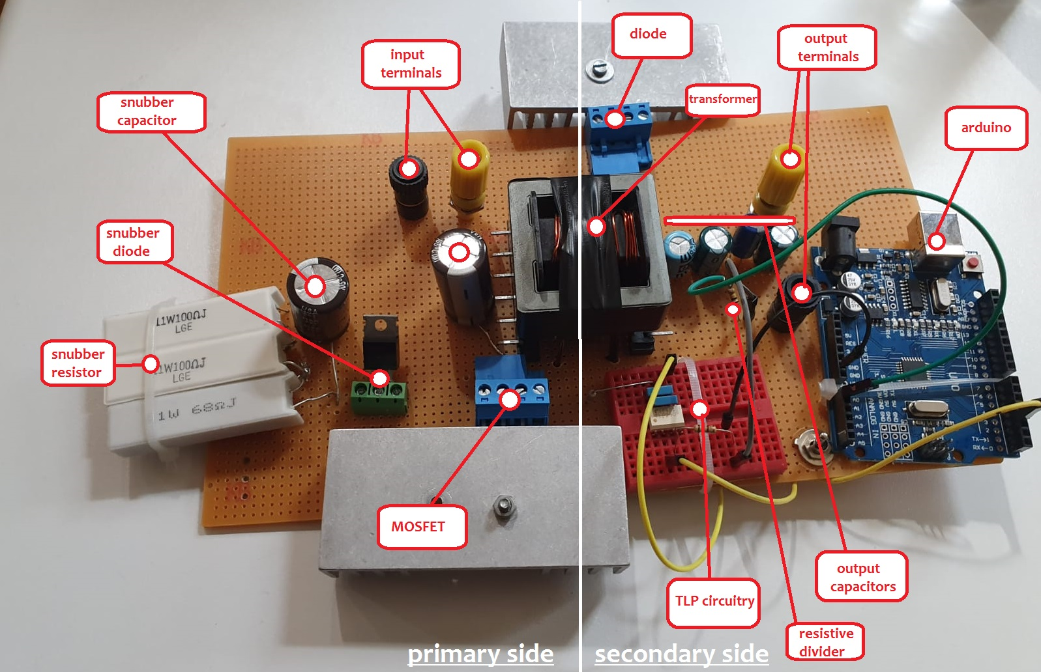

Figure : Overview of the designed Flyback topology with components labeled on

**Chosen Equipments**

**MOSFET:**

*IRFP250NPBF, 30A, 200V, n-channel, TO247-3 package*

Considering that the largest input voltage value is 48V, it may seem unnecessary to choose a 200V MOSFET. However, there is the effect of leakage flux component of the transformer causing a larger voltage on MOSFET. Hence, we prefered to take the advantage of overdesign while choosing it. Also note that 30A current rating is enough for our purposes because primary side current is around 9A for our specs. To further decrease the effect of leakage component, we coupled our switching device with a large heat-sink.

**RCD SNUBBER:**

*Resistor unit: 100Ω,11W sand stone resistors, 3 of them in series*

*Capacitor: 250V, 100uF, aluminum electrolytic*

*Diode: DSA30I100PA, Schottky, 30A, 100V, TO220AC package*

The main purpose of utilizing an RCD snubber is to discharge leakage component originated from the transformer used. Although we accomplished to design a transformer having a relatively low leakage inductance (0.7uH), we still prefered to design a large snubber unit with bigger components than it would be needed. In our resistor unit, we used three sand stone resistors with large wattage in order not to burn them while dissipating leakage current. Selection of capacitor is again an example of overdesign since the voltage in primary never rises to 250V, but we used what we had in our hands. Finally, diode is the same with the one used in secondary side which is a fast switching device with enough ratings. Thanks to low leakage inductance value, we did not need to couple this diode with a heat-sink.

**INPUT CAPACITOR:**

*250V,100uF, aluminum electrolytic*

The motivation behind using such a component is to get away from the inductance effect of the cables reaching the primary of our transformer by connecting a capacitor between primary side of the transformer and the source side of MOSFET. By this way, we supply the system with a better DC and get rid of voltage fluctuations in this manner.

**TRANSFORMER:**

*Chosen E-core: 00K6527E060, Kool Mu 60u, AL= 300 ± 8% nH/T2*

*Cable: AWG20*

Noting that the aimed Lm being 23uH, Dmax being 0.46, Nratio being 4/6 and fswitching being 31.250kHz, we needed for a core core with high AL value in order to have maximum mutual inductance value with minimum number of turns in order to have less core losses and a higher efficiency. In addition, we paid attention for the core being as small as possible to get away from leakage inductance effect as much as possible and also a high permeability to store enough energy. Considering these facts we have chosen *00K6527E060* core by making our windings with AWG20 with double row (in order to have enough current rating i.e. Imax-AWG20=5A<Iprimary=9A) for each turn. Note that we placed an air-gap between our E-cores to increase stored energy and also to coincide with required mutual inductance value. Consequently, designed core supplied us with a Lleakage of 0.7uH which is good in order to minimize the burder of snubber circuitry and obtain a higher efficiency. Finally, note that the obtained A.T value was around 230 which corresponds to an AL utilization factor larger than 80% which is good enough in order not to saturate our core.

**SECONDARY SIDE DIODE:**

*DSA30I100PA, Schottky, 30A, 100V, TO220AC package*

While deciding the ratings of this diode, we have taken into account that the voltage rating being larger than approximately 20V (possible fluctuations included) even though the output voltage was 12V for our specs. In addition 30A current rating is more than enough for our purposes since output current was around 6A as specified. Finally, we paid attention for this switching device to be fast enough in terms of obtaining a steady output voltage characteristic and to discharge mutual inductance rapidly in order not to saturate our core. Hence, we have chosen a Schottky one.

**RESISTIVE DIVIDER (feedback):**

*100kΩ, 4 of them in series*

Noting that the maximum voltage value that can be supplied to arduino being 3.3V, we divided output voltage by 4 to be 3V by using a serial resistive divider (placed in parallel to output terminals) in order to be supplied to our micro-controller for a closed-loop control. The reason behind choosing these resistors as large as 100kΩ is to pass lower current and not to burn our feedback topology.

**ARDUINO & CONTROLLING ALGORITHM:**

According to the voltage magnitude coming from the resistive divider, this micro-controller manages the gating signals (with a switching frequency of 31.250kHz) in order to maintain a constant output voltage by increasing duty cycle 0.2% in each switching period. Due to this incremental ratio being small, our controller’s response is a little slow i.e. it takes around 15 seconds to converge rated output voltage value. However, it maintains a lower switching loss. Also note that the arduino code makes us to operate soft-starting by starting with a duty cycle of 20%. Finally, there is an upper limit for PWM in order not to saturate our core and also an lower limit since it would be meaningless a negative PWM signal. Related arduino code is attached below:

float pwm=20;

void setup() {

pinMode(3, OUTPUT);

TCCR2B = TCCR2B & B11111000 | B00000001; // for PWM frequency of 31372.55 Hz

Serial.begin(9600);}

void loop() {

int voltage = analogRead(A0);

Serial.print ("voltage");

voltage = map(voltage, 0 , 1023 , 0 , 100);

Serial.println (voltage);

if (voltage==0){

pwm=20;

Serial.print ("sabit pwm=");

Serial.print(pwm);

analogWrite(3,map(pwm,0,100,0, 255));}

else if (voltage<=64) {

pwm=pwm+0.2;

if(pwm<0){

pwm=0;

}

if (pwm>60){

pwm=60;

}

Serial.print ("artıyor pwm=");

Serial.print(pwm);

analogWrite(3,map(pwm,0,100,0, 255));

}

else if (voltage>64) {

pwm=pwm-0.2;

if(pwm<0){

pwm=0;

}

if (pwm>60){

pwm=60;

}

Serial.print ("azalıyor pwm=");

Serial.print(pwm);

analogWrite(3,map(pwm,0,100,0, 255));

}

delay(300);}

**TLP CIRCUITRY:**

*Capacitors: 47nF two of them in parallel*

*Resistors: 100Ω from Arduino to TLP*

*560kΩ*2 from TLP to gate of MOSFET*

This arrangement is placed in order not to distort the isolation between primary and secondary sides while taking feedback from the output. The critical point here is to shorten the distance while supplying the gating signals which we directly have done by using resistors without using any cable. If this distance is not short enough, gating signals gets distorted and we would not switch our MOSFET successfully.

**OUTPUT CAPACITORS:**

*35V, 220uF, aluminum electrolytic capacitors 4 of them in parallel.*

These capacitors are used for filtering purposes i.e. to decrease voltage ripples in output. While choosing our capacitors, we paid attention for them to have at least 20V rating with possible spikes included. Consequently, we accomplished to have 0.8V peak-to-peak ripple which is enough for our purposes.

**Introduction**

In this project, our aim was to design and implement an isolated DC supply topology called “Flyback”. For this purpose we were supplied with some requirements that are listed below and also the overall design schematic is available in Figure 2:

FLY#5:

Minimum input voltage: 24V

Maximum input voltage: 48V

Output voltage: 12V

Output power: 70W

Output voltage ripple: 4%

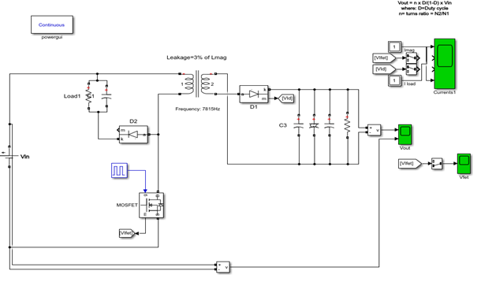

Figure - Overall design schematic of the Flyback converter topology

The project is implemented after a couple of simulations to see if our system works well,i.e. obeys them specifications, with chosen components. Meanwhile, there were a number of challenges related to design and implementation process that are; operating with an efficiency at least 70%, building a system having high-power-density, applying closed loop without distorting the isolation, operating soft-switching, obeying line and load regulation limits, obtaining a reasonable output voltage limitation and operating the system for at least two minutes while rated load connected.

In the rest of this report, simulation and test results are going to be given and also the compliance between them is going to be investigated. Afterwards, design strategy is going to be evaluated by giving the main criteria while choosing necessary equipments. Finally, a concluding part is going to be the last section of the report.

**Conclusion**

By completing such a project, we got experienced about the practical aspects of implementing an isolated power supply as well as designing it from scratch. In other words, we have learnt the process while making a magnetic design and also the related challenges. In addition, we had the chance to operate a closed loop control for the first time. Moreover, we further experienced in choosing components by paying attention to a number of critical points such as voltage, current and wattage ratings, non-ideal factors and efficiency concerns. Regarding our implementation process, we made some changes in our design i.e. we changed our core and decreased number of turns as the previous one was not satisfying efficiency limitation because of large leakage inductance, we calibrated our controller PWM increments to maintain a better switching process since larger increments is a burden on switching device and causes it to break down. Additionally, we modified our snubber topology and changed our resistors with sand-stone resistors in order to withstand large amount of power dissipated on snubber. Lastly, we increased the number of parallel output capacitors for a better efficiency. To sum up, we satisfied the requirements -power, voltage, output voltage ripple and efficiency- of our topology i.e. have obtained an efficiency of 71%, around 12V output voltage corresponding to both 24V and 48V of input with an output voltage ripple of 0.8%, output power of 72W by maintaining the isolation between primary and secondary sides which is the main purpose of utilizing such a topology called “Flyback”.