Q.1 Create a application that obtain 4 integer value from the user and display the product.
Aim: Create a console application that obtains 4 integer values from the user and displays their product.
Objective: Practice console input/output, type conversion, arithmetic operations and method usage in C#.
Methods used: Console.WriteLine, Console.ReadLine, Convert.ToInt32, custom method.
Code:
using System;
using System.Collections.Generic;
using System.Linq;
using System.Text;
using System.Threading.Tasks;
namespace products
{
internal class Program
{
public void product()
{
int a, b, c, d, e;
a = Convert.ToInt32(Console.ReadLine());
b = Convert.ToInt32(Console.ReadLine());
c = Convert.ToInt32(Console.ReadLine());
d = Convert.ToInt32(Console.ReadLine());
e = a * b * c * d;
Console.WriteLine(e);
Console.ReadLine();
}
static void Main(string[] args)
{
Program p = new Program();
p.product();

}
}
}

Output:
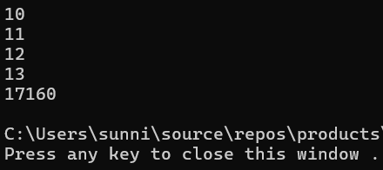
Conclusion:
Program successfully reads 4 integers and displays their product.

