Hello.java:

import java.rmi.Remote;

import java.rmi.RemoteException;

public interface Hello extends Remote{

String sayHello() throws RemoteException;

}

HelloImpl.java:

import java.rmi.server.UnicastRemoteObject;

import java.rmi.RemoteException;

public class HelloImpl extends UnicastRemoteObject implements Hello{

protected HelloImpl() throws RemoteException{

super();

}

@Override

public String sayHello() throws RemoteException{

return "I am a carrot";

}

}

Server.java:

import java.rmi.registry.LocateRegistry;

import java.rmi.registry.Registry;

public class Server{

public static void main(String args[]){

try{

HelloImpl obj=new HelloImpl();

//Craete registry on port 1099

Registry registry=LocateRegistry.createRegistry(1099);

//Bind the remote object in registry

registry.rebind("HelloService",obj);

System.out.println("Server ready...");

}

catch(Exception e){

System.err.println("Server exception:"+e.toString());

e.printStackTrace();

}

}

}

Output:

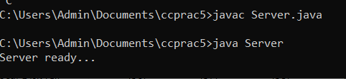

Client.java:

import java.rmi.registry.LocateRegistry;

import java.rmi.registry.Registry;

public class Client{

public static void main(String args[]){

try{

Registry registry=LocateRegistry.getRegistry("localhost",1099);

Hello stub=(Hello)registry.lookup("HelloService");

String response=stub.sayHello();

System.out.println("Response:"+response);

}

catch(Exception e){

System.err.println("Client exception:"+e.toString());

e.printStackTrace();

}

}

}

Output:

