Aim:
Writing a MATLAB program to plot exactly 10 cycles of a cosine signal with a frequency of 500 Hz, maximum amplitude of 5V and constant phase of π / 4

Theory:

We know that a cosine signal function is a periodic waveform described by
x(t)=A·cos(2πft + ϕ)

Where A is the amplitude, f is the frequency in Hertz, t is time in seconds, and ϕ is the phase shift in radians. Here, A = 5V sets the value of the maximum voltage, f = 500 Hz determines the oscillation rate, and ϕ = π/4 shifts the waveform right by 1/4 of a cycle. Since we get 500 Hz as the oscillation rate T = 1/f = 2·10⁻³ seconds.

In MATLAB, we will emulate a continuous signal by creating small increments in time (Δt) at the magnitude of 10⁻⁶.

MATLAB Code:

clc;
clear all; % clear
close all;

% cos Wave Signal

f = 500
T = 1/f; % Declare Variables
t = 0:10^-6:10*T;

signal = 5*cos(2*pi*f*t + (pi/4)); % Obtain Signal

plot(t,signal, 'r', LineWidth=2) % Plot signal
xlabel('Time (s)')
ylabel('Amplitude')
title('Cosine wave signal')
grid on;

Results:

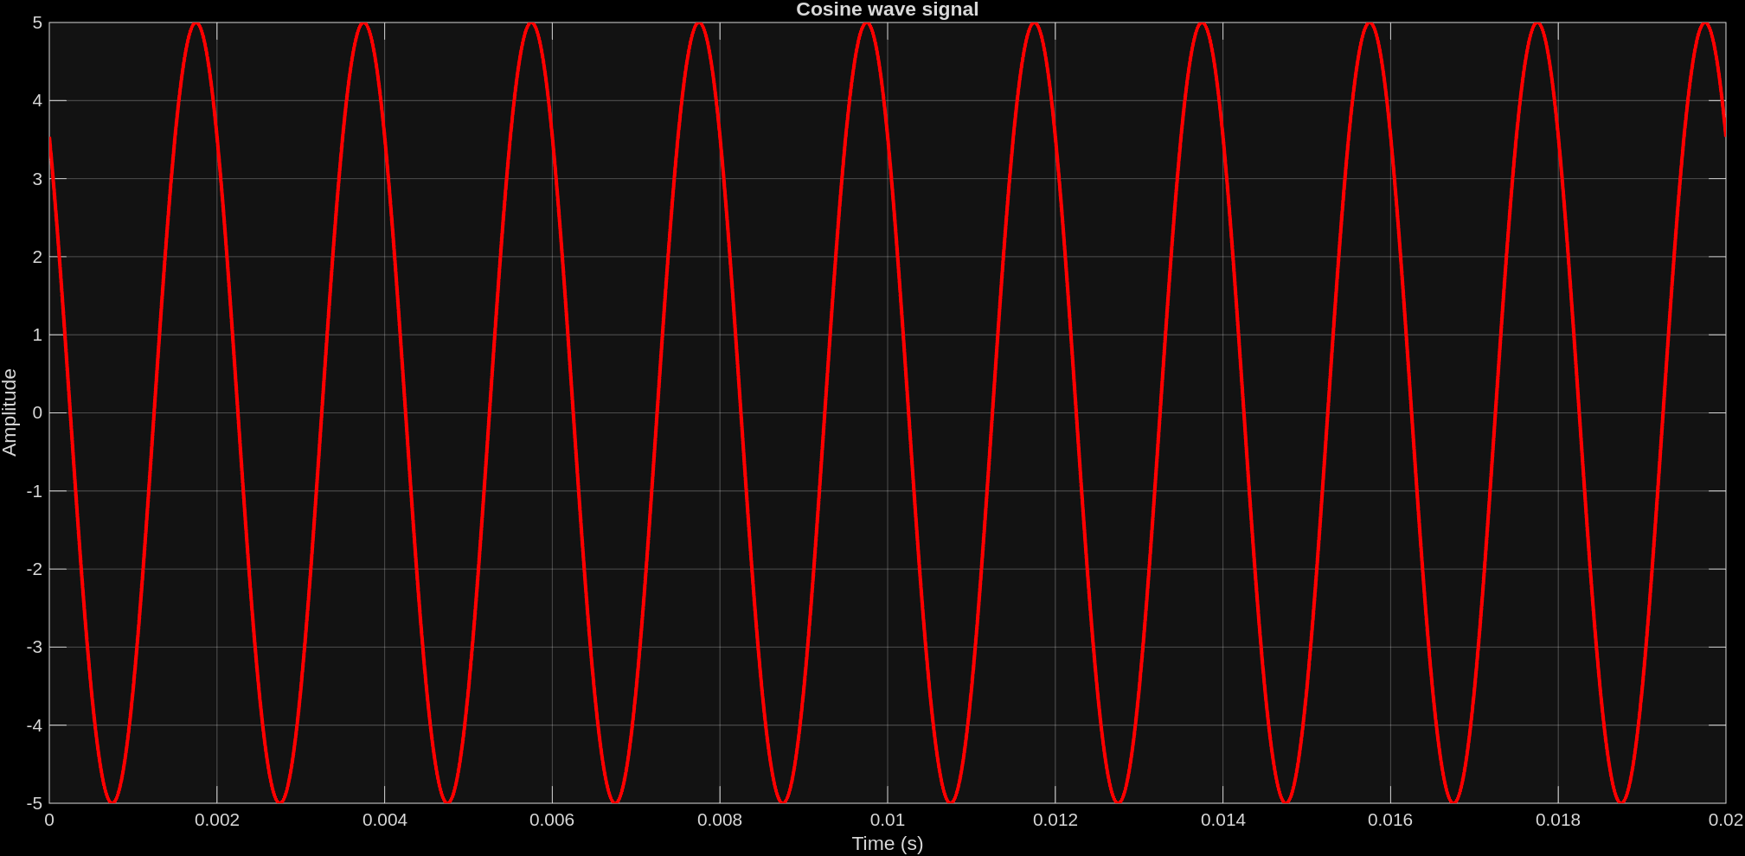

Conculsion:

From this experiment we were able to plot and visualize 10 cycles of a cosine signal with phase difference of π/4 and a maximum amplitude of 5V in MATLAB. In MATLAB, we were able to make a smooth visualization via using a small time sample to prevent aliasing.

