Aim
To synthesize a discrete-time periodic square wave using discrete-time fourier series in MATLAB.

Theory
Discrete-Time Fourier Series (DTFS): A discrete-time periodic signal x[n] with fundamental period N can be represented as a DTFS. Unlike the continuous-time case, the DTFS representation is an exact finite summation & does not exhibit Gibbs phenomenon.
The analysis equation is:

The synthesis equation is:

The square wave is defined as:

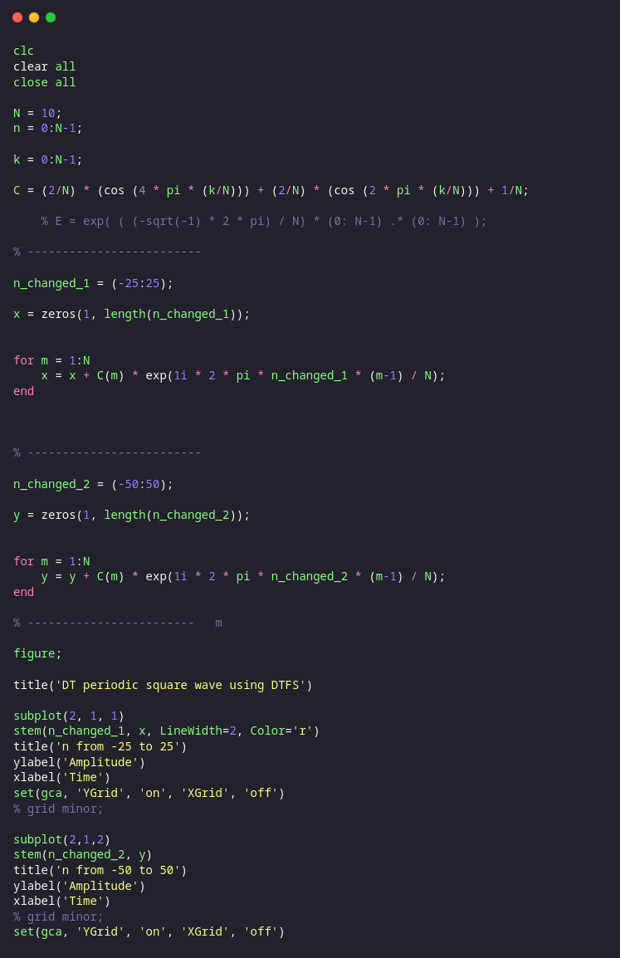
MATLAB Code

Results
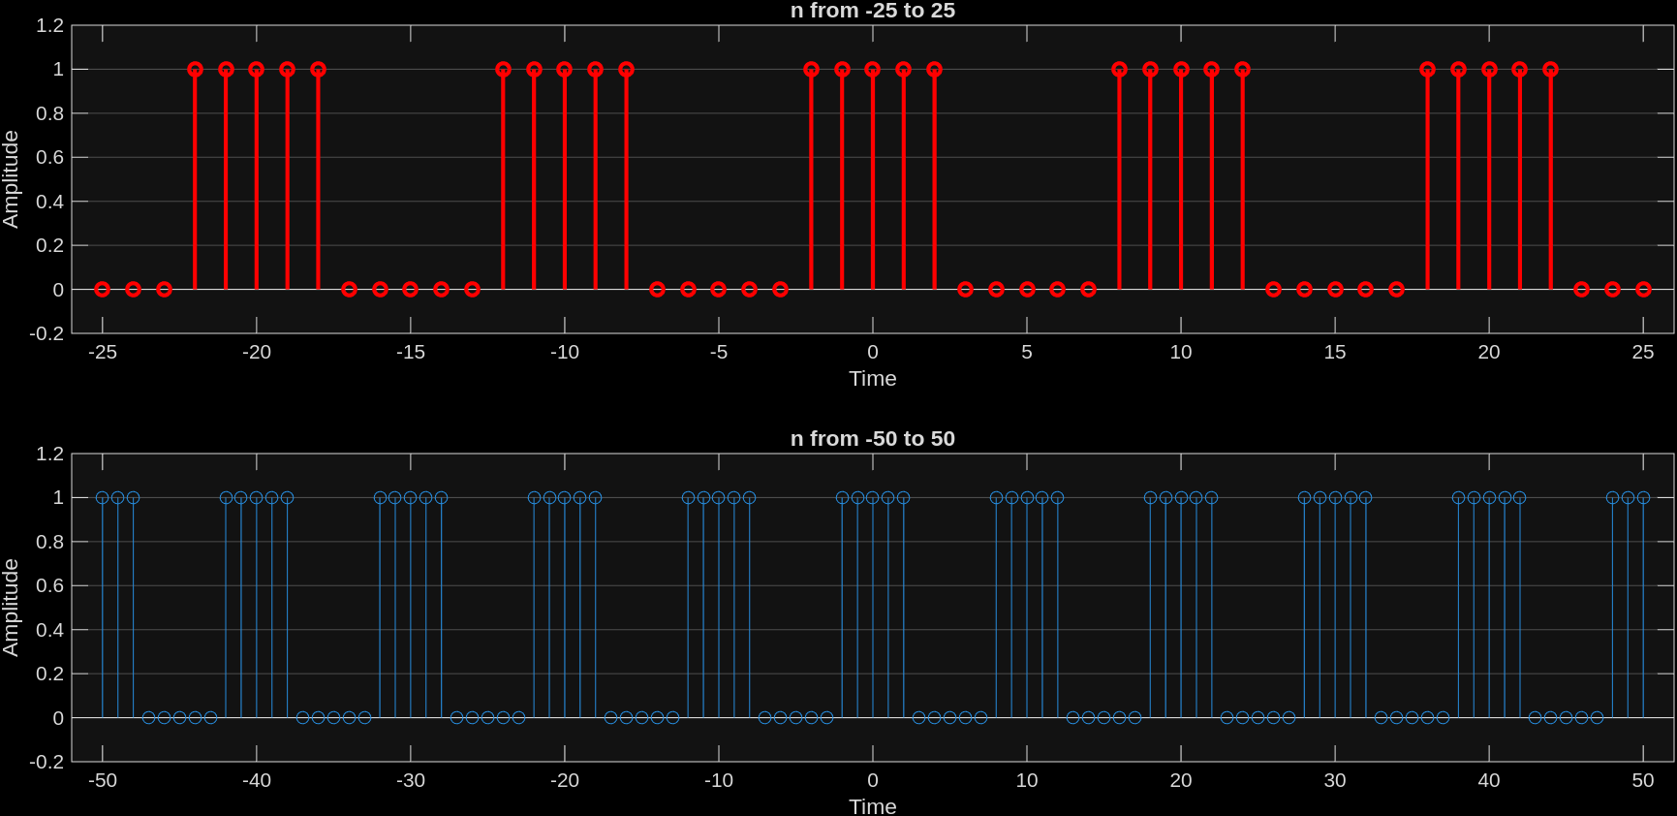

Conclusion
We observe that a square wave can be obtained from approximation from a DTFS to obtain a DT square wave function. We also note that we do not see any over-shoot and under-shoot phenomenon (Gibbs phenomenon).

