Aim
To find the Laplace transform of a unit ramp signal using MATLAB and then plot the signal

Theory
Laplace Transform: The Laplace Transform is an integral transform that converts of time (t) into a function of complex frequency (s). It is used for analyzing time-invarient systems (LTI) which are unstable, or to analyze transient responses or solve differential conditions with initial conditions.
The general formula is given by:

In MATLAB, we will sue the inbuilt laplace() function from the functional math toolbox and we will use syms to declare symbolic variables.

MATLAB Code
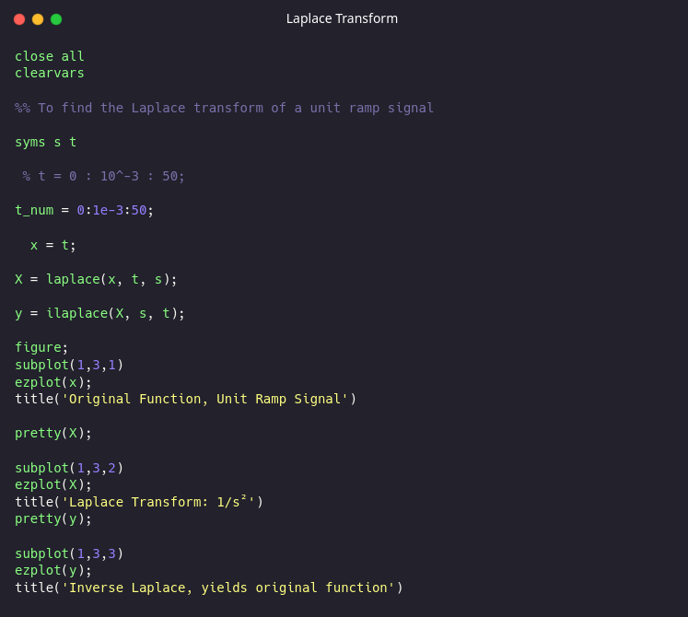

Output

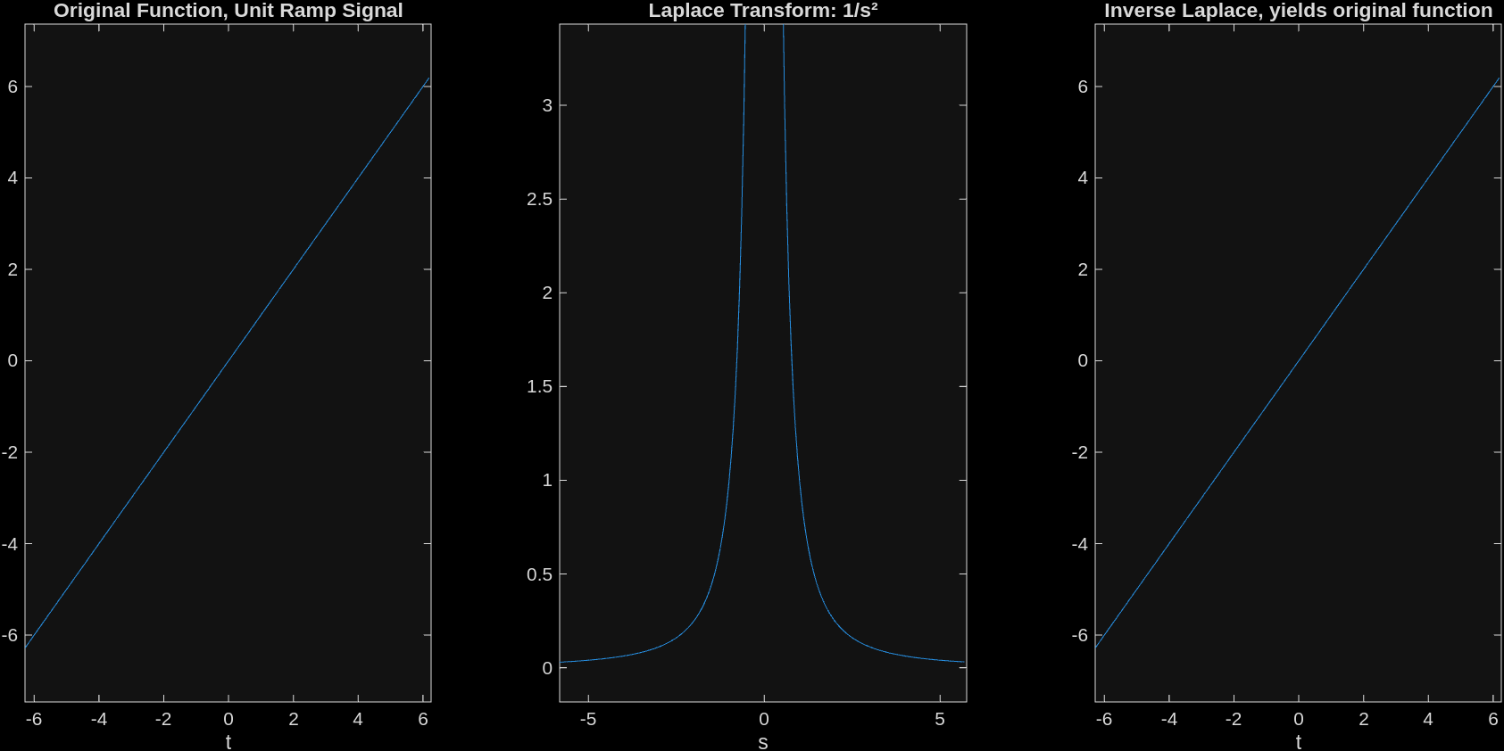

Conclusion
We successfully found the Laplace transform of a unit ramp signal, defined as r(t) = t, was successfully determined using MATLAB’s Symbolic Math Toolbox. The computational result yielded (1/s^2). We also found how the Laplace transform can be reversed to find the original function.

