Aim
To write a MATLAB program to plot a unit step, unit ramp and unit impulse signal in continuous-time and discrete-time domain.

Theory

Unit Step Signal: The continuous-time unit step signal u(t) is zero for t < 0 and one for t ≥ 0 which is represented mathematically as the following:

Whereas in discrete-time, the unit step sequence u(n) follows the same pattern but for integer values, where u[t] is represented mathematially as the following:

Unit Ramp Signal: The unit ramp signal in continuous time or r(t) is zero for t < 0 and equals t for t≥0. This is mathematically represented as the following:

Similar to unit step signal, the unit ramp signal in discrete time or r[t] rises linearly at each discrete step. It is also mathematically represented as the following:

Unit Impulse Signal: The continuous-time unit impulse signal or δ(t) is zero everywhere except at t=0, where it has infinite amplitude but unit area, this can also be represented mathematically as the following:

For a unit impulse signal in discrete time or δ[t], we can represent it mathematically as the following:

Continuous & discrete time domains: Continuous-time signals are defined over real t, these can be plotted smoothly in MATLAB using the plot() function; On the other hand, discrete time signals are visualized using the stem() function. Continuous time signals are defined over every instant of time. Whereas discrete-time signals are defined at only specific points in time.’

MATLAB Code:
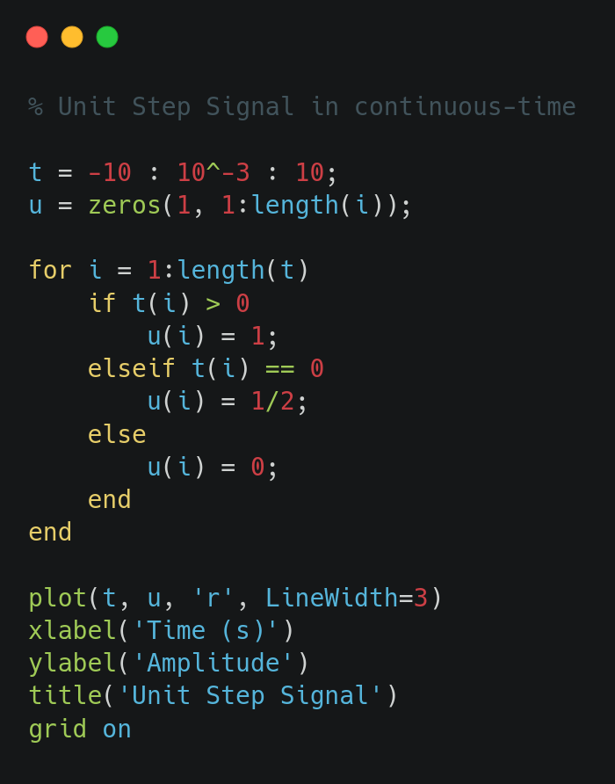
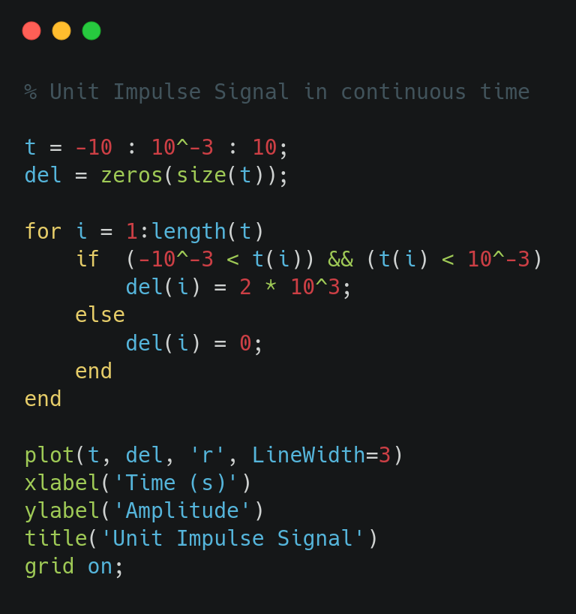
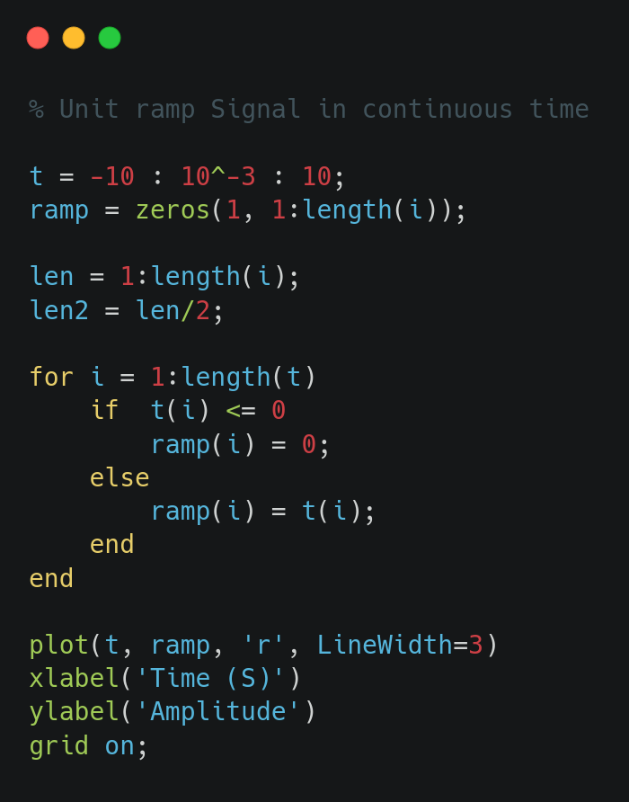

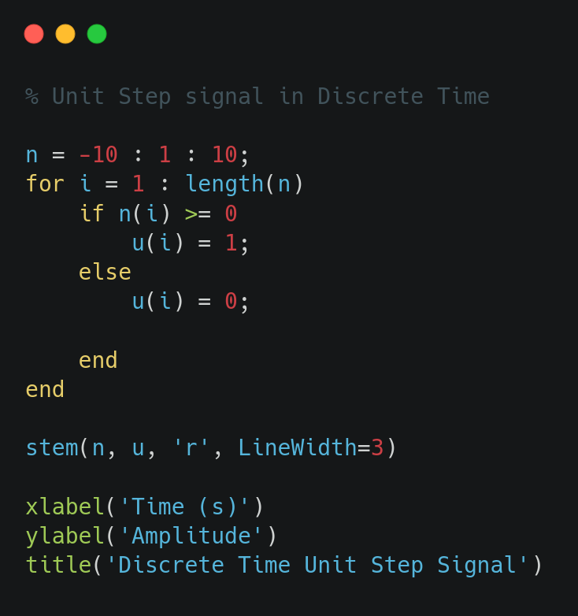
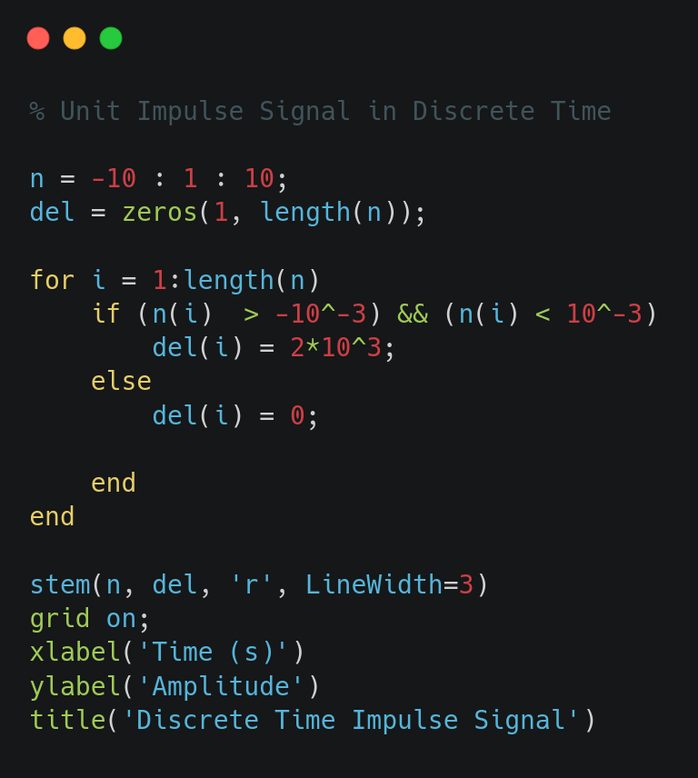
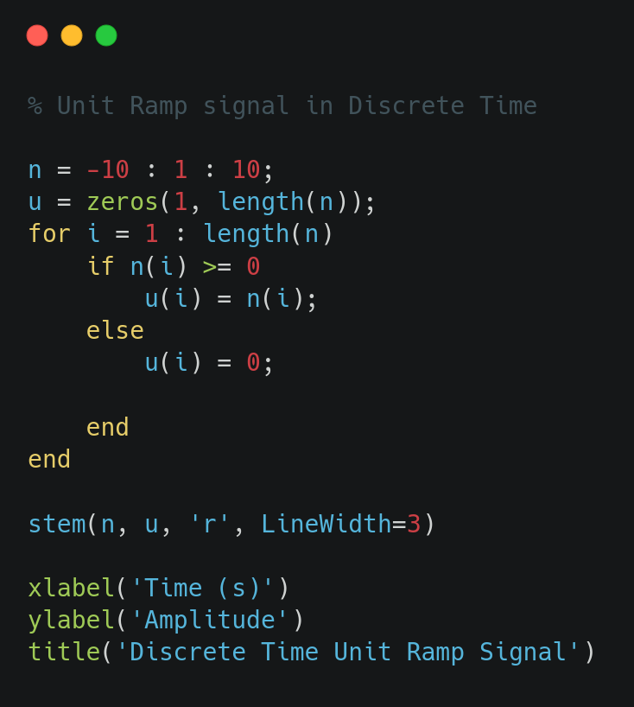

Results/Figures:
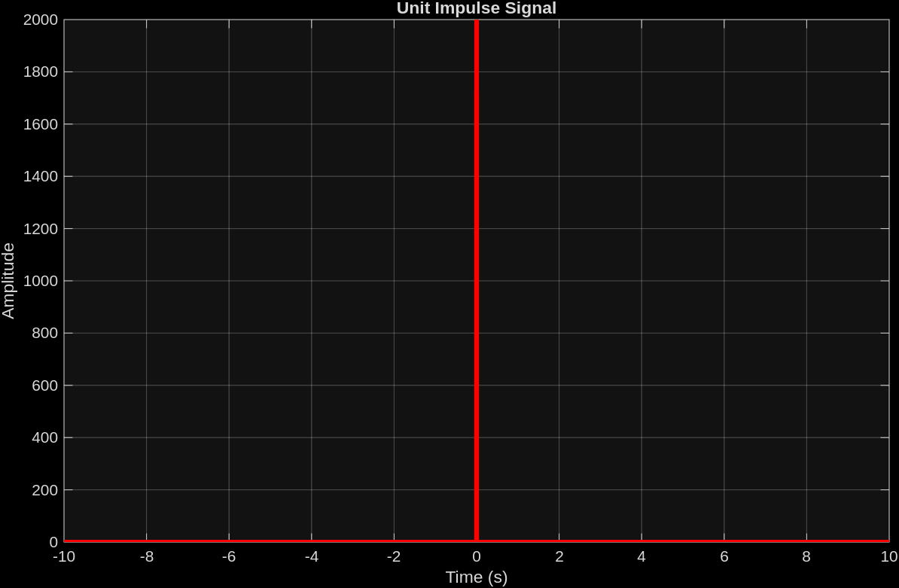
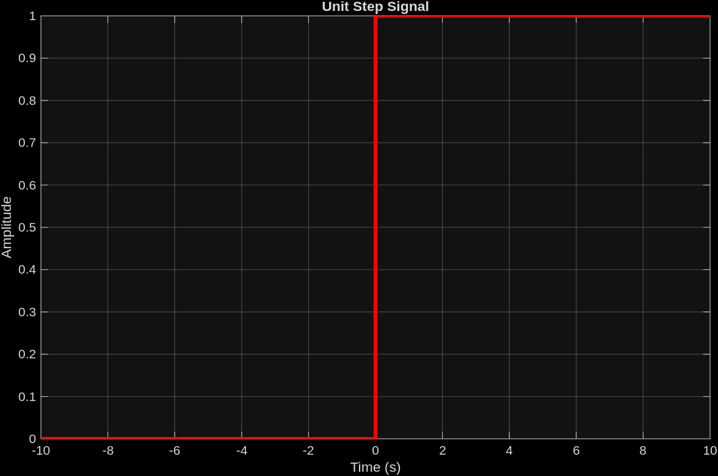
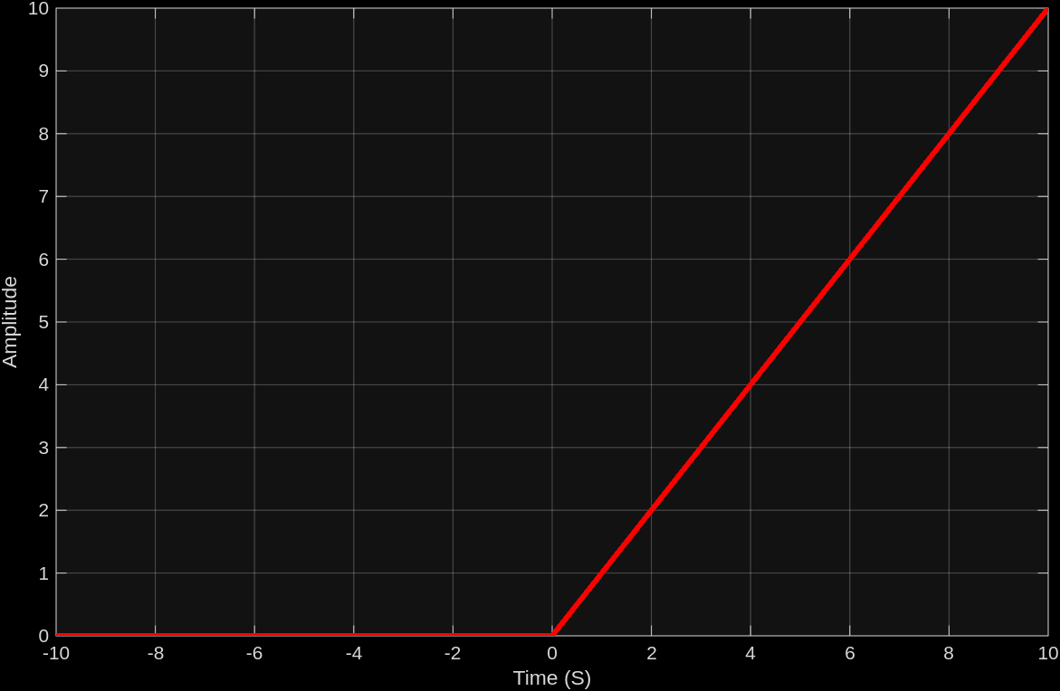
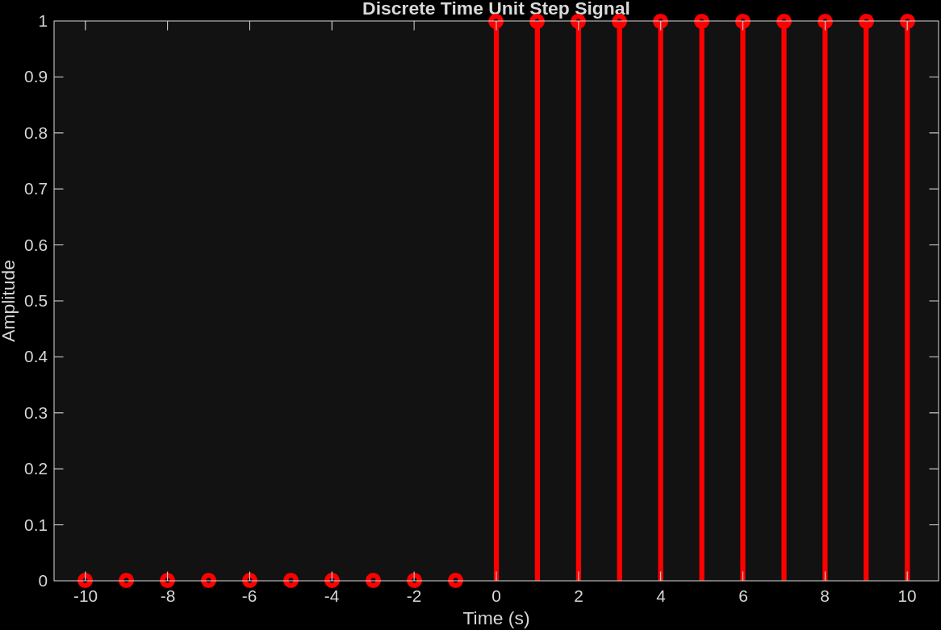
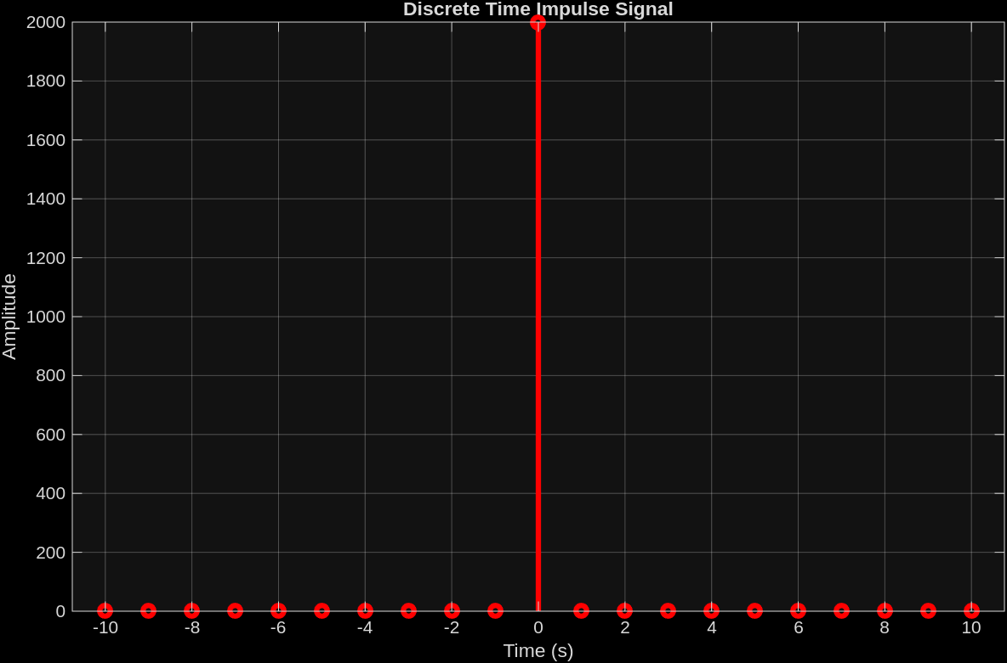
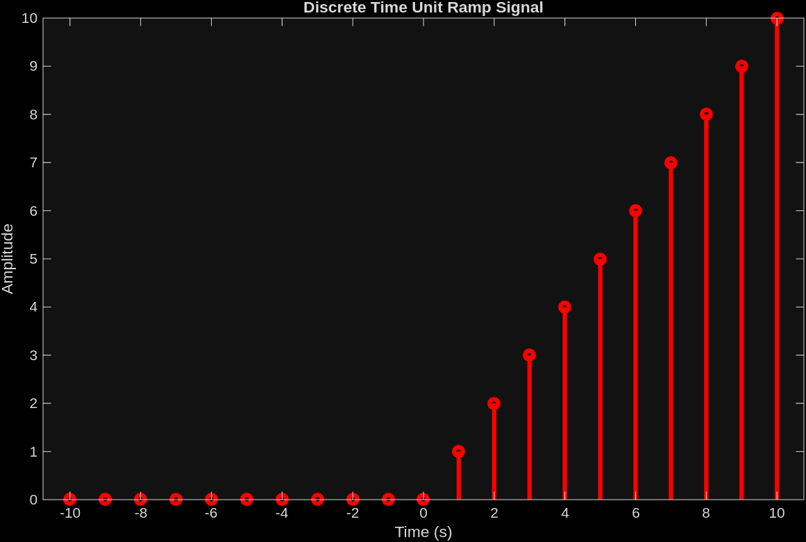
Conclusion:

In this experiment we were able to generate and visualize the fundamental signals, namely unit step, unit ramp and unit impulse in both continuous and discrete time domains using MATLAB. We were able to use the plot() & stem() functions to visualize continuous and discrete-time signals respectively.

