Aim:
Write a MATLAB program to plot f(t-0.2), f(t+0.2), f(2t), f(t/2) and f(-t) for f(t)=sin(2×pi×t) and f(t) as a unit step signal.

Theory:
Time Shifting: Time shifting replaces t with t-tₒ. Here, tₒ is postive if we must to right-shift the signal on the time axis and tₒ is negative if we must left-shift the signal on the time axis. It is important to note that time shifting preserves shape, frequency and symmetry of the signal.
Time Scaling: Time scaling is represented by replacing t with αt where α > 1 compresses (or signal becomes faster) and 0 < α < 1 expands (or signal becomes slower). In time scaling, the frequency of the signal is altered.
Time Reversal: In time reversal, the signal gets mirrored about the y axis. The frequency and symmetry of the signal are not affected.
It is also important to note that none of these operations bring about any alterations to the amplitude axis.

MATLAB Code:
For Unit Step Signal & Derivations:
clear all;
close all;
clc;
%% First We will write unit step signal

t = -1 : 10^-3 : 1;

m1 = zeros(1, length(t));

u = zeros(1, length(t));

shift1 = -0.2;
shift2 = 0.2;
shift_a = 2;
shift_b = 1/2;
shift_c = -1;

for i = 1:length(t)

if t(i) > 0
u(i) = 1;
elseif t(i) == 0
u(i) = 1/2;
else
u(i) = 0;
end
end

%% Now we will apply shifts

for i = 1:length(t)

if t(i) > -shift1
m1(i) = 1;
elseif t(i) == -shift1
m1(i) = 1/2;
else
m1(i) = 0;
end
end

for i = 1:length(t)

if t(i) > -shift2
m2(i) = 1;
elseif t(i) == -shift2
m2(i) = 1/2;
else
m2(i) = 0;
end
end

for i = 1:length(t)

if t(i) < 0
m3(i) = 1;
elseif t(i) == 0
m3(i) = 1/2;
else
m3(i) = 0;
end

end

figure;

subplot(3,2,1)
plot(t, u, 'r', LineWidth=3)
xlabel('Time (s)')
ylabel('Amplitude')
title('Original Signal')
grid on

subplot(3,2,2)

plot(t, u, 'm--', LineWidth=2)
hold on
plot(t, m1, 'r', LineWidth=3)
hold off
xlabel('Time (s)')
ylabel('Amplitude')
title('Right Shift')
grid on

subplot(3,2,3)
plot(t, u, 'm--', LineWidth=2)
hold on
plot(t, m2, 'r', LineWidth=3)
hold off
xlabel('Time (s)')
ylabel('Amplitude')
title('Left Shift')
grid on

subplot(3,2,4)
plot(t, u, 'm--', LineWidth=2)
hold on
plot(t, m3, 'r', LineWidth=3)
hold off
xlabel('Time (s)')
ylabel('Amplitude')
title('Signal Reversal')
grid on

subplot(3,2,5)
plot(t, u, 'm--', LineWidth=2)
hold on
plot(t, u, 'r', LineWidth=3)
hold off
xlabel('Time (s)')
ylabel('Amplitude')
title('Signal Doubled on time axis')
grid on

subplot(3,2,6)
plot(t, u, 'm--', LineWidth=2)
hold on
plot(t, u, 'r', LineWidth=3)
hold off
xlabel('Time (s)')
ylabel('Amplitude')
title('Signal halfed on time axis')
grid on

For Sine Wave & Derivatives:
clear all;
close all;
clc;

t = -1 : 10^-3 : 1;

signal = sin(2 * pi * t);
signal_plus_2 = sin( 2 * pi * (t + 0.2));
signal_minus_2 = sin( 2 * pi * (t - 0.2));
signal_double = sin(2 * pi * (2*t));
signal_half = sin(2 * pi * (t/2));
signal_reverse = sin( 2 * pi * (-t));

figure;
subplot(3,2,1)
plot(t, signal, 'r' ,LineWidth=3)
grid on;
title('Original Signal')

subplot(3,2,2)
plot(t, signal_plus_2, 'r', LineWidth=3)
hold on
plot(t, signal, 'm', LineStyle='--')
hold off
grid on;
title('t + 0.2')

subplot(3,2,3)
plot(t, signal_minus_2, 'r', LineWidth=3)
hold on
plot(t, signal, 'm', LineStyle='--')
hold off
grid on;
title('t - 0.2')

subplot(3,2,4)
plot(t, signal_double, 'r', LineWidth=3)
hold on
plot(t, signal, 'm', LineStyle='--')
hold off
grid on;
title('2 x t')

subplot(3,2,5)
plot(t, signal_half, 'r', LineWidth=3)
hold on
plot(t, signal, 'm', LineStyle='--')
hold off
grid on;
title('t / 2')

subplot(3,2,6)
plot(t, signal_reverse, 'r', LineWidth=3)
hold on
plot(t, signal, 'm', LineStyle='--')
hold off
grid on;
title('Signal Reverse')

Results:
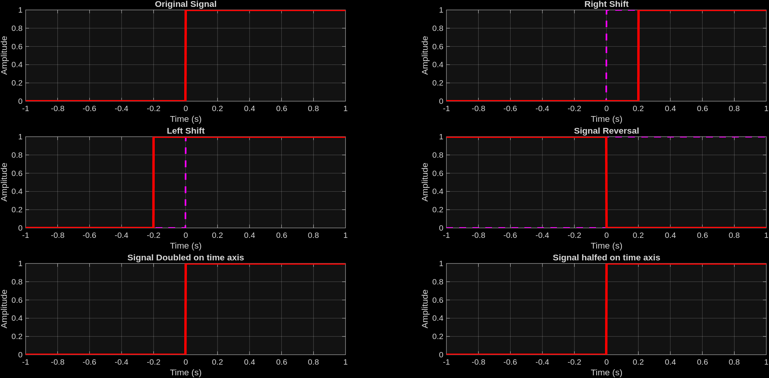
Unit Step Signal and derivatives

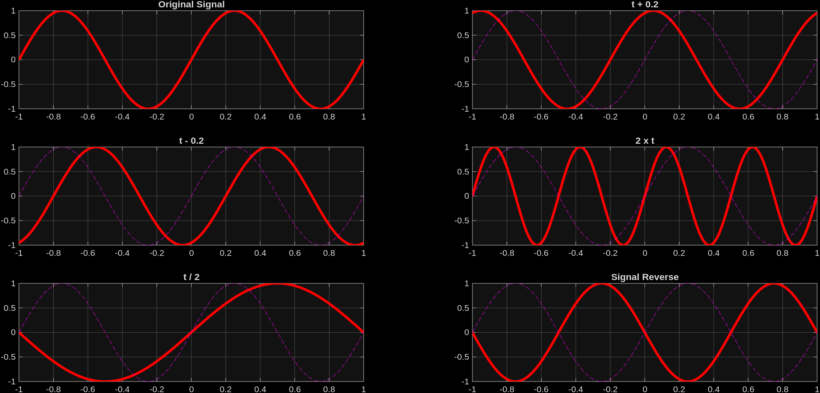
Sine Wave & Derivatives:

Conclusions:
From this experiment, we were able to plot and illustrate how time-shifting, time-scaling and time-reversal for both a sine wave and for a unit step signal. We also note that the maximum amplitude through the signal did not change while performing these transformations. We are clearly able to see the shifts, scaling and reversals as compared to the original signal in the dotted magenta line.

