Experiment 4: Signals and Systems

Aim
Write a MATLAB program to find the odd and even parts of the CT unit step signal and CT unit ramp signal.

Theory
We know that any signal in continuous-time can be decomposed to its even and odd parts. We also note that odd and even functions can be defined as follows:

And we also note that:

And,

MATLAB code

clear;
close all;
clc;

%% Unit step functions:

t = -10 : 10e-4 : 10;
unit_step_signal = zeros(1, 1:length(i));

for i = 1:length(t)
if t(i) < 0
unit_step_signal(i) = 0;
elseif t(i) == 0
unit_step_signal(i) = 1/2;
else
unit_step_signal(i) = 1;

end
end
len = length(unit_step_signal);
mid = floor(len/2) + 1;

signal_negative_part = unit_step_signal(1:mid-1);
signal_positive_part = unit_step_signal(mid:end);

reversed_signal = flip(unit_step_signal);

signal_even = (unit_step_signal + reversed_signal) / 2;
signal_odd = (unit_step_signal - reversed_signal) / 2;

%% Unit Ramp Signal

unit_ramp_signal = zeros(1, 1:length(i));

for i = 1:length(t)
if t(i) < 0
unit_ramp_signal(i) = 0;
else
unit_ramp_signal(i) = t(i);

end
end
len = length(unit_ramp_signal);
mid = floor(len/2) + 1;

signal_negative_part_ramp = unit_ramp_signal(1:mid-1);
signal_positive_part_ramp = unit_ramp_signal(mid:end);

reversed_signal_ramp = flip(unit_ramp_signal);

signal_even_ramp = (unit_ramp_signal + reversed_signal_ramp) / 2;
signal_odd_ramp = (unit_ramp_signal - reversed_signal_ramp) / 2;

%%

figure
subplot(3,2, 2)
plot(t, signal_even, 'r', LineWidth=3)
title('Even Part of Unit Step Signal')

subplot(3,2,3)
plot(t, signal_odd, 'r', LineWidth=3)
title('Odd Part of Unit Step Signal')

subplot(3,2,1)
plot(t, unit_step_signal, 'r', LineWidth=3)
title('Original, Unit Step Signal')

subplot(3,2, 5)
plot(t, signal_even_ramp, 'r', LineWidth=3)
title('Even Part of Unit Ramp Signal')

subplot(3,2,6)
plot(t, signal_odd_ramp, 'r', LineWidth=3)
title('Odd Part of Unit Ramp Signal')

subplot(3,2,4)
plot(t, unit_ramp_signal, 'r', LineWidth=3)
title('Original Unit Ramp Signal')

Results
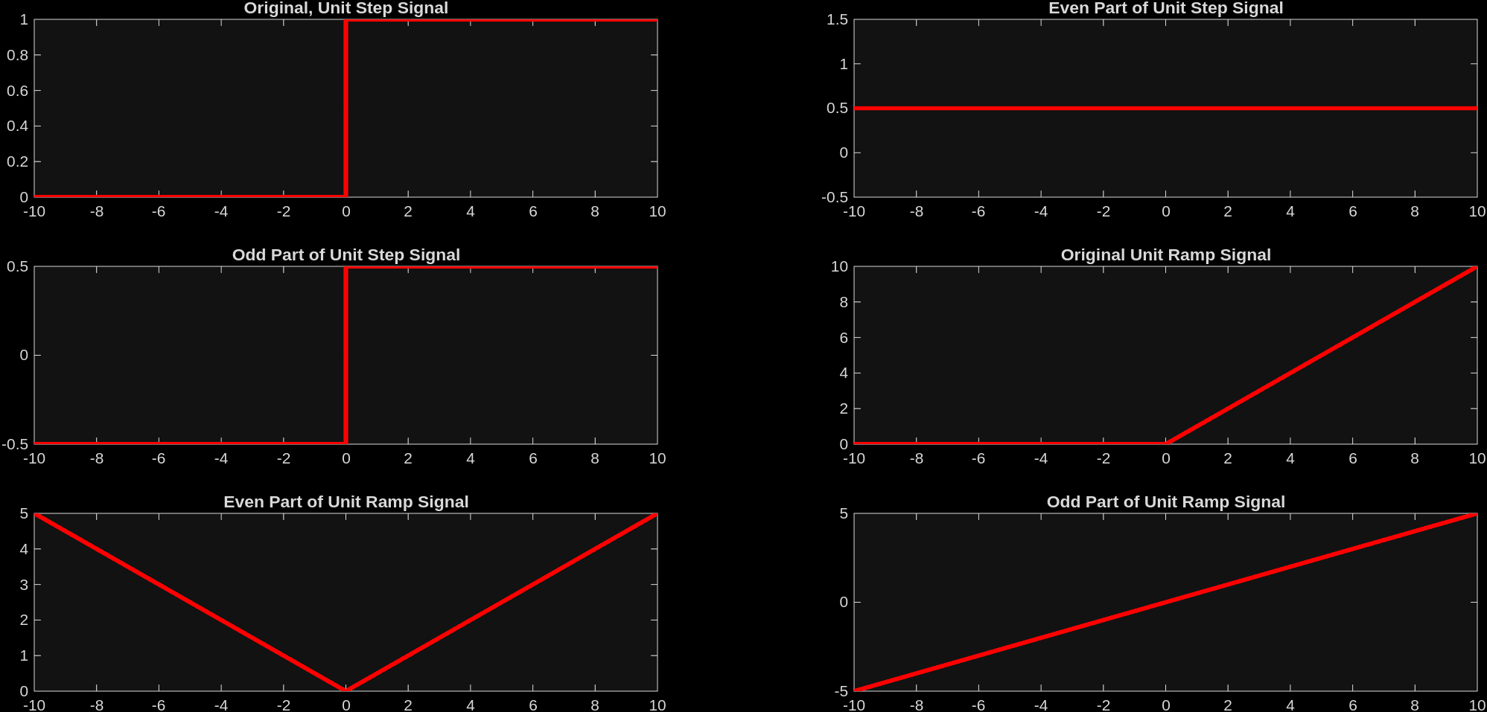

Conclusion
From this experiment we were able to successfully decompose a continuous-time unit step and unit ramp signal into their even and odd components using their standard formulas. We observe that even parts remain symmetric about the origin whereas the odd parts exhibit asymmetry.

