Aim:
Write a MATLAB program to find conjugate symmetric and antisymmetric parts of a discrete-time complex valued signal.

Theory:
We know that any discrete-time complex-valued signal can be decomposed into its conjugate symmetric and conjugate anti-symmtric parts
We define the conjugate symmtric part as:

Where is the complex conjugate
Similarly, we define the conjugate anti-symmetric part as:

We also note the important relation that:

MATLAB Code:
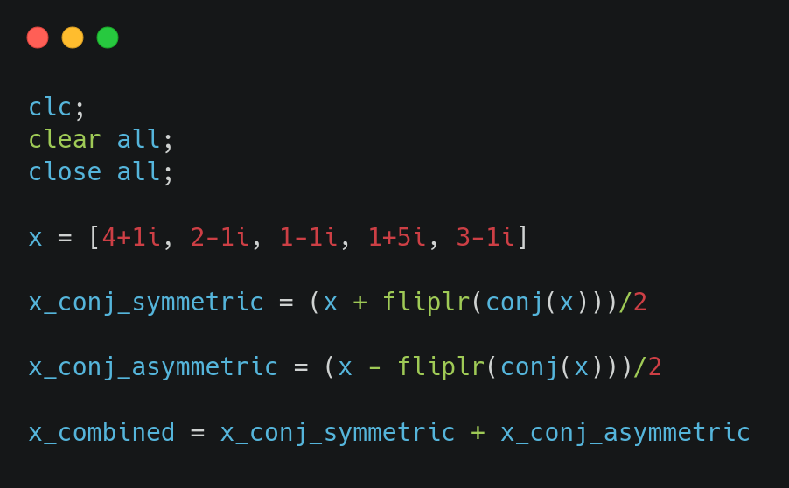

Results:
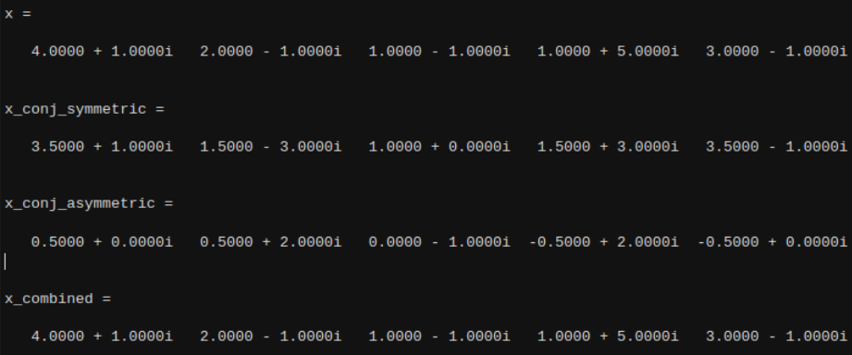

Conclusion:
From, this experiment, we are able to verify how a discrete-time complex signal can be split into its conjugate symmetric and conjugate anti-symmetric parts. We also note that these parts can be recombined to form the original signal.

