Aim
To write a MATLAB program to find the convolution of two discrete time sequences.

Theory
In this program, we will take two sequences, namely x[n] and h[n] and compute their convolution:
We represent this as:

To do this we will perform four steps:
1. Flip: We will convert it as:
2. Shifting: We will now shift the signal which we represent as follows:
3. Multiplication:
4. Integration:

MATLAB Code

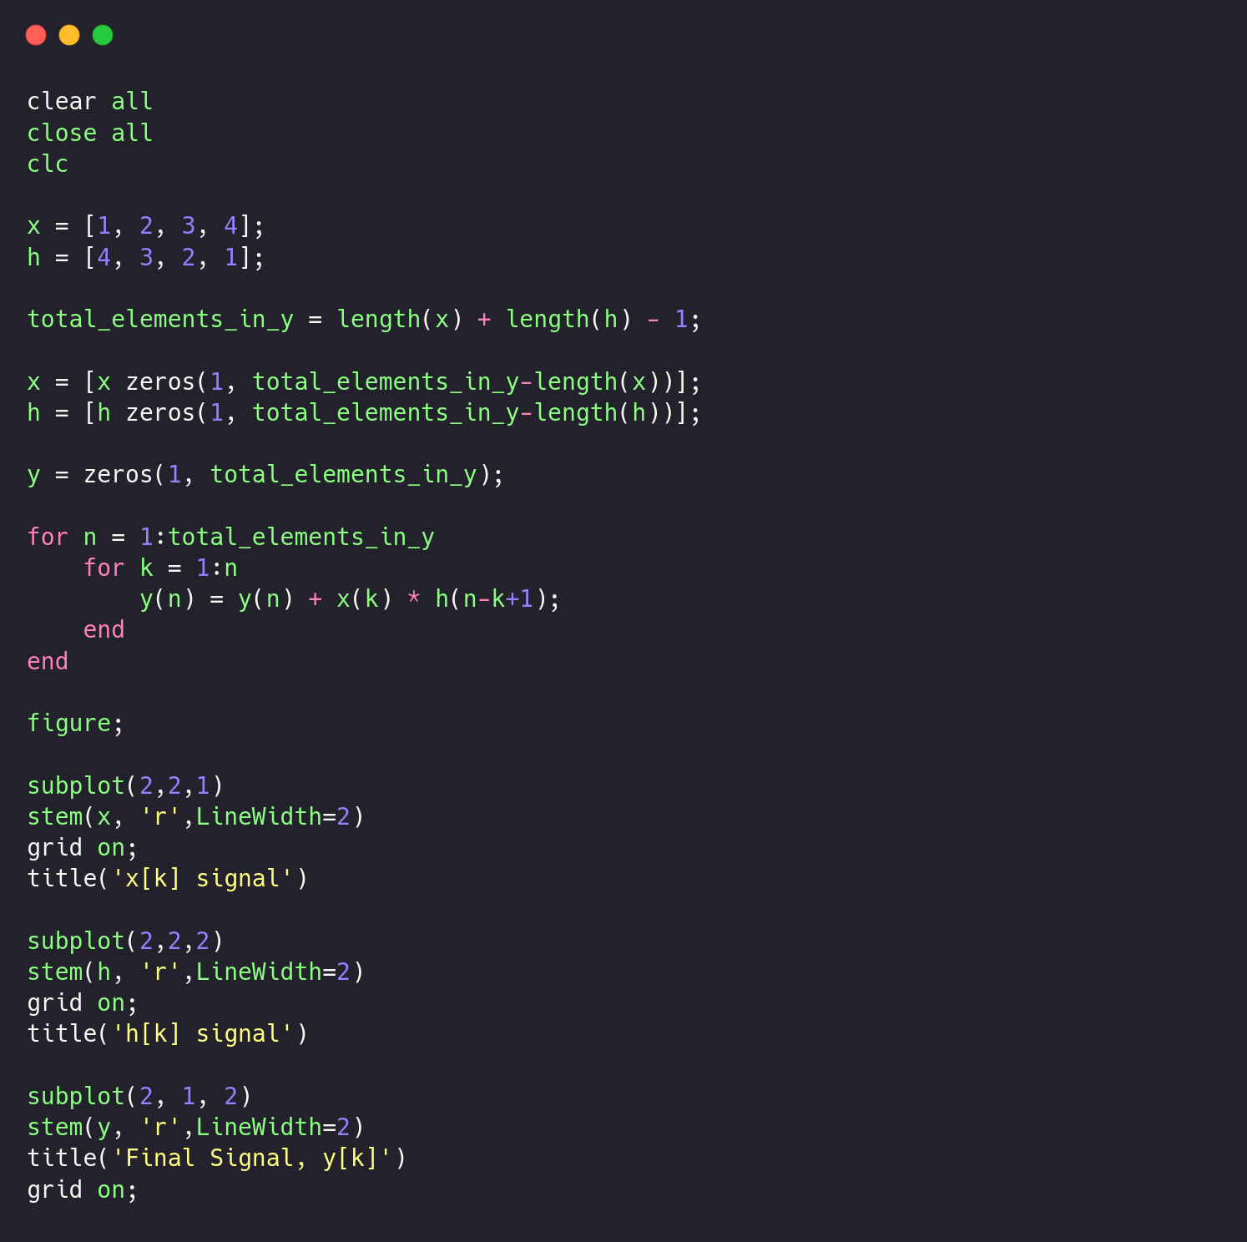

Results

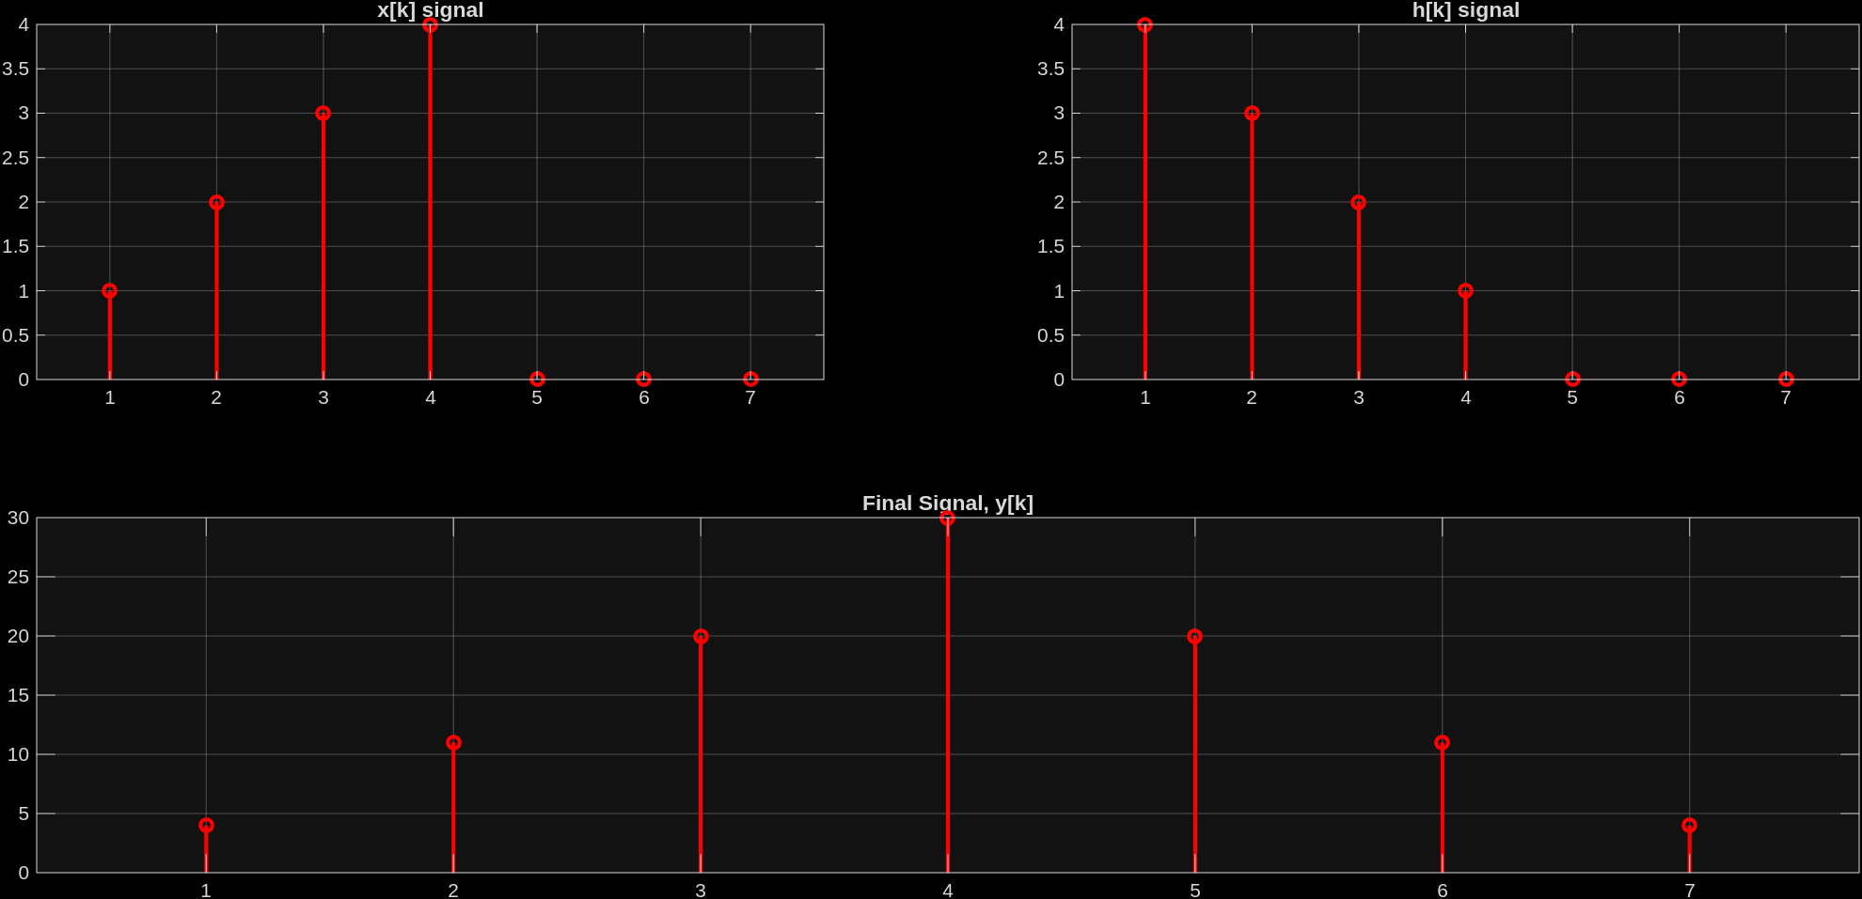

Conclusion
In this experiment, we have successfully shown the computation of linear convolution between two discrete-time sequences. We found that if, for example,

&,

We observe that the convolution of these signals yields:

