Aim
To observe the Gibbs phenomenon of CTFS of a periodic square wave using MATLAB.

Theory
The Gibbs phenomenon occours in Fourier series approximations of discontinous periodic signals (like square waves) where we notice over/undershoots and ripples near the jump discontinuties.
When the number of terms/samples approches infinity, we observe that the over/undershoots approach 9% of the height of the discontiunity.
To find the CTFS for a periodic square wave, we will first find Cn via:

Then we will find the function by using:

Where j = √-1

MATLAB Code
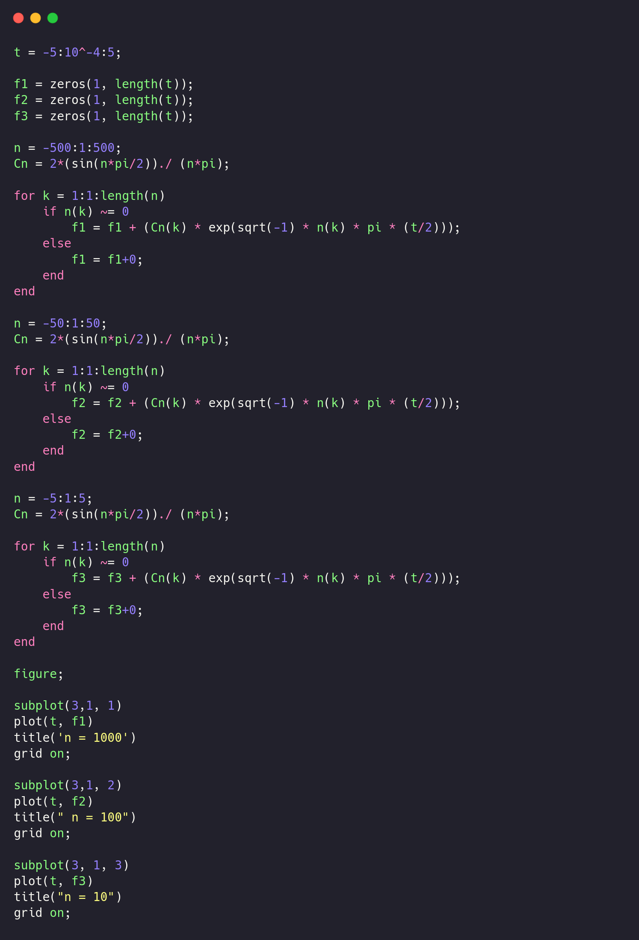

Results
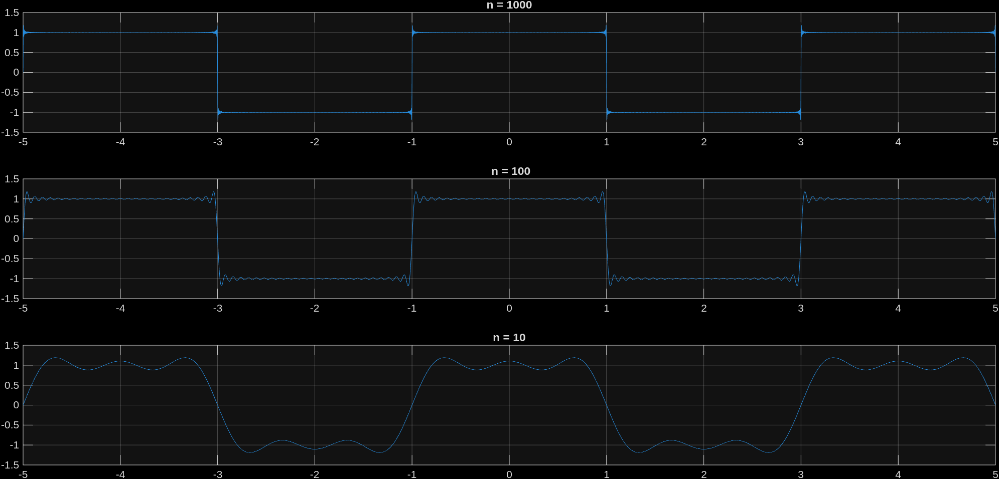

Conclusion
In this experiment, we have demonstated the Gibbs phenomenon through CTFS analysis of a periodic square wave in MATLAB and have found a ~9 over/undershoot at jump discontinuities despite increasing the number of harmonics.

