BPMN SALES ORDER

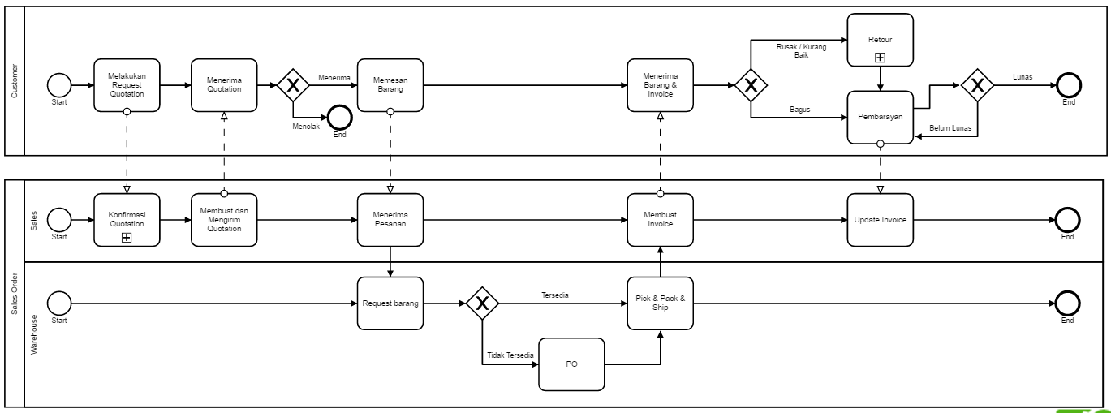

Detail Konfirmasi Quotation

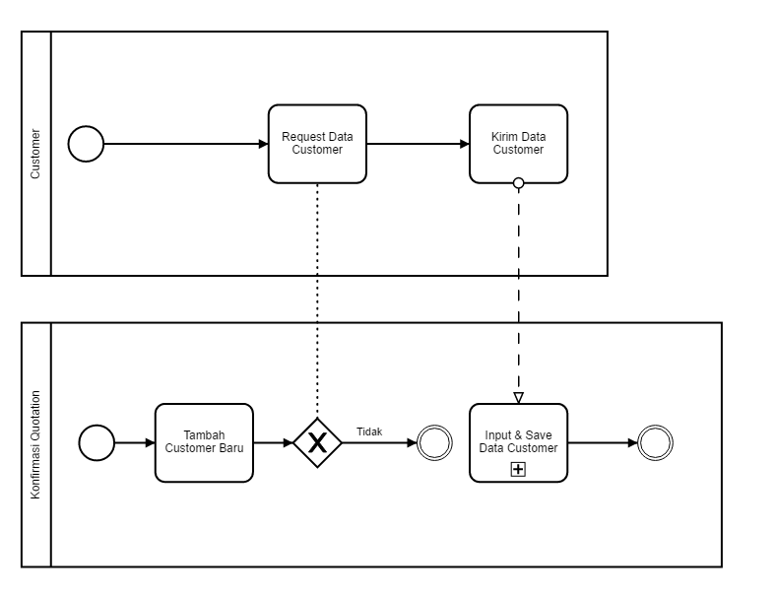

Detail Input dan Save Data Customer

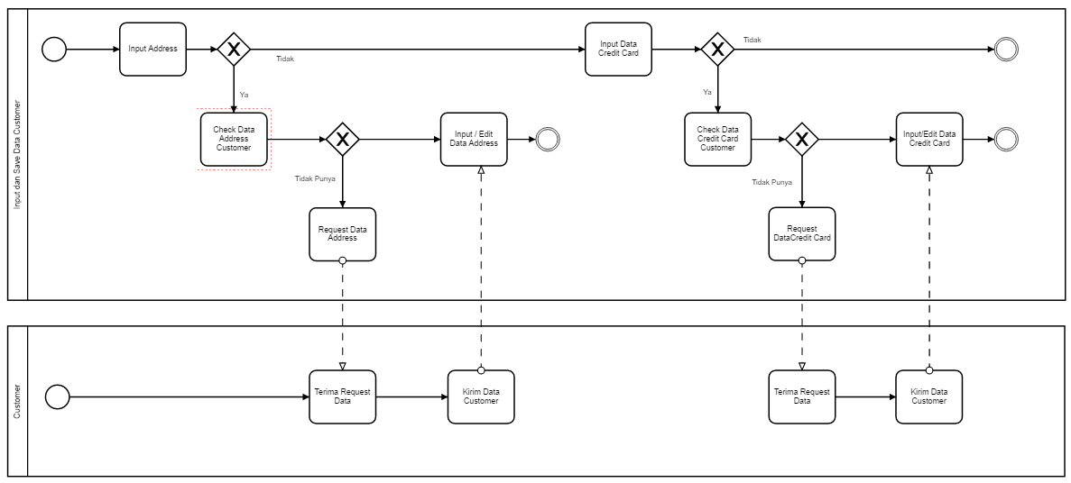

BPMN Delivery

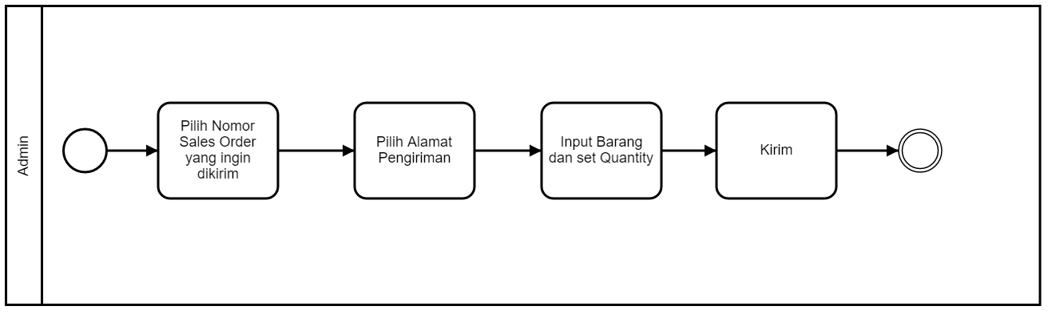

BPMN Add New Produk

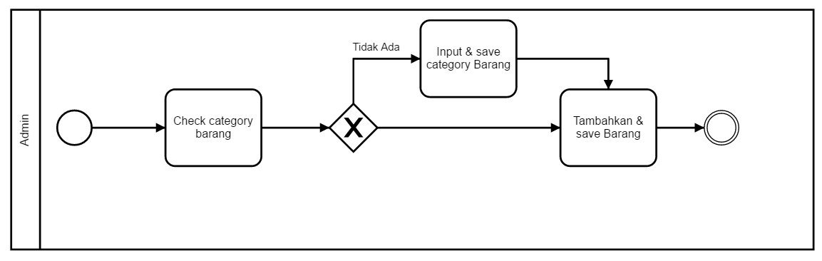

**USE CASE DIAGRAM**



**ACTIVITY DIAGRAM**

