Intersecting pipes
someonesdad1@gmail.com 21 Jan 2011

When working on projects, it sometimes happens that we want to join two cylinders at an angle. For example, in building a bike frame, a person might want to join two pieces of pipe at an angle by welding or brazing. To get a good joint, one of the ends of the pipes must be cut to fit on the other pipe at the requisite angle.
For the average person, the easiest way to tackle this problem is to draw the required curve on a piece of paper, wrap the paper around the end of the pipe and use it as a template to mark the pipe, then cut or grind the end of the pipe to the indicated curve.
Pipe fitters and sheet metal workers use orthographic views and a scale drawing to develop this template. However, having a formula for the curve is nice, as it lets you use a computer to plot the curve. I found a site on the web (http://home.tallships.ca/mspencer/winmiter.html) that gave a perl script for this task (it just printed out the Cartesian coordinates; you needed to hand-plot them on paper). However, it didn't give the derivation of the formula and a few trials convinced me the formula was incorrect for pipes that don't meet at right angles -- thus came the need to derive the formula. The formula is derived in an appendix.
Here's the notation we'll use:

We must have that . If the axes of the pipes are both parallel to the xy plane, then the angle of intersection of the axes is the smallest angle projected onto the xy plane with parallel rays from . This angle is in the interval (0, ] radians. Since pipes intersecting at right angles ( radians) is very common, I chose instead to use the complement of or (this also falls out naturally from the method used to derive the formulas).
A one-parameter vector that traces out the curve of intersection of the pipes is ( is the parameter and is in the interval ):

This vector traces out the curve of intersection assuming your eye is at .
If you want to plot the curve to make a template for cutting the end of the smaller pipe, use this formula:

Here's an algorithm you can use with a calculator or program to plot the curve or print out the (x, y) values for the template:
For , we have

If you want to plot in increments of , then calculate Plot the point (0, 0). Then starting with the angle equal to , calculate and plot the point . Add to , repeat the calculation, and plot the new point. Keep repeating until is greater than A program to print out the coordinates or plot the curve can use the identical algorithm.
Here's a python script that will print out the coordinates:
from __future__ import division
from math import sqrt, pi, cos, sin

a = 0 # Offset of pipe axes
d = 2 # Small pipe diameter
D = 3 # Large pipe diameter
alpha = 0 # Angle between pipe axes in degrees (0 means perpendicular)
dx = 0.25 # Plotting interval

C, d2r = pi*d, pi/180
assert a + d/2 <= D/2, "Offset is too large"
dtheta, theta = dx/C*2*pi, 0
sa, ca, r, R = sin(alpha*d2r), cos(alpha*d2r), d/2, D/2
y0 = (R + r*sa)/ca # Offset for theta == 0
print "D =", D, " d =", d, " alpha =", alpha, "deg", " offset =", a
print "Circumference of small pipe = %.3f" % (pi*d)
print '''
x y
------- -------'''[1:]
while theta <= 2*pi:
x, s, c = C*theta/(2*pi), sin(theta), cos(theta)
y = (sqrt(R*R - (r*s + a)**2) + r*c*sa)/ca - y0
print "%8.2f %8.2f" % (x, -y)
theta += dtheta
You'll get a math exception if the argument of the square root becomes negative; this will happen when for any value of in the interval [0, ).

Plotting
The nicest form of a solution is a plot on a piece of paper. This lets you wrap the paper around the pipe and mark the pipe for cutting. The basic need is for a graphical programming environment to plot the curve; a key need is to be able to accurately plot to scale.
Probably the easiest thing to do is to go to Stan Harder's website and use his nice graphical tool. Otherwise, use the above script to print out a table and manually plot it on some graph paper. Make a template out of sheet metal if you have to mark a number of pipes for cutting.
If you're willing to download a python graphics library that outputs Postscript, you can use the included python script pipes.py to make some plots.

Appendix: Derivation of the formulas
You obviously don't need to understand the derivation in order to use the formulas in the text. However, the derivation just uses basic college algebra and analytic geometry, so it can be followed by most technical folks.
Here's an outline of the derivation. We'll write down a vector that describes the points on a right circular cylinder; this vector involves two parameters to describe the surface. We'll have one cylinder lie along the x axis and another cylinder lie along the y axis. Thus, the two cylinders start off intersecting at a right angle. Next, we'll translate the cylinder along the x axis a distance a above the xy plane, then rotate this cylinder about the z axis by an angle (note these transformations' operators commute). This puts the axis of this cylinder in a plane parallel the xy plane. We then equate the components of the two two-parameter vectors describing the points on the cylinder (this gives us the points in common between the two cylinders) and solve for the parameters. Substituting back into one of the original cylinder equations results in a one-parameter vector describing the intersection curve. Finally, we use the inverse of the rotation transformation to transform this intersection curve back to be symmetric about the x axis. This yields the equation of interest, which is not terribly complicated.
While I devised this method of solution, I made two dumb errors in trying to carry it out. Jerry Mathews at the wonderful Dr Math website did the derivation correctly and his help showed me where I made my mistakes. If you have problems with some math, I recommend the Dr Math website and its volunteers -- they're good folks.
Let and be the radii of the two cylinders. Cylinder 1 lies along the y axis and a parametric Cartesian vector for the points on its surface is
(1)
Let cylinder 2 lie along the x axis so that a parametric Cartesian vector for its points is

In both of these equations, and go from 0 to and u and v are real numbers.
These two cylinders have axes that lie along the coordinate axes and intersect at the origin. Now let's use a rotation matrix to rotate one of these vectors about the z axis:

where is the angle of rotation about the z axis. This is the correct matrix to use as is seen by trying the rotation on (1, 0, 0).
Using the above rotation matrix, transform the cylinder lying on the x axis to lie in the xy plane at an angle to the x axis:
(2)
Equating the components between equations (1) and (2), we get
(3)
(4)
(5)
We'll use for the parameter of the curve, so solve (5) for and (3) for v, both in terms of . Then substitute these and (4) in equation (1) to get a parametric vector G() of the curve of intersection. Note that solving (5) will require to keep things real. The result is

where

To get the equation to plot on a piece of paper to wrap around the pipe for marking the cut, we can use the inverse of to transform the curve of intersection's coordinates back to being parallel to the x axis. This will let us get the requisite equation to plot on a piece of paper to wrap around the pipe to mark it for cutting. Getting the inverse transformation is easy -- since this is an orthogonal transformation, just take the transpose (or just change to ):

The result is (after remembering the inverse of the z translation)

Thus, we see that the height of the curve to plot as a function of the angle is

We can rewrite this using R for the larger radius , r for the smaller radius , and for the parameter:

Remember, measures the angle off the normal, so for pipes intersecting in a right angle, = 0.
Since I prefer to use the diameters of the cylinders, we can rewrite this equation as

Pattern on the other cylinder
If you have to join the two pipes so that a fluid can flow between them, then you need to trace the pattern given above on the end of one pipe as well as cut a hole in the other pipe. We'll figure out the pattern to draw on a piece of paper to encircle the other pipe so the hole can be marked.
Instead of doing the work yourself, you can go to Stan Harder's nice website that prepares drawings for you that can be printed on your printer to make the templates. Stan doesn't give the equations he uses, so you'll have to decide whether his pictures are appropriate. It appears he offers a commercial tool called Digital Pipefitter for $360, but this is a bit steep for the homeowner or hobbyist that only needs one or a few joints. However, it looks like a nice tool and would easily pay for itself in professional use -- download it and give it a try to see if it meets your needs.
I had written a plotting program to draw a template for the pipe's end cut and made a plot for pipe diameters of 2 and 1.5 inches, an offset of 0.1 inches, and an angle off the normal of 45 degrees. I plotted this and captured the image on my computer screen and overlaid it on an image that Stan generates on his website (I first had to scale my image). The two overlaid perfectly:
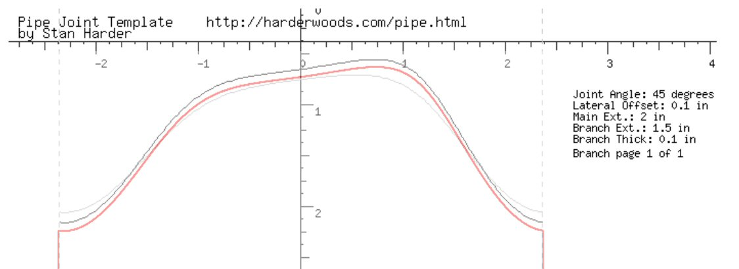
The red curve is what my program produced and the dark gray line is what Stan's produced. These matched perfectly when overlaid, but I offset them a bit so you could see both. This tells me that if our derivations are wrong, at least Stan and I made the same mistakes. ☺
If you only need to mate one or two sets of pipes, you can first cut the end of the smaller pipe to proper shape and use it as a template to trace the hole to cut out on the larger pipe. This is probably the quickest and easiest solution.
If you want to make a plot on a piece of paper for the larger pipe so you can trace the hole, here's how to do it. The coordinates of the parameterized vector describing the surface are

Again, remember r ≤ R.
If you imagine looking down the y axis (i.e., along the axis of the larger pipe), you'll see the following picture:
The point B is on the curve of intersection. The angle . The arc length of the arc AB is . Then when we plot the points (s, y) as goes from 0 to , the cutout will be traced in the plane.
If and and , then we can show that the plotted curve will be virtually indistinguishable from a circle. In this case,

Now

But because , we have . Then we plot the parametric curve , which is a circle.

The General Case
After you go through the problem of finding the intersection of two circular cylinders, you realize that the method should be able to handle finding the intersection curve of two cylinders of any shape. And, as long as a piece of paper can be smoothly placed over the cylinder's surface or end, the method of making a template should work too. Thus, in the shop, this would let us make templates for e.g. elliptical and rectangular tubes too.
The next realization is that the equations involved can be implicit if we're going to solve the problem with a computer. In other words, it's not necessary that we be able to algebraically solve the problem. However, for practical folks, this brings to mind the need for finding roots of nonlinear equations, and this may not be as general a method as it seems.
Regardless, let's take a look at the general equations and see where they lead. We'll use the same general method we used in the circular cylinder case. Cylinder 1 will have the y axis as its axis and cylinder 2 will start with the x axis as its axis, then be rotated and translated.
We'll assume the cross section of the cylinders can be described by plane curves described by a single parameter. Thus, we have the parameterization
(6)
(7)
are in the interval [0, ] and u and v are real numbers.
We translate cylinder 2 by an amount above the xy plane, then rotate it by an angle about the z axis:
(8)
Equating components between equations (6) and (8) gives the three equations

(9)
(10)
(11)
Equation (9) lets us express the parameter v as a function of the parameters :

Equation (10) gives us an expression for u directly and equation (11) can be solved for

Putting this information back into equation (6) lets us have a parameterization of the curve in terms of the parameter

Using the inverse rotation brings this curve back to the x axis

or, translating down by again on the z axis,
(12)
This is the one-parameter curve that describes the intersection of these two cylinders.
A feature of this solution is that there is only one implicit equation, that of . This means that a computer solution for the template for the cutting of the end of the smaller pipe shouldn't be too hard to generate. Plotting a template the hole in the larger pipe will be harder, as we need to be able to calculate the linear distance along the surface of the pipe given the value of the parameter , which we'll interpret as an angle. For circular pipes, this was easy because of the relationship between the angle and the length of the circular arc. For the more general case, we'll have to do a numerical integration to get the arc length along the curve describing the cylinder's cross section -- but this doesn't add any fundamental challenges:
Suppose a one parameter space curve is described by the vector . Then the length of the curve for parameter values to is

where the dot denotes differentiation with respect to the parameter.

Unfortunately, the author of that web page gives no method of contacting him, so the errors will remain.
Note in the script following that I print out the negative of this value to keep most of the table values positive.

